
JOHNS HOPKINS
MEDICINE

Alexander Hillel, MD
Associate Professor
Department of Otolaryngology- Head and Neck Surgery
601 N. Caroline Street, 6th Floor
Baltimore, Maryland 21287-0910
Office #: 410-955-1654
Fax #: 410-614-8610
Email: ahillel@jhmi.edu

Sept 6, 2019

Dear JoVE Editorial Board,

Please find enclosed our revised manuscript titled “Design of a biocompatible drug-eluting tracheal stent in mice with laryngotracheal stenosis” as well as copies of our revised figures to be included with our submission to illustrate our results.

The editorial comments have been addressed and can be found at the end of this document and are also annotated in “track changes”.

All authors have directly participated in the conduct of this research and have read and approved the submitted manuscript. I have full access to all the data in the study and take responsibility for the integrity of the data and the accuracy of the data analysis as well as the decision to submit for publication. We have no conflict of interest to declare or financial interested to report. The work submitted here is the method that was described in our original research report titled, “Engineering an immunomodulatory drug-eluting stent to treat laryngotracheal stenosis,” that was published in Biomaterials Science earlier this year (2019;epub Mar 15:doi:10.1039/c8bm01623b PMID: 30874257). The figures depicting the method and representative results in our submission are different from those published in the above manuscript.

Thank you for your consideration.

Sincerely,
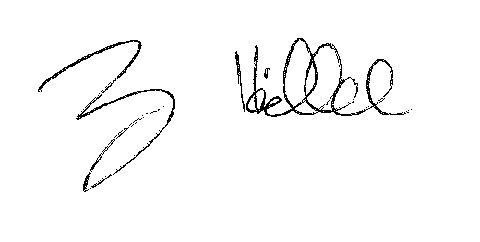

Alexander Hillel, MD

Editorial comments:
1. Please note that the editor has formatted the manuscript to match the journal's style. Please retain the same. The updated manuscript is attached and please use this version to incorporate the changes that are requested.
Changes are made throughout the document that address the comments made. These changes have been tracked. The formatting has been maintained throughout the document.

2. Are any figures reprinted from a previous publication (i.e., ref. 6)? If so, please obtain explicit copyright permission to reuse any figures from a previous publication. Explicit permission can be expressed in the form of a letter from the editor or a link to the editorial policy that allows re-prints. Please upload this information as a .doc or .docx file to your Editorial Manager account. The Figure must be cited appropriately in the Figure Legend, i.e. “This figure has been modified from [citation].”

Data and figures published in this study were not previously published in reference six or were part of different experiment/protocol also not published. For example – Collagen gene expression data and immunohistochemistry was at day 4 versus day 7. Elution data was generated from a different protocol using different time points for measurement.

3. Please address specific comments marked in the attached manuscript.

These have been addressed throughout the document
4. After you have made all the recommended changes to your protocol section, please highlight in yellow up to 2.75 pages (no less than 1 page) of protocol text (including headers and spacing) to be featured in the video. Bear in mind the goal of the protocol and highlight the critical steps to be filmed. Please ensure that the highlighted steps form a cohesive narrative with a logical flow from one highlighted step to the next. Our scriptwriters will derive the video script directly from the highlighted text.

The highlighted text for video manuscript has been selected

5. Figure 2: Please include a space between numbers and their units (10 mm).

This has been corrected

6. Figure 5: Please use the micro symbol (µ) instead of u.

This has been completed

7. Table of Materials: Please ensure that it has information on all relevant supplies, reagents, equipment and software used, especially those mentioned in the Protocol. Please sort the materials alphabetically by material name.
This has been updated and all relevant supplies, reagents, and equipment are noted.

