Dear Author(s),
This document is divided into sections in which you can add your comments to the video and voiceover. Please be aware that our policy is to do a single complimentary revision, so it is critical that all participants in this project offer their comments collectively. In addition, please make sure that your comments are easily interpreted and transparent.
Have fun!
Protocol Name: A Rat Carotid Artery Pressure-Controlled Segmental Balloon Injury with Periadventitial Therapeutic Application
Date: 1/28/2021

Authors and Affiliations
Please fill in any missing author information not included in the video.
Order | Author | Affiliation

Video Comments
Please fill in any comments you wish to make using the table below using the example as a guide. If you need more space to write, please do so below the table. DO NOT ADD CORRECTIONS TO THE NARRATION HERE. PLEASE DO THIS IN THE AUDIO COMMENTS SECTION.
 | Time code | Comment | Requested Change
Example | 2:52 | Onscreen text says use 0.25 mM Fluo-4 | Text should say use 0.50 mM Fluo-4
1. | 0:49 | Clarification of preoperative procedures needed. | Add a caption that reads. See preoperative procedures in written protocol.
2. | 1:36 | Include labels for each visible muscle | Include labels for each visible muscle as in image 1 below
3. | 2:30 | Include labels for each branch of the carotid and the vagus nerve | Include labels for each branch of the carotid as in image 2 below
4. | 2:36 | Include labels for Vagus, Common and Internal Carotid, and Superior Thyroid | Include labels as shown in image 3 below
5. | 2:46 | Include labels for each branch of the carotid and the vagus nerve | Include labels as shown in image 4 below
6. | 3:30 | Include labels for each branch of the carotid | Include labels for each branch of the carotid as in image 5 below
7.
8.
9.
10.
11.
12.
14.
15.
16.
17.
18.
19.
20.
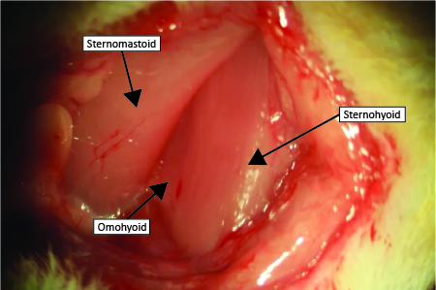Image 1 (1:36)

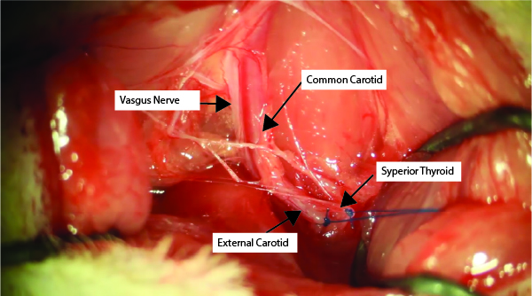
Image 2 (2:30)

Image 3 (2:36) 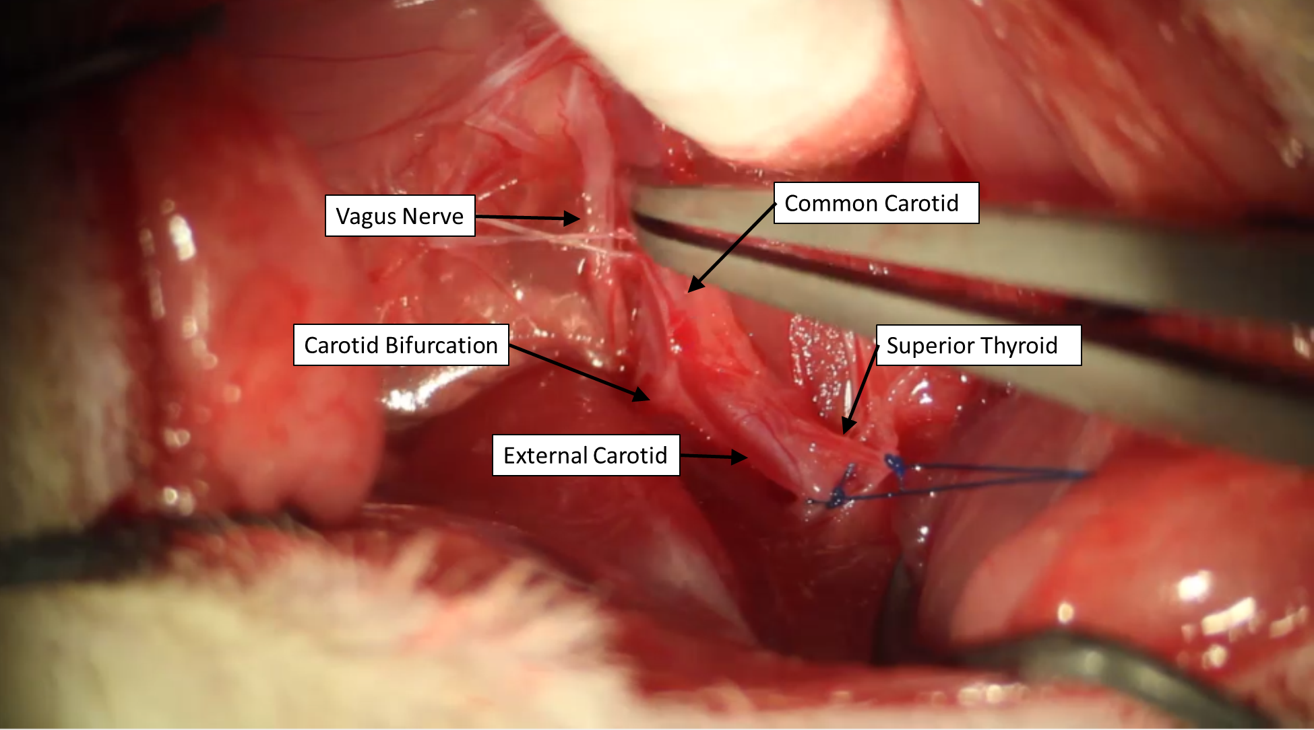
Image 4 (2:46)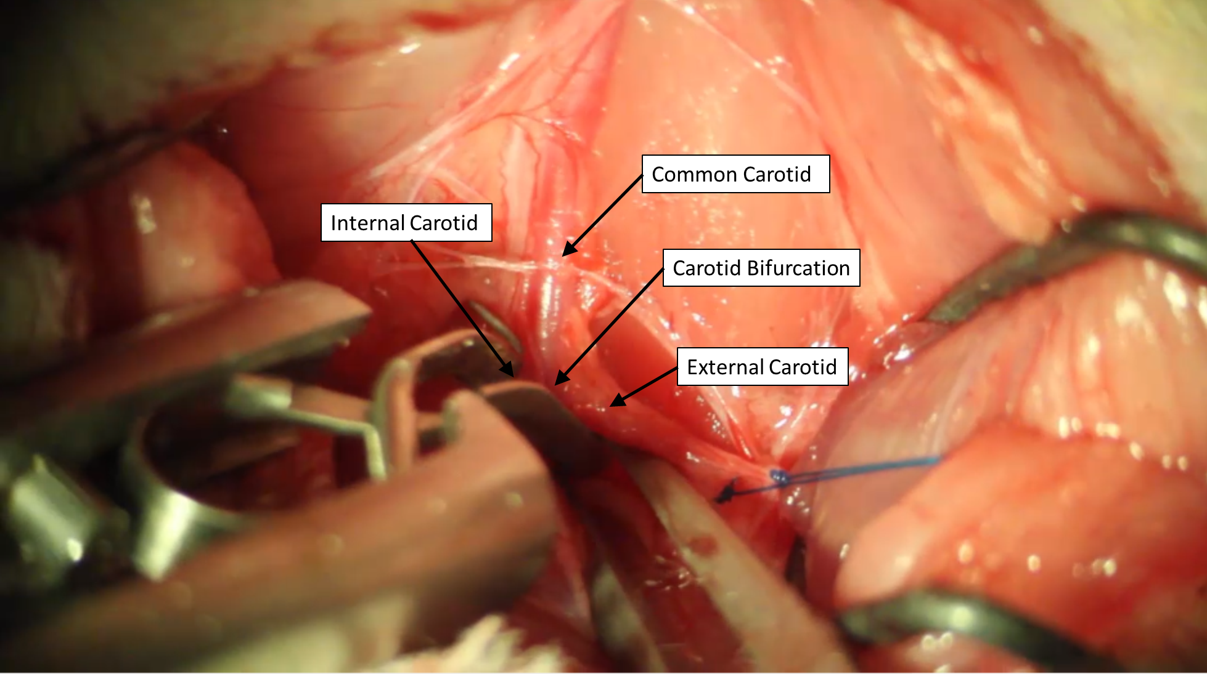
Image 5 (3:30)
Audio Comments
This section is used to specify the changes that need to be made to the narration. Please follow the example below as a guide to list your changes. If there is a pronunciation change, please provide a phonetic pronunciation key or a web link.

 | Time code | Comment | Step(s) in Shotlist | Rewritten Text or Corrected Pronunciation (highlight in bold)
Example | 1:49 | Original Script Text:  “Then, show the participant their electromyography, or EMG patterns, which correspond to eight specific and unique polar plots.” | 2.2 | Rewritten Script Text:  “Then, show the participant the unique and specific polar plots, which correspond to their electromyography, or EMG (pronounced E-M-G) patterns.”
1. | 0:49 | Original Script Text:  “After confirming a lack of response to pedal reflex…” | 2.1 | Rewritten Script Text:  “After performing all of the preoperative procedures according to the University IACUC standards, confirm a lack of response to pedal reflex…”
2. | 0:56 | Original Script Text:  “…and use a scalpel to make a straight, 1.5-2-centimeter, superficial, longitudinal skin incision…” | 2.1 | Rewritten Script Text:  “…and use scissors to make a straight, 1.5-2-centimeter, superficial, longitudinal skin incision …”
3.
4.
5.
6.
7.
8.
9.
10.
11.
12.
13.
14.
15.
16.
17.
18.
19.
20.

