Manuscript, JoVE60446,
Point by point address of the editorial and peer review comments.
To JoVE editorial board,
Thank you for considering our manuscript “Fluorescence-activated cell sorting techniques for the isolation of scleractinian cell populations”.
We thank the reviewers for their detailed suggestions and concerns and feel that the manuscript has become stronger and more complete due to their efforts.
Specifically, we have revised the text to address the comments, we have imaged the sorted cell populations (Figure 3), and we have done sorting purity analysis (Figure 4).
Please find enclosed our point-by-point response to the reviewers’ and editorial comments.
Sincerely on behalf of the authors,
Grace Snyder, William Browne, Nikki Traylor-Knowles, and Benyamin Rosental.

Point-by-point response to comments (Our responses are in Blue)
Editorial comments:
1. Please take this opportunity to thoroughly proofread the manuscript to ensure that there are no spelling or grammar issues. The JoVE editor will not copy-edit your manuscript and any errors in the submitted revision may be present in the published version.
DONE - Thank you for your comment. We have reviewed and addressed this comment.

2. Please use SI abbreviations for all units: L, mL, µL, h, min, s, etc. Please use the micro symbol µ instead of u and abbreviate liters to L (L, mL, µL) to avoid confusion.
DONE - Thank you for your comment. We have reviewed and addressed this comment.

3. Please include a space between all numbers and the corresponding unit: 15 mL, 5 g, 7 cm, 37 °C, 60 s, 24 h, etc.
DONE - Thank you for your comment. We have reviewed and addressed this comment.

4. JoVE cannot publish manuscripts containing commercial language. This includes trademark symbols (™), registered symbols (®), and company names before an instrument or reagent. Please remove all commercial language from your manuscript and use generic terms instead. All commercial products should be sufficiently referenced in the Table of Materials. You may use the generic term followed by “(Table of Materials)” to draw the readers’ attention to specific commercial names. Examples of commercial sounding language in your manuscript are: CellRox Green, LysoTracker, Sony, etc.
DONE - Thank you for your comment. We have reviewed and addressed this comment. All commercial products including reagent and cytometry brands have been specified only in the Table of Materials.

5. Please revise the Protocol to contain only action items that direct the reader to do something (e.g., “Do this,” “Ensure that,” etc.). The actions should be described in the imperative tense in complete sentences wherever possible. Avoid usage of phrases such as “could be,” “should be,” and “would be” throughout the Protocol. Any text that cannot be written in the imperative tense may be added as a “NOTE.” Please include all safety procedures and use of hoods, etc.
DONE - Thank you for your comment. We have reviewed and addressed this comment throughout the document.

6. 2.1.1: What volume of cell staining media is used to rinse?
DONE - Thank you for your comment. We have reviewed and addressed this comment; we stated the volume before and after centrifugation in Protocol step 3.3.
LINE 193: 3.3) Pellet 500 µL of stained cells by centrifugation at 4 ° C at 450 x g for 5 minutes. Remove the supernatant and resuspend in 500 µuL of cell staining media. Transfer to a new 5 mL round-bottom tube and store on ice.

7. Sections 4-6: For actions involving software usage, please provide all specific details (e.g., button clicks, software commands, any user inputs, etc.) needed to execute the actions.
DONE - Thank you for your comment. We have reviewed and addressed this comment throughout Protocol sections 5-7.

8. 6.1.1: How to adjust the PMT voltage?
DONE - Thank you for your comment. We have reviewed and addressed this comment in Protocol section 6.1.1.
LINE 253-259: In the scatter plot, adjust the photomultiplier voltage (PMT voltage) in order to center the points. The PMT voltage is used to amplify the signal strength of photons being measured; if the PMT voltage is too weak, fewer cells will be read, and if the PMT voltage is too strong, cells will be measured near maximum value and different cell types will be indistinguishable from one another. An adequate PMT voltage ensures that distinguishable events will populate the scatter plot. Event separation is easier to visualize by projecting logarithmic or biexponential scales on FSC and SSC scatter plots.

9. 6.2: Please describe how to create a selection.
DONE - Thank you for your comment. We have reviewed and addressed this comment in Protocol section 6.2.
LINE 267-270. Drawing rectangular gates is a regular option on flow cytometry software programs and good for clear, distinct cell populations. For cell populations that take a more irregular shape on the scatter plots, use a polygonal gating option.

10. After you have made all the recommended changes to your protocol section (listed above), please highlight in yellow up to 2.75 pages (no less than 1 page) of protocol text (including headers and spacing) to be featured in the video. Bear in mind the goal of the protocol and highlight the critical steps to be filmed. Our scriptwriters will derive the video script directly from the highlighted text.

11. Please highlight complete sentences (not parts of sentences). Please ensure that the highlighted steps form a cohesive narrative with a logical flow from one highlighted step to the next. The highlighted text must include at least one action that is written in the imperative voice per step. Notes cannot usually be filmed and should be excluded from the highlighting.
DONE. Without considering the mentioned notes, the highlighted sections fall within 2.75 pages.

12. References: Please include journal volume/issue number as well as page numbers.
DONE - Thank you for your comment. We have reviewed and addressed this comment in the References section.

13. Please remove the embedded figure(s) from the manuscript. All figures should be uploaded separately to your Editorial Manager account. Each figure must be accompanied by a title and a description after the Representative Results of the manuscript text.
DONE - Thank you for your comment. We have reviewed and addressed this comment.

14. Table of Materials: Please ensure that it has information on all relevant supplies, reagents, equipment and software used, especially those mentioned in the Protocol.
DONE - Thank you for your comment. We have reviewed and addressed this comment.

Reviewers' comments:
Reviewer #1:

Manuscript Summary:
This manuscript provides detailed instructions for FACS sorting of isolated coral cells

Major Concerns:
The authors discuss their technique solely in terms of looking at the response of coral cells to stress. However, there are many other basic science reasons that one might want to study pure populations of coral cells. Just as two examples, one might want to study how gene expression in cnidocytes differs from that in other ectodermal cells, or how gene expression in calicoblast cells differs from that in other ectodermal cells not involved in calcification. So, I think it would increase interest in their paper if they were to point out some of these other possible uses.
DONE - Thank you for your comment. We addressed this in both the introduction and last paragraph of the discussion.
LINE 104-107: In addition to studying cell-specific responses to stress, this technology has the potential to clarify gene-specific expression and illuminate the evolutionary and developmental history of cell types entirely unique to cnidarians, such as calicoblasts and cnidocytes.

LINE 429-433: The application of this fine-scale information will provide insight into cell type behavior and function and may reveal characteristics associated with the evolution of cnidarian-specific cell types such as calicoblasts and cnidocytes. Additionally, the application of FACS technology to the development of improved stress assays and biomarkers may prove useful for the protection of severely threatened coral reefs.

Minor Concerns:

I question the logic of the first sentence of the Abstract: "Coral reefs are under threat due to anthropogenic stressors caused by climate change." Are the authors of the belief that climate change is not anthropogenic? I suggest dropping "caused by climate change".
DONE - Thank you for your comment. We addressed this in the first line of the Abstract.
LINE 38: Coral reefs are under threat due to anthropogenic stressors.

Line 83 What is the antecedent of "its"? I suggest substituting "their".
DONE - Thank you for your comment. We addressed this in the first sentence of the fifth paragraph of the Introduction.
LINE 85-87: Thus far, the application of flow cytometry to coral cells has mainly been for the analysis of symbiotic Symbiodiniaceae and other bacterial populations by utilizing their strong, natural autofluorescence ²⁰⁻²².

Line 119 Can the authors suggest a suitable viability test? Perhaps add "such as DAPI, which will only stain dead and dying cells."
DONE - Thank you for your comment. We have addressed this and suggested DAPI in Protocol step 1.1.2.
LINE 128-129: A viability test may be performed to a subset of the cell slurry with a simple hemocytometer and a DAPI dye exclusion assay, visualized on a compound microscope.

Line 193 "longer" not "larger" wavelengths
DONE - Thank you for your comment. We addressed this in Protocol section 4.2.2, but the relevant sentence was ultimately removed. “Larger wavelengths” was not used anywhere else in the manuscript.
LINE 213-216: For the detection of light emitted by the green ROS signal, use a filter with a BP of 530/30 (wavelength range of 515 to 545 nm). A fluorescein isothiocyanate (FITC) or green fluorescent protein (GFP) filter is recommended. This filter will measure the concentration of ROS in each cell.

Line 229 "which" rather than "and" will be flushed out
DONE - Thank you for your comment. We addressed this and rephrased the last sentence of Protocol section 6.1.
LINE 250-251: Allow approximately 30 seconds to pass before starting analysis to clear any debris left in the cytometer chambers from previous experiments.

Fig 3B caption or labels on the graph need to explain what solid and dotted lines are separating. DAPI only stains dead and dying (i.e. membrane compromised) cells. If that is the case then I suggest putting a label "dead cells" to the right of the dotted line, but what is the solid line at 600 telling me? Is it only to say that 89.1% of the cells are viable or is it a cut-off of some sort? If the former, then I suggest getting rid of that line, putting "89.1 % live cells" in the box to the left of the dotted line, and "dead cells" to the right.
We have revised the figure and discussed the DAPI positive population in the legend and the results.

Reviewer #2:

Manuscript Summary:
This manuscript describes a protocol for sorting coral cells via FACS. This protocol will be useful for anyone who is interested in a detailed description of how to sort different cnidarian cell populations starting with isolating coral tissue and dissociating the cells into a suspension of single cells to labeling the cells with various stains and markers and finally gating and sorting the cells.

Major Concerns:

Overall this manuscript is well written and detailed. I believe that it will be useful to any biologist studying cnidarians at a cellular level.

I have only a few major concerns to raise.

(1) The authors state that the cells are stained in 3.3X PBS solution (with FCS and HEPES). It would be helpful if the authors could state in the manuscript why this particular concentration of PBS was chosen (rather than 3X, for example) and what the salinity of 3.3X PBS (with FCS and HEPES) is. Different marine organisms are cultured in various levels of salinity and might need to adjust the PBS concentration accordingly. This could be stated explicitly. Also, if this recipe comes from another published source, please cite it.
DONE - Thank you for your comment. We have addressed this in Protocol section 1.2.1.
LINE 137-139: 3.3X PBS concentration was chosen as demonstrated in Rosental et al. 2017¹⁸ to mimic the salinity of seawater. This concentration needs to be adjusted for species found in other environments to mimic their salinity.

(2) I would highly recommend adding compound microscope images of the following:
a. A heterogeneous mixture of cell types in the suspension of single cells after dissociation but before sorting. These could be stained with DAPI, Trypan Blue or other viability dye to show the proportion of live vs dead cells.
b. Sorted cell types corresponding to the different gated populations in Figure 3A, C, D. This could be similar to what was done in Figure 4 of Rosental et al. 2017 BMC Cell Biology, although those images were quite tiny and it would be great if they could be bigger (even in a separate figure). It would be quite helpful to see the morphology and homogeneity of the sorted cell populations to verify what the authors are stating about the isolated coral cell populations. To show that the CellRox and LysoTracker dyes are working you could also show fluorescence micrographs of these sorted cell populations and discuss any morphological differences in the sorted populations.
Thank you for your comment. As suggested, we have revised Figure 3 and have added the images of the sorted cell populations, as well as an example of an unsorted sample:
Figure 3:
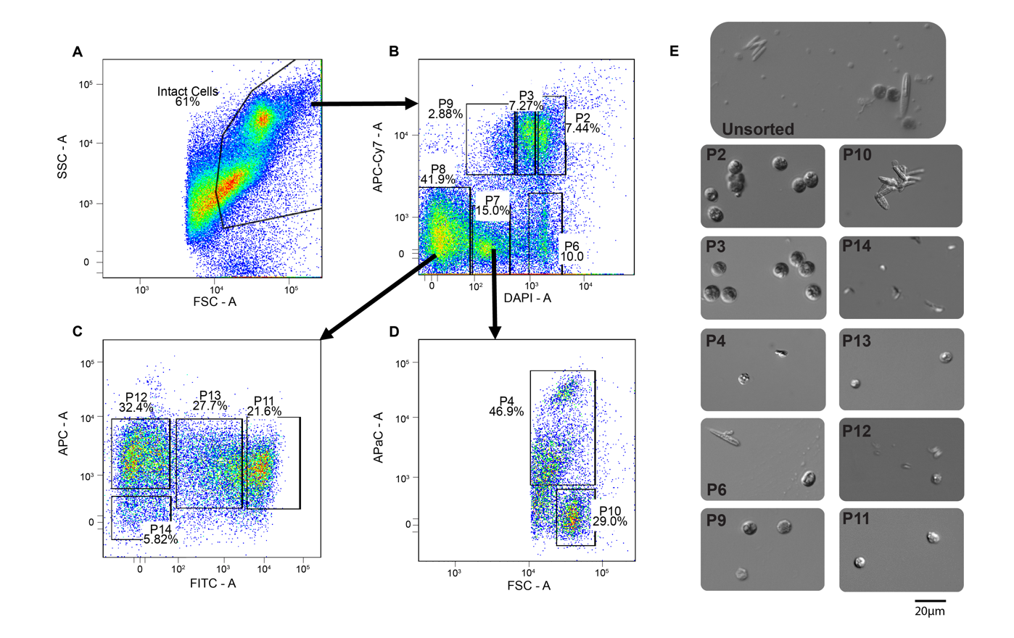

(3) One step that should be added would be a "purity check" where you take a small subsample from the sorted sample and run it back through the sorter again to make sure all cells in the sorted population fall within the target gate. This is common practice in the field of cell sorting and gives more confidence that the sorted cells are truly exclusively from the target population.
DONE - Thank you for your comment. We have addressed this by adding Figure 4 and referring to it in Protocol section 7.2.4.
7.2.4) Each time a new stain, species, or sorter is used, a purity check needs to be done on the population of interest. Do this by sorting at least 20,000 cells of interest into 500 µL staining media, and then re-analyze the sorted cells and confirm that the cells are being read within the gate used to initially sort (Figure 4).

FIGURE 4:
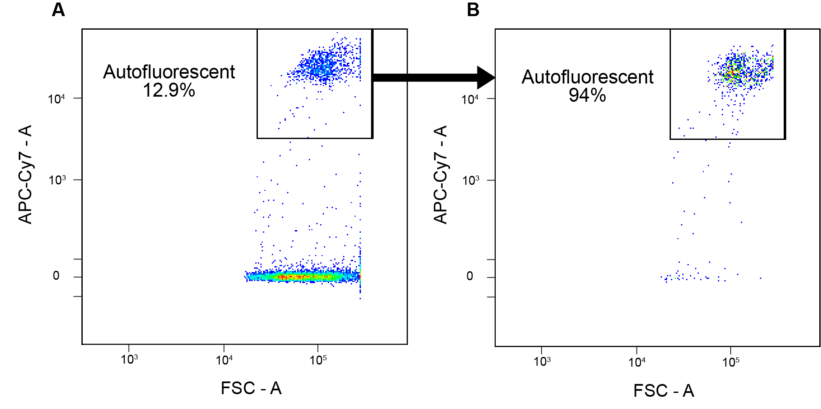
Figure 4: Purity check of the autofluorescent Symbiodiniaceae-associated cells. A) Cells positive for fluorescence on the APC-Cy7 filter from the unstained control sample were sorted. This sorted group of cells was then re-run on the cytometer and re-analyzed under the same conditions, showing 94% purity (B). Forward scatter (x-axis, FSC) was used for the anchoring axis, but is interchangeable with any of the other parameters. The same process can be performed on the stained samples.

Minor Concerns:
None.

