August 7, 2019

Dear Dr. Phillip Steindel,

The explicit permission with respect to Figure 1 in the manuscript is available from the following URL:

https://www.rsc.org/journals-books-databases/journal-authors-reviewers/licences-copyright-permissions/#reuse-permission-requests

I attach a screenshot of the above website with this letter.

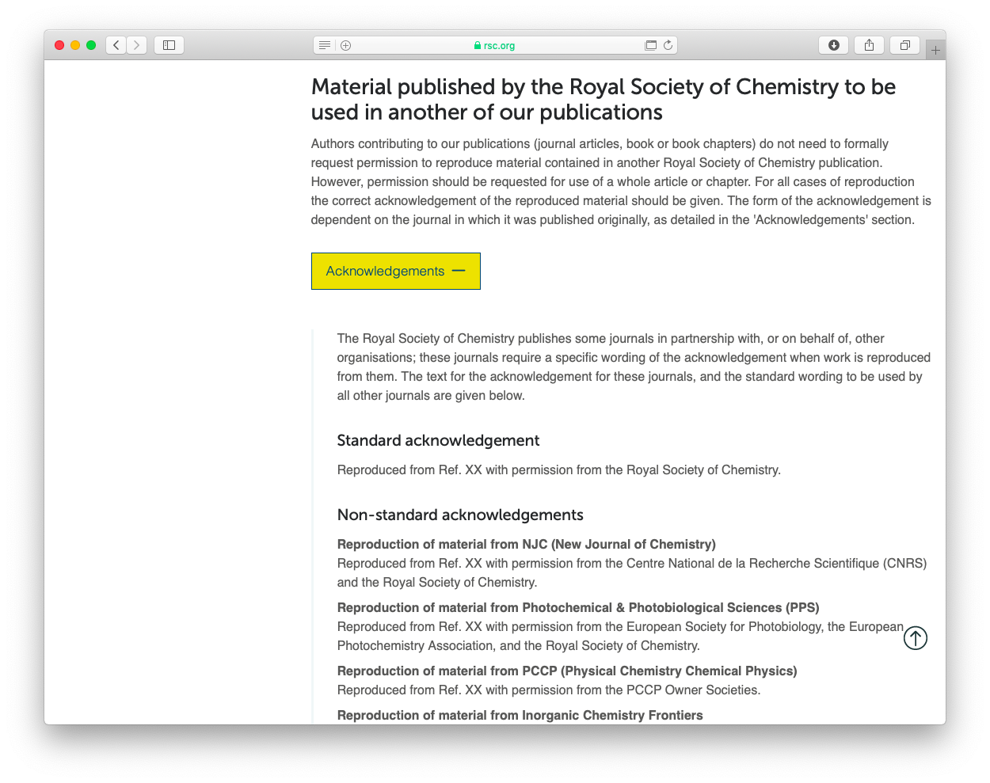

Sincerely yours,

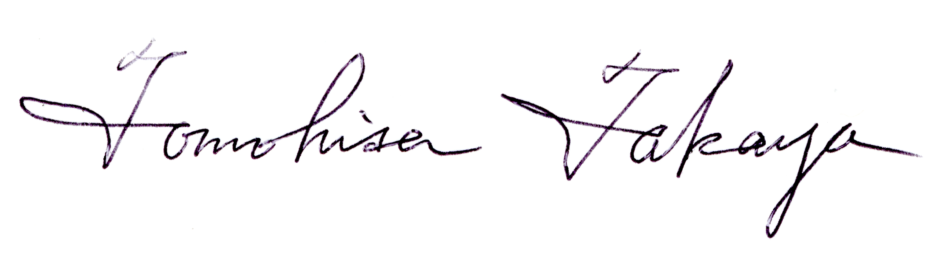

Tomohisa Takaya
Department of Chemistry, Faculty of Science
Gakushuin University
1-5-1 Mejiro, Toshima-ku, Tokyo 171-8588
Japan

