Supplementary File

Protocol test
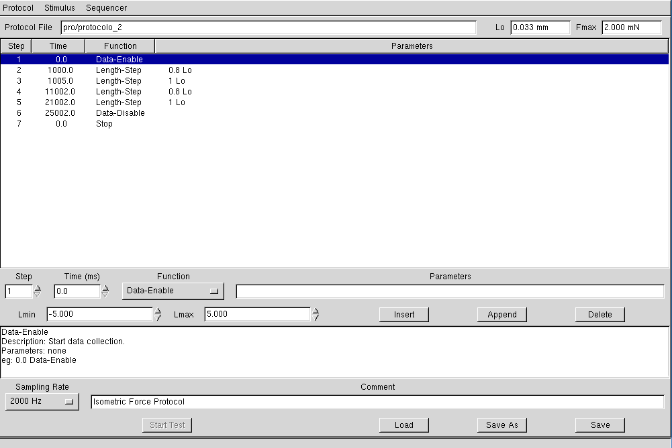
Protocol sequence
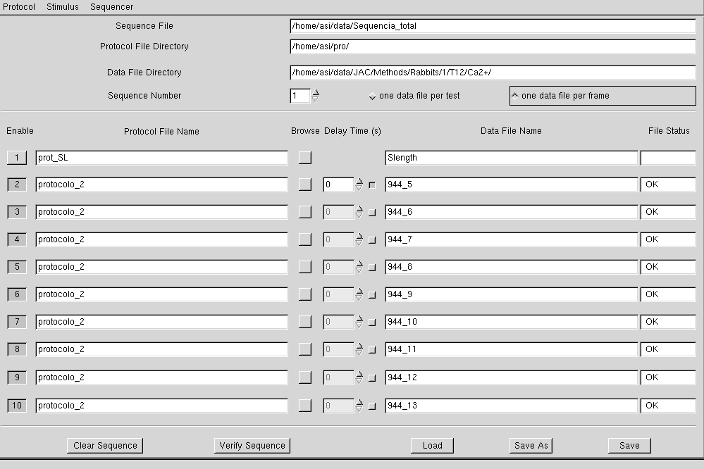
Figure 1: A print screen of the acquisition software programming underlying a myofilaments Ca²⁺-sensitivity protocol.

Appendix A:
The custom-made program named Cellprog was designed to extract data from the files derived from the software provided by the manufacturer of our equipment (Figure 1B). Cellprog automatically calculates absolute and CSA-normalized values of F_{total}, F_{active} and F_{passive} (as described in step 9.2) as well as ktr. The fitting of the curve to calculate ktr is detailed below and depicted in Figure 2B. The program automatically delivers these values in a spreadsheet as represented in Figure 3B.

Calculation of Ktr value
To calculate Ktr fit we used a Levenberg-Marquardt convergence algorithm for 1st and 2nd order using two models. The algorithm needs the initial values (Starting parameters, that corresponds to the values immediately after 1st cell shorting) to be able to calculate the approximate curve (do Curve Fitting). Now these calculations are done as follows:

First order exponential model:

-Model:${A(1-e}^{-Bx})+C$
- A: $F(start fit+duration)-F(start fit)$

- B: $\frac{2}{duration}$

- C: $F(start fit)$

Second order exponential model:

-Model:${A(1-e}^{-Bx})+L\left(1-e^{-Kx}\right)+C$
- A: $0,75×(F\left(start fit+duration\right)-F\left(start fit\right))$

-B:$\frac{2}{duration}$
- C: $F(start fit)$

- K: $0,25×(F\left(start fit+duration\right)-F\left(start fit\right))$

- L: $\frac{0.667}{duration}$

Calculation of error associated to the approximation:
$$R=\sqrt{1-\frac{{∑(Y_{data}-y_{fit})}^{2}}{{∑(Y_{data}-y_{fit avg})}^{2}}}$$

${Error}_{i}=\sqrt{{covariance}_{ii}.MSE}$

Covariance= Covariance matrix
MSE = Meam square error

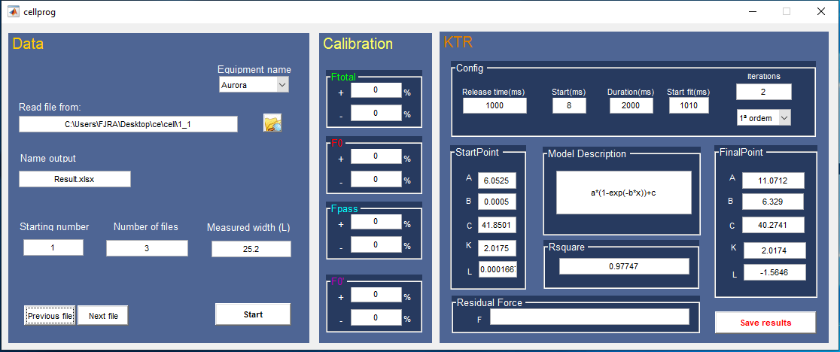

Figure 1B: Representative image of our custom-made program display.

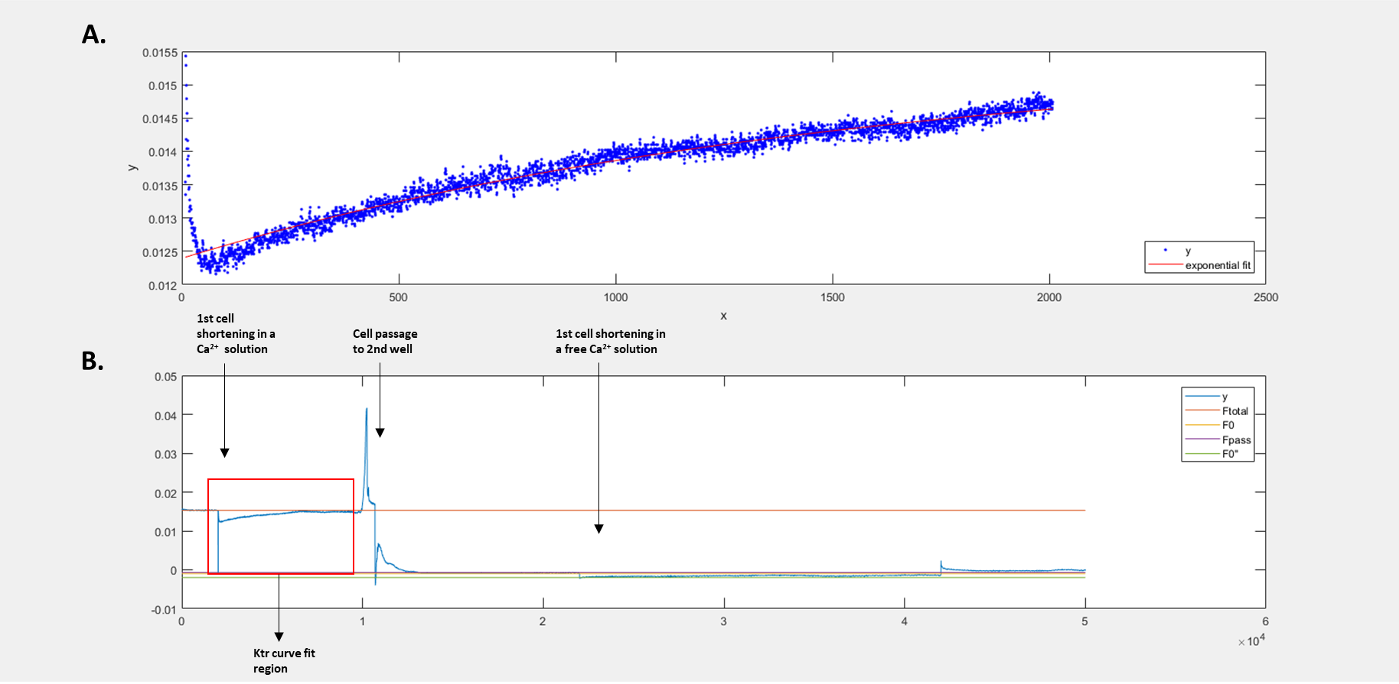

Figure 2B: Representative image from a single cell record using our custom-made Program. A. Prediction of curve fit immediately after the 1st cell slack (in Ca²⁺ solution). B. Representative image of a typical protocol. First cell is submerged in a Ca²⁺ solution (1st cell shortening), then it is passed to a second well with relaxing solution where a 2nd cell shortening will occur.

Figure 3B: Representative image from a typical result spread sheet with results for different Ca²⁺ solutions tests.
Legend: Bf- Ktr value; CSA- Cross-sectional Area; Ta- Active Force; TaN- Active Tension; Tp- Passive Force; TpN- Passive tension; Tt- Total Force; TtN- Total Tension; R- r squared for Ktr fit curve.

