60427_screenshot_1 2:00
6.3.
Measure the distance between the two extremes of the cardiomyocyte (from the motor to the transducer glue halo, Figure 3) after the optimal sarcomere length has been set (2.2 µm). Record the value as myocyte length in the software.

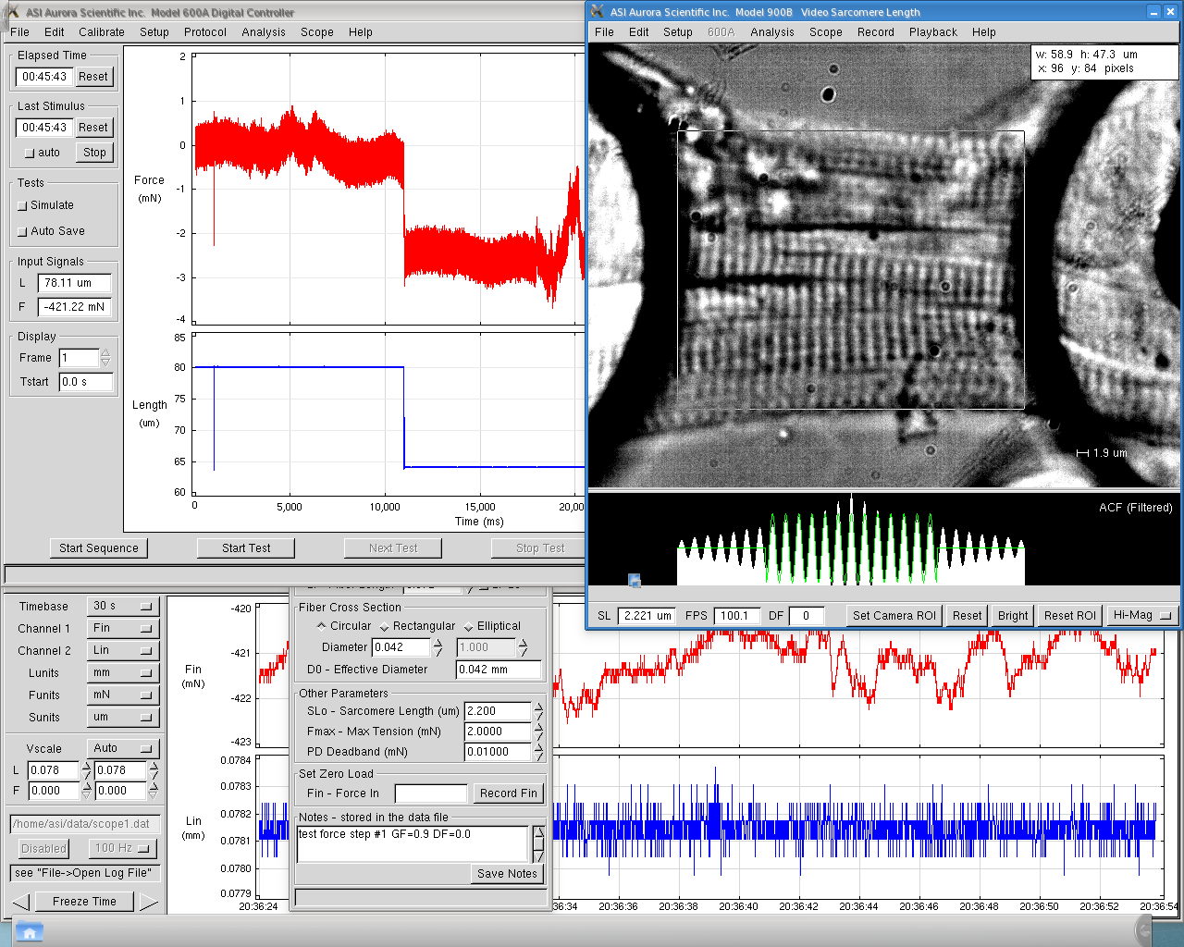

60427_screenshot_2 00:20
6.7.
Select the protocol in software that contains two cells shortening (80% of its initial length), that will occur when the cell is emerged in Ca²⁺ solution and in relaxing solution, respectively.

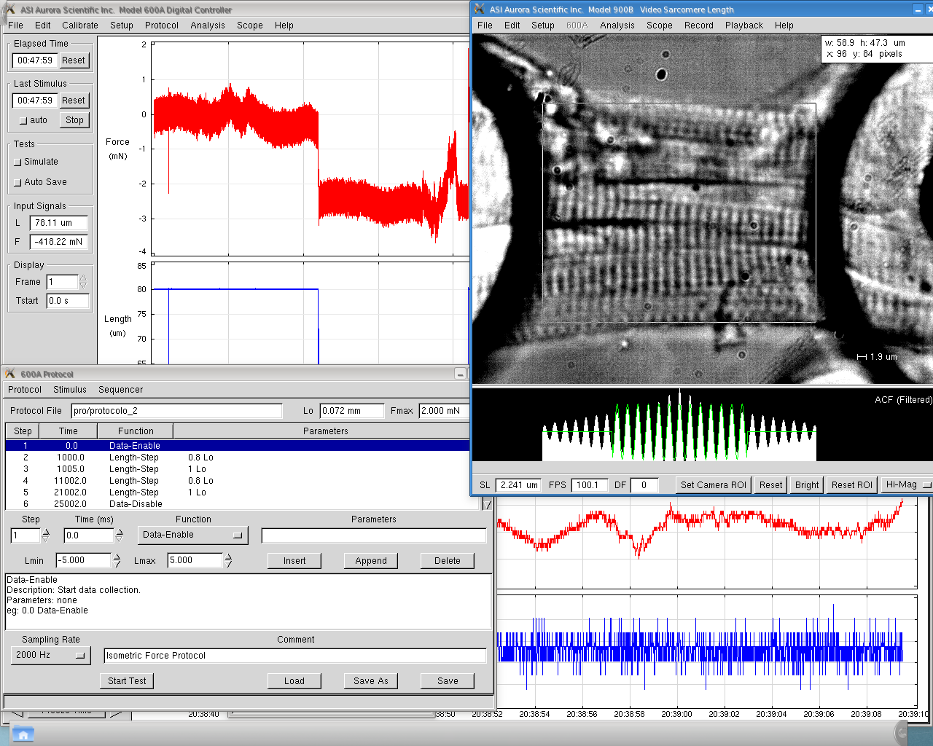

60427_screenshot_3
6.9.
Upon reaching force plateau, start recording the force data.

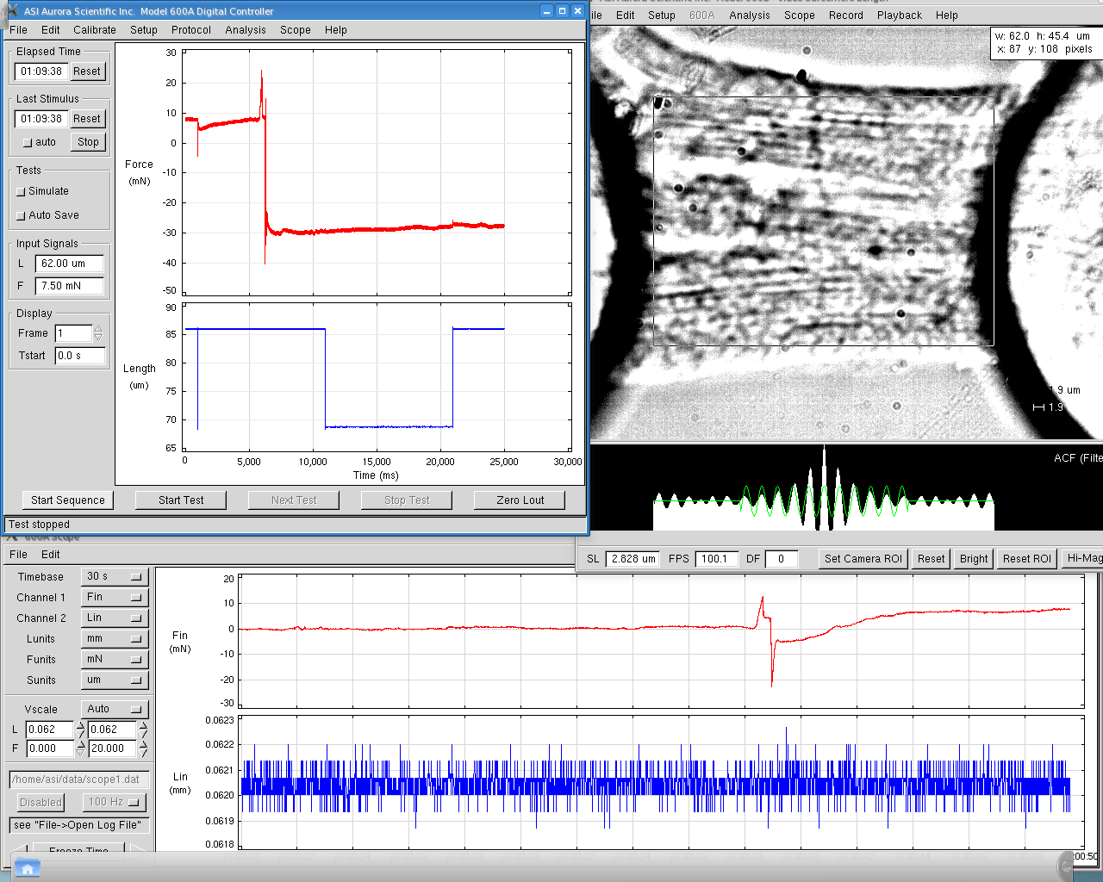

60427_screenshot_4
6.12. Wait until the test stops.

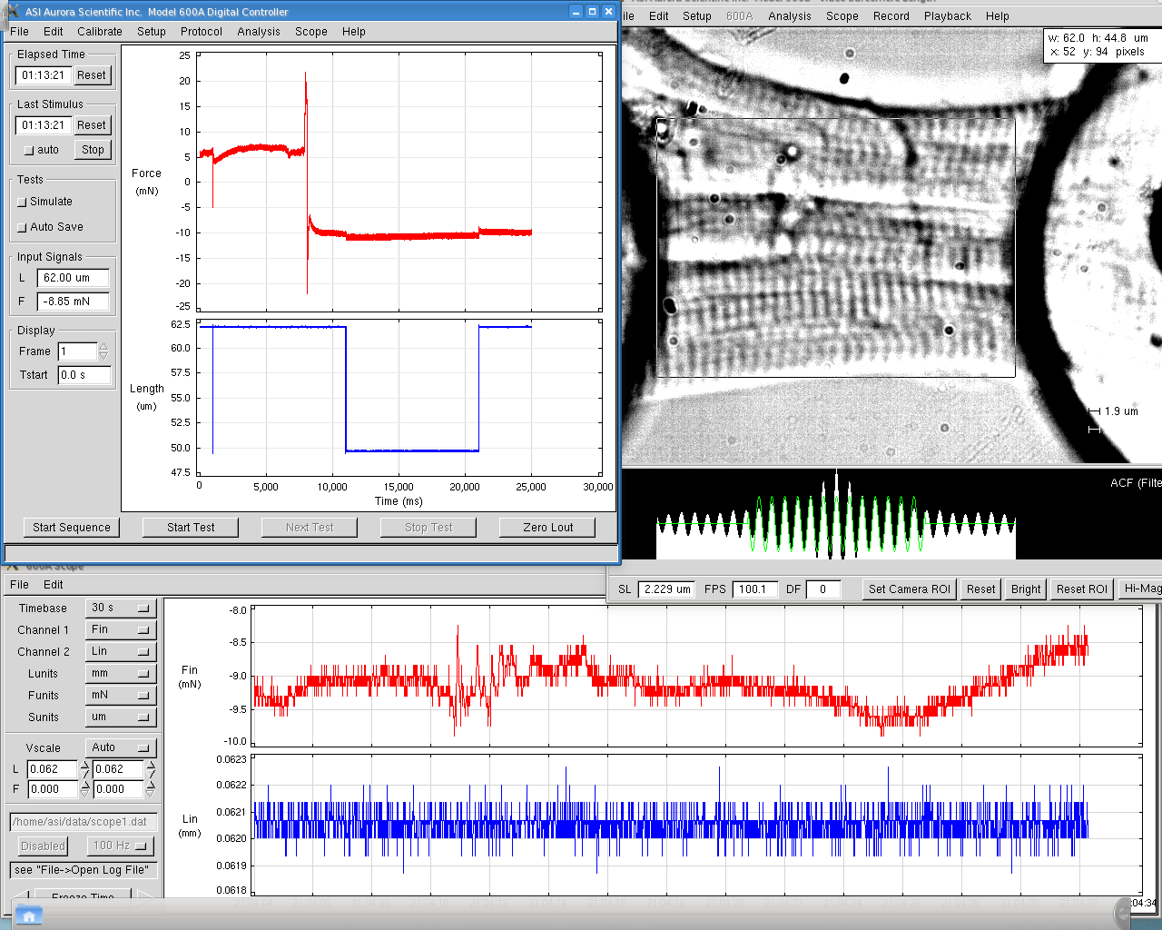

60427_screenshot_5
6.13.
Continue to step 6.13.2 for Ca²⁺ sensitivity protocol or save the data and detach the cell from needles and clean them with acetone to remove the glue
We did not performed screen for tis one since the data is automatically save into the folder created before for that specifically experiment.

