Dear Author(s),
This document is divided into sections in which you can add your comments to the video and voiceover. Please be aware that our policy is to do a single complimentary revision, so it is critical that all participants in this project offer their comments collectively. In addition, please make sure that your comments are easily interpreted and transparent.
Have fun!
Protocol Name:
Date:

Authors and Affiliations
Please fill in any missing author information not included in the video.
Order | Author | Affiliation

Video Comments
Please fill in any comments you wish to make using the table below using the example as a guide. If you need more space to write, please do so below the table. DO NOT ADD CORRECTIONS TO THE NARRATION HERE. PLEASE DO THIS IN THE AUDIO COMMENTS SECTION.
 | Time code | Comment | Requested Change
Example | 2:52 | Onscreen text says use 0.25 mM Fluo-4 | Text should say use 0.50 mM Fluo-4
1. | 02:23 | 1 min, 348 x g, RT | Please increase 2 seconds the time when this comment appears. It passes to quick.
2. | 02:26 | Repeat wash and centrifuge until no bubbles observed | Remove “until no bubbles observed” from the video comment
3. | 00:04 | Replace “Unidade de Investigação Cardiovascular” | By “Unidade de Investigação e Desenvolvimento Cardiovascular”
4. | 0:50 | Please replace the sentence: “Procedures involving animal subjects have been approved by Portuguese Veterinary Governmental Authorities at the Portuguese Foundation for Science and Technology.” | By “Procedures involving animals were approved by Portuguese Veterinary Governmental Authorities.”
5. | 1:05 | Please highlight the upper left corner, where 15ºC appears, otherwise it seems that we made a mistake (as the 20ºC appears more evident). | Like this  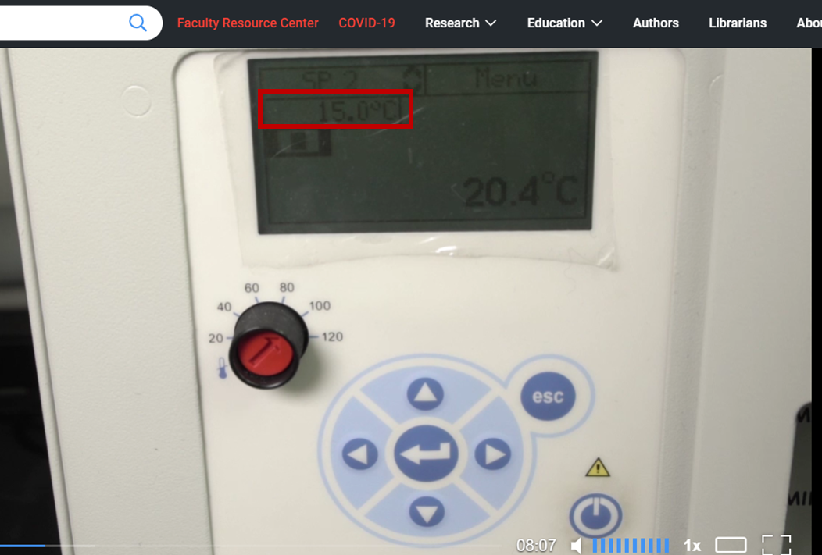
6. | 2:52 | Please replace the sentence that is being read “Add a drop of cell suspension onto a coverslip placed on top of a glass slide in a confocal microscope slide holder” “ | By “Add a drop of cell suspension onto a coverslip placed on top of a glass slide in an inverted microscope slide holder”
7. | 6:06 | The second line of the first column of the table has “Active tension,” | It should be replaced by “Active tension”  (without the comma in the end)
8. | 6:06 | The last line of the first column of the table has “Ktr, s-1” | I should be replaced by “Ktr, s⁻¹”  (⁻¹ is upperscript)
9.
9.
10.
11.
12.
14.
15.
16.
17.
18.
19.
20.

Audio Comments
This section is used to specify the changes that need to be made to the narration. Please follow the example below as a guide to list your changes. If there is a pronunciation change, please provide a phonetic pronunciation key or a web link.

 | Time code | Comment | Step(s) in Shotlist | Rewritten Text or Corrected Pronunciation (highlight in bold)
Example | 1:49 | Original Script Text:  “Then, show the participant their electromyography, or EMG patterns, which correspond to eight specific and unique polar plots.” | 2.2 | Rewritten Script Text:  “Then, show the participant the unique and specific polar plots, which correspond to their electromyography, or EMG (pronounced E-M-G) patterns.”
1. | 03:15 | Original Script Text: “..use a cotton swab tip to place a thin line of glue along the side of the coverslip” | 3.2 | Rewritten Script Text:  “use a pipete tip to place a thin line of glue along the side of the coverslip”
2. | 07:09 | Original Script Text: “… the sarcomere length dependencies of the calcium-activated force per cross-sectional area [2] and the calcium-independent tension can be calculated [3]. “ | 5.7 | Rewritten Script Text:  “… the sarcomere length dependencies of passive tension [2] and the sarcomere length dependencies of the calcium-activated force per cross-sectional area [3]. “
3.
4.
5.
6.
7.
8.
9.
10.
11.
12.
13.
14.
15.
16.
17.
18.
19.
20.

