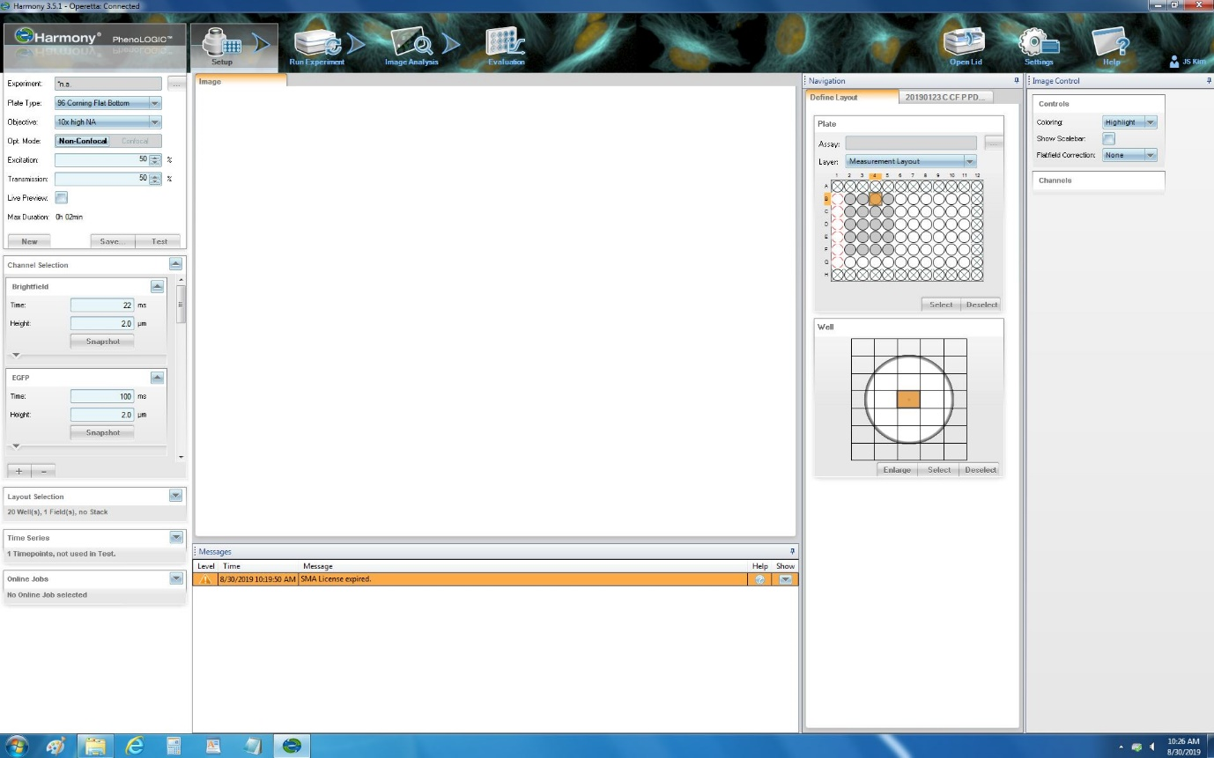
60419_8.4: Set up the parameters. Click Set up, select the plate type (96-well corning flat-bottom) and add the channels (bright-field and EGFP channels).

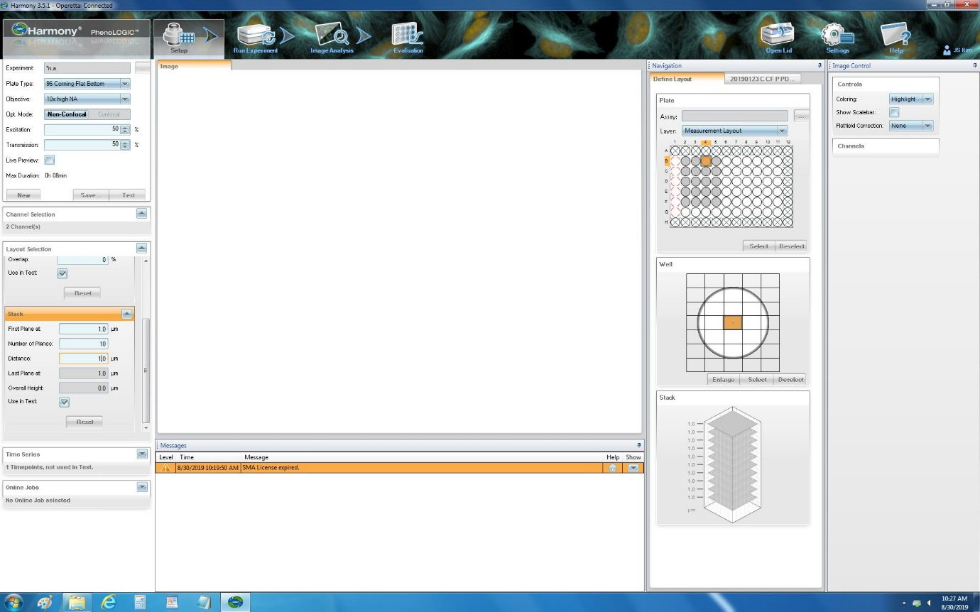
60419_8.5: Adjust the layout. Go to the Layout selection, and then select Track and adjust the parameters (first picture at 1 µm, number of planes are 10, distance is 1 µm).

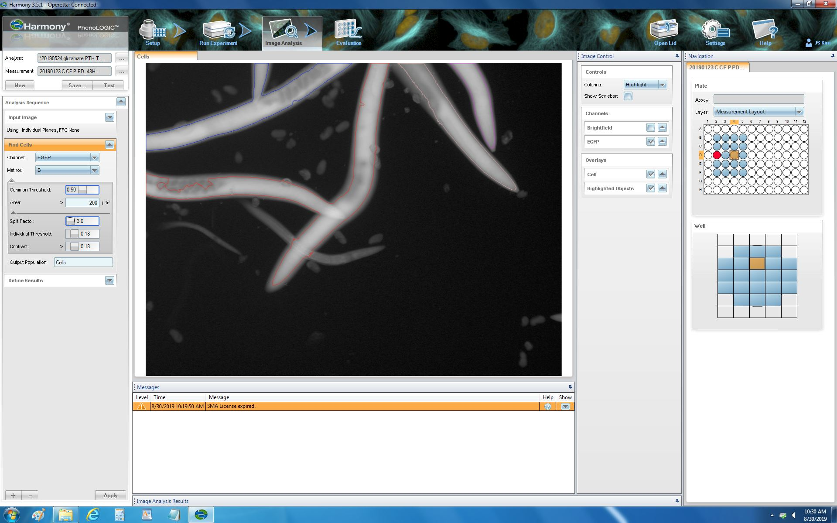
60419_8.9: Set up the measurement of fluorescence. To measure the intensity of the fluorescence, go to the image analysis section and input the image. Find the cell by choosing the EGFP channel and method B. Adjust the common threshold to 0.5, area to >200 µm², split factor to 3.0, individual threshold to 0.18 and contrast to more than 0.18. Then, calculate the intensity properties and choose the mean as the output. Press the Apply icon to save the setup.

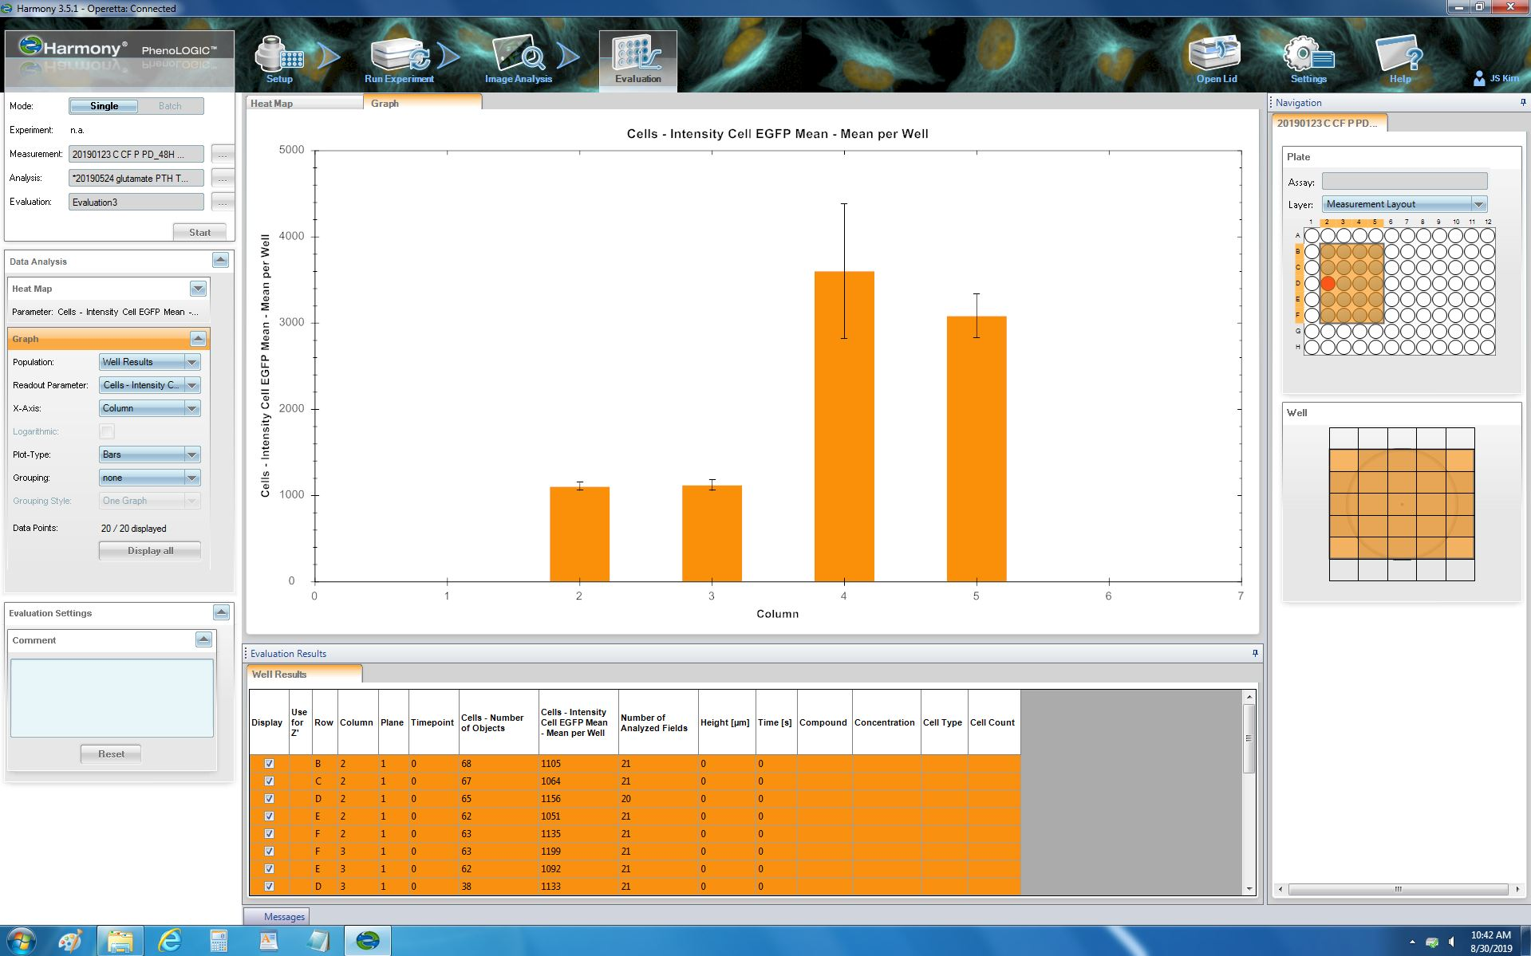
60419.8_10: Evaluation the fluorescence. Go to the Evaluation section to measure the intensity by obtaining a heatmap and data table. Set the Readout parameter to Cells – Intensity Cell EGFP Mean – Mean per Well and start the evaluation.

