Supplementary figure 1
The blood glucose level of parabionts 1 day after parabiosis surgery was tested (Supplementary figure 1). The results showed that the donor mice had a significant increase of blood glucose level 1 min after glucose injection, while the blood glucose level of recipient mice was not elevated. These results demonstrated that the circulation chimerism in parabionts was not successfully established 1 day after parabiosis surgery.

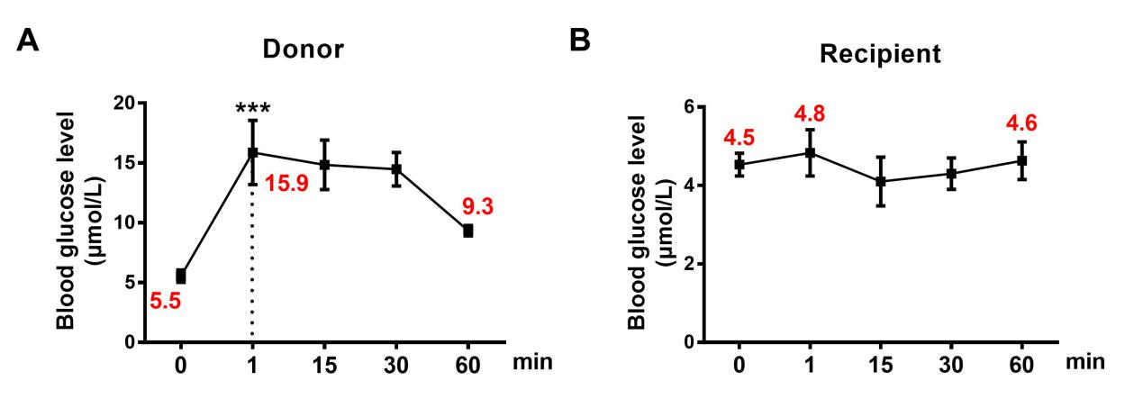
Figure 1. Blood glucose level of donor and recipient mice 1 day after parabiosis surgery. n=3. The data are presented as the mean±S.E.M. ***p<0.001 vs. 0 min.

Supplementary figure 2
Evans blue method was also used (Supplementary figure 2). Similarity, the blood OD level in recipient mice was not elevated as donor mice did. These results demonstrated that the glucose fluctuation method was as effective as Evans blue method.
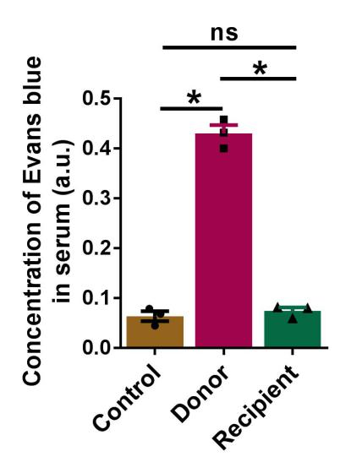
Figure 2. The concentration of Evans blue in the serum of the parabionts 1 day after parabiosis surgery was measured by microplate reader. n=3. The data are presented as the mean±S.E.M. *p<0.05, ns presents no significance between the two groups.
Supplementary Table 1 & 2
We found two pairs of parabionts didn’t establish blood chimerism 15 days after parabiosis surgery, which was tested by glucose fluctuation method and Evans blue method. As shown by the following results, the two recipient mice didn’t have an increased blood glucose level within 60 min after glucose injection into donor mice (Supplementary Table 1). Similarity, the blood concentration of Evans blue in recipients was also not elevated as shown in donor mice (Supplementary Table 2). These results demonstrated that glucose fluctuation method was as effective as Evans blue method.

Glucose fluctuation method:
Table 1. Blood glucose level (μmol/L) in parabionts 15 days after parabiosis surgery
 | 0 min | 5 min | 15 min | 20 min | 40 min | 60 min
Donor-1 | 5.7 | 26.2 | 21.2 | 17.6 | 16.9 | 15.4
Recipient-1 | 6.7 | 5.8 | 5.9 | 6.2 | 5.2 | 5.4
Donor-2 | 8.4 | 25.5 | 21.1 | 20.5 | 17.4 | 13.8
Recipient-2 | 6.7 | 5.8 | 5.9 | 6.2 | 5.2 | 5.4

Evans blue method:
Table 2. Blood concentration of Evans blue (OD value) in parabionts 15 days after parabiosis surgery
 | Control-1 | Donor-1 | Recipient-1 | Control-2 | Donor-2 | Recipient-2
OD value | 0.059 | 0.935 | 0.062 | 0.068 | 0.862 | 0.073

Supplementary figure 3
We tested the blood insulin level in mice 1h and 3h after injection of 100 μL of glucose (1.2 g/kg) into tail vein (Supplementary figure 3). We found the blood insulin level was remarkably decreased 1 h after glucose injection because of quickly increased glucose, while recovered to normal level at 3 h. These results demonstrated that the effects of glucose we injected on insulin metabolism was restorable.
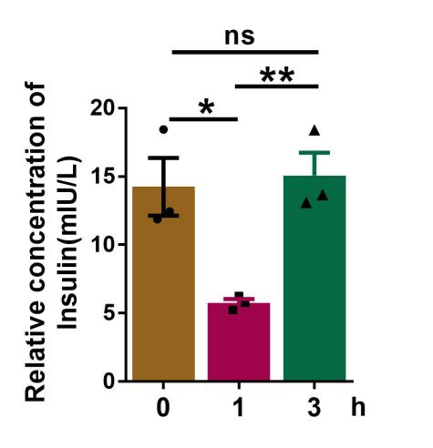
Figure 3. The concentration of insulin in serum of mice after glucose injection. n=3. The data are presented as the mean±S.E.M. *p<0.05, **p<0.01. ns presents no significance between the two groups.

