Supplementary Information

Rendering SiO₂/Si surfaces omniphobic by carving gas-entrapping microtextures comprising reentrant and doubly reentrant cavities or pillars

AUTHORS AND AFFILIATIONS:
Sankara Arunachalam¹, Eddy M. Domingues¹, Ratul Das¹, Jamilya Nauruzbayeva¹, Ulrich Buttner², Ahad Syed², and Himanshu Mishra¹

¹King Abdullah University of Science and Technology (KAUST), Water Desalination and Reuse Center (WDRC), Biological and Environmental Science and Engineering (BESE) Division, Thuwal 23955-6900, Saudi Arabia.
²King Abdullah University of Science and Technology (KAUST), Core Labs, Thuwal 23955-6900, Saudi Arabia

Email addresses of co-authors:
Sankara Arunachalam (sankara.arunachalam@kaust.edu.sa)
Eddy M. Domingues (empdomingues@gmail.com)
Ratul Das (ratul.das@kaust.edu.sa)
Jamilya Nauruzbayeva (jamilya.nauruzbayeva@kaust.edu.sa)
Ulrich Buttner (ulrich.buttner@kaust.edu.sa)
Ahad Syed (ahad.syed@kaust.edu.sa)

Corresponding author:
Himanshu Mishra (himanshu.mishra@kaust.edu.sa)

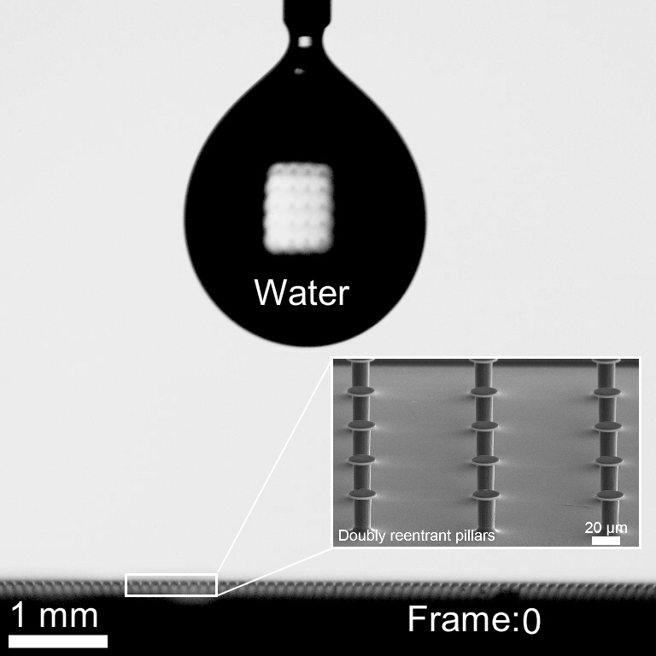
Movie S1. High speed image sequence (15K fps) of water droplet bouncing from microtextured surfaces comprising of doubly reentrant pillars. This movie was reprinted from ref 35. Copyright (2019), with permission from Elsevier.
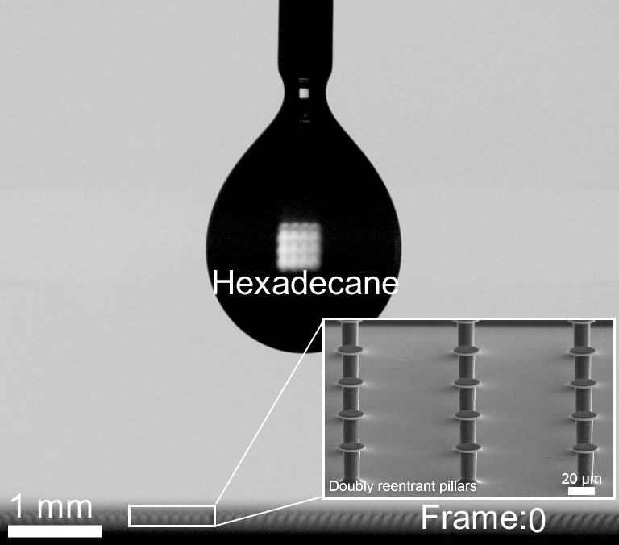

Movie S2. High speed image sequence (19K fps) of hexadecane droplet bouncing from microtextured surfaces comprising of doubly reentrant pillars. This movie was reprinted from ref 35. Copyright (2019), with permission from Elsevier.

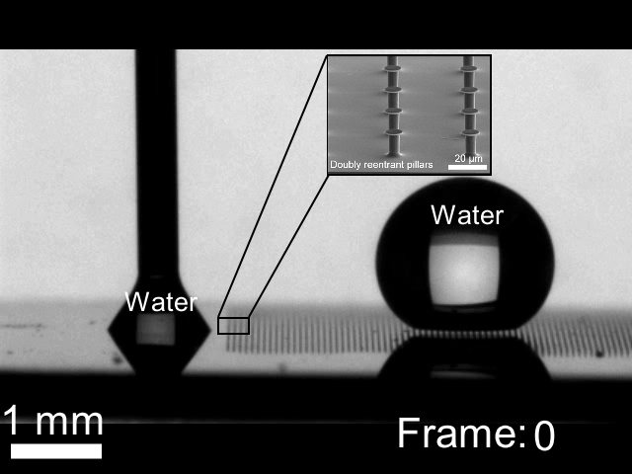
Movie S3. Image sequence (200 fps) of water imbibition into microtexture comprising of doubly reentrant pillars. This movie was reprinted from ref 35. Copyright (2019), with permission from Elsevier.

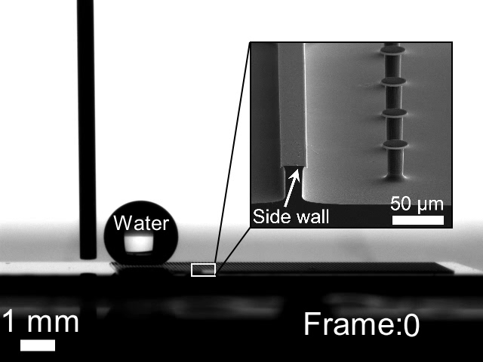
Movie S4. Image sequence (200 fps) water drop advancing next to hybrid microtexture. Presence of doubly reentrant boundary wall prevents liquid invasion into the microtexture, which makes the surface omniphobic under immersion also. This movie was reprinted from ref 35. Copyright (2019), with permission from Elsevier.

