Editorial comments:
General:
1. Please take this opportunity to thoroughly proofread the manuscript to ensure that there are no spelling or grammar issues.
Response: We re-checked typos and grammar issues.

2. Please include email addresses for all authors in the manuscript.
Response: All authors’ emails now are included.

3. Please define all abbreviations before use, e.g., CD, CNC.
Response: Abbreviations are defined as shown in the box below.
ABSTRACT:
A three-dimensional spheroid cell culture can obtain more useful results in cell experiments because it can better simulate cell microenvironments of the living body than a two-dimensional cell culture. In this study, we fabricated an electrical motor-driven Lab-on-a-CD (compact disc) platform, called a centrifugal microfluidic-based spheroid (CMS) culture system, to create 3D cell spheroids implementing high centrifugal force.
…

INTRODUCTION:
...
In this study, we demonstrate the performance of the centrifugal microfluidic-based spheroid (CMS) system by mono-culture or co-culture of human adipose-derived stem cells (hASC) and human lung fibroblasts (MRC-5). This paper describes in detail the methodology of the existing paper of our group¹⁵, thus the spheroid culture in CD platform can be easily reproduced. A CMS generating system comprising a CMS culture chip, a chip holder, a DC motor, a motor mount, and a rotating platform, is presented. The motor mount is 3D printed with the acrylonitrile butadiene styrene (ABS). The chip holder and rotating platform are CNC (computer numerical control) machined with the PC (polycarbonate). The rotational speed of motor is controlled from 200 to 4500 rpm by encoding a PID (proportional-integral-derivative) algorithm based on pulse width modulation. Its dimensions are 100 x 100 x 150 mm³ and it weighs 860 g, making it easy to handle. Using the CMS system, spheroids can be generated under various gravity conditions from 1 to 521 G, so the study of cell differentiation promotion under high gravity can be extended from 2D cell^{16, 17} to 3D spheroid. Co-culture of various types of cells is also a key technology for effectively mimicking the in vivo environment¹⁸. The CMS system can easily generate mono-culture spheroids, as well as co-culture spheroids of various structure types (concentric, Janus, and sandwich). The CMS system can be utilized not only in simple spheroid studies but also in 3D organoid studies, which considers human organ structures.

4. JoVE cannot publish manuscripts containing commercial language. This includes trademark symbols (™), registered symbols (®), and company names before an instrument or reagent. Please limit the use of commercial language from your manuscript and use generic terms instead. All commercial products should be sufficiently referenced in the Table of Materials and Reagents. For example: Sylgard, Dow Corning, Sigma-Aldrich, ATCC, Autodesk Inventor
Response: All commercial languages are deleted from the manuscript, as shown in the box below.
PROTOCOL:
…
1.2 Mix PDMS base and PDMS curing agent at a ratio of 10: 1 (w/w) for 5 min and place in a desiccator for 1 h to remove air bubbles.
…
2.2 Add 1 mL of Dulbecco’s Modified Eagle Medium (DMEM) to vial and gently mix with 1000 μL pipette.
...
3.1 Put 2.5 mL of 4 % (w/v) pluronic F-127 solution into the inlet hole of CMS culture chip (Figure 2A) while rotating the chip at 500-1000 rpm and then rotate the chip at 4000 rpm for 3 min using CMS system (Figure 2B).
…
3.6 Add 100 μL of cell suspensions that contain either 5 × 10⁵ hASCs or 8 × 10⁵ MRC-5s by pipetting while the chip rotates at 500-1000 rpm and resuspend the cells 3-5 times by pipetting to be uniformly distributed.

FIGURE AND TABLE LEGENDS:
Figure 1: Dimensions of the top and bottom layers of a CMS culture chip designed by Autodesk Inventor 2019. PC mold was fabricated using CNC machine and replicated with PDMS to make a CMS culture chip of the drawing created by 3D CAD (computer-aided design) program. The four circles at the edges of the top and bottom layers are for aligning the two layers. The unit is ‘mm’.
Protocol:
1. For each protocol step, please ensure you answer the “how” question, i.e., how is the step performed? Alternatively, add references to published material specifying how to perform the protocol action. If revisions cause a step to have more than 2-3 actions and 4 sentences per step, please split into separate steps or substeps.

Specific Protocol steps:
1. 1.4: Please provide more detailed instructions or a reference for plasma bonding.
Response: The plasma bonding process is described in detail. To address this issue, changes were made (in red) to the manuscript, as shown in the box below.
PROTOCOL:
…
1.4 Place them in the vacuumed plasma cleaner with the surfaces to be bonded facing up and expose them to air-assisted plasma at a power of 18 W in 30 s.
1.5 Bond the two layers of the CMS culture chip and place it in the heat chamber at 80 ° C for 30 min to increase adhesion strength.
1.6 Sterilize the CMS culture chip in an autoclave sterilizer at 121 °C and 15 psi.

2. 2.1: How is the chip rotated, exactly? How is the solution put into it while it is spinning? Please refer to Figures as necessary.
Response: The CMS culture chip is rotated by the rotation system in Figure 2B. The solution is injected through the inlet hole. To address the above-mentioned issues clearly, some changes were made (in red) to the manuscript, as shown in the box below.
PROTOCOL:
…
3. Mono-culture spheroid formation
3.1 Put 2.5 mL of 4 % (w/v) pluronic F-127 solution into the inlet hole of CMS culture chip (Figure 2A) while rotating the chip at 500-1000 rpm and then rotate the chip at 4000 rpm for 3 min using CMS system (Figure 2B).

3. 2.6: How do you resuspend?
Response: We used a pipette. To address this, changes were made (in red) to the manuscript, as shown in the box below.
PROTOCOL:
…
3.6 Add 100 μL of cell suspensions that contain either 5 × 10⁵ hASCs or 8 × 10⁵ MRC-5s by pipetting while the chip rotates at 500-1000 rpm and resuspend the cells 3-5 times by pipetting to be uniformly distributed.

4. 3.2.1, 3.3.1, 3.3.4, 3.4.1, 3.4.3, 3.4.5: Are these steps similar to 2.6 (i.e., 100 µL solution, pipetting)?
Response: The steps mentioned are the same as the 2.6 step. The protocol has been modified in the same way, as shown in the box below.
PROTOCOL:
…
4.2.1 Add the first cells, 2.5 × 10⁵ hASCs and rotate the chip at 3000 rpm. After 3 min, add the second cells, 4 × 10⁵ MRC-5s and rotate the chip at 3000 rpm for 3 min. When the cells are injected, shift the rotational speed to 500-1000 rpm and 100 μL of cell suspensions are injected by pipetting.
...
4.3.1 Add 100 μL of cell suspensions containing the first cells, 2.5 × 10⁵ hASCs by pipetting while the chip rotates at 500-1000 rpm and rotate the chip at 3000 rpm for 3 min.
…
4.3.3 Add 100 μL of cell suspensions containing the second cells, 4 × 10⁵ MRC-5s by pipetting while the chip rotates at 500-1000 rpm and rotate the chip at 3000 rpm for 3 min.
…
4.4.1 Add 100 μL of cell suspensions containing the first cells, 1.5 × 10⁵ hASCs by pipetting while the chip rotates at 500-1000 rpm and rotate the chip at 3000 rpm for 3 min.
…
4.4.3 Add 100 μL of cell suspensions containing the second cells, 3 × 10⁵ MRC-5s by pipetting while the chip rotates at 500-1000 rpm and rotate the chip at 3000 rpm for 3 min.
…
4.4.5 Add 100 μL of cell suspensions containing third cells, 1.5 × 10⁵ hASCs by pipetting while the chip rotates at 500-1000 rpm and rotate the chip at 3000 rpm for 3 min.

Figures:
1. Figure 1: Please include units.
Response: We added the unit (mm) in the caption., as shown in the box below.
FIGURE AND TABLE LEGENDS:
Figure 1: Dimensions of the top and bottom layers of a CMS culture. PC mold was fabricated using CNC machine and replicated with PDMS to make a CMS culture chip of the drawing created by 3D CAD (computer-aided design) program. The four circles at the edges of the top and bottom layers are for aligning the two layers. The unit is ‘mm’.
2. Figure 2A: The numbers here aren’t apparent in the diagram in Figure 1; please clarify how they are made. Also, how long is the scale bar?
Response: The numbers above the microwells represent the individual numbers of the microwells, from 1 to 100. These numbers were engraved into the mold using the CNC machine. The scale bar was added. To address the above-mentioned issues, changes were made (in red) to the manuscript, as shown in the box below.
FIGURE AND TABLE LEGENDS:
...
Figure 2: Photographs of the CMS. (A) Photographs of the completed CMS culture chip. The diameter of the chip is 6 cm and the diameter of the microwell is 400 μm. The numbers above the microwells represent the individual numbers of the microwells, from 1 to 100. These numbers were engraved into the mold using the CNC machine. The scale bar corresponds to 400 μm. (B) Photograph of the whole CMS system. The CMS system comprises the CMS culture chip, chip holder, DC motor, and rotating platform. CMS devices can generate gravity conditions up to 521G through rotational force. The chip holder prevents separation of the CMS culture chip from high gravity.
3. Figure 3: ‘3 days’, not ‘3days’ (i.e., include a space).
Response: Figure 4 is now corrected as shown below.
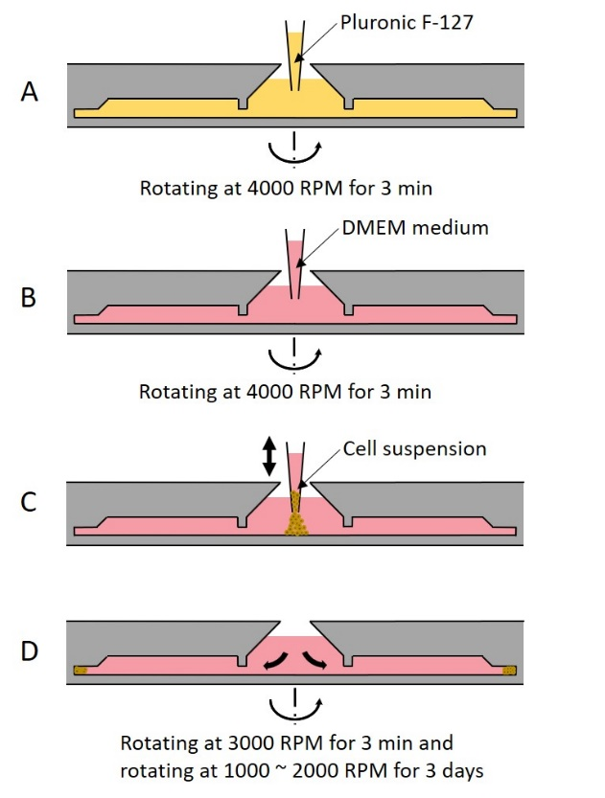

References:
1. Please ensure that the references appear as the following: [Lastname, F.I., LastName, F.I., LastName, F.I. Article Title. Source. Volume (Issue), FirstPage – LastPage (YEAR).] For more than 6 authors, list only the first author then et al.
2. Please do not abbreviate journal titles.
Response: Reference format is now corrected as advised.
Table of Materials:
1. Please ensure the Table of Materials has information on all materials and equipment used, especially those mentioned in the Protocol.
Response: Information of plasma cleaner, 3D computer-aided design program, 3D printer, ABS, Petri dish, Trypsin, Antibiotic-Antimycotic, DMSO, and live/dead kit were added in the Table of Materials.

Reviewers' comments:
Reviewer #1:
Minor Concerns:
The authors describe interesting method of producing cell spheroids for different applications. The described protocol looks quite detailed and well established.
The benefits and shortcomings of the protocol are mentioned in the text.
However, I believe the manuscript misses one important part about the harvesting of spheroids from the Lab-on-a-CD system.
I believe it would be valuable, since the spheroid generation (by using any method) is only a first step in their further application.
Such an addition would increase the significance of the presented method.
The comments/description page is unclear.
Response: We thank the reviewer for this helpful comment. It is important to harvest the spheroids as reviewer asked. In this study, it is difficult to collect spheroids by pipetting from the combined CMS culture chip. So, plasma bonded chip is separated, and spheroids are collected. We added related contents and figure.

To address the above-mentioned issues, changes were made (in red) to the manuscript, as shown in the box below.
DISCUSSION:
The CMS is a closed system in which all injected cells enter the microwell without waste, making it more efficient and economical than conventional microwell-based spheroid generation methods. In the CMS system, the media is replaced every 12-24 h through a suction hole designed to remove the media in the chip (Figure 3A). During the media suction process, there is barely any escape of the media from inside the microwell due to the action of surface tension between the media and the wall of microwell, so the media change process is bothered. A user can easily remove the trapped media by pressing near the microwell region of the chip with a finger as the chip made of PDMS is elastic and flexible. Cells in the microwell remain stable without escaping, even with multiple media changes. To achieve the same quality of spheroid in all 100 microwells, the rotation of the device should not be eccentric, and the chip should be axisymmetrical. Otherwise, a variable number of cells may enter each well and the size and shape of the spheroid would differ. In the conventional microwell system, since the air is often trapped in the microwell, it is necessary to remove the air bubbles. However, the CMS system does not require the bubble removal process because the high centrifugal force generated by the rotation causes the media to push the bubbles and squeeze them out from the microwells.
The CMS system also has its limitations compared to conventional methods. The CMS system requires a larger culture space (e.g. large incubator space) as it comprises a motor, rotating platform, and a controller, and its total size is approximately 100 x 100 x 150 mm³ (Figure 2B). In addition, it causes a slight but persistent vibration. We expect that the miniaturization of the system (hopefully similar the size of 6-well plates) will solve these issues.
It should be noted that the cultured spheroids can be collected by separating the two plasma-bonded layers of the CMS system (Figure 9). The bonding of the two layers is strong enough to prevent the media from leaking during system operation, however, owing to the small bonding area, it is separable by hand. The spheroids arecan be simply collected from the bottom layer by pipetting.
The CMS system has better reproducibility and productivity than conventional methods of spheroid generation. The conventional methods such as normal microwell or hanging droplet method are labor-intensive. However, in the CMS system, it is much easier to increase the number of spheroids without the need of extra effort by simply increasing the chip size. With this device, it is also possible to generate organoids that require culture of multi-cell types, which is not easy to do in conventional culture methods. In addition to the demonstrated cells in this study (hASC and MRC-5), CMS could be used for spheroid production using various types of cells that can form spheroids.
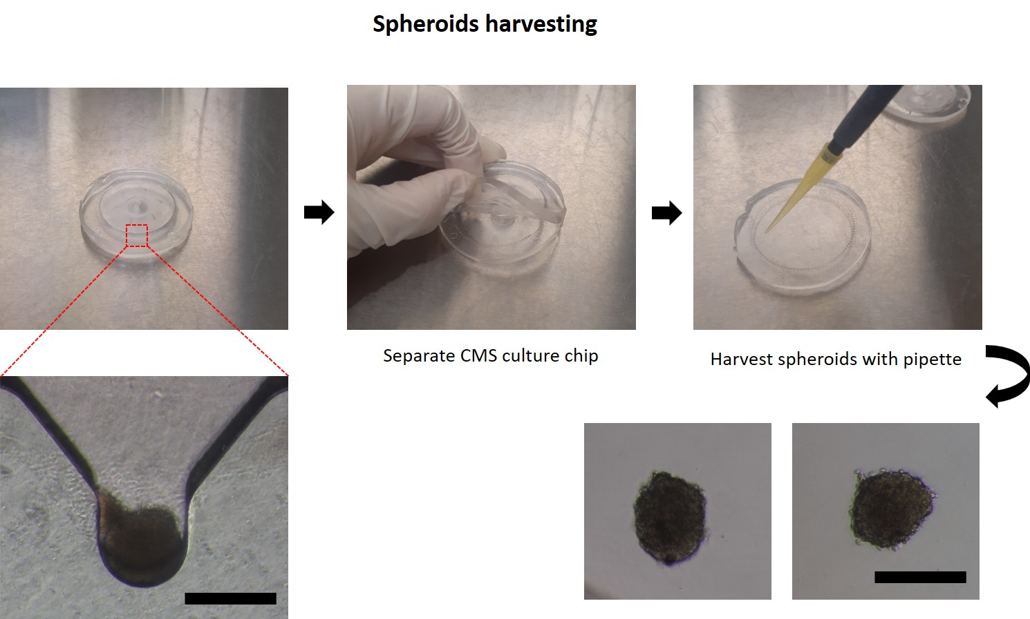

Reviewer #2:
Manuscript Summary:
In this manuscript, authors report a protocol to fabricate the uniform spheroids using centrifugal force via an integrated motor device. The results make sense, and writing is good. However, there are some drawbacks or unclear technological details. The reliability could be a concern. Thus, I suggest to reject this work at this moment.
Major Concerns:
1) Authors claimed a high throughput method in fabricating cell spheroids. However, the demonstrated throughput is only 100, which is similar to normal 96 well plates or hanging drop methods.
Response: We appreciate the reviewer’s comment. If spheroids are cultured in a 96 well plates, 96 pipetting is needed. The hanging droplet method also requires one pipetting per drop. So, these two methods are very labor-intensive and difficult to develop into a high-throughput system. However, using the CMS system, even if the number of spheroids increases, the labor does not increase significantly, and it is easy to generate more spheroids by simply increasing the size of the chips. However, we agree that the high-throughput is not an advantage of our system currently, therefore, we remove the term from the manuscript.

To address the above-mentioned issues, changes were made (in red) to the manuscript, as shown in the box below.
DISCUSSION:
...
The CMS system has better reproducibility and productivity than conventional methods of spheroid generation. The conventional methods such as normal microwell or hanging droplet method are labor-intensive. However, in the CMS system, it is much easier to increase the number of spheroids without the need of extra effort by simply increasing the chip size. With this device, it is also possible to generate organoids that require culture of multi-cell types, which is not easy to do in conventional culture methods. In addition to the demonstrated cells in this study (hASC and MRC-5), CMS could be used for spheroid production using various types of cells that can form spheroids.
2) 2. On page 7, line 238: It was mentioned that "Cells in the microwell remain stable without escaping, even with multiple media change". Authors didn't clearly demonstrate how to remove the fabricate cell spheroids from the CD chip.
Response: We appreciate the reviewer’s concern. It is important to remove the fabricated spheroids from the chip. In this study, it is difficult to collect spheroids by pipetting from the combined CMS culture chip. So, plasma bonded chip is separated to collect spheroids. We added related contents to the manuscript and figure was also added, as shown in the box below.
DISCUSSION:
...
The CMS system also has its limitations compared to conventional methods. The CMS system requires a larger culture space (e.g. large incubator space) as it comprises a motor, rotating platform, and a controller, and its total size is approximately 100 x 100 x 150 mm³ (Figure 2B). In addition, it causes a slight but persistent vibration. We expect that the miniaturization of the system (hopefully similar the size of 6-well plates) will solve these issues.
It should be noted that the cultured spheroids can be collected by separating the two plasma-bonded layers of the CMS system (Figure 9). The bonding of the two layers is strong enough to prevent the media from leaking during system operation, however, owing to the small bonding area, it is separable by hand. The spheroids can be simply collected from the bottom layer by pipetting.
The CMS system has better reproducibility and productivity than conventional methods of spheroid generation. The conventional methods such as normal microwell or hanging droplet method are labor-intensive. However, in the CMS system, it is much easier to increase the number of spheroids without the need of extra effort by simply increasing the chip size. With this device, it is also possible to generate organoids that require culture of multi-cell types, which is not easy to do in conventional culture methods. In addition to the demonstrated cells in this study (hASC and MRC-5), CMS could be used for spheroid production using various types of cells that can form spheroids.
3) In considering that authors couldn't harvest spheroid from 3D chip. They also didn't show the long-term culture (two week or more)of cell spheroids and cell spheroids' viability during the culture in CD chip.
Response: We appreciate the reviewer’s concern. As mentioned in response 2, spheroids can be collected by separating the CMS culture chip. So, we do not have the result of culturing spheroids for more than two weeks. But we successfully cultured hASC cells for 7 days. live/dead analysis showed that most of the cells survived.

To address the above-mentioned issues, changes were made (in red) to the manuscript, as shown in the box below.
REPRESENTATIVE RESULTS:
...
The number of cells injected is independent on the cell size. Time-lapse images of both cells were taken at 2000 rpm until day 3 of cell culture (Figure 5). Co-culture spheroids of hASC and MRC-5 were also generated with concentric, Janus, and sandwich structures. In the case of concentric spheroids, the first cell (2.5 × 10⁵ hASCs) is injected and the second cell (4 × 10⁵ MRC-5s) is injected 3 min later (Figure 6A). When the first cell is injected, the cell becomes U-shaped due to high gravity, and when the second cell is injected, it moves to the middle of the U-shape. Over time, the first cell in the outer U-shape surrounds the second cell in the middle and completes the concentric spheroid. In the case of Janus spheroids, the second cell (4 × 10⁵ MRC-5s) is injected 3 h after the first cell (2.5 × 10⁵ hASCs) is injected (Figure 6B). When the injection interval between the two cells is long, the shape of first cell changes from U-shape to elliptical shape by cell aggregation. The second cell is added to the elliptical shape of the first cell, and the Janus spheroid is generated. In the case of the sandwich spheroid, the first cell (1.5 × 10⁵ hASCs) is injected and the second cell (3 × 10⁵ MRC-5s) is injected 3 h later, and the third cell (1.5 × 10⁵ hASCs) is injected (Figure 6C) after another 3 h. Similar to the Janus spheroid, each cell aggregates into an elliptical shape, and three layers are stacked to generate sandwich spheroid. Lastly, to demonstrate the long-term culture capability of the CMS, hASCs were cultured being exposed to high gravity for 7 days followed by a live/dead assay performed to show that the most cells survived (Figure 7). Also, photos of all microwells of the CMS were taken after 3 days of MRC-5s cultivation to show excellent uniformity and sphericity of spheroids (Figure 8).
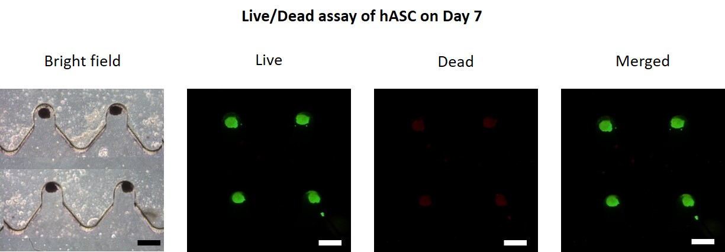
4) How does the centrifugal force impact on the cell viability?
Response: We thank the reviewer for this helpful question. This question seems to have been fully shown through the live/dead experiment in response 3.

To address the above-mentioned issues, changes were made (in red) to the manuscript, as shown in the box below.
REPRESENTATIVE RESULTS:
...
The number of cells injected is independent on the cell size. Time-lapse images of both cells were taken at 2000 rpm until day 3 of cell culture (Figure 5). Co-culture spheroids of hASC and MRC-5 were also generated with concentric, Janus, and sandwich structures. In the case of concentric spheroids, the first cell (2.5 × 10⁵ hASCs) is injected and the second cell (4 × 10⁵ MRC-5s) is injected 3 min later (Figure 6A). When the first cell is injected, the cell becomes U-shaped due to high gravity, and when the second cell is injected, it moves to the middle of the U-shape. Over time, the first cell in the outer U-shape surrounds the second cell in the middle and completes the concentric spheroid. In the case of Janus spheroids, the second cell (4 × 10⁵ MRC-5s) is injected 3 h after the first cell (2.5 × 10⁵ hASCs) is injected (Figure 6B). When the injection interval between the two cells is long, the shape of first cell changes from U-shape to elliptical shape by cell aggregation. The second cell is added to the elliptical shape of the first cell, and the Janus spheroid is generated. In the case of the sandwich spheroid, the first cell (1.5 × 10⁵ hASCs) is injected and the second cell (3 × 10⁵ MRC-5s) is injected 3 h later, and the third cell (1.5 × 10⁵ hASCs) is injected (Figure 6C) after another 3 h. Similar to the Janus spheroid, each cell aggregates into an elliptical shape, and three layers are stacked to generate sandwich spheroid. Lastly, to demonstrate the long-term culture capability of the CMS, hASCs were cultured being exposed to high gravity for 7 days followed by a live/dead assay performed to show that the most cells survived (Figure 7). Also, photos of all microwells of the CMS were taken after 3 days of MRC-5s cultivation to show excellent uniformity and sphericity of spheroids (Figure 8).

Minor Concerns:
The image resolution of Figure 1 is low.
Response: The resolution in Figure 1 is improved.
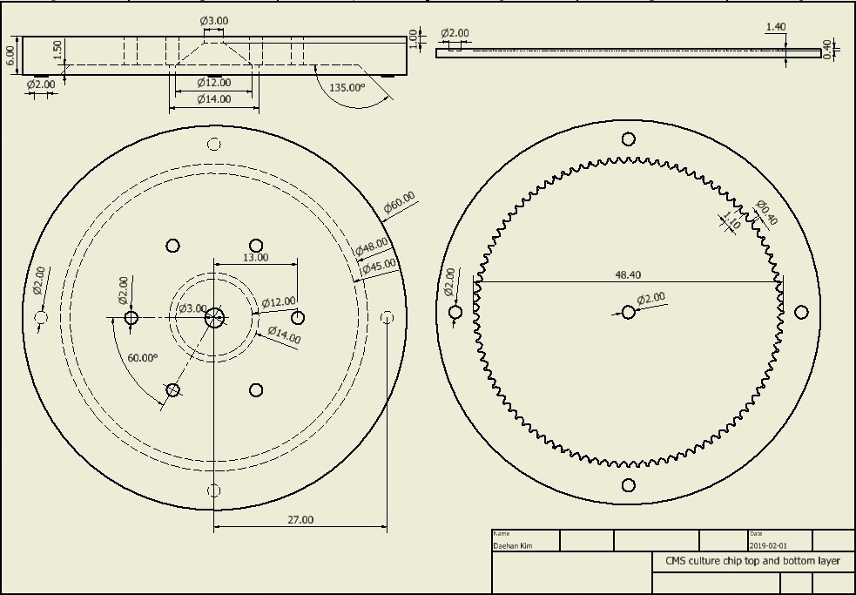
Scale bars in Fig 5 and 6 are missing.
Response: Scale bars have been added in Figures 5 and 6.
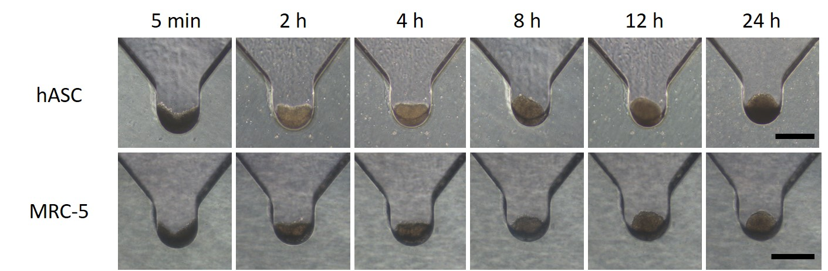
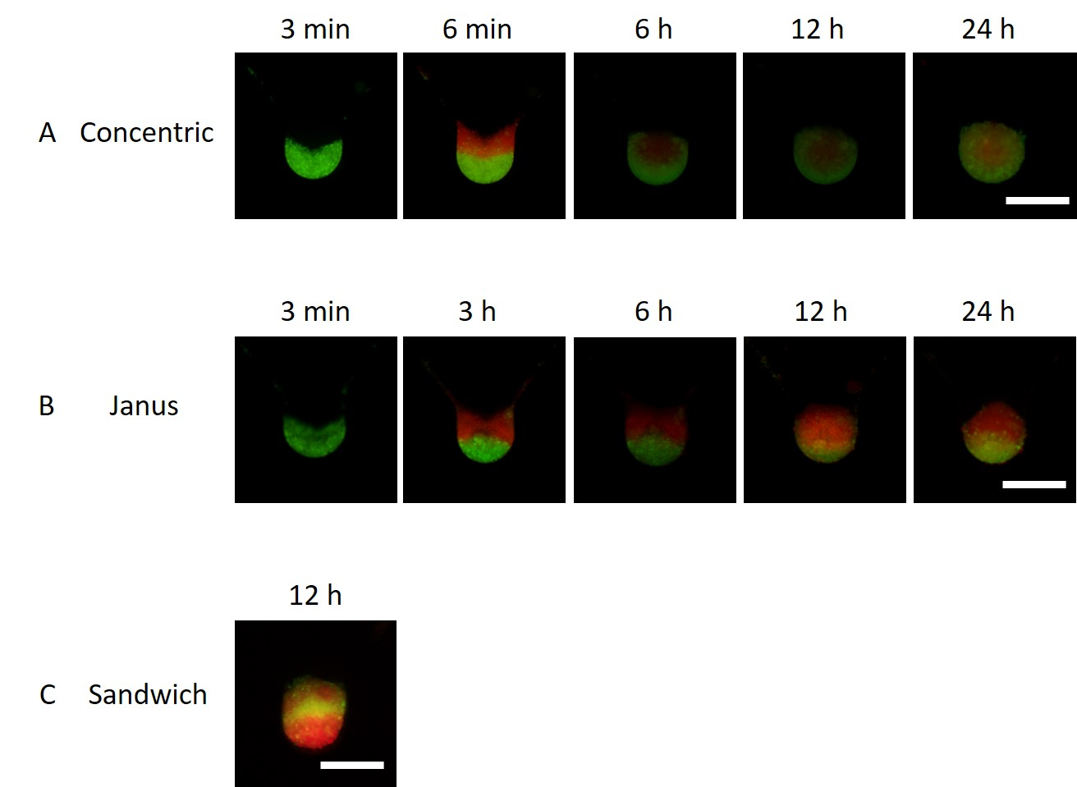

Reviewer #3:
Manuscript Summary:
Authors present a method regarding 3D cell culture for generation of spheroids on a Lab-on-a-CD platform. The method is based on mono- and co-culturing of human adipose-derived stem cells and human lung fibroblasts cells under hyper-gravity conditions. The technique leads the formation of spheroids in a high throughput manner.
Major Concerns:
- In the manuscript, the protocol for 3D spheroid formation based on authors' previous work (DOI: 10.1088/1758-5090/aa9472) was presented in detail. Authors' previous work should be mentioned in the manuscript. If there are some modifications related to previous work, it can be explained.
Response: We thank the reviewer for this helpful comment. As the reviewer has advised, we have mentioned and referenced existing papers in the manuscript. However, since there were no changes in the experiment except for small changes, we did not mention any additional details.

To address the above-mentioned issues, changes were made (in red) to the manuscript, as shown in the box below.
INTRODUCTION:
...
In this study, we demonstrate the performance of the centrifugal microfluidic-based spheroid (CMS) system by mono-culture or co-culture of human adipose-derived stem cells (hASC) and human lung fibroblasts (MRC-5). This paper describes in detail the methodology of the existing paper of our group¹⁵, thus the spheroid culture in CD platform can be easily reproduced. A CMS generating system comprising a CMS culture chip, a chip holder, a DC motor, a motor mount, and a rotating platform, is presented. The motor mount is 3D printed with the acrylonitrile butadiene styrene (ABS). The chip holder and rotating platform are CNC (computer numerical control) machined with the PC (polycarbonate). The rotational speed of motor is controlled from 200 to 4500 rpm by encoding a PID (proportional-integral-derivative) algorithm based on pulse width modulation. Its dimensions are 100 x 100 x 150 mm³ and it weighs 860 g, making it easy to handle. Using the CMS system, spheroids can be generated under various gravity conditions from 1 to 521 G, so the study of cell differentiation promotion under high gravity can be extended from 2D cell^{16, 17} to 3D spheroid. Co-culture of various types of cells is also a key technology for effectively mimicking the in vivo environment¹⁸. The CMS system can easily generate mono-culture spheroids, as well as co-culture spheroids of various structure types (concentric, Janus, and sandwich). The CMS system can be utilized not only in simple spheroid studies but also in 3D organoid studies, which considers human organ structures.
- Other 3D cell culture techniques such as magnetic-based ones (DOI: 10.1038/s41598-018-25718-9, 10.3389/fbioe.2018.00192) should be discussed in order to cover alternative ways for 3D spheroid cell culture.
Response: We thank the reviewer for this helpful comment. We have presented a variety of ways to make spheroids, but we did not mention about their features. We referenced the 3D cell culture paper suggested by the reviewer and commented on its features.

To address the above-mentioned issues, changes were made (in red) to the manuscript, as shown in the box below.
INTRODUCTION:
It is easier to simulate biological in vivo microenvironments with three-dimensional (3D) spheroid cell culture than with two-dimensional (2D) cell culture (e.g. conventional Petri dish cell culture) to produce more physiologically realistic experimentalresults¹. Currently available spheroid formation methods include the hanging drop technique², liquid-overlay technique³, carboxymethyl cellulose technique⁴, magnetic force-based microfluidic technique⁵, and the use of bioreactors⁶. Although each method has their own benefits, further improvement in reproducibility, production yield, and generating co-culture spheroids is necessary. For example, magnetic force-based microfluidic technique⁵ is relatively inexpensive, however, the effects of strong magnetic fields on living cells must be carefully considered. The benefits of spheroid culture, particularly in the study of mesenchymal stem cell differentiation and proliferation, have been reported in several studies^{7–9}.
- In Figure 1, units should be given. Microwell and barrier dimensions should be indicated.
Response: We thank the reviewer for pointing out this omission. We added in the description of Figure 1 that the unit is mm and dimensions for microwell and barrier have been added.
To address the above-mentioned issues, changes were made (in red) to the manuscript, as shown in the box below.
FIGURE AND TABLE LEGENDS:
Figure 1: Dimensions of the top and bottom layers of a CMS culture chip. PC mold was fabricated using CNC machine and replicated with PDMS to make a CMS culture chip of the drawing created by 3D CAD (computer-aided design) program. The four circles at the edges of the top and bottom layers are for aligning the two layers. The unit of the figure is ‘mm’.
- Plasma bonding parameters (duration, power, pressure, machine, etc.) should be given.
Response: We thank the reviewer for this helpful comment. The plasma bonding process in the protocol is explained in more detail. information about plasma cleaners was added to the table of materials.

To address the above-mentioned issues, changes were made (in red) to the manuscript, as shown in the box below.
PROTOCOL:
...
1.3 After pouring the PDMS mixture into the molds of the CMS culture chip, remove air bubbles for one more hour and cure in a heat chamber at 80 ° C for 2 h.
1.4 Place them in the vacuumed plasma cleaner with the surfaces to be bonded facing up and expose them to air-assisted plasma at a power of 18 W in 30 s.
1.5 Bond the two layers of the CMS culture chip and place it in the heat chamber at 80 ° C for 30 min to increase adhesion strength.
- CMS system (technical drawings, preferred DC motor, controller, etc.) should be explained in detail.
Response: We thank the reviewer for this suggestion. We focused on cell culture, so omitted the description of the CMS system itself. We added the contents as advised.

To address the above-mentioned issues, changes were made (in red) to the manuscript, as shown in the box below.
INTRODUCTION:
...
In this study, we demonstrate the performance of the CMS system by mono-culture or co-culture of human adipose-derived stem cells (hASC) and human lung fibroblasts (MRC-5). A centrifugal microfluidic-based spheroid (CMS) generating system comprising a CMS culture chip, a chip holder, a DC motor, a motor mount, and a rotating platform, is presented. The motor mount is 3D printed with the acrylonitrile butadiene styrene (ABS). The chip holder and rotating platform are CNC (computer numerical control) machined with the PC (polycarbonate). The rotational speed of motor is controlled from 200 to 4500 rpm by encoding a PID (proportional-integral-derivative) algorithm based on pulse width modulation. Its dimensions are 100 x 100 x 150 mm³ and it weighs 860 g, making it easy to handle. Using the CMS system, spheroids can be generated under various gravity conditions from 1 to 521 G, so the study of cell differentiation promotion under high gravity can be extended from 2D cell^{15, 16} to 3D spheroid. Co-culture of various types of cells is also a key technology for effectively mimicking the in vivo environment¹⁷. The CMS system can easily generate mono-culture spheroids, as well as co-culture spheroids of various structure types (concentric, Janus, and sandwich). The CMS system can be utilized not only in simple spheroid studies, but also in 3D organoid studies, which considers human organ structures.
- Standard cell culture protocol to prepare hASCs and MRC-5s should be given.
Response: We appreciate the reviewer's advice. We did not put in the cell culture process because we thought that is the basic one, but it is better to put the basic culture process because of the characteristics of the methodology journal. We were added standard cell culture protocol.

To address the above-mentioned issues, changes were made (in red) to the manuscript, as shown in the box below.
PROTOCOL:
...
2. Cells preparation
2.1 Thaw the 1 mL of vial of containing 5 × 10⁵ to 1 × 10⁶ hASCs or MRC-5s cells at 36.5 °C of water bath for 2 min.
2.2 Add 1 mL of Dulbecco’s Modified Eagle Medium (DMEM) to vial and gently mix with 1000 μL pipette.
2.3 Put 15 mL of the prewarmed DMEM at 36.5 °C to the diameter of 150 mm of Petri dish using pipette and add the cells from vial.
2.4 After 1 day, aspirate DMEM and replace 15 mL of DMEM. After that, change media every 2 or 3 days.
2.5 To detach cells from the Petri dish, add 4 mL of trypsin to the Petri dishes and place the Petri dish in the 36.5 °C and 5 % CO₂ of incubator for 4 minutes.
- In 3.2, 3.3, and 3.4 of the protocol, pull out volume and volume of cell sample should be indicated.
Response: We appreciate the reviewer's careful check. We were added the volume of cells during the protocol.

To address the above-mentioned issues, changes were made (in red) to the manuscript, as shown in the box below.
PROTOCOL:
...
4. Co-culture spheroid formation
4.1 Prepare the CMS culture chip following steps 1.1 to 1.6.
4.2 Concentric spheroids formation
4.2.1 Add the first cells, 2.5 × 10⁵ hASCs and rotate the chip at 3000 rpm. After 3 min, add the second cells, 4 × 10⁵ MRC-5s and rotate the chip at 3000 rpm for 3 min. When the cells are injected, shift the rotational speed to 500-1000 rpm and 100 μL of cell suspensions are injected by pipetting.
4.2.2 Culture the cells in the incubator at 36.5 °C, humidity of >95 %, and 5 % CO₂ by rotating at 1000-2000 rpm. Within 24 h, the concentric spheroids are created. For long-term culture, change culture medium every day.

4.3 Janus spheroids formation
4.3.1 Add 100 μL of cell suspensions containing the first cells, 2.5 × 10⁵ hASCs by pipetting while the chip rotates at 500-1000 rpm and rotate the chip at 3000 rpm for 3 min.
4.3.2 Incubate the chip at 36.5 °C, humidity of >95 %, and 5 % CO₂ by rotating at 1000-2000 rpm for 3 h.
4.3.3 Add 100 μL of cell suspensions containing the second cells, 4 × 10⁵ MRC-5s by pipetting while the chip rotates at 500-1000 rpm and rotate the chip at 3000 rpm for 3 min.
4.3.4 Culture the cells in the incubator at 36.5 °C, humidity of >95 %, and 5 % CO₂ by rotating at 1000-2000 rpm. Within 24 h, the Janus spheroids are created. For long-term culture, change culture medium every day.

4.4 Sandwich spheroids formation
4.4.1 Add 100 μL of cell suspensions containing the first cells, 1.5 × 10⁵ hASCs by pipetting while the chip rotates at 500-1000 rpm and rotate the chip at 3000 rpm for 3 min.
4.4.2 Incubate the chip at 36.5 °C, humidity of >95 %, and 5 % CO₂ by rotating at 1000-2000 rpm for 3 h.
4.4.3 Add 100 μL of cell suspensions containing the second cells, 3 × 10⁵ MRC-5s by pipetting while the chip rotates at 500-1000 rpm and rotate the chip at 3000 rpm for 3 min.
4.4.4 Incubate the chip again at 36.5 °C, humidity of >95 %, and 5 % CO₂ by rotating at 1000-2000 rpm for 3 h.
4.4.5 Add 100 μL of cell suspensions containing third cells, 1.5 × 10⁵ hASCs by pipetting while the chip rotates at 500-1000 rpm and rotate the chip at 3000 rpm for 3 min.
4.4.6 Culture the cells in the incubator at 36.5 °C, humidity of >95 %, and 5 % CO₂ by rotating at 1000-2000 rpm. Within 12 h, the sandwich spheroids are created. For long-term culture, change culture medium every day.
- Long-term cell culture (e.g. 24 h) protocol on the chip should be explained in detail.
Response: We thank the reviewer for this helpful comment. For long-term culture, it only needed to change media every day. We were added long-term culture protocol.

To address the above-mentioned issues, changes were made (in red) to the manuscript, as shown in the box below.
PROTOCOL:
...
3.8 Culture the cells for three days in the incubator at 36.5 °C, humidity of >95 %, and 5 % CO₂ atmosphere by rotating at 1000-2000 rpm. Change culture medium every day.
...
4.2.2 Culture the cells in the incubator at 36.5 °C, humidity of >95 %, and 5 % CO₂ atmosphere by rotating at 1000-2000 rpm. Within 24 h, the concentric spheroids are created. For long-term culture, change culture medium every day.
...
4.3.4 Culture the cells in the incubator at 36.5 °C, humidity of >95 %, and 5 % CO₂ atmosphere by rotating at 1000-2000 rpm. Within 24 h, the Janus spheroids are created. For long-term culture, change culture medium every day.
...
4.4.6 Culture the cells in the incubator at 36.5 °C, humidity of >95 %, and 5 % CO₂ atmosphere by rotating at 1000-2000 rpm. Within 12 h, the sandwich spheroids are created. For long-term culture, change culture medium every day.
- Fluorescent cell staining protocols used in Fig. 6 should be given.
Response: We thank the reviewer for this suggestion. We were added protocol for the process of staining cells. Information about fluorescence can be found in the table of materials.

To address the above-mentioned issues, changes were made (in red) to the manuscript, as shown in the box below.
PROTOCOL:
...
5. Cell staining
5.1 Warm the cell fluorescence to room temperature (20 °C).
5.2 Add 20 μL of Anhydrous dimethylsulfoxide (DMSO) per vial to make 1mM.
5.3 Dilute the fluorescence to a final working concentration of 1 μM using DMEM.
5.4 Add the fluorescence to cell suspension and gently resuspend using pipette.
5.5 Incubate 20 min at 36.5 °C, humidity of >95 %, and 5 % CO₂.
- Gathering process of resulting spheroids was mentioned in the manuscript. This protocol should be explained in detail.
Response: We thank the reviewer for this advice. The process of harvesting the spheroids is a simple process of separating the chips and harvesting the spheroids, so we wrote a little more detail on the discussion than the protocol and we added figure.

To address the above-mentioned issues, changes were made (in red) to the manuscript, as shown in the box below.
DISCUSSION:
The CMS is a closed system in which all injected cells enter the microwell without waste, making it more efficient and economical than conventional microwell-based spheroid generation methods. In the CMS system, the media is replaced every 12-24 h through a suction hole designed to remove the media in the chip (Figure 3A). During the media suction process, there is barely any escape of the media from inside the microwell due to the action of surface tension between the media and the wall of microwell, so the media change process is bothered. A user can easily remove the trapped media by pressing near the microwell region of the chip with a finger as the chip made of PDMS is elastic and flexible. Cells in the microwell remain stable without escaping, even with multiple media changes. To achieve the same quality of spheroid in all 100 microwells, the rotation of the device should not be eccentric, and the chip should be axisymmetrical. Otherwise, a variable number of cells may enter each well and the size and shape of the spheroid would differ. In the conventional microwell system, since the air is often trapped in the microwell, it is necessary to remove the air bubbles. However, the CMS system does not require the bubble removal process because the high centrifugal force generated by the rotation causes the media to push the bubbles and squeeze them out from the microwells.
The CMS system also has its limitations compared to conventional methods. The CMS system requires a larger culture space (e.g. large incubator space) as it comprises a motor, rotating platform, and a controller, and its total size is approximately 100 x 100 x 150 mm³ (Figure 2B). In addition, it causes a slight but persistent vibration. We expect that the miniaturization of the system (hopefully similar the size of 6-well plates) will solve these issues.
It should be noted that the cultured spheroids can be collected by separating the two plasma-bonded layers of the CMS system (Figure 9). The bonding of the two layers is strong enough to prevent the media from leaking during system operation, however, owing to the small bonding area, it is separable by hand. The spheroids arecan be simply collected from the bottom layer by pipetting.
The CMS system has better reproducibility and productivity than conventional methods of spheroid generation. The conventional methods such as normal microwell or hanging droplet method are labor-intensive. However, in the CMS system, it is much easier to increase the number of spheroids without the need of extra effort by simply increasing the chip size. With this device, it is also possible to generate organoids that require culture of multi-cell types, which is not easy to do in conventional culture methods. In addition to the demonstrated cells in this study (hASC and MRC-5), CMS could be used for spheroid production using various types of cells that can form spheroids.
- Effect of vibration and high-g conditions on cell viability should be discussed.
Response: We appreciate the reviewer’s suggestion. To check the viability of the cells, live/dead assay was performed to hASC spheroids after 7 days. We added content about long-term culture and figure of live/dead assay.

To address the above-mentioned issues, changes were made (in red) to the manuscript, as shown in the box below.
REPRESENTATIVE RESULTS:
...
Over time, the first cell in the outer U-shape surrounds the second cell in the middle and completes the concentric spheroid. In the case of Janus spheroids, the second cell (4 × 10⁵ MRC-5s) is injected 3 h after the first cell (2.5 × 10⁵ hASCs) is injected (Figure 6B). When the injection interval between the two cells is long, the shape of first cell changes from U-shape to elliptical shape by cell aggregation. The second cell is added to the elliptical shape of the first cell, and the Janus spheroid is generated. In the case of the sandwich spheroid, the first cell (1.5 × 10⁵ hASCs) is injected and the second cell (3 × 10⁵ MRC-5s) is injected 3 h later, and the third cell (1.5 × 10⁵ hASCs) is injected (Figure 6C) after another 3 h. Similar to the Janus spheroid, each cell aggregates into an elliptical shape, and three layers are stacked to generate sandwich spheroid. Lastly, to demonstrate the long-term culture capability of the CMS, hASCs were cultured being exposed to high gravity for 7 days followed by a live/dead assay performed to show that the most cells survived (Figure 7). Also, photos of all microwells of the CMS were taken after 3 days of MRC-5s cultivation to show excellent uniformity and sphericity of spheroids (Figure 8).
- Uniformity of formed spheroids should be also discussed.
Response: We appreciate the reviewer’s helpful comment. Figure 8 shows a total of 100 spheroids, so it shows the uniformity of the CMS system. if not the vibration is strong when the cells are injected or if not the rotational centroid of the CMS system is not misaligned, a similar number of cells enter each microwell.

To address the above-mentioned issues, changes were made (in red) to the manuscript, as shown in the box below.
REPRESENTATIVE RESULTS:
...
Over time, the first cell in the outer U-shape surrounds the second cell in the middle and completes the concentric spheroid. In the case of Janus spheroids, the second cell (4 × 10⁵ MRC-5s) is injected 3 h after the first cell (2.5 × 10⁵ hASCs) is injected (Figure 6B). When the injection interval between the two cells is long, the shape of first cell changes from U-shape to elliptical shape by cell aggregation. The second cell is added to the elliptical shape of the first cell, and the Janus spheroid is generated. In the case of the sandwich spheroid, the first cell (1.5 × 10⁵ hASCs) is injected and the second cell (3 × 10⁵ MRC-5s) is injected 3 h later, and the third cell (1.5 × 10⁵ hASCs) is injected (Figure 6C) after another 3 h. Similar to the Janus spheroid, each cell aggregates into an elliptical shape, and three layers are stacked to generate sandwich spheroid. Lastly, to demonstrate the long-term culture capability of the CMS, hASCs were cultured being exposed to high gravity for 7 days followed by a live/dead assay performed to show that the most cells survived (Figure 7). Also, photos of all microwells of the CMS were taken after 3 days of MRC-5s cultivation to show excellent uniformity and sphericity of spheroids (Figure 8).
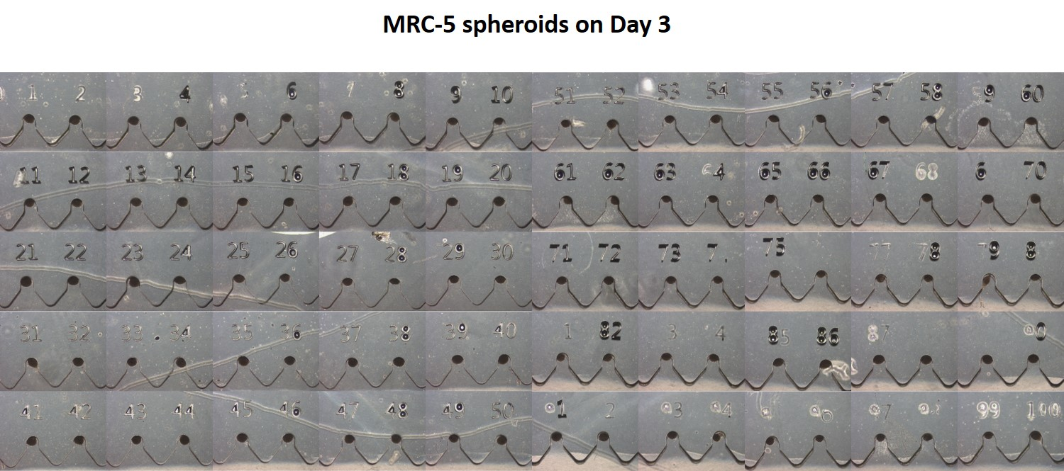

- Reproducibility and productivity of the presented method should be compared in detail with conventional methods
Response: We thank the reviewer for this helpful comment. We demonstrated fabricating 100 spheroids with a few injections. However conventional methods such as the microwell or the hanging droplet methods require much more labor to fabricate the same number of spheroids. Thus, when making more spheroids later, the CMS system will have much better reproducibility and productivity than conventional methods.

To address the above-mentioned issues, changes were made (in red) to the manuscript, as shown in the box below.
DISCUSSION:
...
The CMS system also has its limitations compared to conventional methods. The CMS system requires a larger culture space (e.g. large incubator space) as it comprises a motor, rotating platform, and a controller, and its total size is approximately 100 x 100 x 150 mm³ (Figure 2B). In addition, it causes a slight but persistent vibration. We expect that the miniaturization of the system (hopefully similar the size of 6-well plates) will solve these issues.
It should be noted that the cultured spheroids can be collected by separating the two plasma-bonded layers of the CMS culture chip (Figure 9). The bonding of the two layers is strong enough to prevent the media from leaking during system operation, however, owing to the small bonding area, it is separable by hand. The spheroids arecan be simply collected from the bottom layer by pipetting.
The CMS system has better reproducibility and productivity than conventional methods of spheroid generation. The conventional methods such as normal microwell or hanging droplet method are labor-intensive. However, in the CMS system, it is much easier to increase the number of spheroids without the need of extra effort by simply increasing the chip size. With this device, it is also possible to generate organoids that require culture of multi-cell types, which is not easy to do in conventional culture methods. In addition to the demonstrated cells in this study (hASC and MRC-5), CMS could be used for spheroid production using various types of cells that can form spheroids.

Minor Concerns:
- In Fig 2A, scale bar length should be given
Response: We thank the reviewer for pointing out this omission. The content of the scale bar has been added to the description in Figure 2.

To address the above-mentioned issues, changes were made (in red) to the manuscript, as shown in the box below.
FIGURE AND TABLE LEGENDS:
...
Figure 2: Photographs of the CMS system. (A) Photographs of the completed CMS culture chip. The diameter of the chip is 6 cm and the diameter of the microwell is 400 μm. The numbers above the microwells represent the individual numbers of the microwells, from 1 to 100. These numbers were engraved into the mold. The scale bar corresponds to 400 μm. (B) Photograph of the whole CMS system. The CMS system comprises the CMS culture chip, chip holder, DC motor, and rotating platform. CMS devices can generate gravity conditions up to 521G through rotational force. The chip holder prevents separation of the CMS culture chip from high gravity.

- The inset image of Fig 3B is not clear. Channels can be indicated on the figure and scale bar can be given.
Response: Yellow lines have been added to clarify the figure. Scale bar was added.

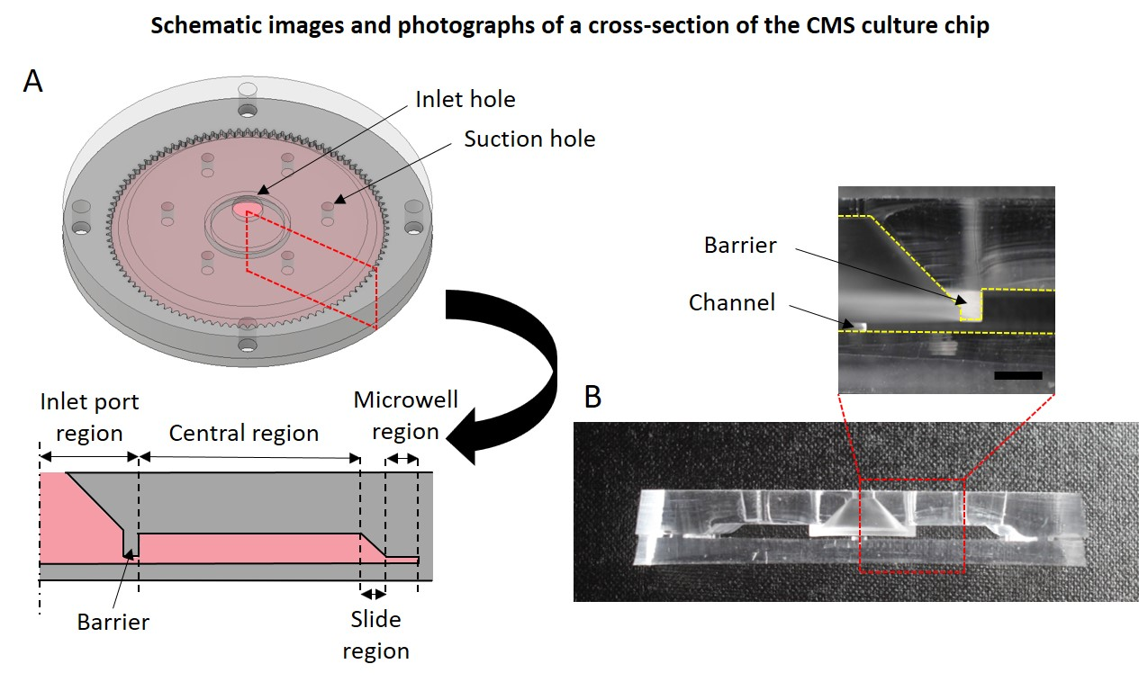
- The article could benefit from a good proofread.
Response: We appreciate the reviewer's careful check. We re-checked typos and grammar errors.

Reviewer #4:
Manuscript Summary:
The author team has developed a new protocol of a centrifugal force-based microfluidic device to fabricate spheroids. 100 spheroids can be produced simultaneously from the device using a wide range of gravity forces.
Major Concerns:
(1) there is no demonstration of distributing cells evenly into each well through the centrifugal forces in this device. During traveling from the inlet port to the sliding region of each well, cells may be subjected to different trajectory pathways and land in each well with different number of cells.
Response: We appreciate the reviewer’s concern. Figure 8 shows a total of 100 spheroids, so it shows the uniformity of the CMS system. if not the vibration is strong when the cells are injected or if not the rotational centroid of the CMS system is not misaligned, a similar number of cells enter each microwell.

To address the above-mentioned issues, changes were made (in red) to the manuscript, as shown in the box below.
REPRESENTATIVE RESULTS:
...
Over time, the first cell in the outer U-shape surrounds the second cell in the middle and completes the concentric spheroid. In the case of Janus spheroids, the second cell (4 × 10⁵ MRC-5s) is injected 3 h after the first cell (2.5 × 10⁵ hASCs) is injected (Figure 6B). When the injection interval between the two cells is long, the shape of first cell changes from U-shape to elliptical shape by cell aggregation. The second cell is added to the elliptical shape of the first cell, and the Janus spheroid is generated. In the case of the sandwich spheroid, the first cell (1.5 × 10⁵ hASCs) is injected and the second cell (3 × 10⁵ MRC-5s) is injected 3 h later, and the third cell (1.5 × 10⁵ hASCs) is injected (Figure 6C) after another 3 h. Similar to the Janus spheroid, each cell aggregates into an elliptical shape, and three layers are stacked to generate sandwich spheroid. Lastly, to demonstrate the long-term culture capability of the CMS, hASCs were cultured being exposed to high gravity for 7 days followed by a live/dead assay performed to show that the most cells survived (Figure 7). Also, photos of all microwells of the CMS were taken after 3 days of MRC-5s cultivation to show excellent uniformity and sphericity of spheroids (Figure 8).

(2) From the current device, how the spheroids can be recovered from this device?
Response: We thank the reviewer for this helpful comment. It is important to harvest the spheroids as reviewer asked. In this study, it is difficult to collect spheroids by pipetting from the combined CMS culture chip. So, plasma bonded chip is separated, and spheroids are collected. We added related contents to the manuscript.

To address the above-mentioned issues, changes were made (in red) to the manuscript, as shown in the box below.
DISCUSSION:
The CMS is a closed system in which all injected cells enter the microwell without waste, making it more efficient and economical than conventional microwell-based spheroid generation methods. In the CMS system, the media is replaced every 12-24 h through a suction hole designed to remove the media in the chip (Figure 3A). During the media suction process, there is barely any escape of the media from inside the microwell due to the action of surface tension between the media and the wall of microwell, so the media change process is bothered. A user can easily remove the trapped media by pressing near the microwell region of the chip with a finger as the chip made of PDMS is elastic and flexible. Cells in the microwell remain stable without escaping, even with multiple media changes. To achieve the same quality of spheroid in all 100 microwells, the rotation of the device should not be eccentric, and the chip should be axisymmetrical. Otherwise, a variable number of cells may enter each well and the size and shape of the spheroid would differ. In the conventional microwell system, since the air is often trapped in the microwell, it is necessary to remove the air bubbles. However, the CMS system does not require the bubble removal process because the high centrifugal force generated by the rotation causes the media to push the bubbles and squeeze them out from the microwells.
The CMS system also has its limitations compared to conventional methods. The CMS system requires a larger culture space (e.g. large incubator space) as it comprises a motor, rotating platform, and a controller, and its total size is approximately 100 x 100 x 150 mm³ (Figure 2B). In addition, it causes a slight but persistent vibration. We expect that the miniaturization of the system (hopefully similar the size of 6-well plates) will solve these issues.
It should be noted that the cultured spheroids can be collected by separating the two plasma-bonded layers of the CMS system (Figure 9). The bonding of the two layers is strong enough to prevent the media from leaking during system operation, however, owing to the small bonding area, it is separable by hand. The spheroids arecan be simply collected from the bottom layer by pipetting.
The CMS system has better reproducibility and productivity than conventional methods of spheroid generation. The conventional methods such as normal microwell or hanging droplet method are labor-intensive. However, in the CMS system, it is much easier to increase the number of spheroids without the need of extra effort by simply increasing the chip size. With this device, it is also possible to generate organoids that require culture of multi-cell types, which is not easy to do in conventional culture methods. In addition to the demonstrated cells in this study (hASC and MRC-5), CMS could be used for spheroid production using various types of cells that can form spheroids.
Minor Concerns:
There are typos and grammar errors in the entire manuscript.
Response: We appreciate the reviewer's careful check. We re-checked typos and grammar errors.

