Dear Author(s),
This document is divided into a number of sections in which you can add your comments to the video, voiceover, and online text/PDF. Please be aware that our policy is to do a single complimentary revision, so it is critical that all participants in this project offer their comments collectively. In addition, please make sure that your comments are easily interpreted and transparent.
Have fun!

Protocol Name: Establishment and Analysis of Three-Dimensional (3D) Organoids Derived from Patient Prostate Cancer Bone Metastasis Specimens and their Xenografts

Date: Jan 09 2020

Authors and Affiliations
Please fill in any missing author information not included in the video.
The website given to the authors for proofreading shown below includes all authors.
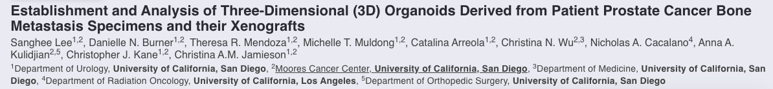
If this section meant to indicate authors shown in the manuscript (as shown above) but not included in the video file, the screen shot attached above shows a list of all authors and their affiliation/e-mail.
Order | Author | Affiliation | Email

Video Comments
Please fill in any comments you wish to make using the table below using the example as a guide. If you need more space to write, please do so below the table. DO NOT ADD CORRECTIONS TO THE NARRATION HERE. PLEASE DO THIS IN THE AUDIO COMMENTS SECTION.
 | Time code | Comment | Requested Change
Example | 2:52 | Onscreen text says use 0.25 mM Fluo-4 | Text should say use 0.50 mM Fluo-4
1. | 3:30 | Video shot 4.1.  The cold room | Please remove this shot showing the cold room as it is not necessary.
2.
3.
4.
5.
6.
7.
8.
9.
10.
11.
12.
14.
15.
16.
17.
18.
19.
20.

Audio Comments
This section is used to specify the changes that need to be made to the narration. Please follow the example below as a guide to list your changes. If there is a pronunciation change, please provide a phonetic pronunciation key.

 | Time code | Comment | Step(s) in Shotlist | Rewritten Text or Corrected Pronunciation (highlight in bold)
Example | 1:49 | Original Script Text:  “Then, show the participant their electromyography, or EMG patterns, which correspond to eight specific and unique polar plots.” | 2.2 | Rewritten Script Text:  “Then, show the participant the unique and specific polar plots, which correspond to their electromyography, or EMG (pronounced E-M-G) patterns.”
1. | 4:08 | Add the desired volume of cold PBS and gently pipette up and down to mechanically disturb pellet but not the organoids. | 4.4. | Add the desired volume of cold PBS and gently pipette up and down to mechanically dislodge the pellet without disrupting the organoids.
2.
3.
4.
5.
6.
7.
8.
9.
10.
11.
12.
13.
14.
15.
16.
17.
18.
19.
20.

Online Text/PDF Protocol
Please use this table to address changes that need to be made to the online text/PDF document. Both the online text and PDF are generated from the HTML template of your article. Since the PDF is generated from the HTML by our conversion software, it may contain formatting errors. For major structural changes or more than 10 spelling or grammatical mistakes, we will require re-upload of the entire document.

 | Protocol Step | Comment | Requested Change (highlight in bold)
Example | 1.1 | Step says “Centrifuge lysate at 2,000 x g.” | Please correct to “Centrifuge lysate at 4,000 x g.”
1. | Figure 4 |  | Please use the updated version of Figure 4 shown below this table. For your convenience, a separate ppt file of all figures is uploaded as well.
2.
3.
4.
5.
6.
7.
8.
9.
10.
11.
12.

