Talent Release Form

Talent Name: ___Sean McDermott___________ Project Title: Jove shoot 60353__________

I hereby consent for value received and without further consideration or compensation to the use (full or in part) of all videotapes taken of me and/or recordings made of my voice and/or written extraction, in whole or in part, of such recordings or musical performance for the purposes of illustration, broadcast, or distribution in any manner.
at ____Northwestern University on ________________________
(Recording Location) (Date)

by _____Dipesh Navani_________________for ___JoVE___________________________
(Producer) (Producing Organization)

Talent's signature____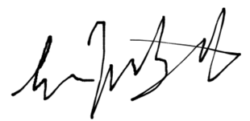
Address __303 E Chicago Ave______________ City _____Chicago________________
State ___IL_________________ Zip code ___60611__________
Date: _7___/__29__/_2019___
__________________________

If the subject is a minor under the laws of the state where modeling, acting, or performing is done:
Legal guardian _________________________ ___________________________
(sign/print name)
Address _____________________________ City ________________________
State ______________________ Zip Code ___________
Date: ____/____/____

