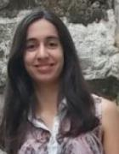

Filipa Santos graduated in Pharmacy at Superior School of Health and Technologies of Porto – Polytechnic Institute of Porto (2008-2012), and obtained her Master Degree in Biochemistry Applied to Biomedicine at University of Minho during 2012-2015. She was a research Fellow in Advanced Therapies for Health at 3B's Research Group (2016-2017) and, in the present, she is a PhD Student in Doctoral Programme of Sustainable Chemistry at Faculty of Sciences and Technology – UNL. Her main research interests are focused on the development of therapeutic deep eutectic solvents (THEDES) ant its therapeutic applications, namely in tuberculosis.

