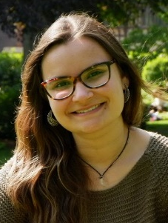
Liane Meneses was born in 1993 in Terceira island, Azores. She graduated in Biomedical Sciences by Universidade de Aveiro in 2015 and obtained her MSc in Biotechnology by Faculdade de Ciências e Tecnologias of the Universidade Nova de Lisboa in 2017. During her master thesis she worked with sub-, supercritical fluids for the extraction and processing of biopolymers, namely polyhydroxyalkanoates. Over the past year her main research focus has been with deep eutectic solvents for different applications such as enzymatic kinetic resolution of racemic compounds and stabilization of added value molecules, such as antioxidants or proteins. Her research interests involve alternative solvents, such as supercritical solvents and deep eutectic solvents and alternative materials, such as biopolymers derived from biomass.

