May, 27th 2019

Editors and
members of the editorial board
of the
Editorial JoVE

Dear Editors and members of the editorial board,

Please find our online submission of the manuscript entitled “Glomerular outgrowth - An ex vivo assay to analyze pathways involved in parietal epithelial cell activation” written by J. Eymael for the JoVE Biology section of the Editorial JoVE.
Parietal epithelial cell activation is one of the key factors involved in the development and progression of glomerulosclerosis. Inhibition of pathways involved in parietal epithelial cell activation could therefore be a tool to attenuate the progression of glomerular diseases. This paper describes a method to culture and analyze parietal epithelial cell outgrowth of encapsulated glomeruli isolated from mouse kidney and can therefore be used as a tool to study the effects of an altered gene expression in transgenic- or knockout -mice or the effects of culture conditions on parietal epithelial cell growth characteristics and signalling. Using this method, important pathways involved in the process of parietal epithelial cell activation and consequently in glomerulosclerosis can be studied.
We confirm that this manuscript has not been published elsewhere and is not under consideration by another journal. All authors have approved the manuscript and agree with submission to JoVE. The study was supported by a grant from the Dutch Kidney foundation (grant 14A3D104) and The Netherlands Organization for Scientific Research (NWO VIDI grant: 016.156.363). The authors have no conflicts of interest to declare.
Sincerely,

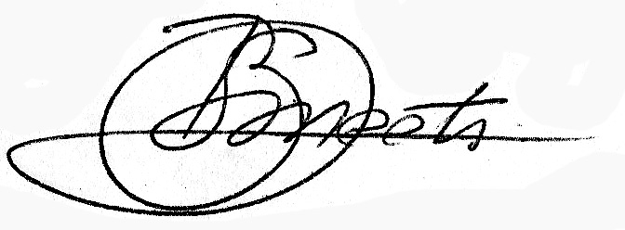

Dr. Bart Smeets, Ph.D.

