Submission ID #: 60323

Scriptwriter Name: Qingyun Ping

Project Page Link: http://www.jove.com/files_upload.php?src=18398563

Title: Pneumococcus Infection of Primary Human Endothelial Cells in Constant Flow

Authors and Affiliations: Hilger Jagau^{1,2}, Ina-Kristin Behrens^{1,3}, Michael Steinert^{1,4}, Simone Bergmann¹

¹Institut für Mikrobiologie, Technische Universität Braunschweig, Braunschweig, Germany
²Devision of Infection Medicine, Department of Clinical Science, Lund University, Lund, Sweden
³Medical Microbiology and Hospital Epidemiology, Max von Pettenkofer Institute, LMU, Munich, Germany
⁴Department of Molecular Infection Biology, Helmholtz Center for Infection Research, Braunschweig, Germany

Corresponding Author:

Simone Bergmann

simone.bergmann@tu-bs.de

Email addresses for Co-authors:

hilger.jagau@med.lu.se

behrens@mvp.uni-muenchen.de

m.steinert@tu-bs.de

simone.bergmann@tu-bs.de

Author Questionnaire:

1. Microscopy: Does your protocol involve video microscopy, such as filming a complex dissection or microinjection technique? (Yes)
Can you record movies/images using your own microscope camera? (Y/N)
If no, JoVE will need to record the microscope images using our scope kit (through a camera port or one of the oculars). Please list the make and model of your microscope.
We use a Confocal Laser Scanning Microscope from Leica DMi8, Sp8, with LasX-Software, with an integrated DFC 365 FX camera (1392 x 1040, 1.4 Megapixel), additionally equipped with fluorescence filter and Xenon-Light.

2. Does your protocol include software usage? (Yes)
If yes, we will need you to record using screen recording software to capture the steps. If you use a Mac, QuickTime X also has the ability to record the steps.

3. Which steps from the protocol section below are the most important for viewers to see? Please list 4-6 individual steps using the step numbers listed in this document. This information is important to prepare your Videographer for your shoot. (You do not need to include steps that will be screen captured. Please do not list entire sections.)
Step 2.2.2: Seeding of cells into the chamber slide
Step 2.6.3: Removing air from the perfusion tubing
Step 2.7.2: Connecting chamber slide to the perfusion set
Step 4.3.1: Creating snap shots

4. What is the single most difficult aspect of this procedure and what do you do to ensure success? Please list 1-2 individual steps using the step numbers listed in this document. (Please do not list entire sections.)
The single most difficult aspect is to ensure that the endothelial cells remain attached to the chamber slide surface during the whole experiment under shear stress condition.
To ensure success, we use primary cells in low passages directly after isolation, we seed them on gelatin (step 2.2.2) and remove any air bubbles out of the perfusion system (step 2.6.3). As further option to protect the pump system against sudden strong power peaks, which might induce strong pressure fluctuation, an independent power supply and shielded wiring can be used.

5. Will the filming need to take place in multiple locations? No, all takes place on the same flour in two laboratories quite close to each other.

Section - Introduction
Videographer: Interviewee Headshots are required. Take a headshot for each interviewee.

Authors, these headshots will be used for the JoVE Dedicated Author Webpage. Here is one example if you wish to take a look.

- REQUIRED Interview Statements: (Said by you on camera) - All interview statements may be edited for length and clarity.

  - Simone Bergmann: The use of a constantly perfused endothelial cell culture system enables the simulation of bacterial infection processes on a perfused endothelial surface and the identification of involved bacterial and host-derived factors [1].
    - INTERVIEW

  - Simone Bergmann: The main advantage of this technique lays in the possibility to microscopically monitor any bacterial interaction with the human vascular surface under a continuous, pulseless and defined physiological shear stress.
    - INTERVIEW

OPTIONAL Interview Statements: (Said by you on camera) - All interview statements may be edited for length and clarity.

  - Hilger Jagau: The implications of this technique extend toward the knowledge about the development of long term vascular complications which are reported to take place months and even years after severe pneumococcal infections [1].
    - INTERVIEW

  - Ina-Kristin Behrens: This method could provide insight into several other areas of research correlated with the perfused vascular system such as endothelial cell differentiation, wound healing, thrombogenesis and angiogenesis [1].
    - INTERVIEW

  - Hilger Jagau: One of the key steps is the accurate handling of the primary endothelial cells which requires some technical experience and routine. Therefore, the standardized cell cultivation should be trained beforehand [1].
    - INTERVIEW

  - Hilger Jagau: This technique requires some special handling at certain critical protocol steps which might not be clear enough to the experimentator only by verbal explanation [1].
    - INTERVIEW

Section - Protocol

The microfluidic cell cultivation was performed with commercial primary human umbilical vein endothelial cells (HUVEC). The company isolated the cells with informed consent of the donor. This study was approved by the Ethics Committee of Doctors Chamber of the Federal State Baden-Wuerttemberg with the reference number 219-04.
- Endothelial Cell Cultivation of HUVEC, Induction of VWF (Von Willebrand Factor)-release and Visualization of Multimerized VWF Strings
  - To begin, work in a sterile environment using a clean bench [1]. Use a Luer syringe to inject 100 microliters of a 2% sterile-filtered porcine gelatin solution in PBS solution into one of the reservoirs of a temperature-equilibrated channel slide [2].
    - WIDE: Talent works at a clean bench.
    - CU: Talent injects solution into one reservoir.
  - Place the gelatin-coated channel slide on a thin polystyrene or styrofoam plate to prevent a drop in the slide temperature [1]. With a 1-milliliter Luer syringe to add 100 microliters of the 4 x 10⁶ per milliliter HUVEC (pronounce as hjˈuːvɛk) suspension into the slide to seed and cultivate the HUVEC [2].
    - Talent places the channel slide on a surface.
    - CU: Talent injects cell suspension into the slide. Videogrpaher: Take multiple shots, as this will be used later. Important Step
  - Incubate the channel slide with the HUVEC for 60 minutes at 37 degrees Celsius and 5% carbon dioxide [1]. After that, fill up each medium reservoir at both ends of the channel slide with 60 microliters of ECGMS (pronounce as E-C-G-M-S) medium [2-TXT]. Incubate for another 1 hour at 37 degrees Celsius and 5% carbon dioxide [3].
    - Talent places the slide into an incubator.
    - CU: Talent adds solution into both ends. TEXT: ECGMS: endothelial cell growth medium, supplemented with fetal calf serum and magnesium sulfate
    - Talent places the slide into an incubator.
  - Next, to adjust the microfluidic pump, first connect the equilibrated perfusion set to the pump unit, fill with 13.6 milliliters of ECGMS-medium [1], and start the pump control software [2].
    - Talent connects perfusion set to pump unit, and fills solution.
    - Talent operates on the computer.
  - In the menu of the fluidic unit set up, select the adequate perfusion set and type of chamber slide using the scroll down windows. Choose 0.007 dyne second per square centimeter in the software for medium viscosity [1-LM].
    - Supplementary Figure 1. Video editor: emphasize the yellow arrow when VO says “In the menu of the fluidic unit set up”; emphasize the red arrow when VO says “using the scroll down windows”; emphasize the green arrow when VO says “Choose 0.007…”

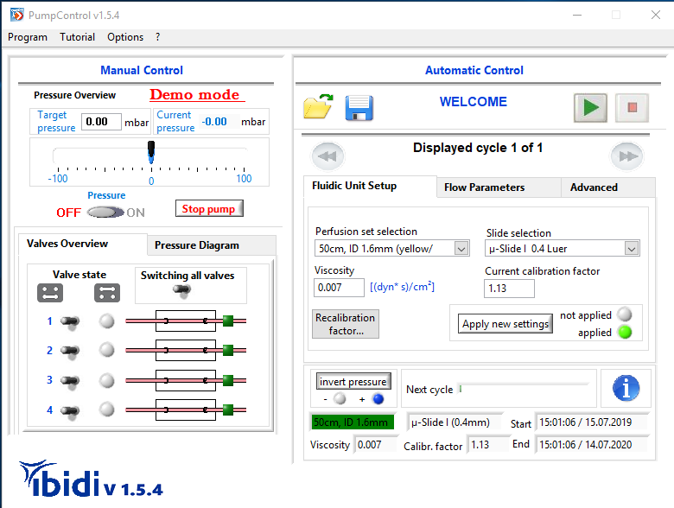
  - Outside of the incubator, connect a glass bottle filled with drying silica beads to the air pressure tubing [1]. Select Flow Parameters in the software menu, set the pressure to 40 millibar, and flush the pump tubes with the liquid medium by starting the continuous medium flow [2].
    - Talent connects a bottle to the tubing.
    - Supplementary Figure 2. Video editor: emphasize the red arrow when VO says “Select Flow Parameters”; emphasize the yellow arrow when VO says “set the pressure to 40”; emphasize the green arrow when VO says “by starting the continuous medium flow.

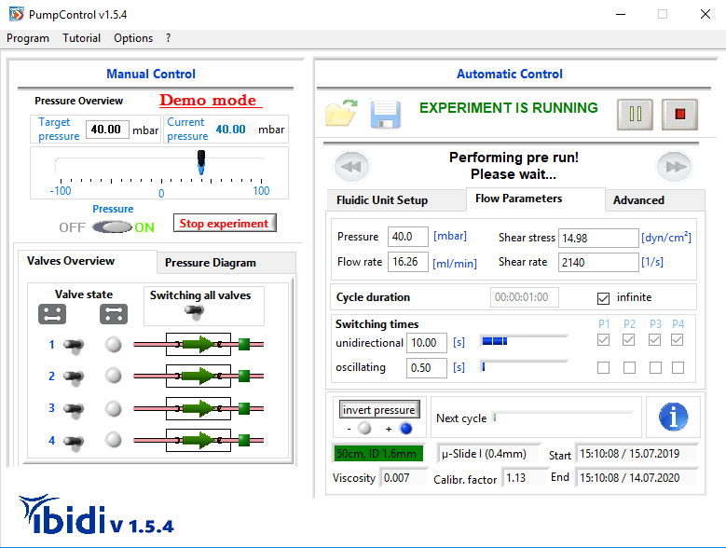
  - Hilger Jagau: We ensure a tight cell attachment by using subconfluently grown cells of low passage, by removing the air and by using an independent power supply to avoid sudden power peaks [1].
    - INTERVIEW
  - Tap at the tubing connections to remove air bubbles [1], and ensure that no air bubbles are circulating in the pump system [2].
    - Talent removes air bubbles by tapping at the tubing connections. Important Step
    - Shot of the circulating system showing no bubbles.
  - For connecting the channel slide, stop the flow circulation in the pump control software [1] and hold the medium flow in the perfusion tubing by clamping the tubes near the Luer connections. Connect the channel slide, thereby avoiding air bubbles [2].
    - Talent sits in front of the computer to stop the flow circulation.
    - CU: Talent clamps the tubes, and connects the channel slide. Important Step
  - In the PumpControl software, Advanced tab, use the software tool “Cycle Creator” [1] to program the desired shear stress cycles for flow cultivation [2].
    - Supplementary Figure 3A. Video editor: emphasize the yellow arrow when VO says”Advanced tab”; emphasize the red arrow when VO says “Cycle Creater”.
    - Supplementary Figure 3A.

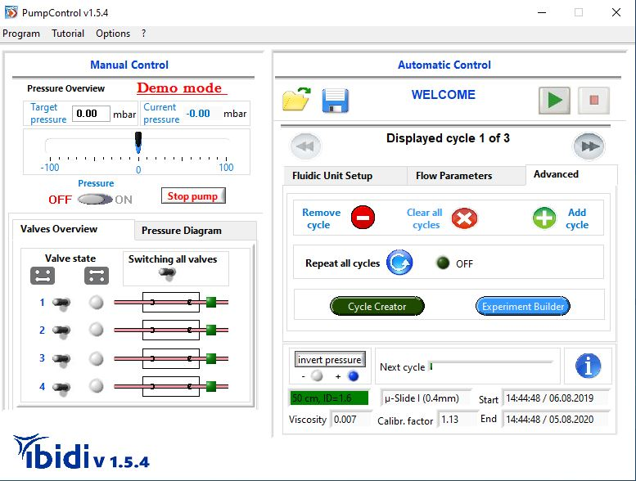
  - Program the shear stress levels for flow circulation and start longterm perfusion. Start with 5 dyne per square centimeter which corresponds to a flow rate of 5.44 mL/min for 30 minutes followed by continuous flow at shear stress of 10 dyne per square centimeter which corresponds to a flow rate: 10.85 mL/min [1]. Control balanced reservoir pumping [2].
    - Supplementaryfileupdatedrev.pptx
    - Talent starts pumping
  - Place the fluidic unit with the connected channel slide in an incubator at 37 degrees Celsius and 5% carbon dioxide [1].
    - Talent places the unit into an incubator.
  - Start the microscope software control and adjust the principal settings for the fluorescence microscopic monitoring by selecting the appropriate filter settings [1].
    - Talent starts the microscope software, and selects filter.
  - For microscopic visualization, place the fluidic unit into the 37-degree Celsius heating chamber, place the channel slide on the stage of a prewarmed microscope [1]. Control the cell morphology and the integrity of the HUVEC layer prior to injection of histamine and bacteria to the flow circulation [2-LM].
    - Talent places the unit into a heating chamber of the microscope, and places the channel slide on the stage.
    - 2_14_2.mp4
  - Maintain the flow setting. Induce the release of VWF (pronounce as V-W-F) from endothelial Weibel Palade Bodies by injecting 136 microliters of a 100 millimolar histamine stock solution through an injection port into the ECGMS (pronounce as E-C-G-M-S)-medium circulating in the perfusion tubing [1].
    - Talent injects solution into the tubing.
  - For immunofluorescence detection of multimerized VWF strings, inject 20 microgramms of a VWF-specific FITC (pronounce as F-I-T-C)-conjugated antibody in a volume of 200 microliters of PBS into the circulating 13.6 milliliters of ECGMA-medium [1].
    - Talent injects solution into the circulating medium.
- Microscopic Evaluation of Bacterial Attachment to VWF-strings in Flow in Real Time and after Sample Fixation
  - To quantify pneumococcal attachment to the VWF-strings generated on HUVEC (pronounce as hjˈuːvɛk) cell surfaces, inject 1.35 x 10⁸ CFU per milliliter RFP-expressing pneumococci in a maximum volume of 1 milliliter into the ECGMS-medium using the injection port [1].
    - Talent holds the flow and injects solution.
  - Select a 63x oil-immersion objective for microscope magnification [1] and adjust the fluorescence filter settings in the microscope software to the RFP-channel with a 540-nanometer detection filter for detection of RFP-expressing pneumococci [2].
    - Talent adjusts objective.
    - Talent adjusts the filter settings.
  - For quantification of bacterial attachment to the VWF strings, create snapshots of Z-stacks of at least 30 representative field views [1], each containing approximately 10 morphologically intact HUVEC, and count the amount of pneumococci [2].
    - Talent creates snapshots. Important Step
    - Talent points to the 10 HUVEC, and then points to pneumococci.
  - To evaluate bacterial attachment after fixation, prior to immunofluorescence staining, stop the flow, remove 10 milliliters of ECGMS-medium from the pump reservoirs [1], and add 10 milliliters of PBS supplemented with 5% paraformaldehyde and proceed according to the manuscript [2].
    - Talent stops the flow, and removes solution.
    - Talent adds buffer.

Section – Results
- Results: Analyses of Bacterial Attachment to VWF Strings
  - In this protocol, the principal experimental steps begin with the precultivation of primary endothelial cells to subconfluency in cell culture flasks. Cells are then seeded into a gelatin-coated channel slide [1].
    - Figure 1 – Video editor: emphasize insert 1.
  - Bacteria are grown on agar plates followed by cultivation in a complex liquid medium to mid-log phase [1]. For microfluidic cell culture, a channel slide with endothelial cells is connected to the perfusion tubes of a fluidic unit of the pump system and subjected to constant flow for cell differentiation [2].
    - Figure 1 – Video editor: emphasize insert 2.
    - Figure 1 – Video editor: emphasize insert 3.
  - The generation of the VWF-strings was induced by histamine injection at a shear stress of 10 dyne second per square centimeter and microscopically monitored by immunofluorescence detection using FITC-labelled VWF-specific antibodies [1].
    - Figure 1 – Video editor: emphasize insert 4, and emphasize the green arrow.
  - After injection of RFP (pronounce as red fluorescence protein)-expressing bacteria to the circulating medium, pneumococcus attachment to the VWF-strings was microscopically visualized in real time by fluorescence emission at 450 nanometers [1].
    - Figure 1 – Video editor: emphasize insert 5, and emphasize the red arrow.
  - After fixation of the cells using PFA, differential immunofluorescence staining provides the visualization of bacterial attachment at specific infection time points [1].
    - Figure 1 – Video editor: emphasize insert 6, and emphasize the red arrow.

Section - Conclusion
- Conclusion Interview Statements: (Said by you on camera) - All interview statements may be edited for length and clarity.
  - Simone Bergmann: The most important step of this procedure is to ensure a tight attachment of the endothelial cells on the slide surface by adjusting physiological shear stress levels and by avoiding pump pressure fluctuations [1].
    - INTERVIEW – Video editor: B-roll suggestion: Shot 2.2.2
  - Simone Bergmann: In addition to the microscopic visualization, this method can be applied to study the pharmacological effects of new anti-infectiva and to analyse longterm consequences of infections on the vascular system [1].
    - INTERVIEW
  - Simone Bergmann: Yes, this technique pave way to explore the impact of systemic bacterial infections under physiological shear stress conditions on the vascular integrity including implications on thrombogenesis, inflammation responses and immune regulation [1].
    - INTERVIEW
  - Simone Bergmann: The microfluidic system perfuses bacterial pathogens by air pressure. To prevent any transition via aerosols, the pump system should be handled always considering the recommended biosafety precautions [1].
    - INTERVIEW

