First, we would like to thank you for the reviewer’s comments and questions. By incorporating the suggestions and comments from the reviewers, it really strengthened our manuscript. Below are our responses to the reviewer’s comments and questions.
Editorial comments:
1. Please take this opportunity to thoroughly proofread the manuscript to ensure that there are no spelling or grammar issues. The JoVE editor will not copy-edit your manuscript and any errors in the submitted revision may be present in the published version.
Response: We have proofread the manuscript.
2. Authors and affiliations: Please provide an email address for each author.
Response: Email address added for each author.
3. Please add a Summary section before the Abstract section to clearly describe the protocol and its applications in complete sentences between 10−50 words: “Here, we present a protocol to …”
Response: Summary section added.
4. JoVE cannot publish manuscripts containing commercial language. This includes trademark symbols (™), registered symbols (®), and company names before an instrument or reagent. Please remove all commercial language from your manuscript and use generic terms instead. All commercial products should be sufficiently referenced in the Table of Materials. You may use the generic term followed by “(Table of Materials)” to draw the readers’ attention to specific commercial names. Examples of commercial sounding language in your manuscript are: PerkinElmer Inc., IVIS SPECTRUM, Living Image, Maestro software, etc.
Response: Brand names are replaced with generic names.
5. Please adjust the numbering of the Protocol to follow the JoVE Instructions for Authors. Step 1 followed by 1.1, followed by 1.1.1, etc. Each step should include 1−2 actions and contain 2−3 sentences. Use subheadings and substeps for clarity if there are discrete stages in the protocol. Please refrain from using bullets, dashes, or indentations.
Response: Manuscript updated to JoVE format.
6. Please revise the Protocol to contain only action items that direct the reader to do something (e.g., “Do this,” “Ensure that,” etc.). The actions should be described in the imperative tense in complete sentences wherever possible. Avoid usage of phrases such as “could be,” “should be,” and “would be” throughout the Protocol. Any text that cannot be written in the imperative tense may be added as a “NOTE.” Please include all safety procedures and use of hoods, etc. However, notes should be used sparingly and actions should be described in the imperative tense wherever possible. Please move the discussion about the protocol to the Discussion.
Response: Imperative tense is adopted in the revised manuscript.
7. Please add more details to your protocol steps. There should be enough detail in each step to supplement the actions seen in the video so that viewers can easily replicate the protocol. Please ensure you answer the “how” question, i.e., how is the step performed? Alternatively, add references to published material specifying how to perform the protocol action. See examples below.
Response: Detail steps were added.
8. Lines 89-91: Please describe how the cells are transfected.
Response: Cells were a commercial product, we did not transfect those cells. We noted in the protocol that those cells are purchased from a vendor.
9. Lines 92-93: At what conditions are the cells grown? What container is used?
Response: Growing conditions and container information are added.
10. Line 94: How to remove puromycin from the medium?
Response: Puromycin rinsing steps are added.
11. Line 96: Please describe how to trypsinize cells.
Response: Detail trypsinization steps are added.
12. Line 98: What volume of PBS is used to rinse?
Response: 10 ml 1X PBS information is added.
13. Lines 109-110: Please mention how animals are anesthetized and how proper anesthetization is confirmed.
Response: Detailed steps on anesthetizing the mice and testing the depth of anesthesia are added.
14. Please ensure that the manuscript is formatted according to JoVE guidelines—letter (8.5” x 11”) page size, 1-inch margins, 12 pt Calibri font throughout, all text aligned to the left margin, single spacing within paragraphs, and single-line spaces between all paragraphs and protocol steps/substeps. Do not underline any text in the protocol.
Response: Page margins are formatted according to JoVE’s guideline.
15. Please combine some of the shorter Protocol steps so that individual steps contain 2-3 actions and maximum of 4 sentences per step.
Response: Shorter steps are combined.
16. After you have made all the recommended changes to your protocol section (listed above), please highlight in yellow up to 2.75 pages (no less than 1 page) of protocol text (including headers and spacing) to be featured in the video. Bear in mind the goal of the protocol and highlight the critical steps to be filmed. Our scriptwriters will derive the video script directly from the highlighted text.
Response: Text highlighted.
17. Please highlight complete sentences (not parts of sentences). Please ensure that the highlighted steps form a cohesive narrative with a logical flow from one highlighted step to the next. The highlighted text must include at least one action that is written in the imperative voice per step. Notes cannot usually be filmed and should be excluded from the highlighting.
Response: Sentence highlighted.
18. Please include all relevant details that are required to perform the step in the highlighting. For example: If step 2.5 is highlighted for filming and the details of how to perform the step are given in steps 2.5.1 and 2.5.2, then the sub-steps where the details are provided must be highlighted.
Response: Relevant detail steps are highlighted.
19. Please do not highlight any steps describing anesthetization and euthanasia.
Response: None of the anesthetization and euthanasia steps are highlighted.
20. Please upload each Figure individually to your Editorial Manager account as a .png, .tiff, .pdf, .svg, .eps, .psd, or .ai file.
Response: Figures are saved in PDF format individually.
21. Please remove the titles and figure legends from the uploaded figures. Please include all the figure Legends together at the end of the Representative Results in the manuscript text.
Response: Titles and figure legends are moved after the Representative Results section.
22. Please use superscript arabic numerals to cite references in text. The superscript number is inserted immediately next to the word/group of words it applies to but before any punctuation.
Response: Reference fonts and format updated as suggested
23. References: Please do not abbreviate journal titles; use full journal name.
Response: Reference journal names are expanded to full names.

Reviewers' comments:
Reviewer #1:
Manuscript Summary:
The manuscript accurately describes the assay and discusses the strengths and weaknesses within the assay. The authors also discuss the advantages of using IVIS and florescence based methods to detect tumor and metastases both in vivo and ex vivo. Lastly, the authors discuss how this assay could be applied to better the field.
Response: Thank you for the comments.
Major Concerns:
No major concerns.

Minor Concerns:
It would be helpful to reader to address a couple of minor concerns. Figure 6 does not show the most accurate data for what they are trying to show, although it is fully believable that this method would work. While they show the melt curve for cells grown in culture and cells isolated from mice, they are lacking the amplification curves and a negative control (ex. brain tissue from a mouse that did not have cancer cells implanted).

Response:
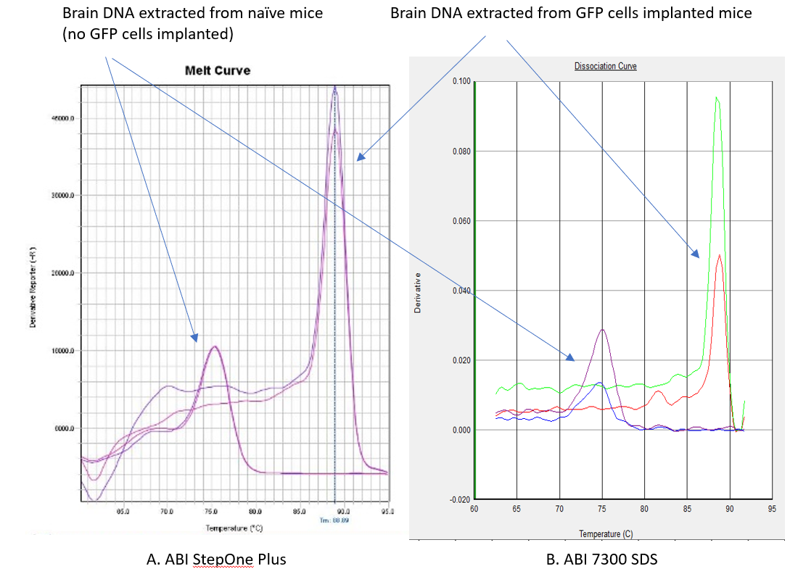

Thank you for the comments. The above melt curves are coming from two different real-time PCR machines and reagents (A & B) shows the same GFP peaks location (close to 90C). The minor peaks close to 75C are the non-specific amplification from the naive mice brain tissue (no GFP cells implanted).
The amplification plot is designed to provide an amplicon’s abundancy information and the result is easily affected by non-specific amplification or the presence contaminants. In this case, our GFP primer pair do induce a minor non-specific amplification and that’s why we do not consider amplification plot is that useful. And that’s why we omit it from this protocol and use the melt curve instead because of it high specificity. Also, the melt curve can provide a reference peak (close to 90C) for any researcher which willing to use our GFP primer pair. In our hand, the GFP peak locations remain at a constant coordination in different PCR settings and studies.

It would also help the readers to better show the specificity of the primers (and publish the primer sequences) by showing non-GFP samples (i.e. negative control) are not amplified with the GFP primers.
Response: The GFP primer pair sequence is included in the protocol.
In figure 5 they show only part of the tumor has GFP cells by IVIS and say the rest of the mass was stroma (figure legend) or necrosis (representative results section) and this makes perfect sense, however it would be helpful to show the histopathological sections they referred to in the text so the readers can see the stroma or necrosis.
Response: Thank you for the comment and suggestion. A histopathological figure is added to demonstrate the area without fluorescent signals in the xenograft.
Figure 4 addresses the time constraints of bioluminescence signal ex vivo and shows GFP is much more stable than bioluminescence, which is true. However, it is unclear if the brain and lungs used in these figures are the same. If not, it would be better to show the GFP and bioluminescence in the same brain and same lung.
Response: Thank you for the comment. We didn’t make it clear in the original manuscript. The brain and lung images are coming from the same mice in each group. We have added the mice's information in the context.

Reviewer #2:
Manuscript Summary:
Agree with the rationale for orthotopic implantation metastatic process as opposed to injection
To have a protocol for accurately evaluating the metastatic patterns for TNBC is necessary in investigating growth and metastatic inhibitory therapy. This is a positive impact.
The use of scanning for lung and brain metastasis before sacrificing the animal will decrease the number of animal necessary to assess the metastatic process compared to euthanizing. DNA analysis of the brain to assess TNBC metastasis as opposed to scanning for visual identification may prove quite a unique method of assessment since visualization to count brain metastasis would prove difficult
Response: Thank you for the comments.
May add significantly to the armamentarium of the researcher studying TNBC

Major Concerns:
The researchers never explained why they use the 4th mammary fat pad.
Response: Physio-anatomical location and physical accessibility are the two main reasons supporting the decision to use that site. Implanting the xenograft on the left or right side does not matter, as long as all animals involved using the same side. This explanation is added to the context.
Page 6, line 105 seem like a lot of extra volume of 40-50% to compensate for dead space in the needle and syringe. The author should explain the actual volume numerically as opposed to percent
Response: The exact dead space volume information was added to the protocol. The reason for using the percentage is because not everyone using the same brand/size/length of syringe and needle.
Explain the tumor volume calculation and why the division by 2 since the usual calculation is L x W x H or L x 2W to get volume in mm3.
Response: We adopted this formula from the Faustino-Rocha A et al publication. They compared different tumor size calculation and determined this is the most accurate formula.
Discuss the consideration of the effect of injecting matrigel into the body of the mice and potential limitation to in vivo growth of the tumor
Response: The discussion of the effects and limitations of matrigel were added to the discussion.

Minor Concerns:
Typographical errors:
Response: All typo errors are corrected.
Abstract
Line 36… delete the duplicate "are"
Introduction
Page 3, line 57… "within" one word.
Page 3, line 59… word is "common" not "commonly"
Page 4, line 76… breast cancer "(MDA-MB-231)" corrected
Page 7, line 134…delete "with"
Page 8, line 153… abbreviation "BL" should be written out somewhere prior to its first use
Page 10, line 186… abbreviation "GFP" should be written out somewhere prior to its first use
Page 14, line 250…injected "into" the mammary fat

