
USGS Southwest Biological Science Center
Moab, UT 84532, USA
Email: ahowell@usgs.gov
Phone: +1(208)3162268

May 23, 2019
Dear Benjamin Werth,
Enclosed is the manuscript we have talked about entitled “Manufacturing and Calibrating Soil Surface Temperature and Moisture Sensors” to be considered as a Methods Article and video produced by JoVE. The data reported in this manuscript have not been submitted for publication elsewhere and are submitted with the knowledge of all listed authors.

This methods manuscript describes the manufacturing of temperature and moisture sensors that explicitly focus on the top few millimeters of the soil surface. Similar sensors have only recently become commercially available. The instructions in this manuscript offer researchers the ability to quickly implement and customize the sensors to their research interests.

In addition to detailed step by step instructions for constructing, testing, and calibrating soil surface temperature and moisture probes we demonstrate their effectiveness in assessing environmental conditions in a global change study. We also provide examples of optimal sensor outputs during substrate-specific calibrations and describe some limitations of using these types of sensors.

We suggest Fernanda Maestre (ft.maestre@gmail.com), David Bowling (david.bowling@utah.edu), and Blaire Steven (blaire.steven@ct.gov) as expert potential reviewers with whom we have no conflict of interest. Thank you for considering our work for JoVE and we look forward to hearing from you.

Sincerely,

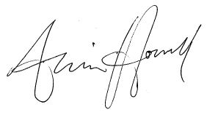

Armin Howell

