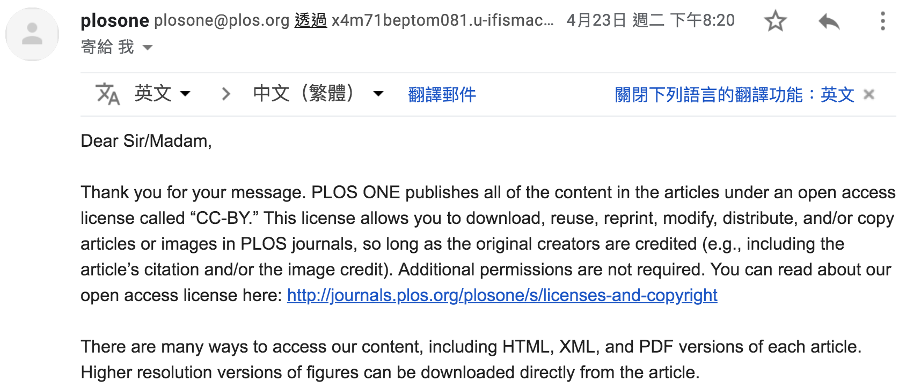

https://journals.plos.org/plosone/s/licenses-and-copyright

