Dear Author(s),
This document is divided into a number of sections in which you can add your comments to the video, voiceover, and online text/PDF. Please be aware that our policy is to do a single complimentary revision, so it is critical that all participants in this project offer their comments collectively. In addition, please make sure that your comments are easily interpreted and transparent.
Have fun!

Protocol Name: Multi-Fiber Photometry to Record Neural Activity in Freely-Moving Animals
Date: Septmeber 23rd 2019

Authors and Affiliations: same
Please fill in any missing author information not included in the video.
Order | Author | Affiliation | Email

Video Comments
Please fill in any comments you wish to make using the table below using the example as a guide. If you need more space to write, please do so below the table. DO NOT ADD CORRECTIONS TO THE NARRATION HERE. PLEASE DO THIS IN THE AUDIO COMMENTS SECTION.
 | Time code | Comment | Requested Change
Example | 2:52 | Onscreen text says use 0.25 mM Fluo-4 | Text should say use 0.50 mM Fluo-4
1. | 4:07 | Referring to step 4.7, Talents points to the 560 nm LED on the photometry system. However, the 560 nm LED fiber is at the really top of the screen difficult to see in the video. | In step 4.7.1, the cable and the cube pointed by the talent should be more centered.
2. | 5:03 | Step 5.2, when mentioning ‘’However, in mice expressing green fluorescent protein or GFP, no change in the signal was detected during the administration of air puffs’’, figure 4C is shown. However, Figure 4 D and E should be shown. | At step 5.2.1, Figure 4D and E should be shown, instead of zooming on Figure 4C.
3.
4.
5.
6.
7.
8.
9.
10.
11.
12.
14.
15.
16.
17.
18.
19.
20.

The same video is shown for both steps 2.5 and 2.6 which may be confusing for the viewers.

For step 2.5, at 1:26, when the narration says ‘’ Advance the 5-axis translator towards the objective, ensuring that the 470 nm light is centered on the fiber at the SMA or FC end of the patch cord, until an image can be resolved on the camera’’, video sections between 1:26-1:30 and 1:32-1:33 should be shown. At this point, we are adjusting the Z axis screw (see image below). Video section at 1:32-1:33 should be shown before 1:26-1:30.

For step 2.6, when the narration says ‘’ Finally, adjust the X and Y axes until the image is centered and well-resolved. Visualize the light emitted from the ferrule-end of the patch cord, as it should appear as an isotropic circle’’, section of the video between 1:37-1:40 and 1:43-1:47 should be shown. At this point, we are adjusting the X and Y axis screws (see image below).
We do not see adjustment of the x axis (see image) while we see the fiber on the image moving in the left-right direction (1:37-1:40). Also, while adjusting the Y axis (1:43-1:47), there is no video showing the fiber moving up and down. If there is a video showing adjustment of the x axis screw, it should be shown before 1:37-1:40. If there is a video showing fiber movement up and down, it should be shown after 1:43-1:47.

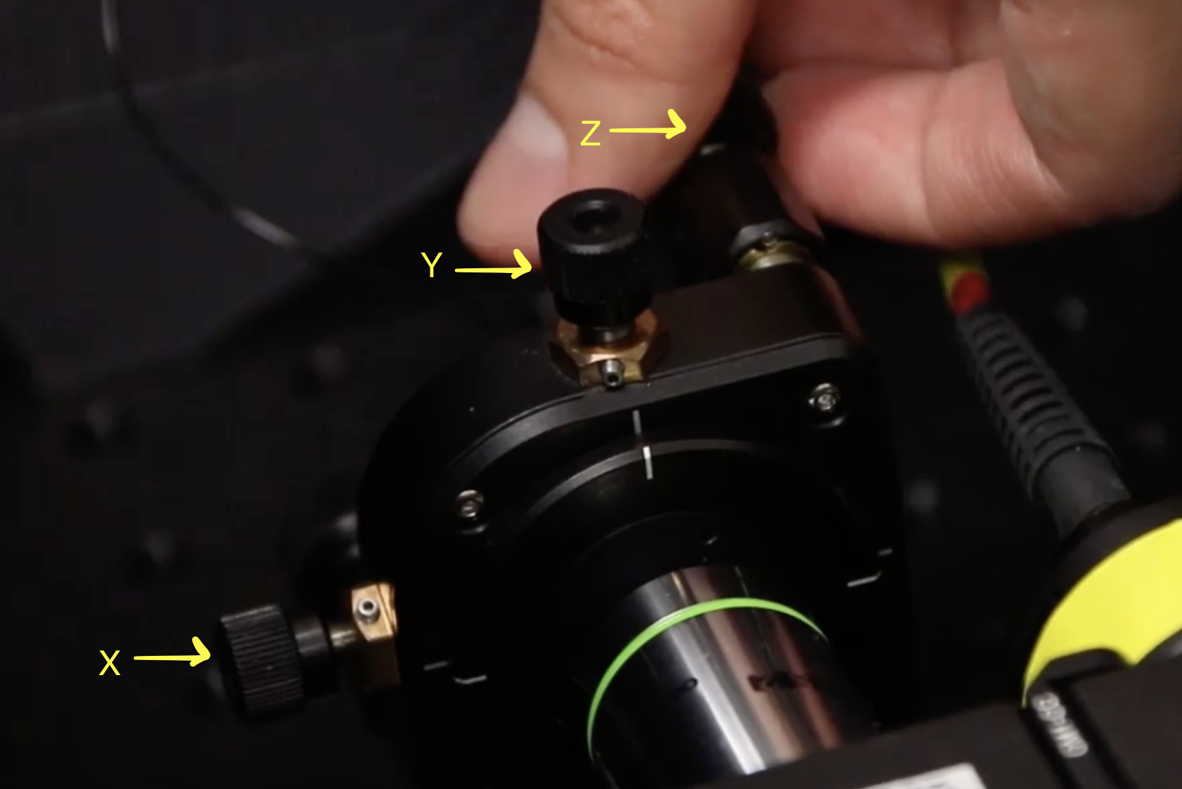

Audio Comments
This section is used to specify the changes that need to be made to the narration. Please follow the example below as a guide to list your changes. If there is a pronunciation change, please provide a phonetic pronunciation key.

 | Time code | Comment | Step(s) in Shotlist | Rewritten Text or Corrected Pronunciation (highlight in bold)
Example | 1:49 | Original Script Text:  “Then, show the participant their electromyography, or EMG patterns, which correspond to eight specific and unique polar plots.” | 2.2 | Rewritten Script Text:  “Then, show the participant the unique and specific polar plots, which correspond to their electromyography, or EMG (pronounced E-M-G) patterns.”
1. | 1:09 | Original Script Text:  ‘Then, turn on the 470 nm excitation light at low power.’’ | 2.3 | Rewritten Script Text:  ‘Then, turn on the 470 nm excitation light at low power, and position the tip of the fiber pointing to an autofluorescent plastic slide.’’
2.
3.
4.
5.
6.
7.
8.
9.
10.
11.
12.
13.
14.
15.
16.
17.
18.
19.
20.

Online Text/PDF Protocol
Please use this table to address changes that need to be made to the online text/PDF document. Both the online text and PDF are generated from the HTML template of your article. Since the PDF is generated from the HTML by our conversion software, it may contain formatting errors. For major structural changes or more than 10 spelling or grammatical mistakes, we will require re-upload of the entire document.

 | Protocol Step | Comment | Requested Change (highlight in bold)
Example | 1.1 | Step says “Centrifuge lysate at 2,000 x g.” | Please correct to “Centrifuge lysate at 4,000 x g.”
1.
2.
3.
4.
5.
6.
7.
8.
9.
10.
11.
12.

