Submission ID #: 60269

Scriptwriter Name: Bridget Colvin
Project Page Link: http://www.jove.com/files_upload.php?src=18382093

Title: Characterization of SiN Integrated Optical Phased Arrays on a Wafer-Scale Test Station

Authors and Affiliations: Nicola A. Tyler, Sylvain Guerber, Daivid Fowler, Stephane Malhouitre, Stephanie Garcia, Philippe Grosse, and Bertrand Szelag

University Grenoble Alpes and CEA, LETI, Minatec Campus

Corresponding Author:
Daivid Fowler
Daivid.fowler@cea.fr

Email addresses for Co-authors:
nicola.a.tyler@gmail.com
sylvain.guerber@cea.fr
stephane.malhouitre@cea.fr
stephanie.garcia@cea.fr
philippe.grosse@cea.fr
Bertrand.Szelag@cea.fr

Author Questionnaire:
1. Microscopy: Does your protocol involve video microscopy? Y
2. Does your protocol demonstrate software usage? Y
3. Which steps from the protocol section below are the most visually important?
2.1., 3.1.-3.3.
4. What is the single most difficult aspect of this procedure and what do you do to ensure success?
4.3., 4.5.-4.9.
5. Will the filming need to take place in multiple locations (greater than walking distance)? N

Section - Introduction
Videographer: Interviewee Headshots are required. Take a headshot for each interviewee.

- REQUIRED Interview Statements (Said by you on camera): All interview statements may be edited for length and clarity.

  - Daivid Fowler: To develop photonic integrated optical circuits built on silicon wafers, we need a characterization method that is fast, automated, and at the wafer-scale [1].

    - INTERVIEW: Named talent says the statement above in an interview-style shot, looking slightly off-camera

  - David Fowler: Our protocol allows us to evaluate our beam steering circuits on the wafer using a lightly modified prober station, which is a standard piece of equipment within the microelectronics industry [1].

    - INTERVIEW: Named talent says the statement above in an interview-style shot, looking slightly off-camera

Introduction of Demonstrator (Said by you on camera):

  - Daivid Fowler: Demonstrating the procedure will be Sylvain Guerber, a post doc from my laboratory [1][2].

    - INTERVIEW: Named talent says the statement above in an interview-style shot, looking slightly off-camera
    - The named technician, post doc, student looks up from workbench or desk or microscope and acknowledges the camera

Section - Protocol
- Optical Coupling: Fiber Alignment

2.0 To begin, load the wafer on your probe station [1].

2.0.1. (Editor: The authors didn’t add a shot description for this, but I assume it’s the action mentioned above)
  - To align the fibers, use a light microscope [1-TXT] to carefully lower the fiber until it touches the wafer surface away from the input grating coupler before moving the fiber up about 20 micrometers [2].
    - WIDE: Talent at microscope, lowering fiber Videographer: Important step
    - SCREEN: 1_screenshot TEXT: Here fiber array is shown but the procedure is the same for a single fiber.

  - To maximize the light intensity at the output gratings, begin sweeping the fiber position over the optical phased array input grating coupler. The light exiting at the optical phased array output gratings should be visible on the image [1-TXT].

    - SCREEN: 2_screenshot Video Editor: please speed up TEXT: Alternative: Use bare image sensor

  - When light is observed from the optical phased array antennas, adjust the polarization to maximize the light intensity at the output gratings, taking care to avoid any movement or vibration of the input fiber [1].

    - SCREEN: 3_screenshot Video Editor: please speed up
- Optical Coupling: Optical Phase Array (OPA) Output Imaging

  - For OPA (O-P-A) output imaging, switch to the far-field imaging sensor [1] and carefully adjust both the exposure time of the sensor and the laser power in such a way that the OPA output is clearly visible on the camera and the beam does not saturate the sensor [2-TXT].

    - WIDE: Talent selecting sensor Videographer: Important step
    - SCREEN: 4_screenshot TEXT: Maximize SNR and avoid sensor saturation

  - If necessary, cover the setup so that the background light does not interfere with the image from the optical phased array beam [1-TXT].

    - Talent covering setup Videographer: Important step TEXT: Weaker background light = lower laser power setting

  - To block the reflections, place a highly reflecting sheet between the reflection and the camera [1].

    - Talent placing sheet between reflection and camera Videographer: Important step
  - Sylvain Guerber: An OPA is by definition extremely sensitive to phase variations. Therefore, all sources of noise must be suppressed, including the injection fiber vibration, polarization instability, and parasitic light [1].

    - INTERVIEW: Named talent says the statement above in an interview-style shot, looking slightly off-camera

- Beam Optimization and Steering

  - To perform beam steering in two directions, first connect the electric circuit for the phase control to a multi-channel electric probe [1] and use the microscope to connect the pins of the electric probe to the metal contact pads of the optical circuit [2].

    - WIDE: Talent connect control to probe
    - SCREEN: 5_screenshot

  - Then switch to the far field sensor to image the output [1].

    - Talent switching to far field sensor

  - To select the parallel emission angle theta using the switching network, observe the far field image of the output while varying the voltages applied to the phase shifters at the ring resonators [1].

    - Talent at system, varying voltages while observing image, with monitor visible in frame Videographer: Difficult step

  - With the correct voltage applied to each resonator, a different area on the sensor will be illuminated, corresponding to a certain theta value [1].

    - SCREEN: 5bis_screenshot

(Editor: The authors added some screenshots below with some suggestions on what they’d like emphasized. Their suggestions don’t seem specific, so please visually communicate their point in whatever way looks best)

  - To select the orthogonal emission angle phi by optimizing the optical phased array phases, select a small pixel area corresponding to the desired phi angle that should be illuminated with a focused output beam and shift the phase of one of the optical phased array channels in small increments [1] [2].
(Author Comment: Please add on the 6_screenshot video an indication of the selected area (green rectangle and text) as shown here : (this should help to understand what is going on).)
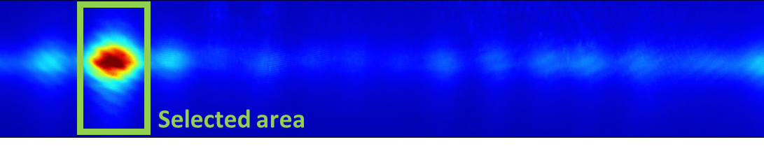

    - SCREEN: 6_screenshot Authors: please indicate the time stamp within this video file for the section of video to be shown with this section of narrative text
(Author Comment: Time stamp : 0 -> 1.5s (a jump of the pattern can be seen, it’s the end of this step))
    - SCREEN: 6_screenshot Authors: please indicate the time stamp within this video file for the section of video to be shown with this section of narrative text

  - After each shift, record the integral of the brightness in the pixel area inside and outside of the selected area and calculate the ratio of the inside light divided by the outside light [1] [2].

    - SCREEN: 6_screenshot Authors: please indicate the time stamp within this video file for the section of video to be shown with this section of narrative text
(Author Comment: This is instantaneous and nothing is visible on the video.) (Editor: I’m not sure what the authors mean by this, though I’m guessing that there’s nothing in the video that connects to this VO. I’m leaving the VO for now, though it might just need to be paused during this narration)
    - SCREEN: 6_screenshot Authors: please indicate the time stamp within this video file for the section of video to be shown with this section of narrative text

  - After a full phase shift cycle between 0 and 2-pi, apply the phase shift with the highest recorded brightness ratio [1].

    - SCREEN: 6_screenshot Authors: please indicate the time stamp within this video file for the section of video to be shown with this section of narrative text
(Author Comment: This is instantaneous, occurring ~ at 1.5s from the beginning of the video. (corresponds to the previously mentioned jump of the pattern)

  - Then switch to the next channel and repeat the previous steps until the optimization process is saturated and a focused output beam is visible [1].

    - SCREEN: 6_screenshot Authors: please indicate the time stamp within this video file for the section of video to be shown with this section of narrative text
(Author Comment: Focused beam started to be visible at ~16s. All channels have been optimized at the end of the video.)

  - To steer the output beam to a different phi angle, select a new pixel area [1] and repeat the optimization process [2].

    - SCREEN: 6_screenshot Authors: please indicate the time stamp within this video file for the section of video to be shown with this section of narrative text
    - SCREEN: 6_screenshot Authors: please indicate the time stamp within this video file for the section of video to be shown with this section of narrative text (Author Comment: There is nothing to see on the video.) (Editor: I’m not sure what the authors mean by this, though I’m guessing that there’s nothing in the video that connects to this VO. I’m leaving the VO for now, though it might just need to be paused during this narration)
  - Once the optimization has been performed for several output phi angle, the beam can be steered [1].

    - [Added Shot]: SCREEN: 6bis_screenshot
(Author Comment: Please add some indications on the screenshot : (this should help to understand what is going on).)

- Beam Divergence Measurement Imaging

(Editor: The authors added some screenshots below with some suggestions on what they’d like emphasized. Their suggestions don’t seem specific, so please visually communicate their point in whatever way looks best)

  - To image the beam divergence, optimize the position of the input fiber [1] and record the image of the OPA output in the far-field [2].

    - WIDE: Talent optimizing fiber position
    - SCREEN: 3_screenshot

  - Make sure that at least two clear interference maxima are visible [1] and use the alignment system to move the wafer to align the next device to the input fiber [2].

    - SCREEN: 7_screenshot
(Author Comment: Please add some indications on the screenshot like below)
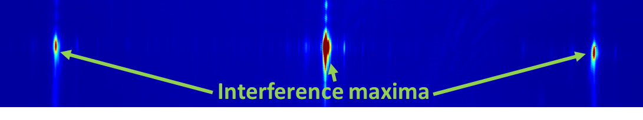
    - Wafer being moved (Author Comment: Added shot, it’s referred as 5.4) (Editor: Unsure of what’s in the added shot, or if it’s just another shot of the wafer being moved)

  - [1-TXT].

Section – Results
- Results: Representative Silicon Nitride (SiN) Integrated OPA Characterization

  - Using precision positioners, light from a fiber is able to be efficiently coupled the integrated optical circuit to obtain a high intensity output beam [1].

    - LAB MEDIA: Figure 5A Video Editor: please emphasize light at OPA gratings

  - The use of a multichannel probe allows all of the electrical connections to be made simultaneously [1].

    - LAB MEDIA: Figure 2B Video Editor: please emphasize squares at bottom of image

  - Using an optimization algorithm, a nicely shaped beam can be obtained on the phi axis [1]. The use of a ring-based switch allows the proper selection of an emission angle in the theta direction [2].

    - LAB MEDIA: Figure 6A Video Editor: please emphasize beam shape in at least one image
    - LAB MEDIA: Figure 6B Video Editor: please emphasize theta direction in image

  - Once the OPA has been calibrated, the beam can be arbitrarily steered in both dimensions [1] and the steering range and beam divergence, the main figures of merit of an OPA, can be accurately characterized [2].

    - LAB MEDIA: Figure 7B Video Editor: please emphasize phi and theta directions
    - LAB MEDIO: Figure 7C Video Editor: please emphasize peaks in each graph

Section - Conclusion
- Conclusion Interview Statements: (Said by you on camera) - All interview statements may be edited for length and clarity.
  - Daivid Fowler: It is essential to eliminate any mechanical, optical, or electronic instabilities as much as possible during the calibration procedure [1].
    - INTERVIEW: Named talent says the statement above in an interview-style shot, looking slightly off-camera
  - Daivid Fowler: Once satisfactory circuits have been identified and calibrated, integrate the circuits with the other constituents of the LIDAR system before performing rudimentary spatial imaging [1].
    - INTERVIEW: Named talent says the statement above in an interview-style shot, looking slightly off-camera

