Supplement 2
Variability in statistical parameter maps with different statistical thresholds
Results for each individual at a range of thresholds (each k=0 voxels). The figure presented in the main manuscript shows p (uncorr) = 0.1. For each individual, the cross-hairs are centred at the peak voxel. For p<.05, .01, .001, and FWE p<.05, the colourbar is identical to that shown for p<.1.

Threshold (p uncorr) | Bolus-Only | Infusion-Only | Bolus/Infusion
1 (no threshold) | 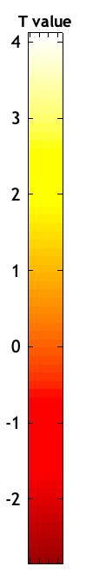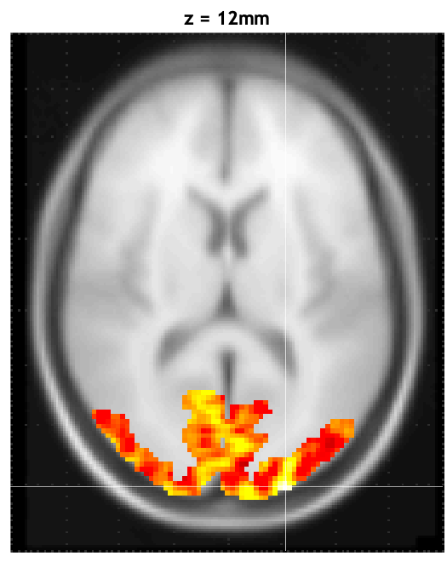 | 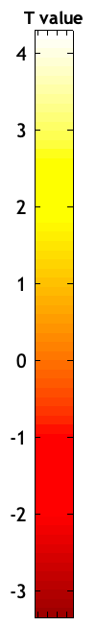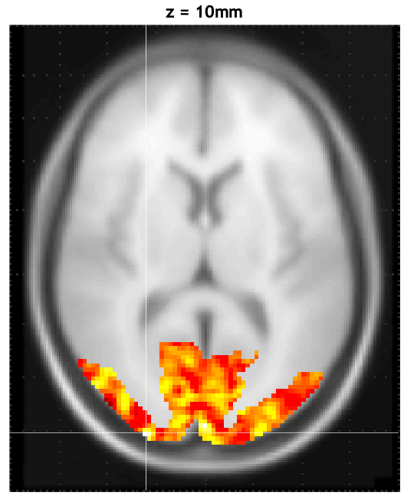
.1 | 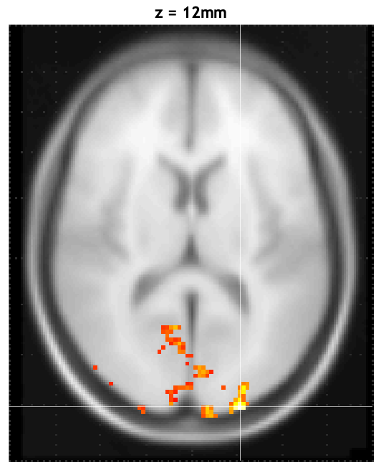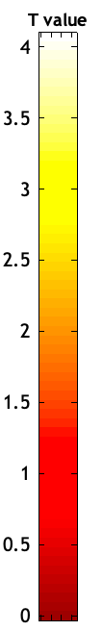 | 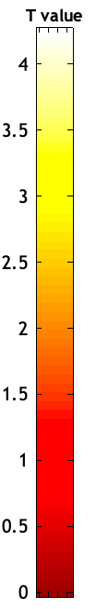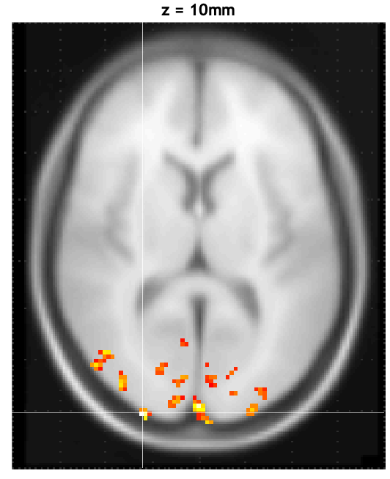 | 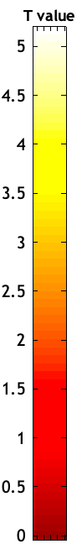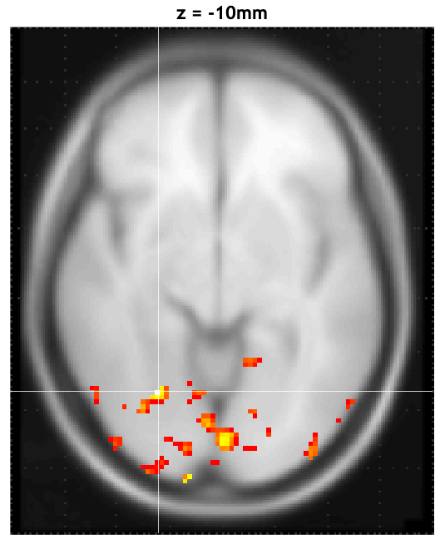
.05 | 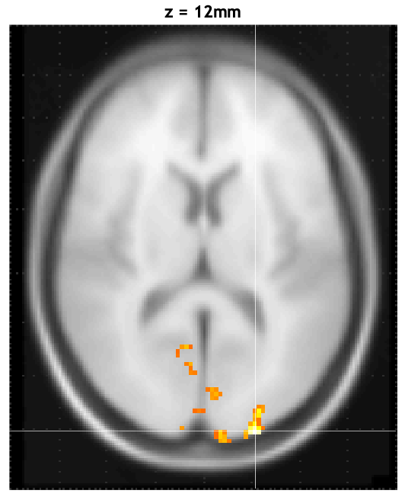 | 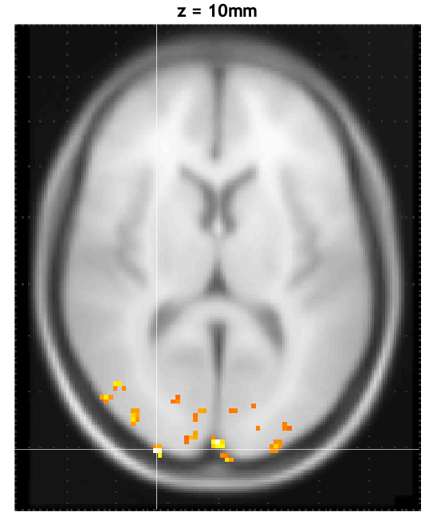 | 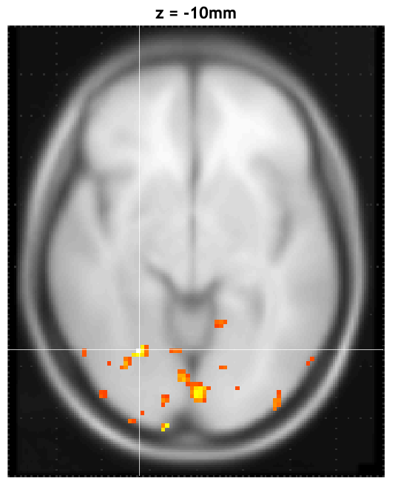
.01 | 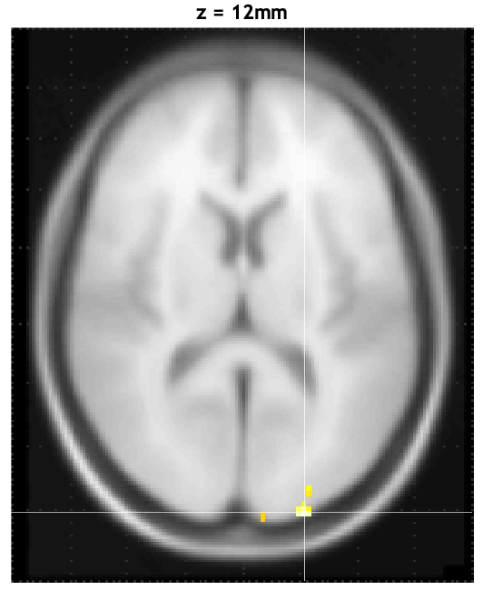 | 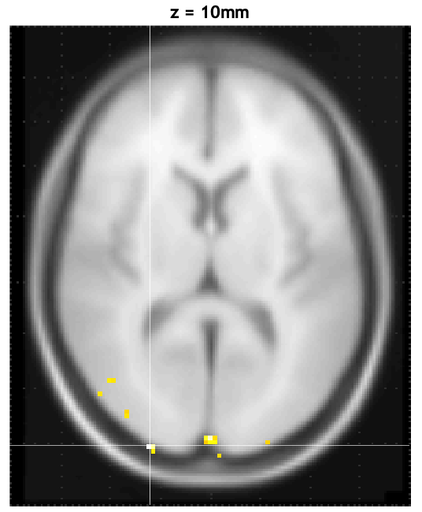 | 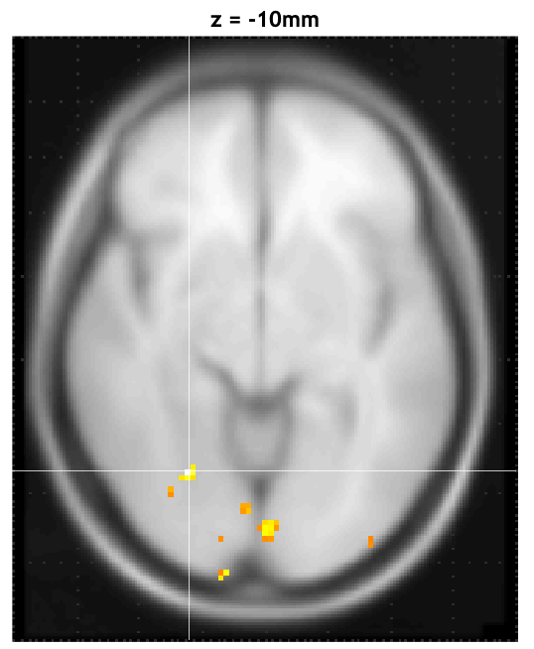
.001 | 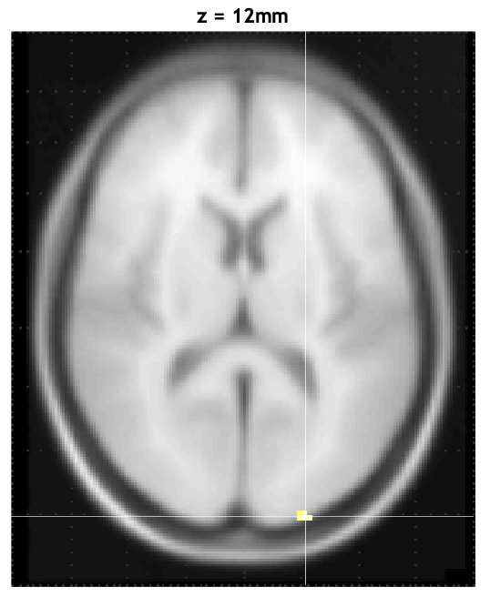 | 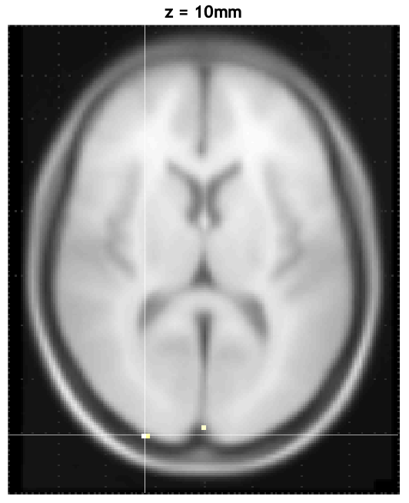 | 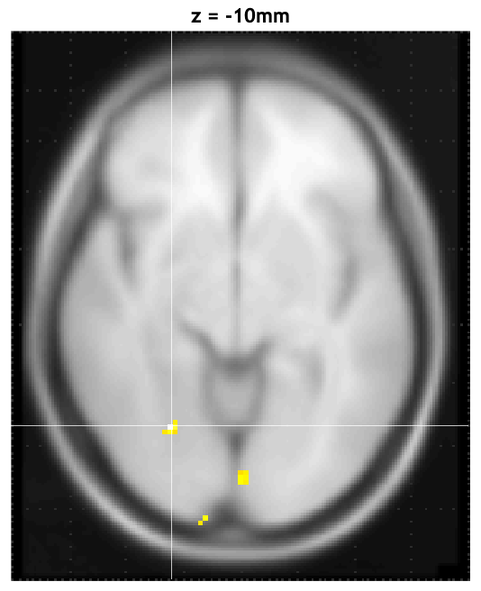
FWE corrected p<.05 | no significant voxels | no significant voxels | 