We would like to thank the reviewers for reading the text and providing us with comments that helped us to improve the manuscript. In this point-to-point reply, we address the provided comments and suggestions.

Editorial comments:
1. Please take this opportunity to thoroughly proofread the manuscript to ensure that there are no spelling or grammar issues. The JoVE editor will not copy-edit your manuscript and any errors in the submitted revision may be present in the published version.
The manuscript has been proofread by the authors
2. Please obtain explicit copyright permission to reuse any figures from a previous publication. Explicit permission can be expressed in the form of a letter from the editor or a link to the editorial policy that allows re-prints. Please upload this information as a .doc or .docx file to your Editorial Manager account. The Figure must be cited appropriately in the Figure Legend, i.e. “This figure has been modified from [citation].”
The copy right permissions have been obtained from the publishers and a document containing the statements for re-use have been included in the submission files.
3. Please add more specific details (e.g. button clicks or menu selections for software actions, numerical values for settings, etc.) to the following steps. Please also provide specific values to be used in these steps.
4. 2.1.1: It is unclear how to select the whole-body protocol from Figure 3. Figure 3 shows “Replace” or “Append” for the protocol type.
We added a new figure where the radio-button is set on ‘append’ instead of ‘replace’, in the description of the figure, we added text to let the user know how to select a protocol.
5. 2.1.2: How to acquire a scout scan? Do you select a specific button?
The scout scan is started by pressing the round yellow button with the radiation sign. The scout scan can be stopped by either pressing the stop or abort button. We added a new figure depicting the scanner’s control box with which key to press.
6. 2.1.4: Please specify the bed positions selected here. Figure 4 does not show the bed positions.
Also in line with the comments of the reviewer, we decided to create a new figure where the topogram and overlaying bed positions are visible. The description has been changed and the bed position that is gated is highlighted in an orange color
7. 2.1.6: Please specify the image recording time used. Figure 5 does not show this.
We specified the image recording time in the legend of figure 5
8. 2.2.2: Please specify the image reconstruction protocol selected.
We added further information on the two image reconstruction protocols that are selected. There are two protocols (one for viewing, which is a high resolution image) and one for image quantification (this is a lower resolution image optimized for image quantification).
9. Table of Materials: Please ensure that it has information on all relevant supplies, reagents, equipment and software used, especially those mentioned in the Protocol (e.g., radiotracer, venous cannula, syringe, etc.).

Reviewers' comments:
Reviewer #4:
I would like to thank the author for addressing all my comments thoroughly. I don't have any further comments.
We would like the reviewer for the detailed comments and suggestions provided and we are happy to hear that the changes made are to the satisfaction of the reviewer
Reviewer #7:
Manuscript Summary:
This manuscript is a good review of an optimized gating method (ORG) for PET/CT in the chest and upper abdomen. Dealing with respiratory motion is an important concept for optimal PET imaging for both visualization and quantification. This manuscript describes the set up and operation of the method that has been proposed and demonstrated elsewhere, and gives some examples of the impact of the ORG method. However, impact of this manuscript is limited as the complexity of the method is not high and the user would likely be able to implement ORG protocols with minimal guidance from either a collaborator or from the vendor depending on the setting of research or clinical deployment of ORG.
We would like to thank the reviewer for the detailed comments and suggestions, the answers to the queries are addressed below in a point-wise fashion
Minor Concerns:
Line 250: add some guidance on secondary options for the placement of the bellows.
We added some guidance on the placement of the respiratory belt around the patient (including the visual inspection and more details regarding the anatomical placement of the pressure sensor). Would this description appropriately address this point?
Line 268: should the respiratory correction beds also cover the upper abdomen as well as the thorax?
Depending on the clinical indication (whether the area of interest is located in the thoracic region or upper abdomen), the upper abdomen can be included in the gated bed positions (for example for pancreatic or liver lesions). We added this to the text.
Line 283: note that the respiratory belt should be repositioned before the acquisition of the respiratory corrected beds? Repositioning after has no impact on the acquired data.
We added some text (line 291) to explicitly say that the adjustments should be done before acquisition of the gated bed positions.
Comment on how to deal with drifting respiratory signal.
We included more text under point 2.17 on how to deal with baseline drifting. It is important to counter baseline drifting through adjustment of the belt before acquisition of gated bed positions is performed.
Comment on whether the ORG can recalculate the window, or whether the user can use different duty cycles at different points through the acquisition to optimize reconstruction if the respiratory signal quality changes.
The ORG only uses the duty cycle to calculate the optimal amplitude range. This is the only input the user can change when using ORG. Though the user can specify a different duty cycle by reconstructing different bed positions separately, this is usually not performed given that the image quality will vary per bed positions. We added a comment on this in the text (line 304 – 310).
Include a figure showing the impact of changing the duty cycle, i.e. the progression from low noise and blurry images to higher noise and sharper images, and which also shows a comparison to standard amplitude gating.
We included a figure with varying duty cycles in a single patient (figure 11). This image shows the impact of duty cycle on image noise, furthermore it shows that statistical quality of the ORG image with 35% duty cycle and its non-gated equivalent PET image is kept constant.
Part c is missing from figure 2.
We apologize for the absence of figure 2c and included this figure in the new submission of the manuscript.
For Fig 4, extend the figure to show the lower tabs that also appear on Fig 5 to show how the mode is selected.
In line with the comments of the editor we decided to create new figures. The new figure number of this figure is ‘5’ due to insertion of another figure. The new figure displays the topogram and overlying bed positions and the whole screen (including the lower tabs).
In Fig 8, add arrows to show the extent of the primary and satellite lesions.
We included a ‘p’ for primary lesion and ‘s’ for satellite lesion in the figure and updated the figure legend accordingly.
Line 471: Don't use "correct" as this method is about optimal gating not motion correction.
We change the words in this sentence.
In the comments on respiratory motion and the CT used for attenuation correction, you could introduce the ability of hybrid PET/MR to compensate and correct for motion in the AC data, the anatomical image data and the PET data.
In the discussion we put more emphasis on the hybrid PET/MR strategies for motion compensation (paragraph line 581 – 594).
Include the scanner that is used to run this ORG method. Is ORG a vendor-specific product, and is it available on other vendors?
The ORG algorithm is available only on Siemens Biograph mCT scanners and newer models. We included this information at the beginning of the protocol description (just below the ethical statement) (line 200-201).

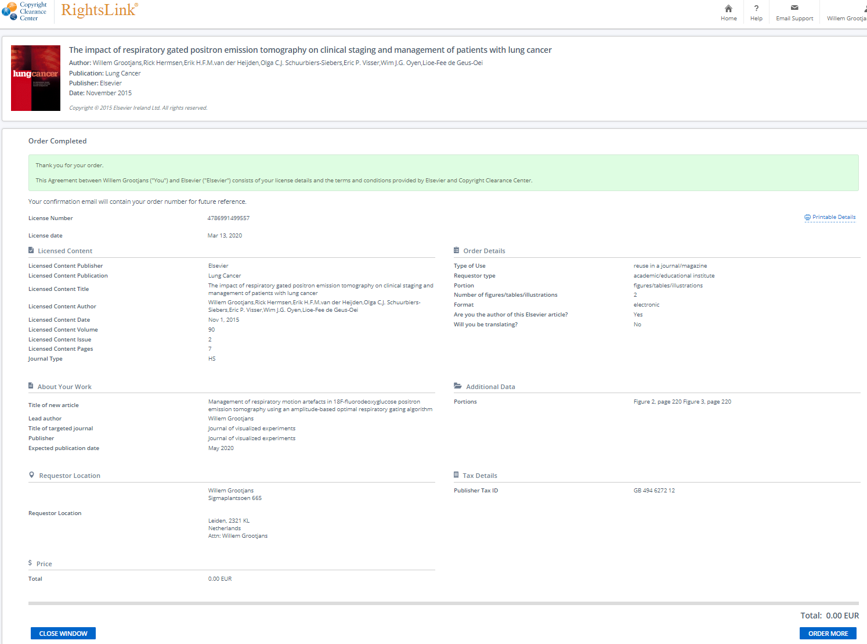
Permission for re-use figure 7 and 8 in manuscript: Screenshot of Rightslink (obtained 13-03-2020)

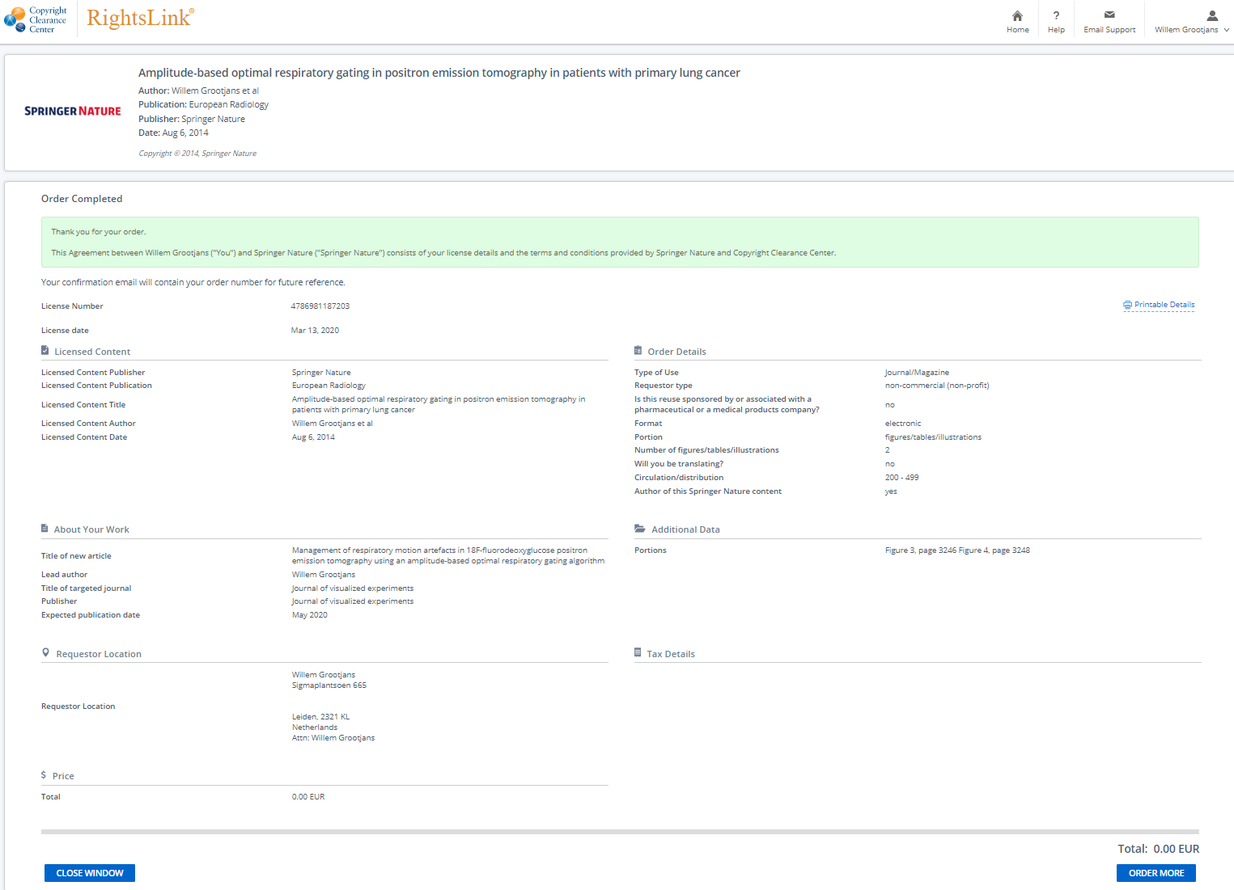

Permission for re-use figure 9 in manuscript: Screenshot of Rightslink (obtained 13-03-2020)

