Supplementary Information

Developing photosensitizer-Cobaloxime hybrid for solar-driven H₂ production in aqueous aerobic conditions
Ab Qayoom Mir¹, Dependu Dolui¹, Shikha Khandelwal¹, Harshil Bhatt², Beena Kumari¹, Sanmitra Barman³, Sriram Kanvah¹, Arnab Dutta¹*
^{[1]} Chemistry Discipline, Indian Institute of Technology Gandhinagar, Gujarat 382355, India
^{[2]} Chemistry Department, Uka Tarsadia University, Bardoli, Gujarat 394350, India
^{[3]}Applied Sciences Department, BML Munjal University, Haryana 122413, India

Bulk Electrolysis or chronocoulometric experiment
The chronocoulometric experiment for complex C1 was executed in a four-neck glass vessel (Volume 150 mL including the head space) where a coiled 23 cm Pt wire (counter electrode), Ag/AgCl (in 1.0 M AgNO₃ as reference electrode), and reticulated vitreous carbon (working electrode) was inserted in three of those necks. The last of the necks was closed with a 14/20 rubber septum, which was used for N₂ purging before the experiment and for headspace gas collection (via gas tight leur-lock syringe). During the experiment, 75 mL of 0.20 mM C1 was included in the vessel along with all the electrodes and a magnetic bead in a gas-tight manner. After that, the solution was purged with N₂ for one hour. Then, the purging was stopped, and the chrono-coulometric experiment was started at -1.3 V vs. ferrocene couple in 30:70 water/DMF. The solution was continuously stirred at 500 rpm with a magnetic stirrer during the experiment. The headspace gas was collected by a gas-tight leur-lock syringe after 30 minutes to analyze via a gas chromatography (GC) instrument. The GC was calibrated with a control gas mixture (49.5% H₂ in N₂).
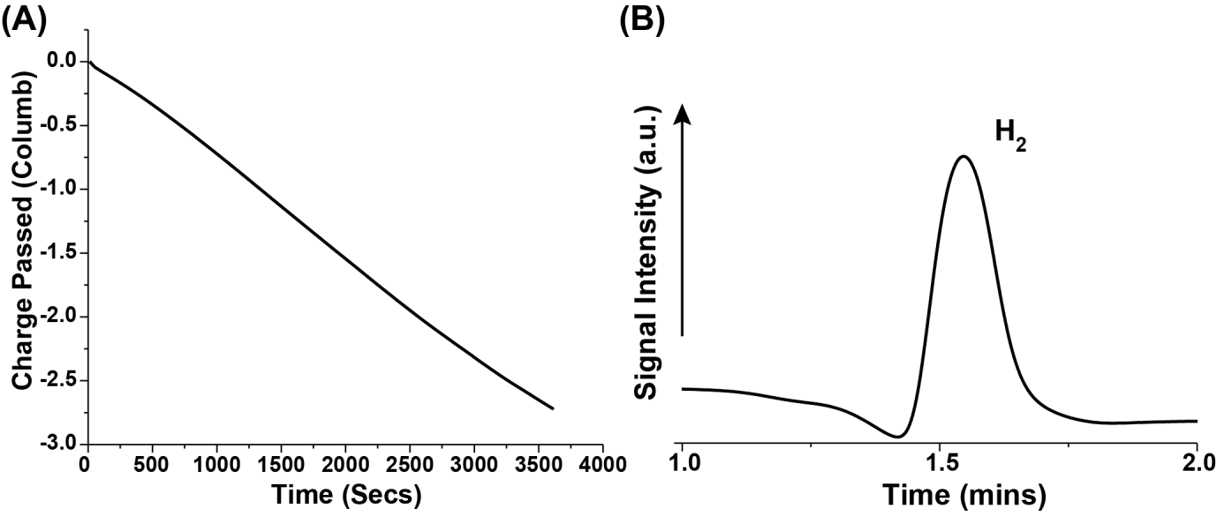
Figure S1. (A) The charge passed during the chronocoulometric experiment performed with 0. 20 mM C1 in 30:70 water: acetonitrile media after 1 hour of electrolysis at -1.3 V vs. ferrocene couple. (B) The gas chromatography trace of the headspace gas following the bulk electrolysis experiment demonstrated the formation of H₂ during the experiment.
Calculation of Faradic efficiency during chronocoulometric experiment
$$Overall charge passed for catalytic HER=3.62 C$$
$$Amount of H_{2} expected= \frac{3.62 C}{96485 ×2 C} mol=18.75 μmol=\left(0.224 \frac{mL}{μmol} × 18.75 mmol\right)=4.2 mL$$
$$Amount of H_{2} detected in headspace by GC=2.9 mL (calibrated by control)$$
$$\% of current effciency of C1 bulk electrolysis= \frac{2.9}{4.2}\%=69\%$$

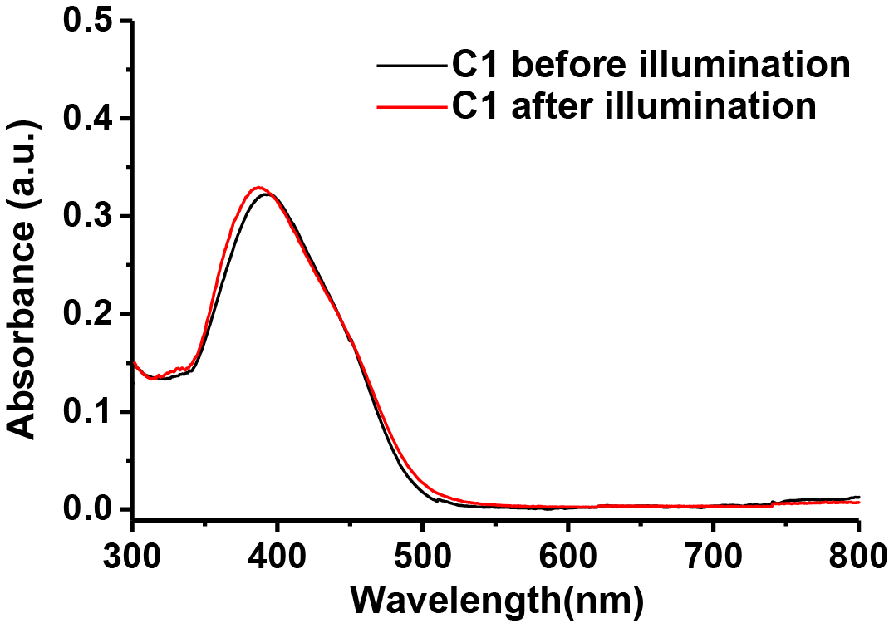
Figure S2. The comparative optical spectra recorded for C1 before (black trace) and after the illumination (red trace) exhibiting the stability of the complex during the experiment.

Table 1. Crystallographic important parameters for C1.
Crystal Data
CCDC Number | 1883987
Moiety formula | C1.(CHCl₃)
Empirical formula | C₂₃H₃₀ClCoN₆O₄. (CHCl₃)
Formula weight | 668.28
Crystal Size (mm³) | 0.348 x 0.179 x 0.051
Crystal Habit | Red Cubic
Temperature (K) | 297.31
Radiation | MoK_{α} (λ=0.71073)
Crystal system | Triclinic
Space group | P-1
Unit cell dimensions  a/b/c Aº | 11.345 (3)  12.534 (3)  13.244 (3)
Unit cell angles  α/β/ γ (θ) | 64.215 (6)  68.735 (4)  89.672 (5)
Unit cell volume (A^{o3}) | 1554.2 (6)
Z | 2
Calculated density (g/cm³) | 1.428
Absorption coefficient (mm⁻¹) | 0.935
F (000) | 688.0
Θ range for all data collection (θ) | 5.834 to 55.862
Index ranges | -14 < h < 14  -16 < k < 16  -17 < l < 17
Reflections collected | 38751
Independent reflections | 7396 [R_{int}= 0.0816, R_{sigma}= 0.0625]
Data/restraints/parameters | 7396/0/366
Completeness to θ_{max} | 0.993
Refinement statistics
Final R indices [>2σ(I)] | R₁= 0.0754, wR₂= 0.2109
R indices (all data) | R₁= 0.1143, wR₂= 0.2392
Goodness-of-fit on F² | 1.451

Table 2. Bond Lengths for C1(CHCl₃).

Atom | Atom | Length/Å | Atom | Atom | Length/Å
Co⁽¹⁾ | Cl⁽¹⁾ | 2.2342(11) | C⁽³⁾ | C⁽⁴⁾ | 1.497(7)
Co⁽¹⁾ | N⁽¹⁾ | 1.884(3) | C⁽⁵⁾ | C⁽⁶⁾ | 1.491(6)
Co⁽¹⁾ | N⁽²⁾ | 1.898(3) | C⁽⁶⁾ | C⁽⁷⁾ | 1.457(6)
Co⁽¹⁾ | N⁽³⁾ | 1.896(3) | C⁽⁷⁾ | C⁽⁸⁾ | 1.492(6)
Co⁽¹⁾ | N⁽⁴⁾ | 1.885(3) | C⁽⁹⁾ | C⁽¹⁰⁾ | 1.366(5)
Co⁽¹⁾ | N⁽⁵⁾ | 1.965(3) | C⁽¹⁰⁾ | C⁽¹¹⁾ | 1.388(5)
O⁽¹⁾ | N⁽¹⁾ | 1.334(4) | C⁽¹¹⁾ | C⁽¹²⁾ | 1.397(6)
O⁽²⁾ | N⁽²⁾ | 1.348(5) | C⁽¹¹⁾ | C⁽¹⁴⁾ | 1.453(5)
O⁽³⁾ | N⁽³⁾ | 1.353(5) | C⁽¹²⁾ | C⁽¹³⁾ | 1.350(6)
O⁽⁴⁾ | N⁽⁴⁾ | 1.335(4) | C⁽¹⁴⁾ | C⁽¹⁵⁾ | 1.313(5)
N⁽¹⁾ | C⁽⁶⁾ | 1.293(5) | C⁽¹⁵⁾ | C⁽¹⁶⁾ | 1.442(5)
N⁽²⁾ | C⁽²⁾ | 1.282(6) | C⁽¹⁶⁾ | C⁽¹⁷⁾ | 1.390(6)
N⁽³⁾ | C⁽³⁾ | 1.277(5) | C⁽¹⁶⁾ | C⁽²¹⁾ | 1.398(5)
N⁽⁴⁾ | C⁽⁷⁾ | 1.278(5) | C⁽¹⁷⁾ | C⁽¹⁸⁾ | 1.374(6)
N⁽⁵⁾ | C⁽⁹⁾ | 1.343(5) | C⁽¹⁸⁾ | C⁽¹⁹⁾ | 1.397(6)
N⁽⁵⁾ | C⁽¹³⁾ | 1.332(5) | C⁽¹⁹⁾ | C⁽²⁰⁾ | 1.403(7)
N⁽⁶⁾ | C⁽¹⁹⁾ | 1.368(6) | C⁽²⁰⁾ | C⁽²¹⁾ | 1.368(6)
N⁽⁶⁾ | C⁽²²⁾ | 1.489(9) | Cl^{(1S)} | C^{(1S)} | 1.690(9)
N⁽⁶⁾ | C⁽²³⁾ | 1.379(8) | Cl^{(2S)} | C^{(1S)} | 1.666(8)
C⁽¹⁾ | C⁽²⁾ | 1.503(6) | Cl^{(3S)} | C^{(1S)} | 1.657(8)
C⁽²⁾ | C⁽³⁾ | 1.465(7)

