https://s100.copyright.com/AppDispatchServlet
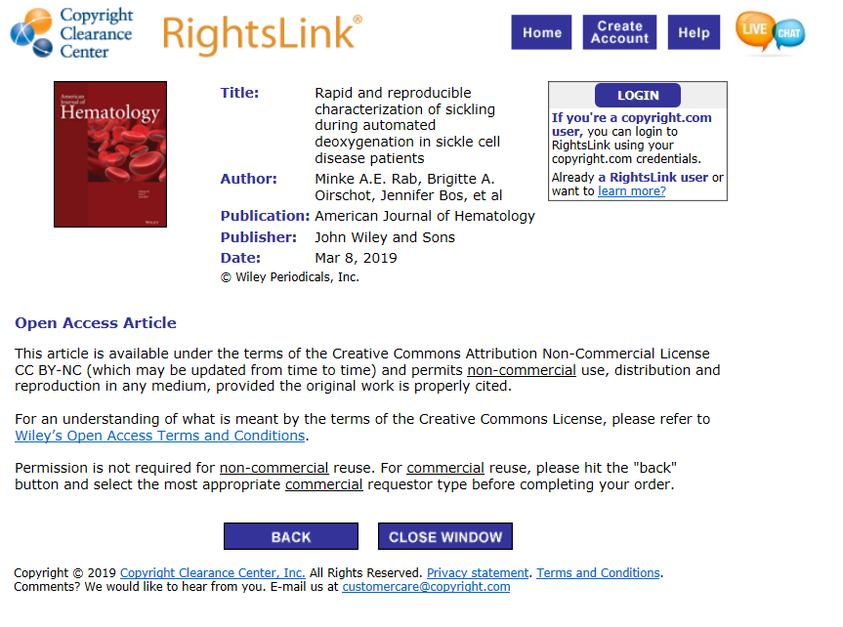

https://onlinelibrary.wiley.com/page/journal/10968652/homepage/permissions.html
