Copyright Permission

Link to the editorial policy:
https://www.elsevier.com/about/policies/copyright

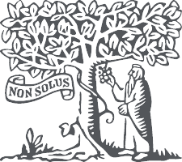
- About Elsevier
- Products & Solutions
- Services
- Shop & Discover
- Search

- Home

- About

- Policies

- Copyright

Copyright
Describes the rights related to the publication and distribution of research. It governs how authors (as well as their employers or funders), publishers and the wider general public can use, publish and distribute articles or books.
- Journal author rights
- Government employees
- Elsevier's rights
- Protecting author rights
- Open access

Journal author rights
In order for Elsevier to publish and disseminate research articles, we need publishing rights. This is determined by a publishing agreement between the author and Elsevier. This agreement deals with the transfer or license of the copyright to Elsevier and authors retain significant rights to use and share their own published articles. Elsevier supports the need for authors to share, disseminate and maximize the impact of their research and these rights, in Elsevier proprietary journals* are defined below:
For subscription articles | For open access articles
Authors transfer copyright to the publisher as part of a journal publishing agreement, but have the right to:  - Share their article for Personal Use, Internal Institutional Use and Scholarly Sharing purposes, with a DOI link to the version of record on ScienceDirect (and with the Creative Commons CC-BY-NC- ND license for author manuscript versions)  - Retain patent, trademark and other intellectual property rights (including research data).  - Proper attribution and credit for the published work. | Authors sign an exclusive license agreement, where authors have copyright but license exclusive rights in their article to the publisher**. In this case authors have the right to:  - Share their article in the same ways permitted to third parties under the relevant user license (together with Personal Use rights) so long as it contains a CrossMark logo, the end user license, and a DOI link to the version of record on ScienceDirect.  - Retain patent, trademark and other intellectual property rights (including research data).  - Proper attribution and credit for the published work.
*Please note that society or third party owned journals may have different publishing agreements. Please see the journal's guide for authors for journal specific copyright information.
**This includes the right for the publisher to make and authorize commercial use, please see "Rights granted to Elsevier" for more details.

Help and Support
- Download a sample publishing agreement for subscription articles in English and French.
- Download a sample publishing agreement for open access articles for authors choosing a commercial user license and non-commercial user license.
- For authors who wish to self-archive see our sharing guidelines
- See our author pages for further details about how to promote your article.
- For use of Elsevier material not defined below please see our permissions page or FAQs or email us at the permissions help desk.

Government employees
Elsevier has specific publishing agreements with certain government and inter-governmental organizations for their employee authors. These agreements enable authors to retain substantially the same rights as detailed in the "Author Rights section" but are specifically tailored for employees from the relevant organizations, including:
- World Bank
- World Health Organization
- For US government employees, works created within the scope of their employment are considered to be public domain and Elsevier's publishing agreements do not require a transfer or license of rights for such works.
- In the UK and certain commonwealth countries, a work created by a government employee is copyrightable but the government may own the copyright (Crown copyright). Click here for information about UK government employees publishing open access

Rights granted to Elsevier
For both subscription and open access articles, published in proprietary titles, Elsevier is granted the following rights:
- The exclusive right to publish and distribute an article, and to grant rights to others, including for commercial purposes.
- For open access articles, Elsevier will apply the relevant third party user license where Elsevier publishes the article on its online platforms.
- The right to provide the article in all forms and media so the article can be used on the latest technology even after publication.
- The authority to enforce the rights in the article, on behalf of an author, against third parties, for example in the case of plagiarism or copyright infringement.

Protecting author rights
Copyright aims to protect the specific way the article has been written to describe an experiment and the results. Elsevier is committed to its authors to protect and defend their work and their reputation and takes allegations of infringement, plagiarism, ethic disputes and fraud very seriously.
If an author becomes aware of a possible plagiarism, fraud or infringement we recommend contacting their Elsevier publishing contact who can then liaise with our in-house legal department. Note that certain open access user licenses may permit quite broad re-use that might otherwise be counted as copyright infringement. For details about how to seek permission to use an article see our permission page.

Open access

How copyright works with open access licenses

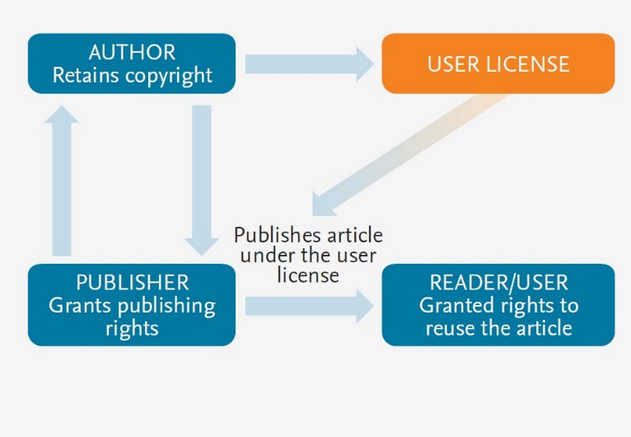
For Elsevier proprietary journals the following steps apply:
- Authors sign a publishing agreement where they will have copyright but grant broad publishing and distribution rights to the publisher, including the right to publish the article on Elsevier's online platforms.
- The author chooses an end user license under which readers can use and share the article.
- The publisher makes the article available online with the author's choice of end user license.

Quick definitions

Personal use
Authors can use their articles, in full or in part, for a wide range of scholarly, non-commercial purposes as outlined below:
- Use by an author in the author’s classroom teaching (including distribution of copies, paper or electronic)
- Distribution of copies (including through e-mail) to known research colleagues for their personal use (but not for Commercial Use)
- Inclusion in a thesis or dissertation (provided that this is not to be published commercially)
- Use in a subsequent compilation of the author’s works
- Extending the Article to book-length form
- Preparation of other derivative works (but not for Commercial Use)
- Otherwise using or re-using portions or excerpts in other works
These rights apply for all Elsevier authors who publish their article as either a subscription article or an open access article. In all cases we require that all Elsevier authors always include a full acknowledgement and, if appropriate, a link to the final published version hosted on Science Direct.

Commercial use
This is defined as the use or posting of articles:
- For commercial gain without a formal agreement with the publisher.
  - For example by associating advertising with the full-text of the article, by providing hosting services to other repositories or to other organizations (including where an otherwise non-commercial site or repository provides a service to other organizations or agencies), or charging fees for document delivery or access
- To substitute for the services provided directly by the journal.
  - For example article aggregation, systematic distribution of articles via e-mail lists or share buttons, posting, indexing, or linking for promotional/marketing activities, by commercial companies for use by customers and intended target audiences of such companies (e.g. pharmaceutical companies and healthcare professionals/physician-prescribers).
If you would like information on how to obtain permission for such uses click here or if you would like to make commercial use of the article please contact us.

Internal institutional use
- Use by the author's institution for classroom teaching at the institution and for internal training purposes (including distribution of copies, paper or electronic, and use in coursepacks and courseware programs, but not in Massive Open Online Courses)
- Inclusion of the Article in applications for grant funding
- For authors employed by companies, the use by that company for internal training purposes

