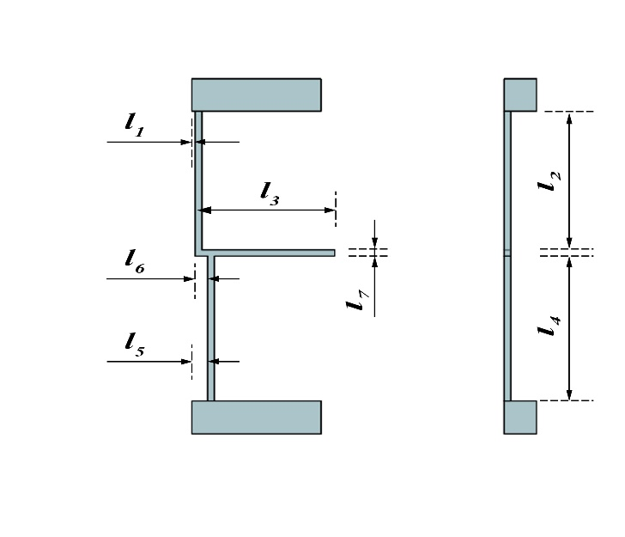
The length, width and height of the amplifying mechanism are 4×1×11mm, and the thickness of the upper and lower anchor pads is 1mm, and the thickness of the rest parts is 0.1mm.
Length: 4mm
Width: 1mm
Height: 11mm
Thickness of the upper and lower anchor pads: 1mm
Thickness of the rest parts: 0.1mm
l₁: 0.1mm
l₂: 4.5mm
l₃: 4mm
l₄: 4.5mm
l₅: 0.4mm
l₆: 0.3mm
l₇: 0.2mm

