  - Analyze the infarct volume.
60166_screenshot_1
3.8.1 Pre-treatment the photo with photoshop software
      - Import the photo using photoshop CS6. 00:00-00:14
3.8.1.2 Click Select to select the brain slices, click Select | Inverse. 00:15-00:36
3.8.1.3 Click Foreground to select black and click OK. 00:37-00:42
3.8.1.4 Press Alt +Delete to fill the background color, and CTRL +D to deselect. 00:43-00:46
3.8.1.5 Click File | Save to desktop. 00:47-01:08
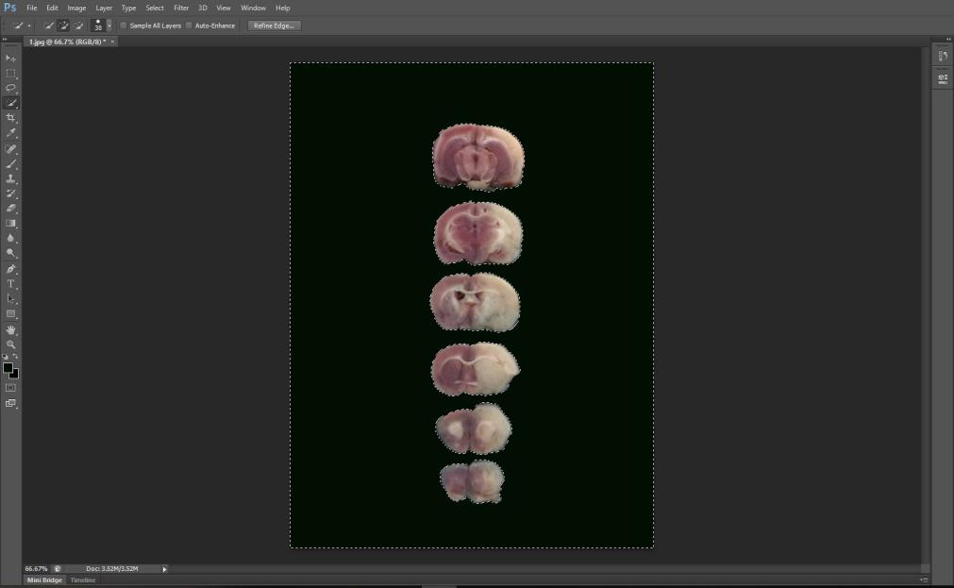
60166_screenshot_1
60166_screenshot_2
3.8.2 Pre-treatment the photo with Image Pro Plus software
3.8.2.1 Open Image Pro Plus 6.0 software and import the photo. 01:09-01:24
3.8.2.2 For defect modification, adjust the brightness with the Contrast Enhancement tool, so that the background is black. 01:25-01:37
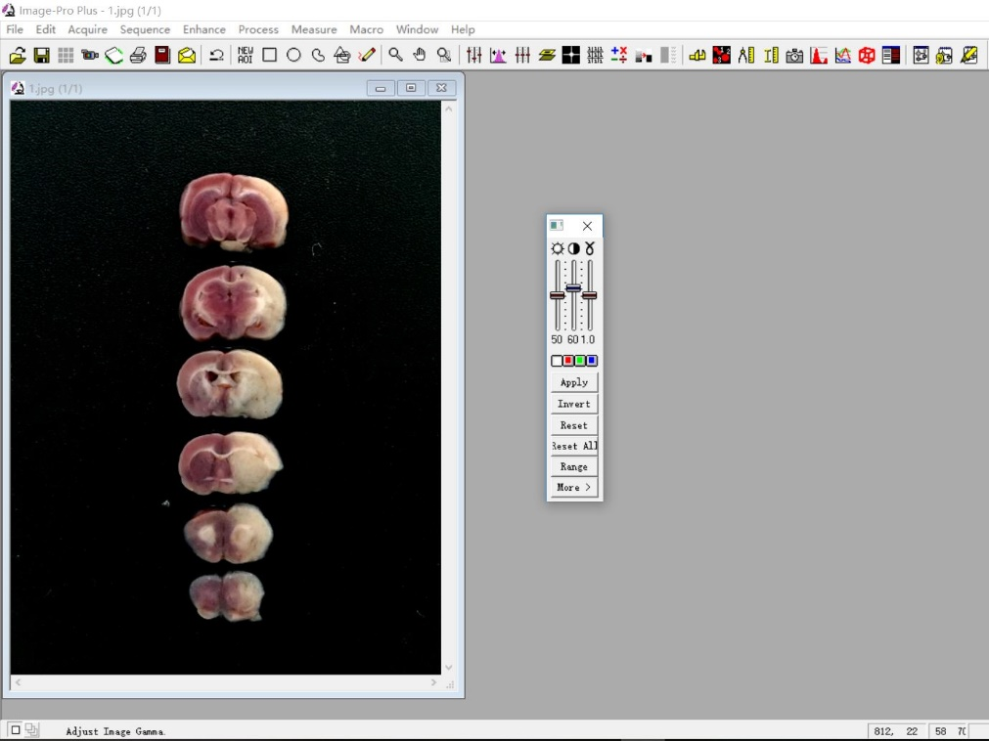
60166_screenshot_2
60166_screenshot_3
3.8.2.3 Use the Median tool in Filter to remove the highlights. 01:38-01:46
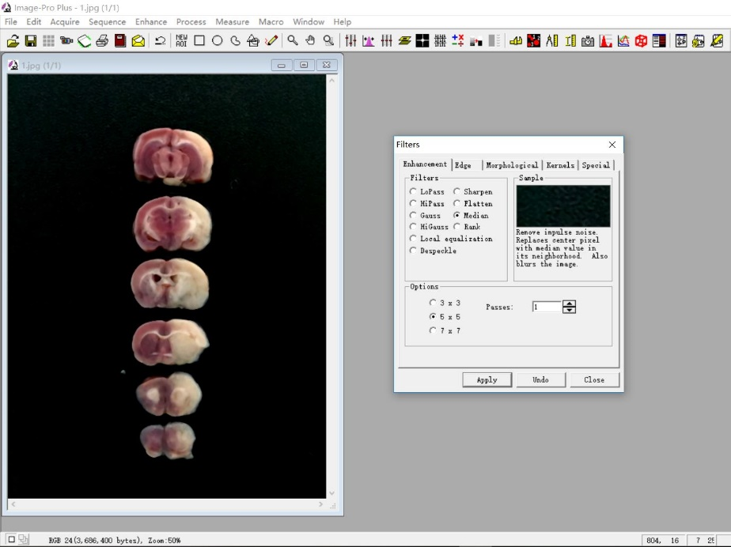
60166_screenshot_3
60166_screenshot_4
3.8.3 Calculate the left (normal) brain area with Image Pro Plus software

3.8.3.1 Select color using Segmentation and adjust the value of H/S/I, so that the brain slices are separated from the black background. 01:47-02:12
3.8.3.2 Return to Count | Size. 02:13-02:16
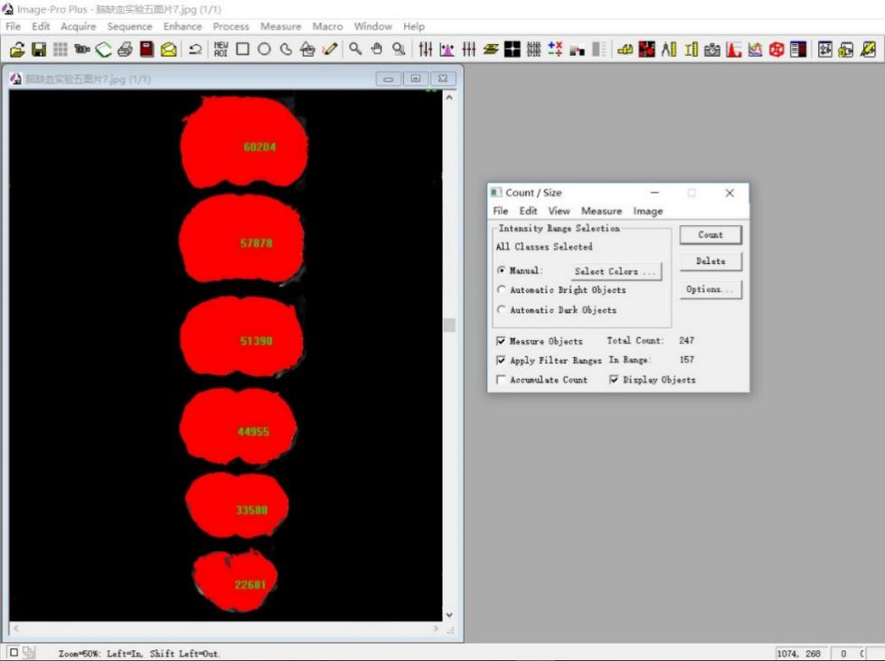
60166_screenshot_4
60166_screenshot_5
3.8.3.3 Click on Count | Split Objects in Edit to separate the brain from the midline. The software will automatically distinguish the left and right brain areas. 02:17-02:49
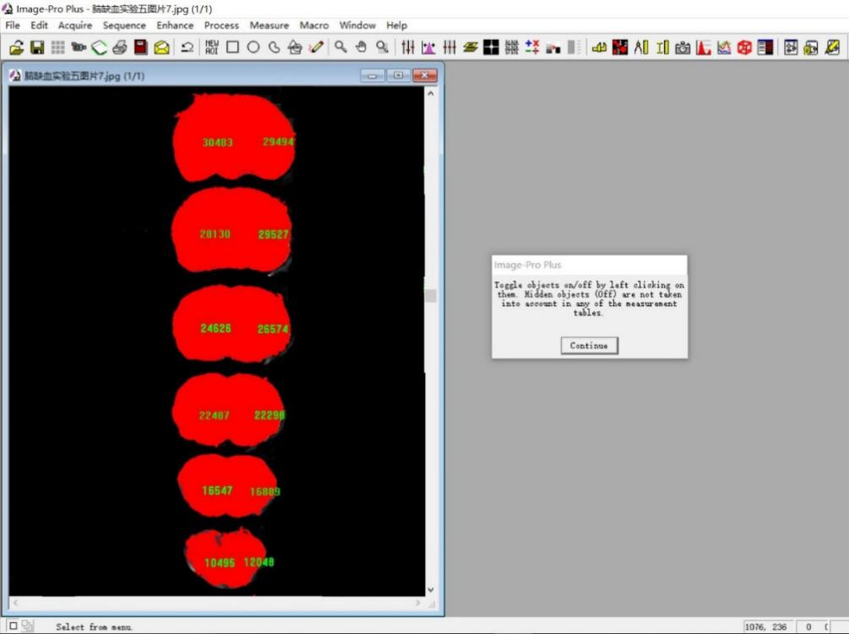
60166_screenshot_5
60166_screenshot_6
3.8.4 Calculate the right infarct brain area with Image Pro Plus software
3.8.4.1 Implement step 3.8.1-3.8.2. 02:50-03:14
3.8.4.2 Select Count | Size. 03:15-03:21
3.8.4.3 Click on Draw | Merge Objects tool in Edit. Manually select the ischemic area and click Count to calculate the ischemic area. 03:16-05:31
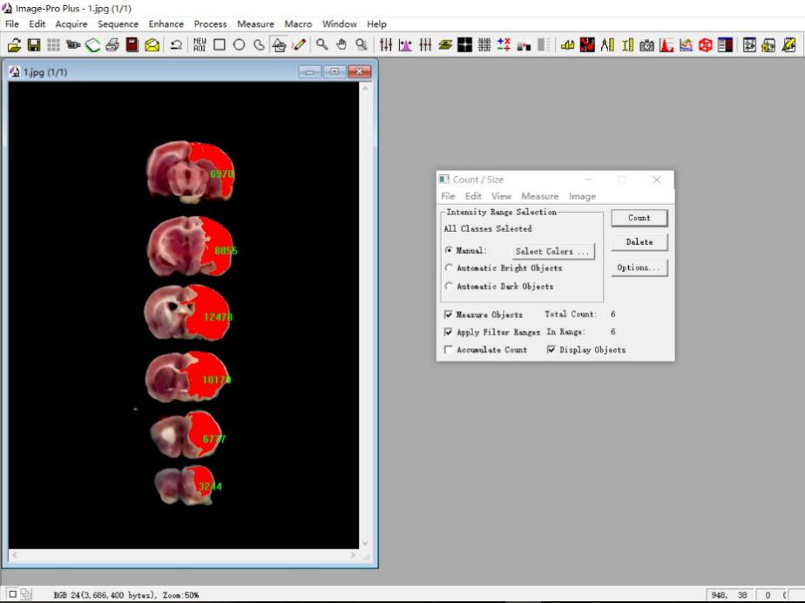
60166_screenshot_6
60166_screenshot_7
3.8.5 Calculate the health brain area with Image Pro Plus software
3.8.5.1 Implement step 3.8.1-3.8.2. 05:32-06:44
3.8.5.2 Select color using Segmentation and adjust the value of H/S/I, so that the normal part of brain slices are separated from the black background. 06:45-07:10
3.8.5.3 Return to Count | Size and click on Count to calculate this area. 07:11-07:21
3.8.5.4 Click on Split Objects in Edit to separate the brain from the midline. The software will automatically distinguish the left and right brain areas. 07:22-08:08
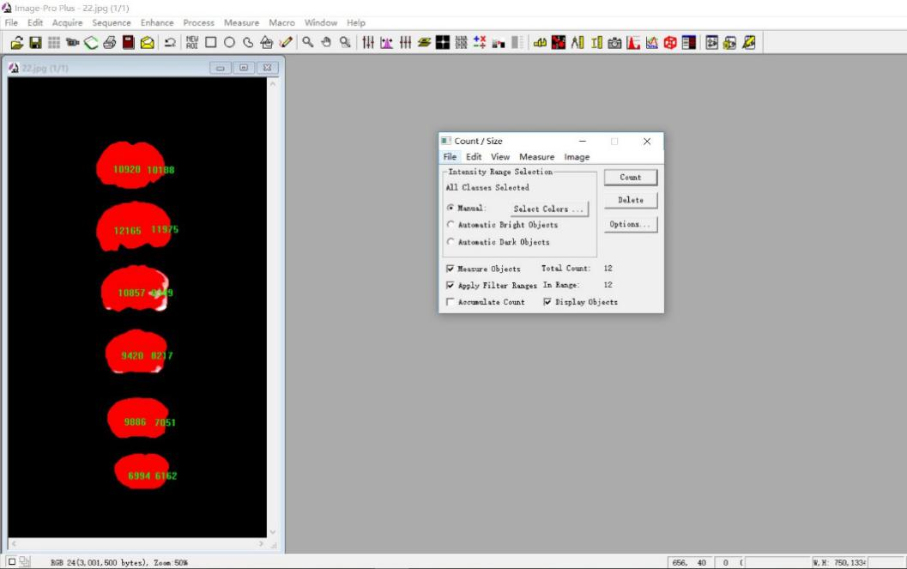
60166_screenshot_7

