  - Rotarod test
60166_screenshot_8
4.3.1 Set up the rat rotating bar fatigue apparatus (diameter 90 mm) of rats using the supporting software to a speed of 13 rpm over a 5 min period on the computer. 00:00-00:22
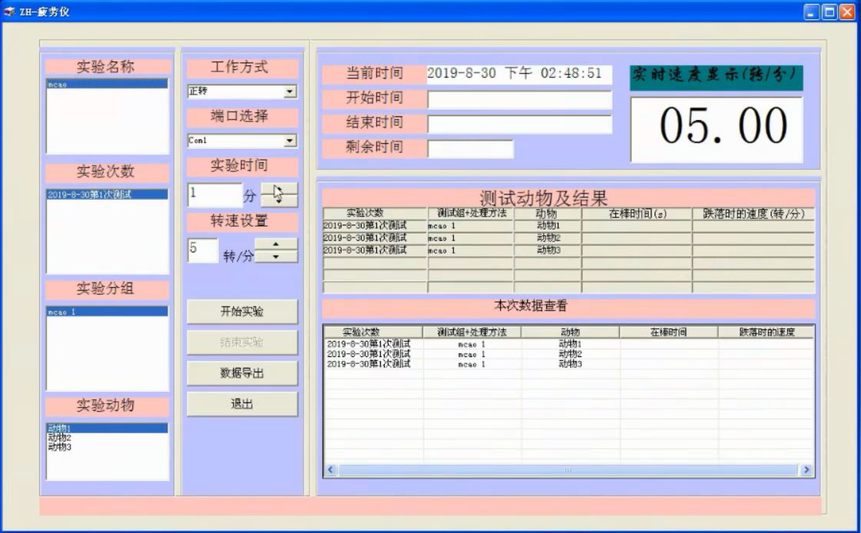
60166_screenshot_8
60166_screenshot_9
4.3.2 Start the computer programs and place the rat on the rotarod rungs at the same time.00:23-00:32
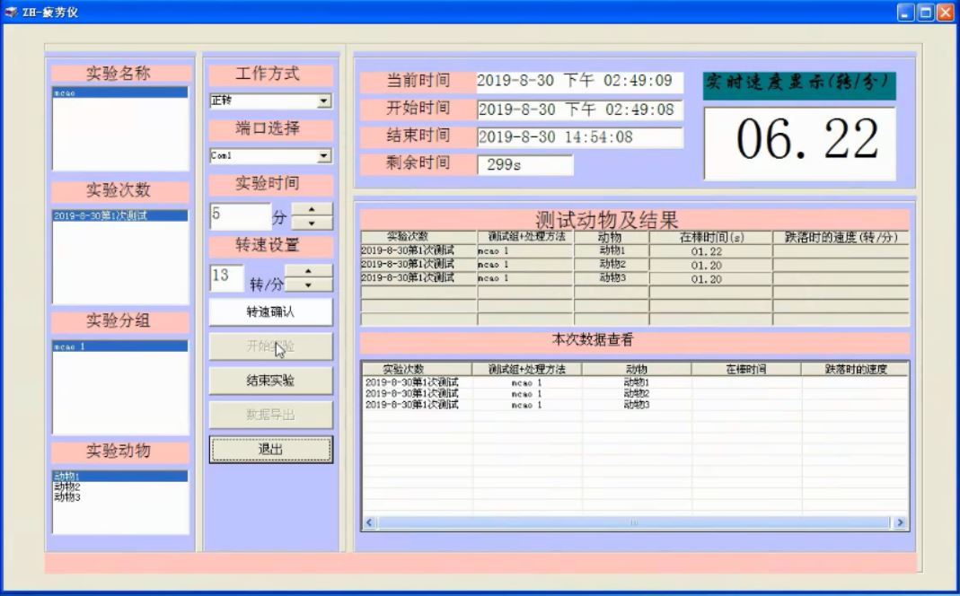
60166_screenshot_9
60166_screenshot_10
4.3.3 End a trial if the rat falls off the rung or keeps walking for 5 min and record the rotating time.00:33-01:00
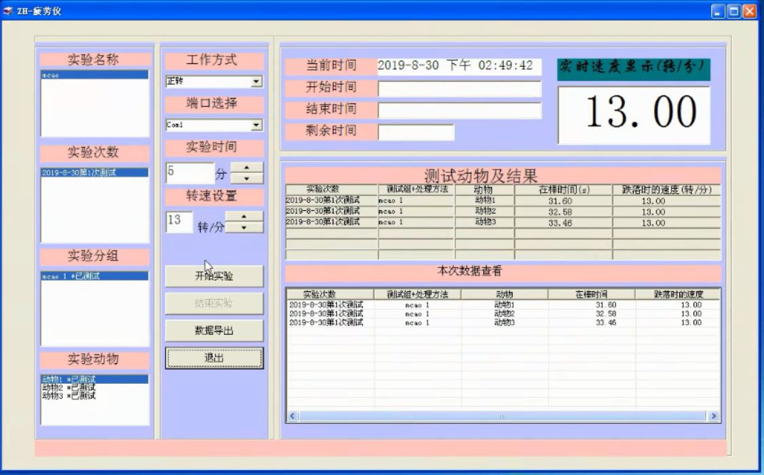
60166_screenshot_10
4.3.4 Have the rat rest for 30 min.
4.3.5 Repeat steps 4.3.2−4.3.4 twice more and choose the maximum value to be the last rotating time.

