Craig M. Crews, Ph.D.  Kline Biology Tower 400  P. O. Box 208103  New Haven, CT 06520-8103  Phone (203) 432-9364  Fax (203) 432-6161  email: craig.crews@yale.edu  www.yale.edu/crews | YALE UNIVERSITY  DEPARTMENT OF MOLECULAR, CELLULAR & DEVELOPMENTAL BIOLOGY  DEPARTMENT OF CHEMISTRY  DEPARTMENT OF PHARMACOLOGY  

May 30, 2019
Dear Dr. Vineeta Bajaj,
We appreciate your great interest and suggestions for our manuscript “Generation of chimeric axolotls with mutant haploid limbs through embryonic grafting." We greatly appreciate that the reviewers note the detail and rigor of the protocol and that it will be a great resource to the field. The described method provides a way to reduce the time and space required for functional screening of genes implicated in limb regeneration in the axolotl by generating chimeric axolotls with mutant haploid limbs, and we are happy that the reviewers universally acknowledge the great value of this method. We thank them for their input, as it has led to a number of substantial improvements in the manuscript.
The current submission contains a number of changes to address the reviewers’ comments. We have included a flow chart and additional detail to more clearly convey the parallel steps of the protocol. We have included more text to describe the history of research with haploid salamanders, the advantages of conducting mutagenesis in haploids over diploids, and potential limitations of this technique. We have clarified several figures by providing bright-field images and outlined areas of interest within images. We have included additional data and images to report the morphological differences between haploid and diploid limbs and to demonstrate the complete regeneration of haploid limbs. We have added data to report the success rates of egg activation. We have successfully added a missing figure (which was errantly omitted previously), changed the formatting to adhere to JoVE’s editorial standards, and uploaded several videos demonstrating different steps of the protocol. We believe that these changes have addressed the reviewers’ concerns and markedly increased the quality of the manuscript.
As we have discussed over the phone with different editors and with you via email, we have submitted a concurrent manuscript using the techniques detailed in this protocol to research candidate genes in regeneration. This manuscript is currently under review. This additional manuscript contains a more detailed characterization of the quality and rate of regeneration of haploid limbs, including a figure. As reviewers 3 and 4 asked us to elaborate upon these topics, we have provided additional data and images. These data and figures are not the same as those in the additional manuscript to avoid any potential conflicts.
As mentioned before, because of upcoming construction and relocation which will shut down our axolotl facility and the associated lab space, this concurrent submission was required if we are to film the necessary footage for this video protocol while the lab space is accessible. If you choose to publish this work, we request that the filming be scheduled in a timely fashion, even as we temporarily withhold its publication to coincide with the concurrent manuscript’s acceptance and publication.
Thank you for your consideration, and we look forward to your decision.
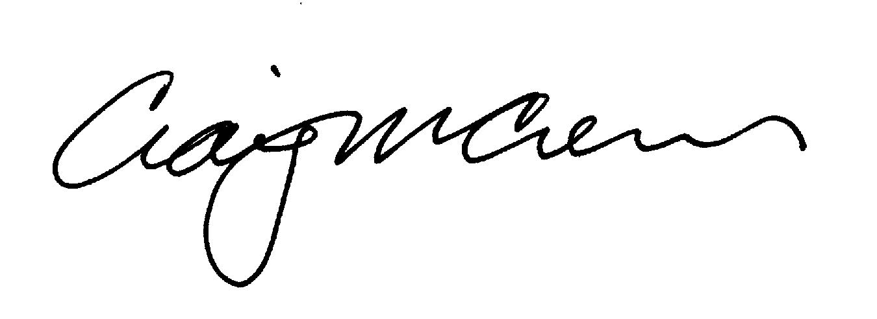
Craig M. Crews, Ph.D.
Lewis B. Cullman Professor of Molecular, Cellular and Developmental Biology
Professor of Chemistry
Professor of Pharmacology
Executive Director, Yale Center for Molecular Discovery

