Response to the editorial and peer reviewer comments
Editorial comments:
Note that some changes have been made to better fit JoVE format and correct some grammatical and usage errors.
1. Formatted per JoVe guidelines (e.g., spaces between every step/substep) the highlighted portion of the protocol exceeds 2.75 pages. Please reduce the length of the highlighted portion.
Aw: As per suggestion, the length of the highlighted portion has been reduced accordingly.
2. 2.1: 5% isoflurane is likely too high a concentration for anesthesia; please check.
Aw: Isoflurane 4~5% has been used for induction whereas 1~2% for maintenance of anesthesia. We added this information in line 203.
3. 3.1: If this is to be filmed, please at least describe what ‘no estrus cycle change’ looks like.
Aw: I removed the highlight mark. I think it is hard to film. No estrus cycle change is decided by vaginal smear test ¹, which has been published in JoVE journal. Provide with a reference.

¹ McLean, A. C., Valenzuela, N., Fai, S. & Bennett, S. A. Performing vaginal lavage, crystal violet staining, and vaginal cytological evaluation for mouse estrous cycle staging identification. J Vis Exp. 10.3791/4389 (67), e4389, (2012).
4. 6.4/7: If the behaviors seen and their timing are to be shown in the video, they should be highlighted and/or discussed more in the protocol. Note that, for section 7, all steps/substeps should be no more than 4 sentences and should have at least one instruction (i.e., in the imperative).
Aw: I removed the highlights of 6.4, 6.6, and 6.7. For section 7, the description has been revised.
5. Please remove the embedded tables and upload as separate .xls/.xlsx files, 1 per table (i.e., 2 in total).
Aw: Thank you for the reminder and the file have been uploaded as per suggested format.
6. Figure 1: The surgery is still shown without the use of sterile drapes; perhaps you could zoom in on the incision site and not show the table at all?
Aw: Thank you for the kind reminder. I have revised the figure 1. But I hope to be able to take a new picture for display in the formal article when we make video product.
7. Table 1/Figure 3/Results: The p-value shown for intromission latency in the text and table (0.015) still contradicts the value indicated in the Figure (<0.01).
Aw: The error has been corrected.
8. Table 2: Could you discuss the lack of normality a bit in the Results?
Aw: Previously, I treated the number of mounts, intromission, mating (now it is copulatory series) as discrete data, because the occurrence is small. Hence, median and inter-quartile ranges were used to describe the data. Non-parametric test was used to test the hypothesis. This time, I consulted a statistician and he told me that these indexes can be treated as continuous variables in our case. Therefore, I tested the distribution and homogeneity of variance of data. The results show as follows: the distribution is normal and the variances are equal. Student-t test is used to compare the differences of three index between isolation and control mice. No statistically significant differences are found between the two groups in terms of number of mounts, intromission, and copulatory series. The results has been revised in the revised manuscript.
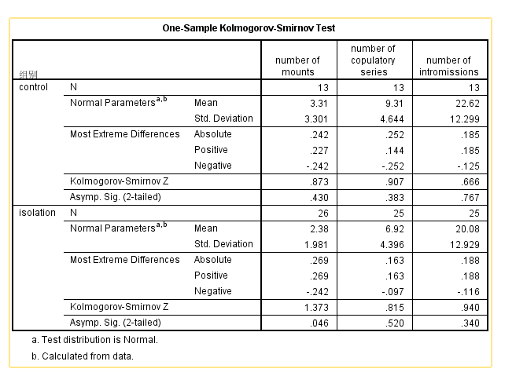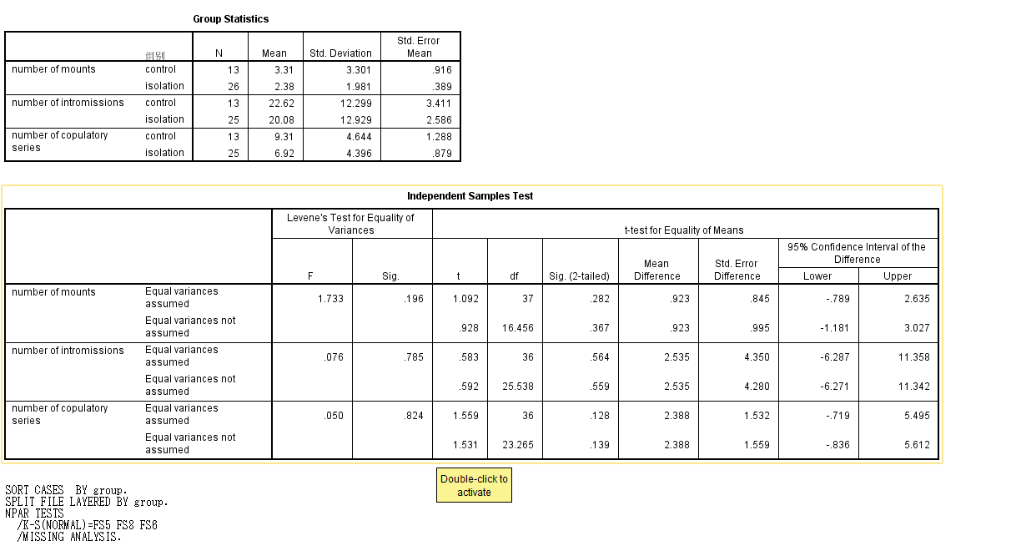

Reviewers' comments:
Reviewer #2:
Manuscript Summary:
The revised manuscript " Assessment of Sexual Behavior of Male Mice" by Zi-Wei Liu with co-authors sounds better now and present a fully described method which would be helpful for researchers to replicate this behavioral set up to study sexual behavior in laboratory mice.
Major Concerns:
none
Minor Concerns:
none
Reviewer #3:
Manuscript Summary:
The aim of this study is to present the standard procedure for measuring male sexual behavior in laboratory setting. The manuscript includes the information on preparing ovariectomized female stimuli for hormone-induced estrus ovariectomized female model and assessing the mating behavior of male mice.
Major Concerns:
1. In this revision, authors claimed that they used isofluorane anesthesia. However, the mouse shown in Fig. 1 is same as one in original manuscript. I am not convinced that they really used inhalation anesthesia in this study.
Aw: We had not taken a photograph record in the formal experiment. This picture was taken in a practice experiment. The mouse in the figure1 was anesthesia by pentobarbital sodium (there is no buying channel now). We do have isoflurane and the apparatus for anesthesia showed as following. I will take a more clear picture for display in the formal article when we make formal video product

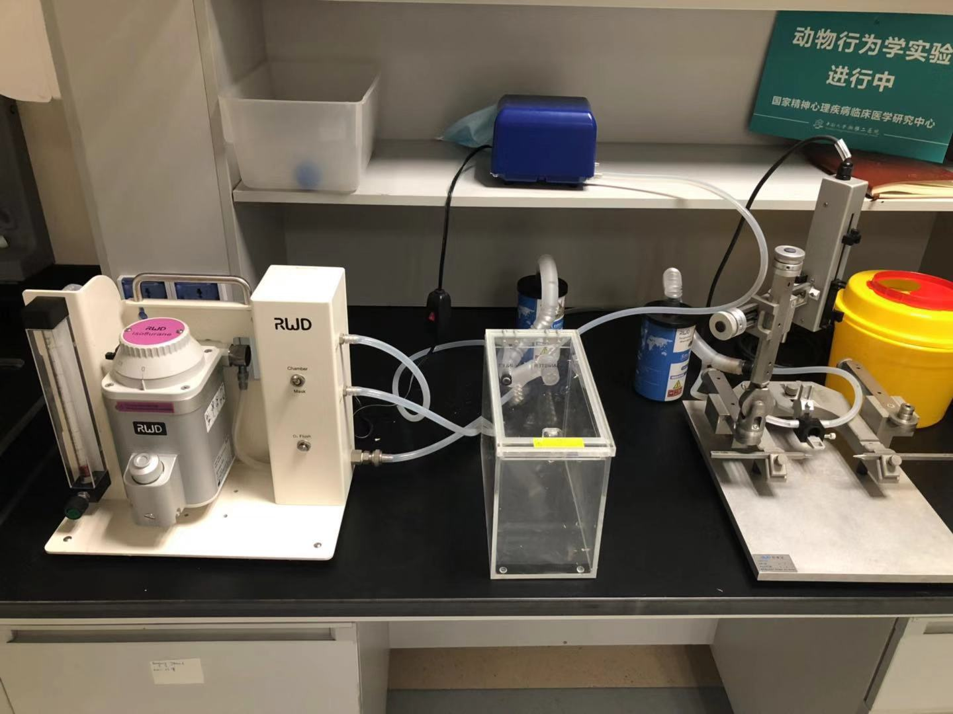
2. Authors should specify that the "isolation" is the post-weaning isolation starting at PND 23.
Aw: I added the following information of “Male CD-1 mice were randomly assigned into the isolation-reared group (IS, one mouse per cage, n = 30) and group-housed group (GH, five mice per cage, n = 15). The mice underwent isolation rearing from postnatal day 23 to day 93. Then, both groups of mice assessed for sexual behavior” in line 422 to 425.
3. Is there any reason to employ i.p. injection for EB and P administration? Why not s.c. injection?
Aw: Most of the past studies recommended using s.c injection in sexual behavior test of the rat. Based on our experience, repeatedly s,c injection with oil often forms a lump at the injection site. The position of s.c. injection is usually chosen posterior to neck on the dorsal side of the female mouse where the male mouse used to put head during copulation. A lump in the back mentioned location would change the shape of body of female mice, which may affect the behavior of male mice. The lump size has a bigger impact on mouse than rat due to the different body sizes. In order to reduce the possible impact of experimental manipulation. I speculate that i.p. inject produce a small lump and its position is on the abdomen of female which results in little effect on the male’s behavior. Hence I employed i.p. injection instead of s.c. injection. However, the drug absorption is quicker in i.p, injection than that of s.c. injection. The difference between i.p, and s.c. injection on sexual behavior is still needed to be explored in the further study.
Besides, before the test of sexual behavior, we examine the receptivity of female mouse by whether female mouse accepts genital insertion of a male mouse three and more times.
4. In this revised manuscript, authors defined "Number of mounting" as the number of mounting times before the first ejaculation with and without intromission, "Number of intromissions" as the total number of intromissions before the first ejaculation, "Total number of mounting" as the total number of mounting during the observation period, and "Total number of mating" as the total number of mating (including mounting, intromission, ejaculation, and refractory period) during the observation period. If so, how is it possible that the median for "Number of intromission" become higher than the median for "Number of mounting", "Total number of mounting", or "Total number of mating".
I would also like to know 1) the means for these data, 2) how many mice in each group showed each behavior, and 3) how many mice in each group ejaculated.
Aw: I update more concise definitions of mounting, intromission, and copulatory behavior in the revised manuscript. Mouse would keep a mounting posture during the whole sex process until ejaculation completion. However, there may be one to more than 100 intromissions before ejaculation ¹, which indicated male mice would make repeated attempts of intromission meanwhile keeping the mounting posture. Hence, the number of intromission could be higher than the number of mounts.

- The staff of the Jackson laboratory. Biology of the Laboratory Mouse, Second Edition, Chapter 11. Dover publications, inc., New York, (2007).

Besides, I added the means of each behavior, the sample size in Table 1 in the revised manuscript. As for the last question, there 24 of 30 mice ejaculated in the social isolation group determined by the behavioral performance and examined the residual semen or a copulatory plug at the vaginal open of female mice. In the control group, 13 of 15 mice ejaculated.
Minor Concerns:
1. Six weeks old seems to be too young for ovariectomy. Did they properly react to the EB & P treatment?
Aw: According to the book of Biology of the Laboratory Mouse, Parkes ( 1925) stated that his albino mice were usually mature by 7 weeks of age, whereas Engle and Rosasco ( 1927) reported a median age of 35 days and a range of 28 to 49 days also in an albino strain ¹. Six weeks old mice seems to be sexual mature. In our study, we ovariectomized the female at postanal 6 weeks, and healing period extended for about three weeks. When female mouse employed in the test, they were gain sexual maturity. They showed a good sexual receptivity in the tests.

^{1.} The staff of the Jackson laboratory. Biology of the Laboratory Mouse, Second Edition, Chapter 11. Dover publications, inc., New York, (2007).

Reviewer #5:
Manuscript Summary:
Acceptable for publication, no suggestions.
Major Concerns:
None
Minor Concerns:
Authors described the methods in detail and very well. Nonetheless, there are a few suggestions for improving their manuscript:
Line 189. Should read "observation of mouse movement"
Aw: Thank you for the reminder. Corrected it.
Line 208. Authors indicate that habituation occurs twice a day for 2 days. Does this mean 4 times? How long in between each day?
Aw: Each mouse habituated for 30 mins every day and habituated for twice in total. Habituation was conducted in two consecutive days preceding the testing day.
Line 216. Suggested wording: Place the testing mouse in the center of the open field box, allowing…
Aw: The error has been corrected.
Line 219. Is female placed in the center of the open field box as well?
Aw: Yes.
Methods do not indicate clearly if new and naïve females are used every time.
Aw: No. all female mice are sexually experienced. I specified that the eligibility of an estrus female is determined by the female accepting genital insertion of a male mouse 3 and more times in the NOTE of 3.3. I added the following description of “Female mouse accepted mating can be not repeated employed in anther sexual behavior test in one day.”in line 340 - 341.
Line 253. How long does the post-ejaculatory period last? Authors indicate a brief time line of other sex behavior components and that seems helpful to give an idea to inexperienced investigators.
Aw: I added following information of “Mouse sexual behavior exists strain differences. For instance, ejaculation latencies ranged from 594 to 6943 seconds, and the numbers of intromissions ranged from 5 to more than 100. Post-ejaculation latencies ranged from 17 to 60 min. However, the introduction of a novel female can decrease this time interval. In some cases, male ejaculating on the first intromission with the new female.” In line 63 -67
Line 289: Suggested to change "time to initiate sex" to "time to initiate sexual behavior"
Aw: The error has been corrected.
Line 322: Suggested modification from "is better" to "is less detrimental"
Aw: The error has been corrected.
Line 372. "Sex" can be changed for "sexual behavior"; "Sexual native" to "sexually naïve?
Aw: The error has been corrected.and thanks again.
Reviewer #6:
Manuscript Summary:
OK
Major Concerns:
1. The introduction does not mention that authors will analyze two population of animals: reared in isolation and group housed. There is information about this manipulation on sexual behavior that authors ignore.
Aw: Thank you for your kind reminder. I re-write the introduction to focus on the measurement of sexual behavior in male mice. Besides, I hope to present an example of sexual behavior. Meanwhile, social isolation can reduce sexual behavior in male mice. Hence, I just want to use it as an example of sexual behavior test, based on our research experience.
2. The reader is confused on whether the main goal of the manuscript is to describe the methods followed to observe sexual behavior in this species or to understand how isolation affects the expression of this behavior. The reader finds isolated reared groups in Results tables for the first time in the manuscript.
Aw: I re-write the introduction to focus on the measurement of sexual behavior in male mice. This time, I hope this revision makes the topic of the manuscript clearer.
3. The manuscript fails to mention the literature reviews on male sexual behavior that consider several species and various strain of mice. For example, Meisel and Sachs or Hull and Rodríguez Manzo.
Aw: I added this information and references in the introduction of the revised manuscript.
4. Authors have to check carefully their interpretations. For example: "Sex is a learning process" is too strong. In many species, like mouse, sex is an innate behavior although modified by experience and other factors. Lordosis is a reflex.
Aw: Thank you for your kind reminder. I have revised this description.
Minor Concerns:
5. Why did authors decided to use rectangular (instead of cylindrical) arenas for their observations?
Aw: In order to avoid the light refraction result from curved edge of cylindrical. Light refraction would blur the image of video. Curved edge is not suitable for video camera to record the action of mice. Rectangular arenas are more easy to observe mouse behavior from a lateral view. Moreover, rectangular arenas provide more stable phenotype and the rectangular edges are preferred to stay by normal mice. In contrast, circular arenas are continuous and mice do not find any safe corner.
6. Why did they selected the 12h of the dark cycle while all authors choose the first hours of the dark phase?
Aw: Female mice should not be bred before 50 days of age. They are continuously "polyestrous," which means that they come into heat at fairly regular intervals (every 4-5 days) throughout the entire year until they are bred. The period during which the female is receptive to the male and allows breeding is about 12 hours and usually occurs at night.
https://www.animalhospitals-usa.com/small-pets/mice-and-rats/mice-rat-reproduction.html
Aw: The first hours of the dark phase is right. I have revised the description in line 309.
7. Figure 2 does not show latencies. Please check citations in the text.
Aw: The error has been corrected.
8. The same group has published figure 3 earlier? Please explain.
Aw: Yes, this figure has been published in Frontiers in Behavioral Neuroscience. Here, I just want to use it as an example to present what the data of sexual behavior look like, which is acceptable by the JoVE journal as far as I know. In addition, I have received the permission of copyright owner and the journal to reuse this result.

