- AFM imaging of the morphology of protein aggregates

  - Turn on the AFM system at least 30 min before the measurements in order to enable the system to reach thermal stability. Click on Setup, then on Probe. In Probe Change window click on Next to prepare Z, Focus Stage.
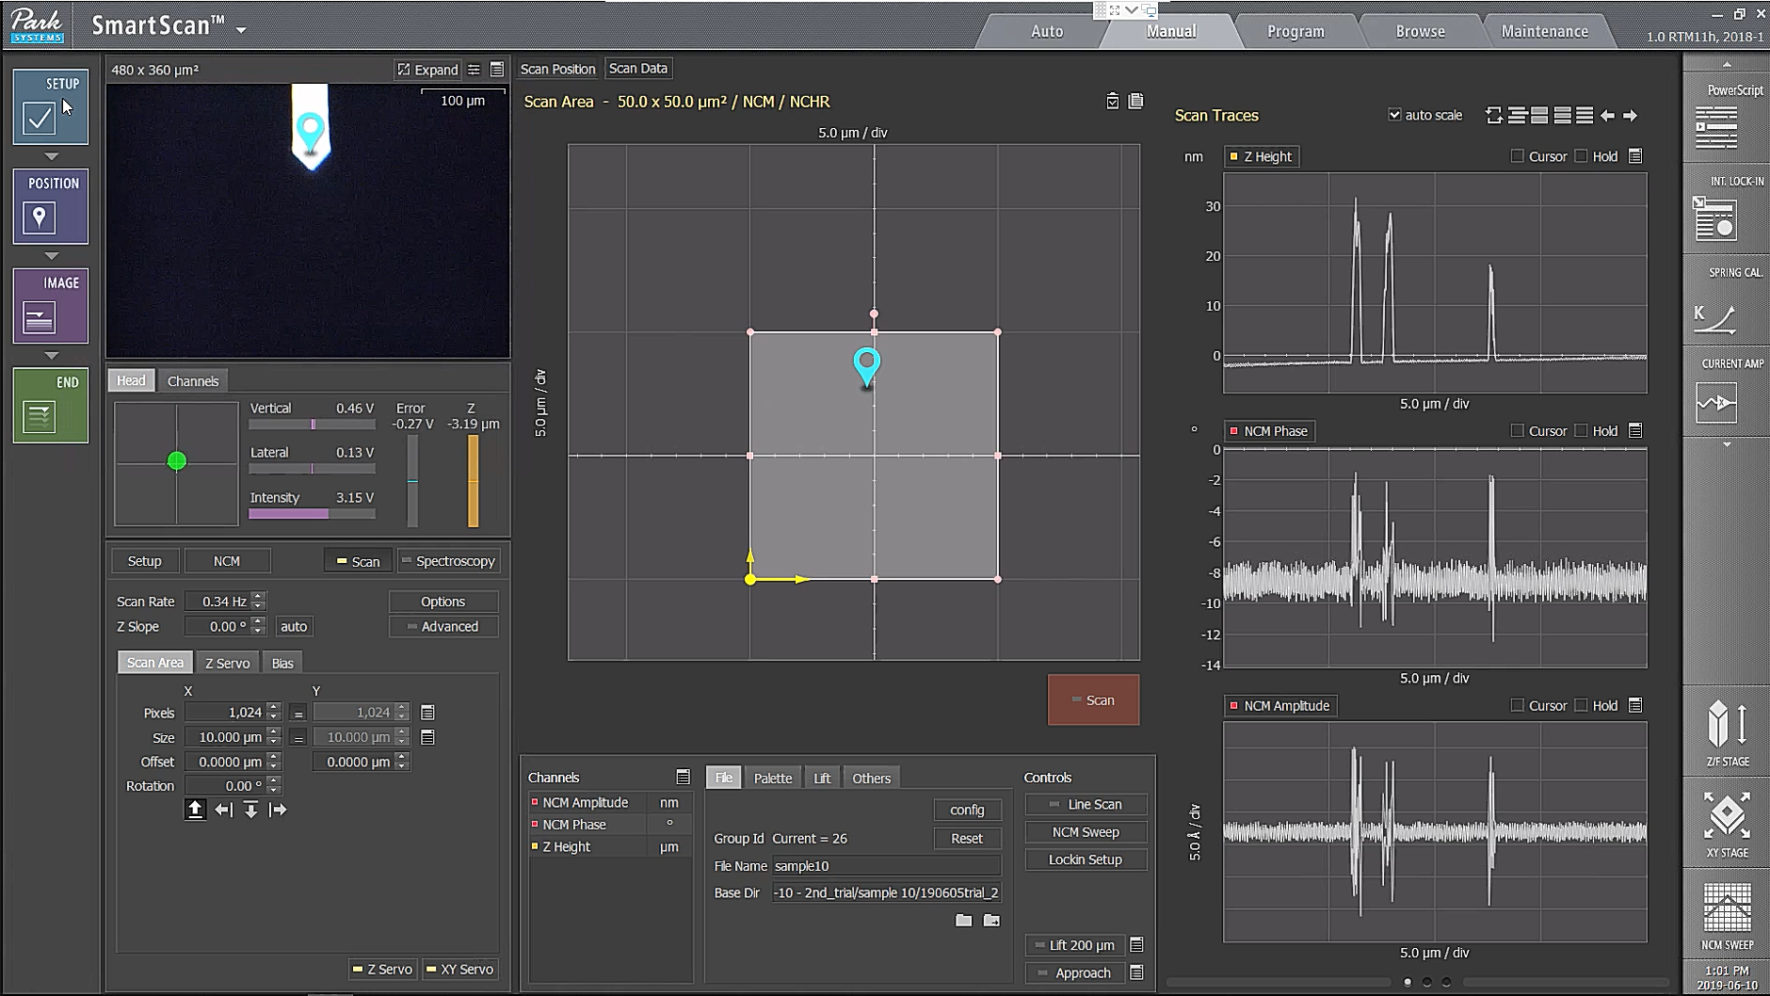

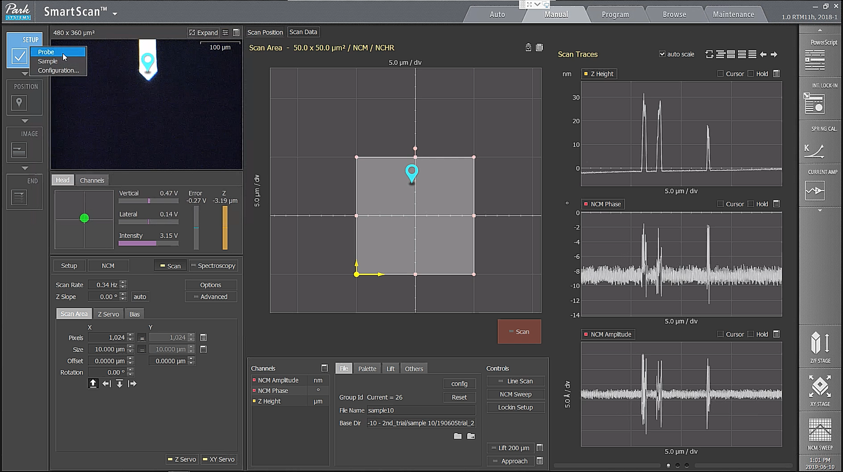

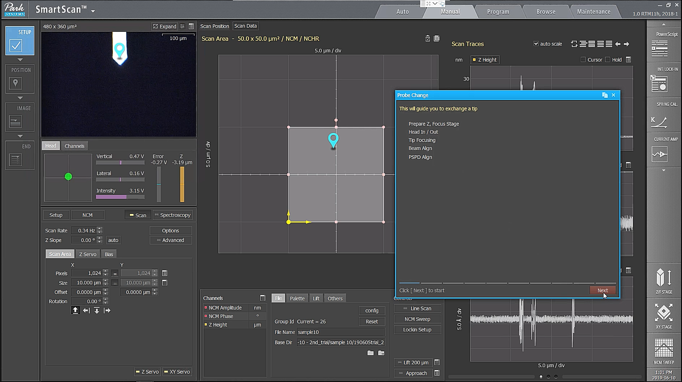

  - Turn off the AFM beam switch (if it is on). Unlock the dovetail locks, disconnect the head from the system and in Probe Change window click on Next.
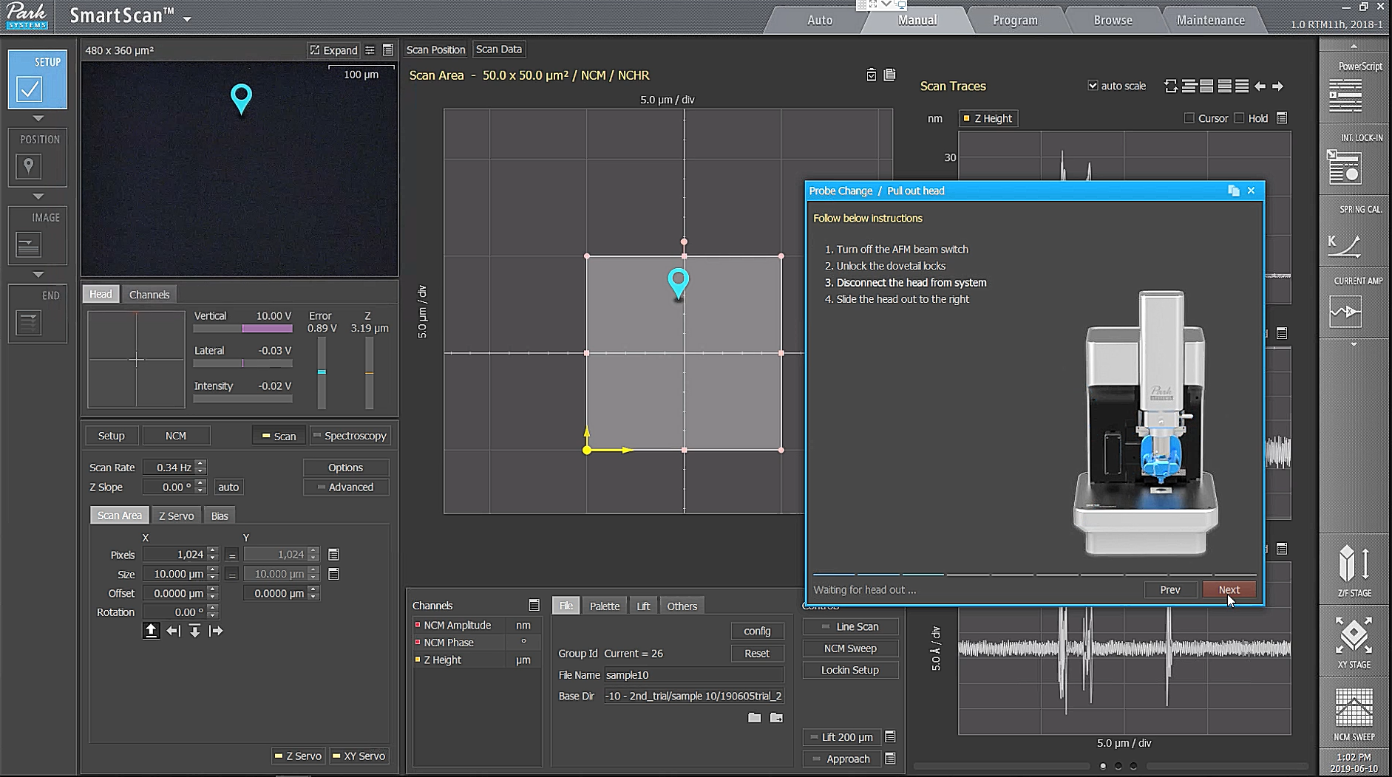

  - Mount the AFM cantilever on the probe holder. Connect the head to the system and lock the dovetail locks.

  - Turn on the AFM laser beam switch and in Probe Change window click on Next.
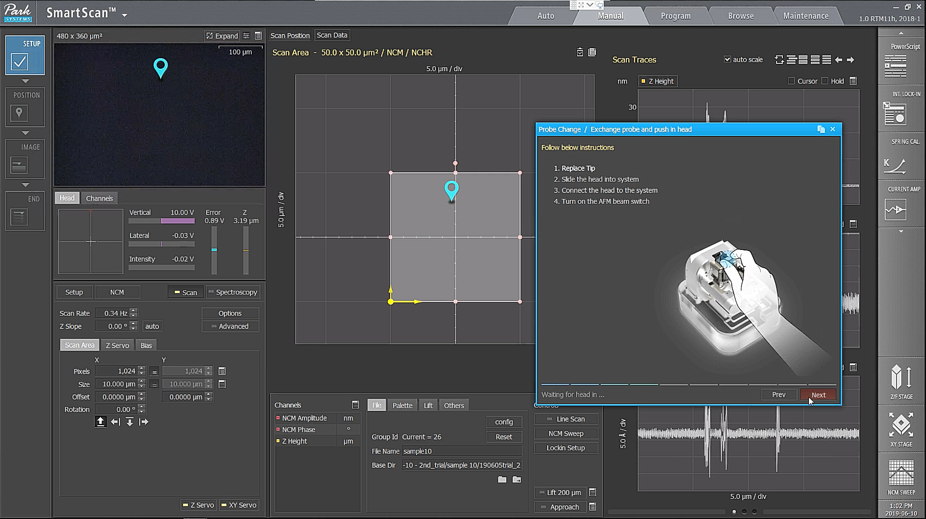

  - In the pop-up window click on No if the cantilever type did not change. Adjust optical alignment knobs to find the cantilever. Adjust focus onto cantilever and click on Next.
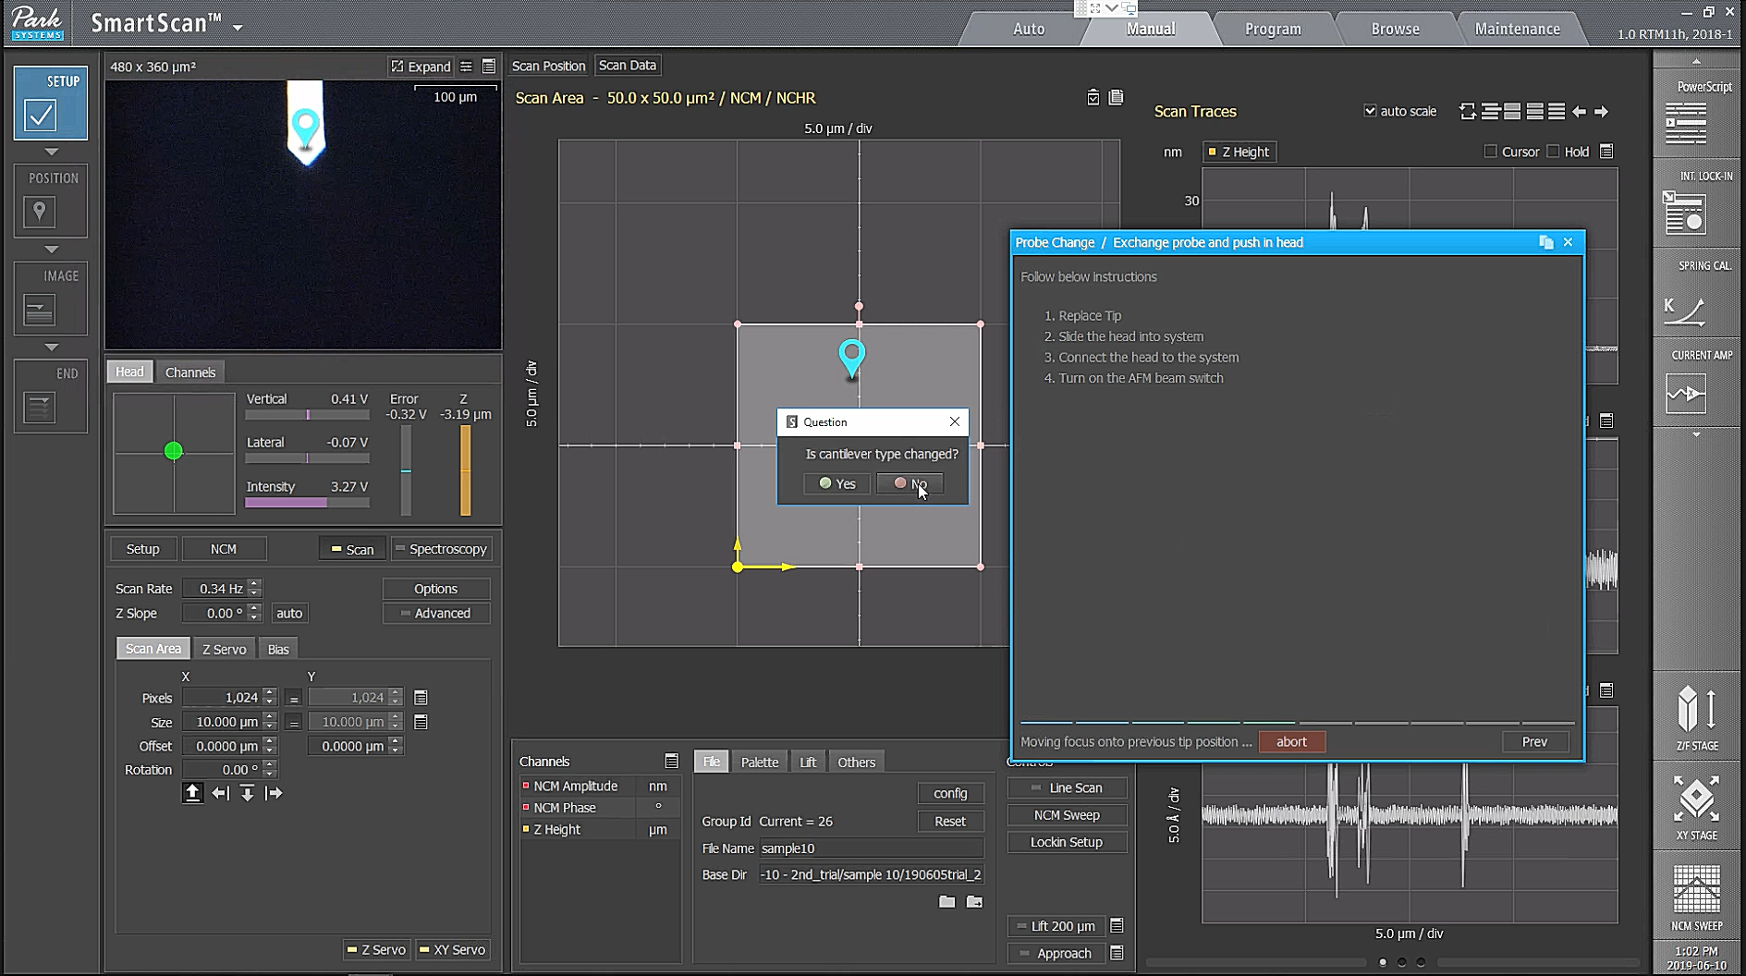

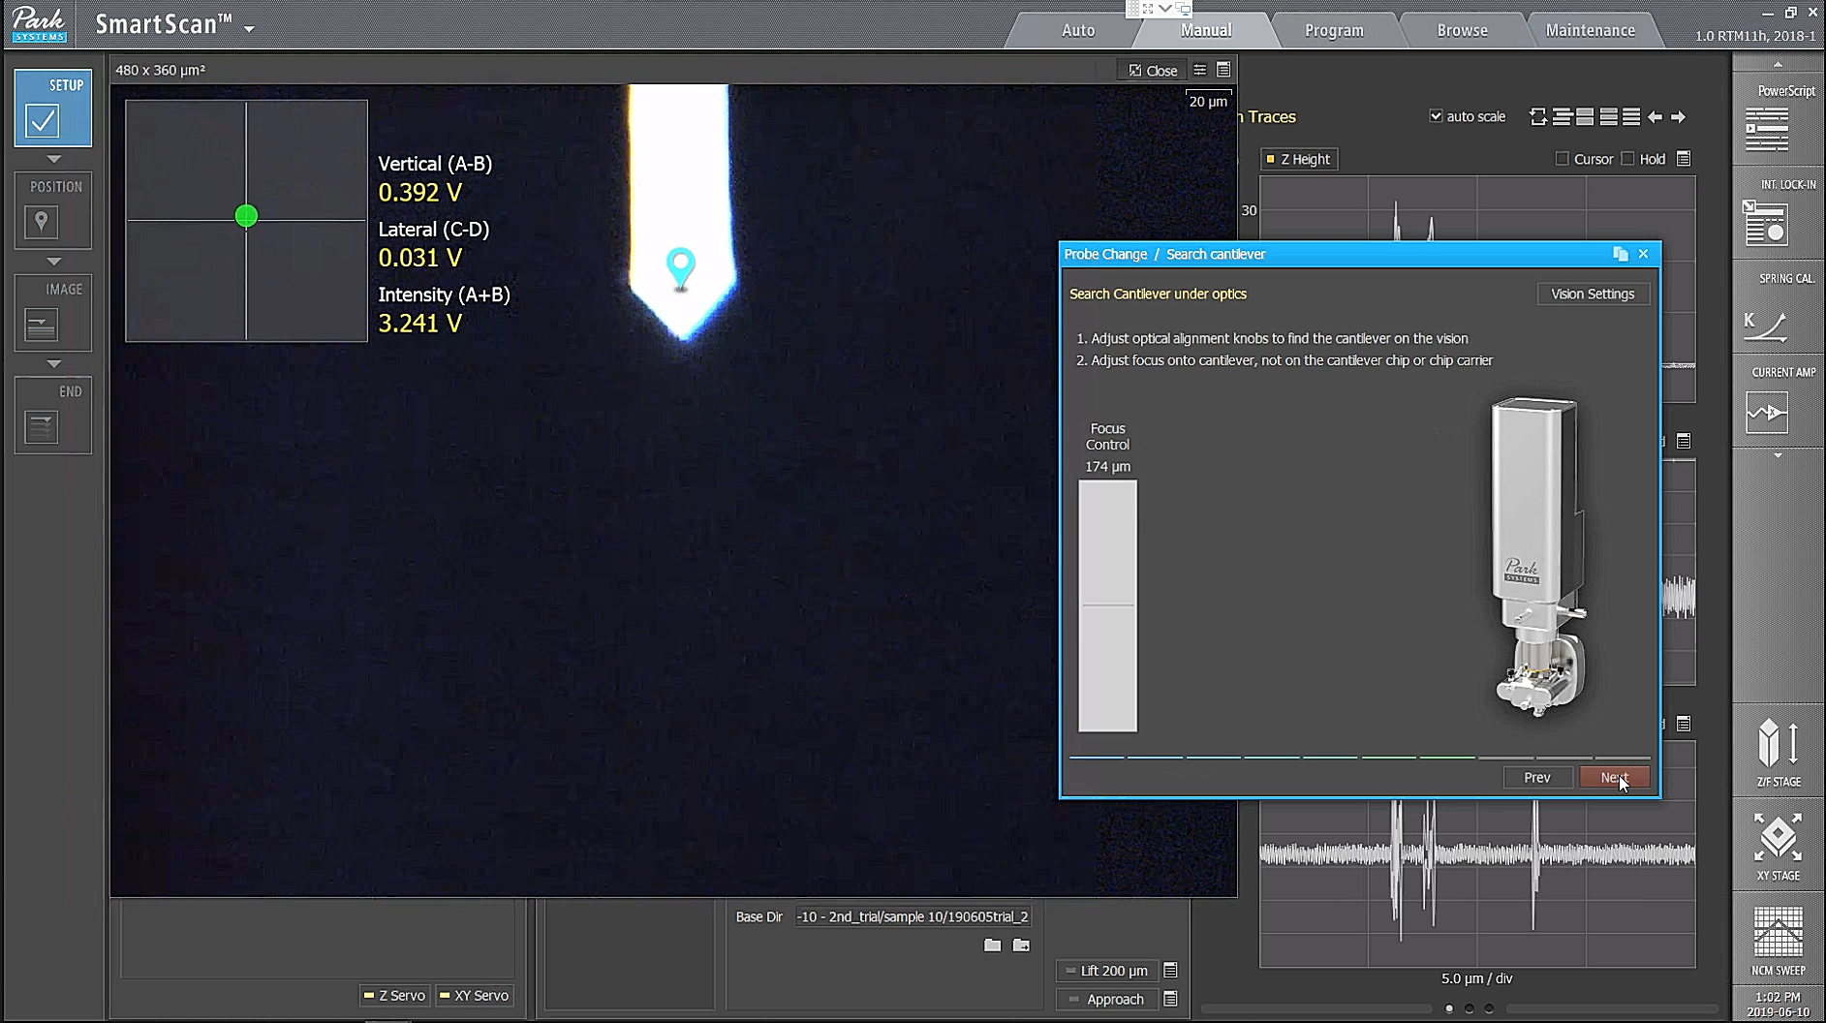

  - In the pop-up window click on Yes if the focus is on the cantilever.
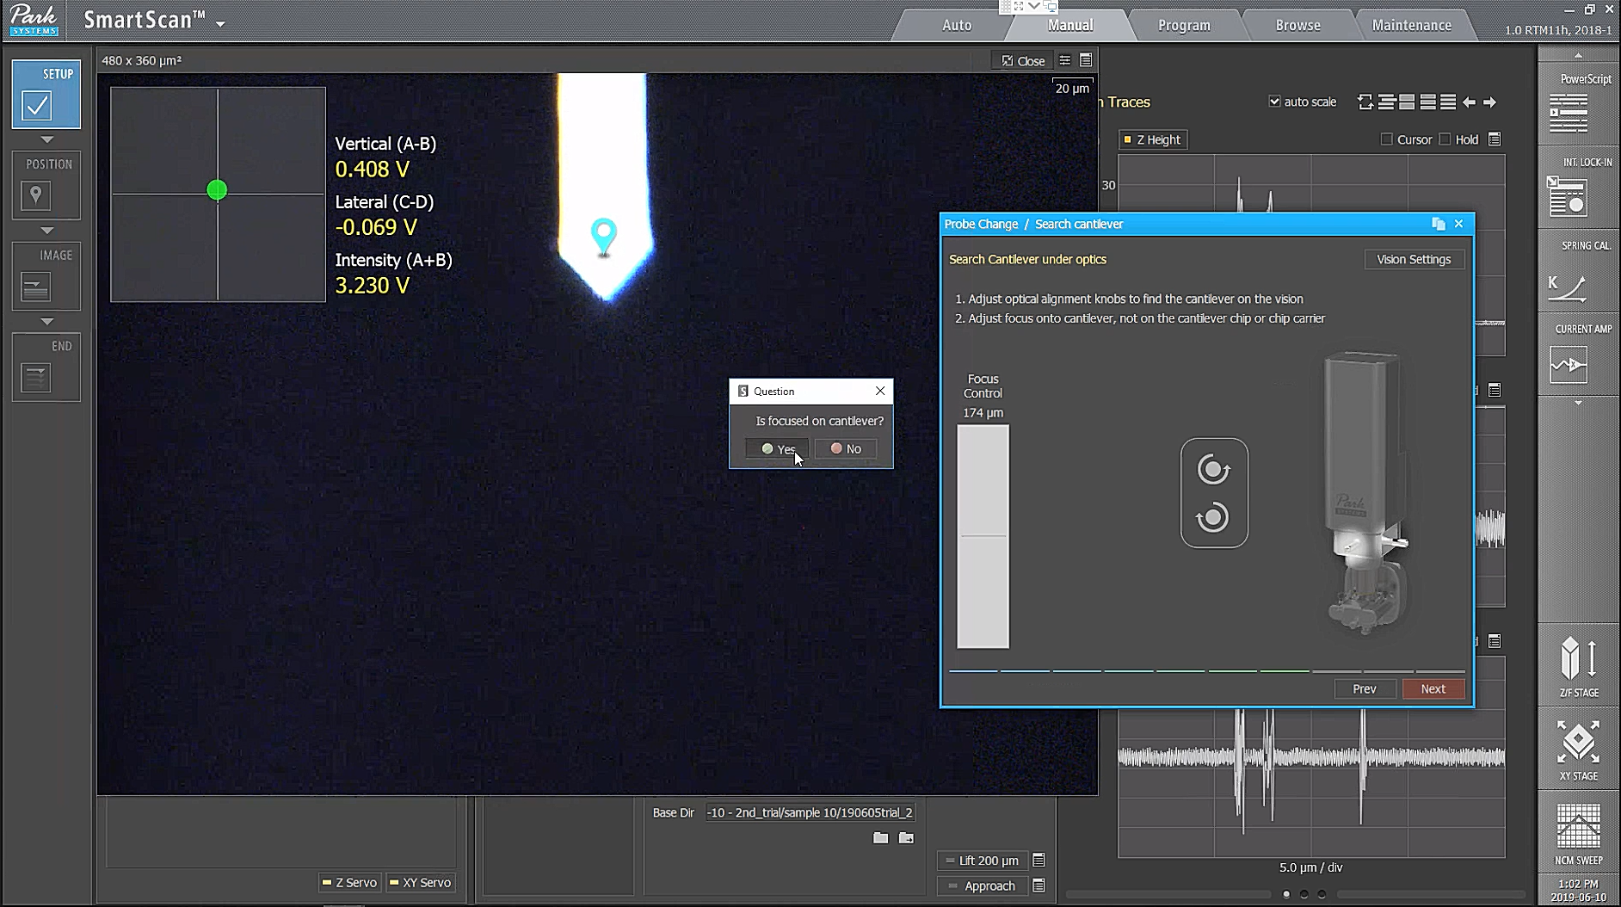

  - Position the laser beam at the end of the cantilever using the knobs controlling position of the detection laser. Maximize the total signal measured by the four-quadrant photodiode to at least >1 V using the knobs controlling the position of the deflected laser beam on the position sensitive photodiode (PSPD). In Probe Change window click on Next and then on Close.
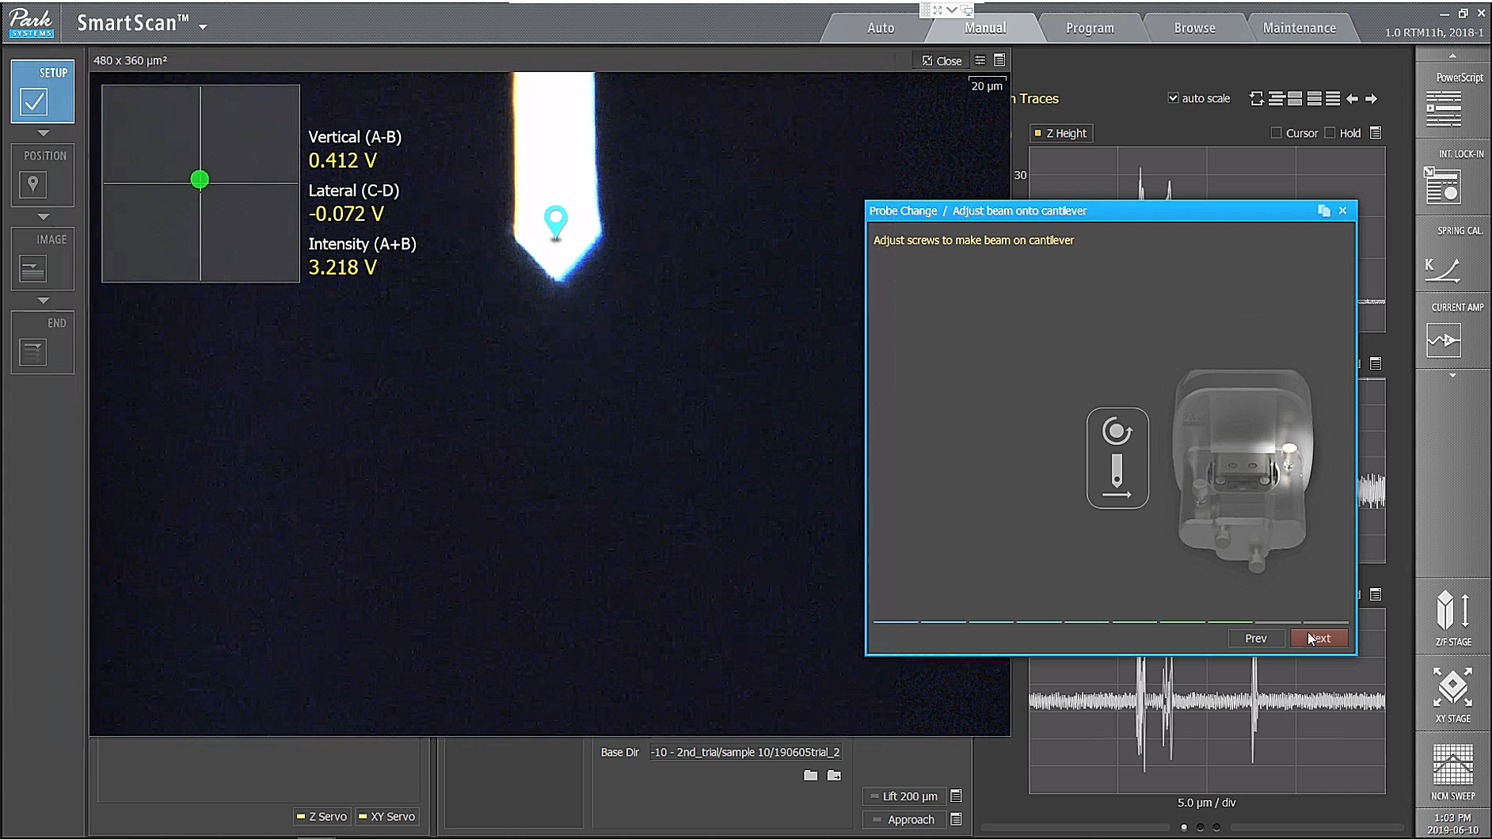

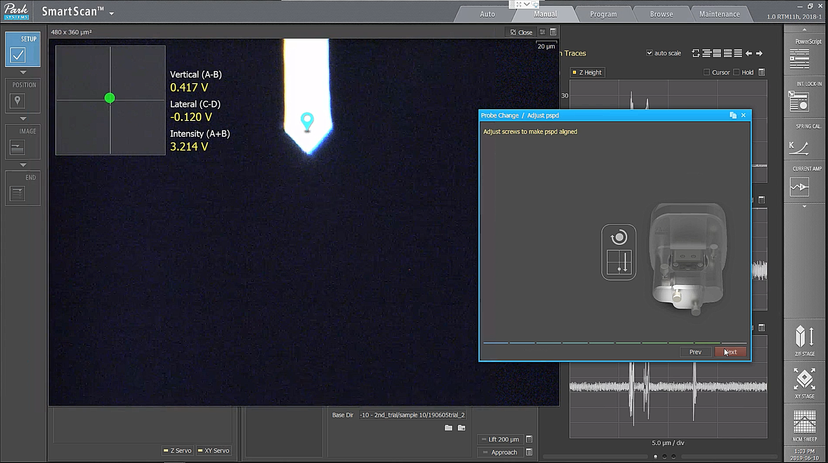

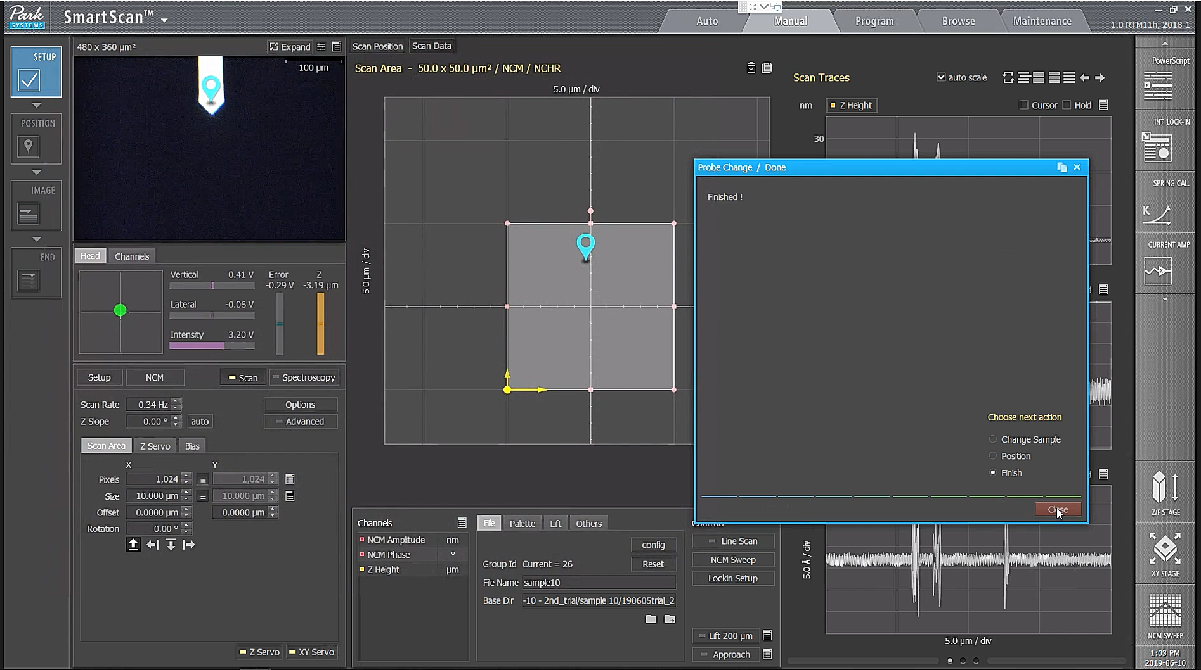

  - Wait 15 min for the cantilever to reach thermal stability. Readjust the position of the deflected laser beam on the PSPD if necessary.

  - Click on NCM SWEEP, choose desired amplitude of oscillation, click on Use Phase, click on auto and tune the cantilever close to the maximum of its first free resonance of oscillation, which is of approximately 300 kHz for a cantilever with a spring constant of 40 N m⁻¹.
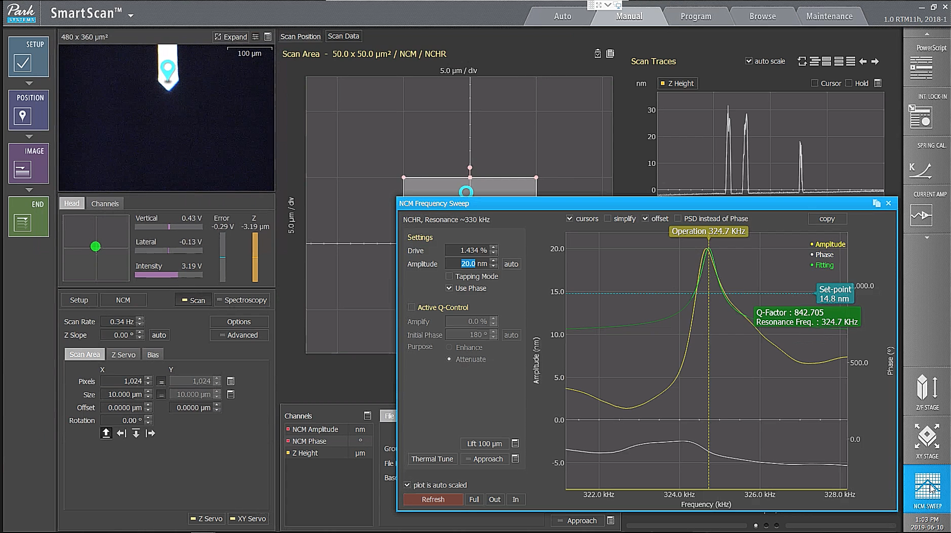

  - Place the sample on the sample holder. Choose suitable imaging parameters. Typical scanning rate is 0.3−1.0 Hz for a scan area of 1 x 1 µm² to 5 x 5 µm². Typical resolution needed is between 256 x 256 and 1024 x 1024 pixels. Click on Scan Area to choose the scan size and the pixel number.
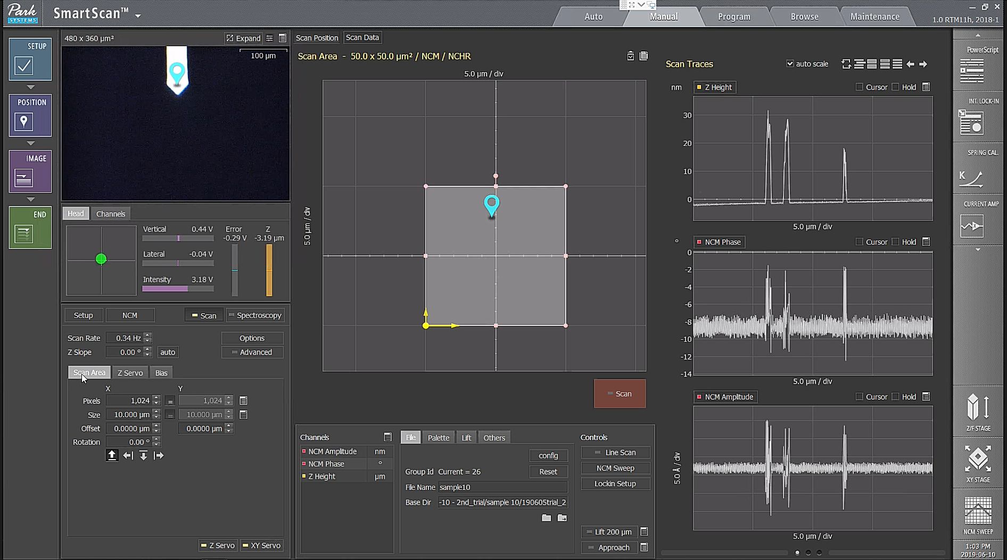

  - Focus the optical view on the sample. Click on Approach to approach the sample surface. Once approach is completed click on Lift 100 µm to rise the AFM tip 100 µm above the surface of the sample. Click Expand on the optical image of the sample. Click on the Focus Stage bar to focus the view on the surface of the sample.

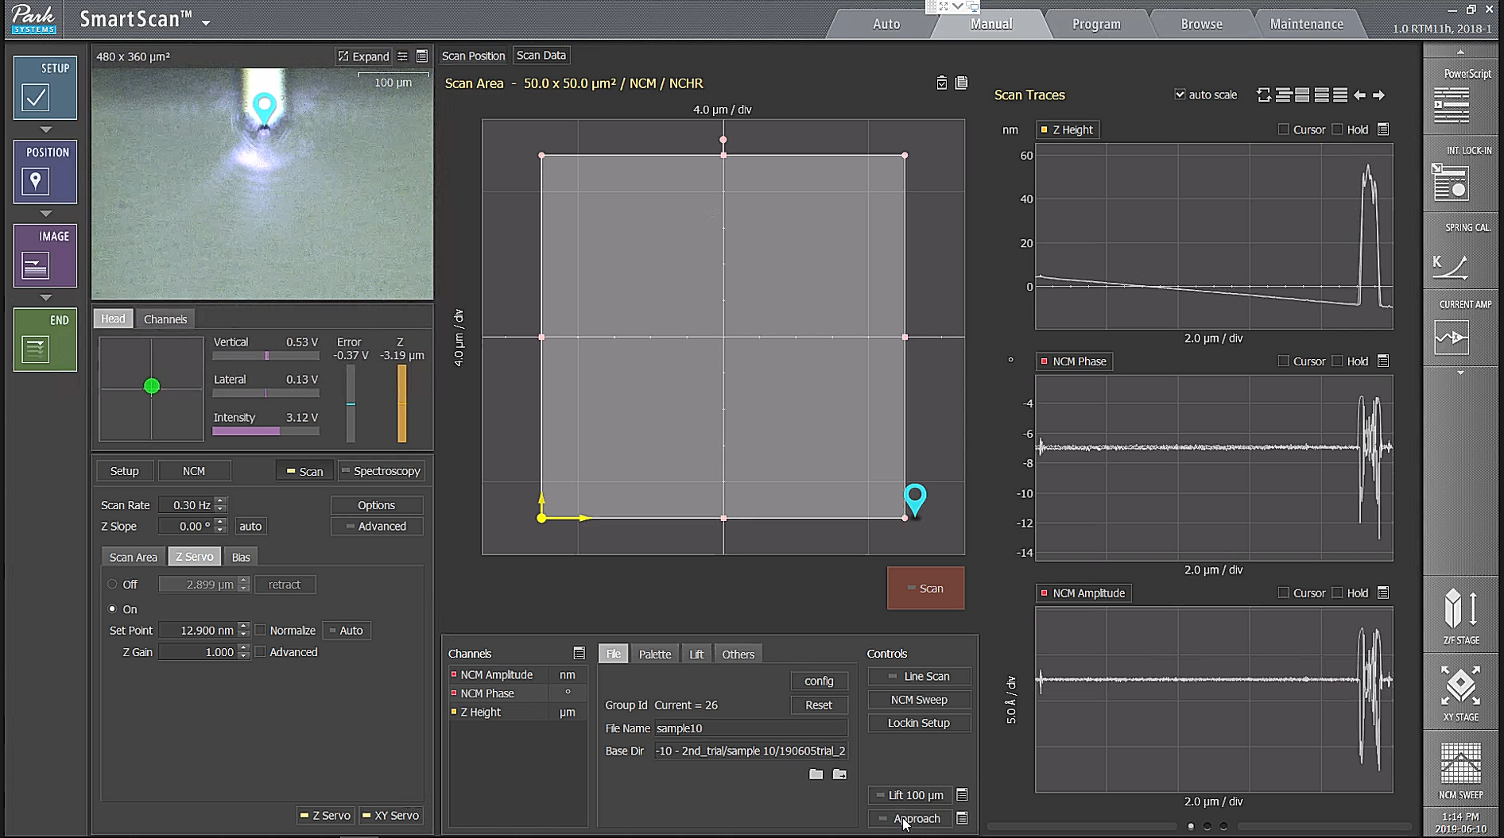

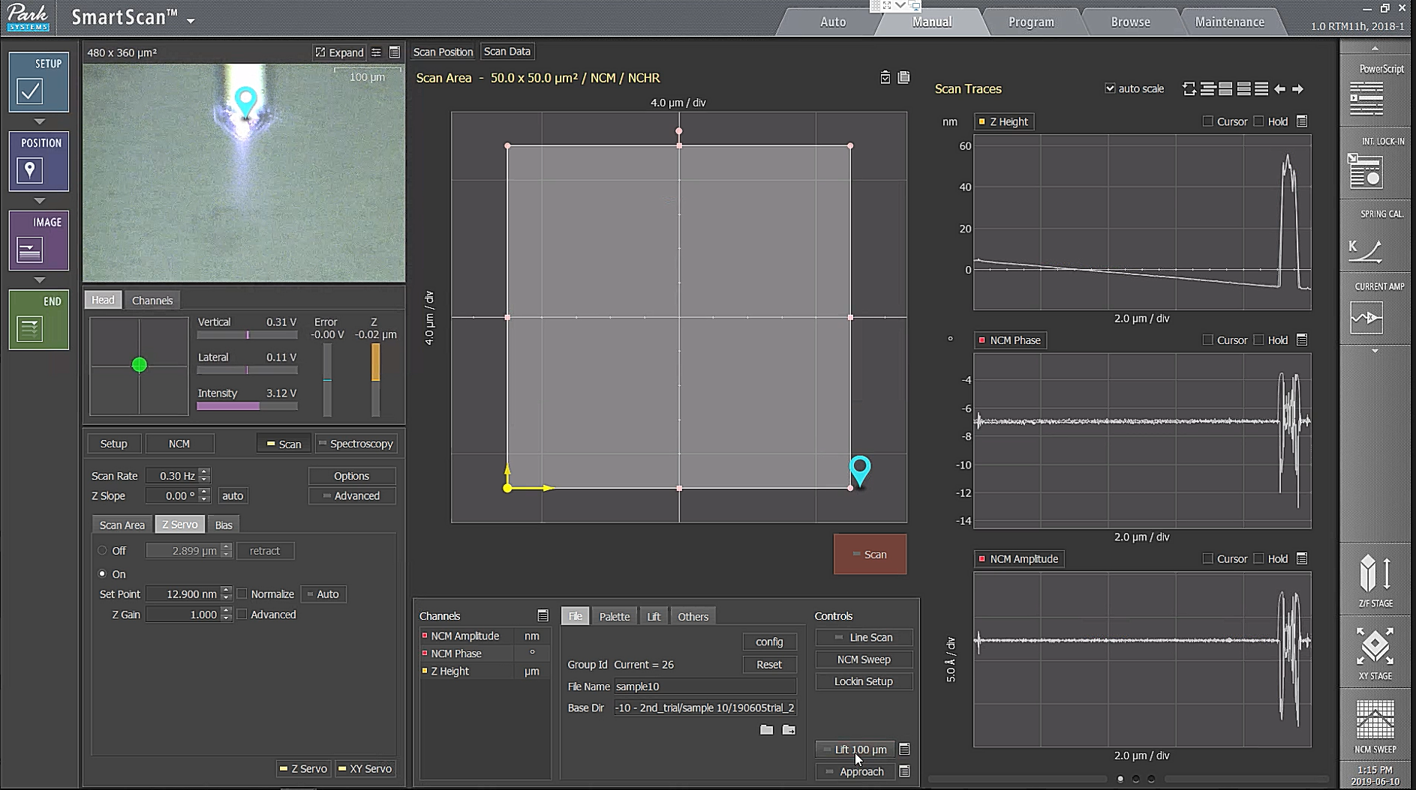

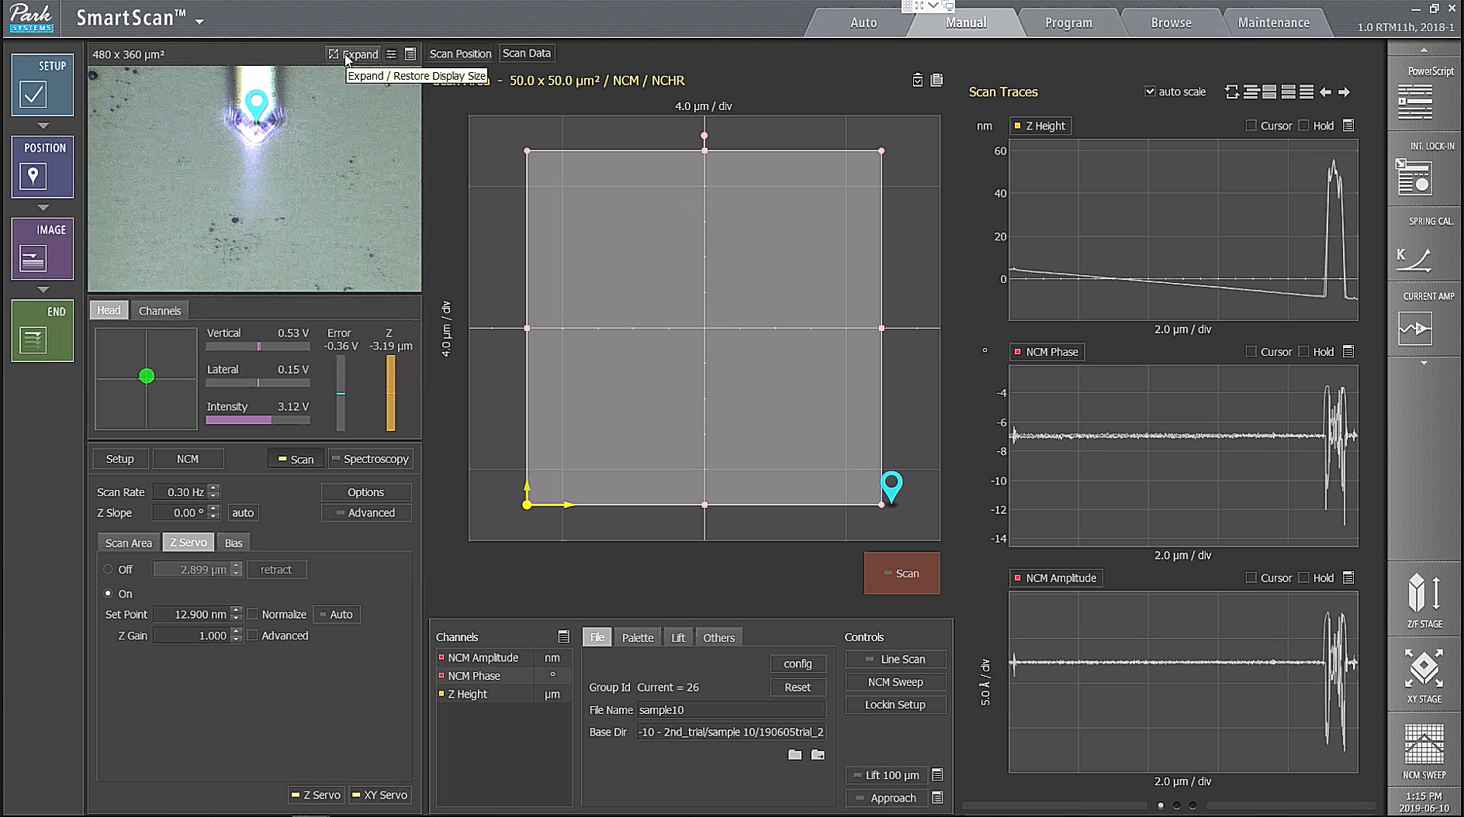

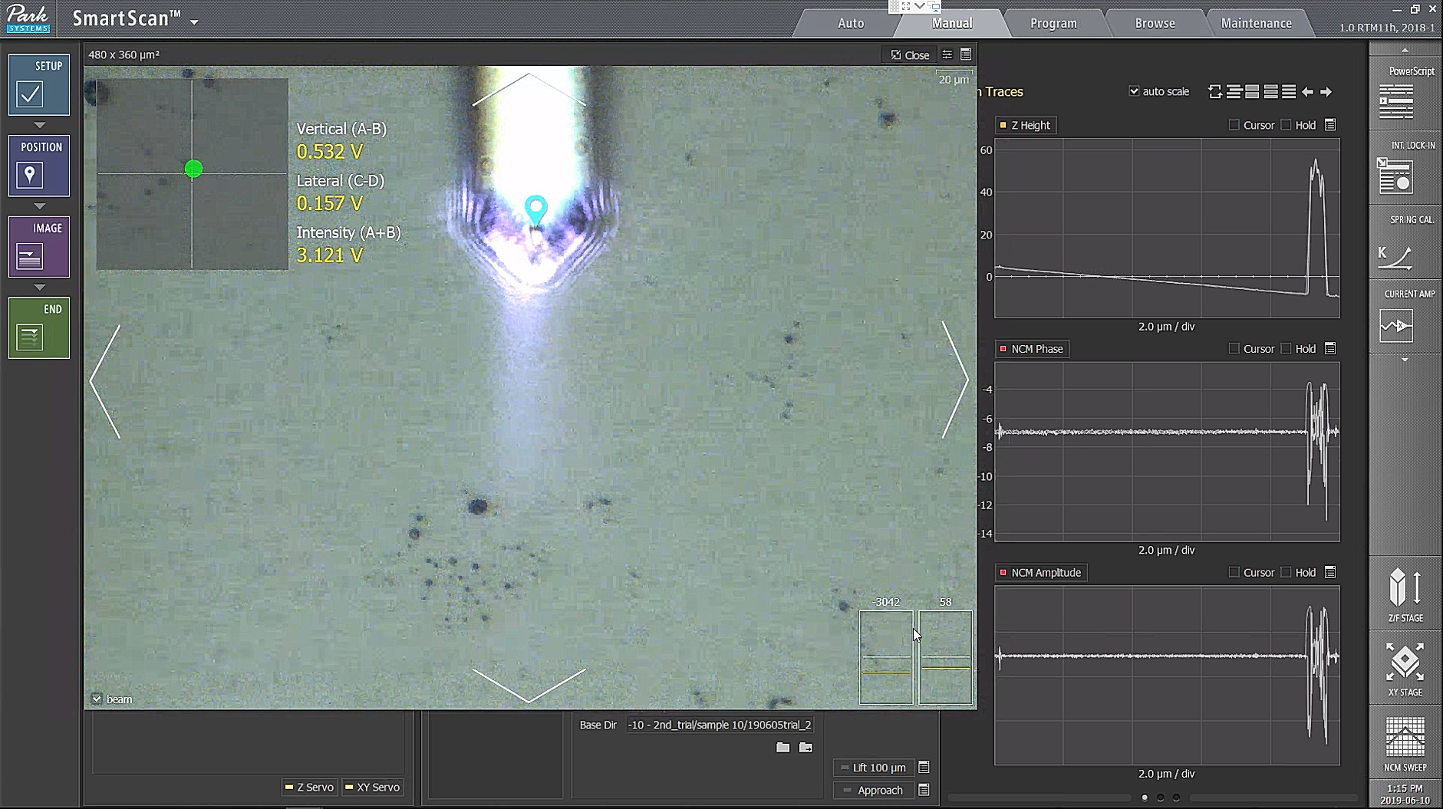

  - Use the arrows to move in the region of the sample of interest. Engage the surface by pressing Approach button. Click on Line Scan button, and check if the tip is following the surface well, if necessary, adjust the Set Point
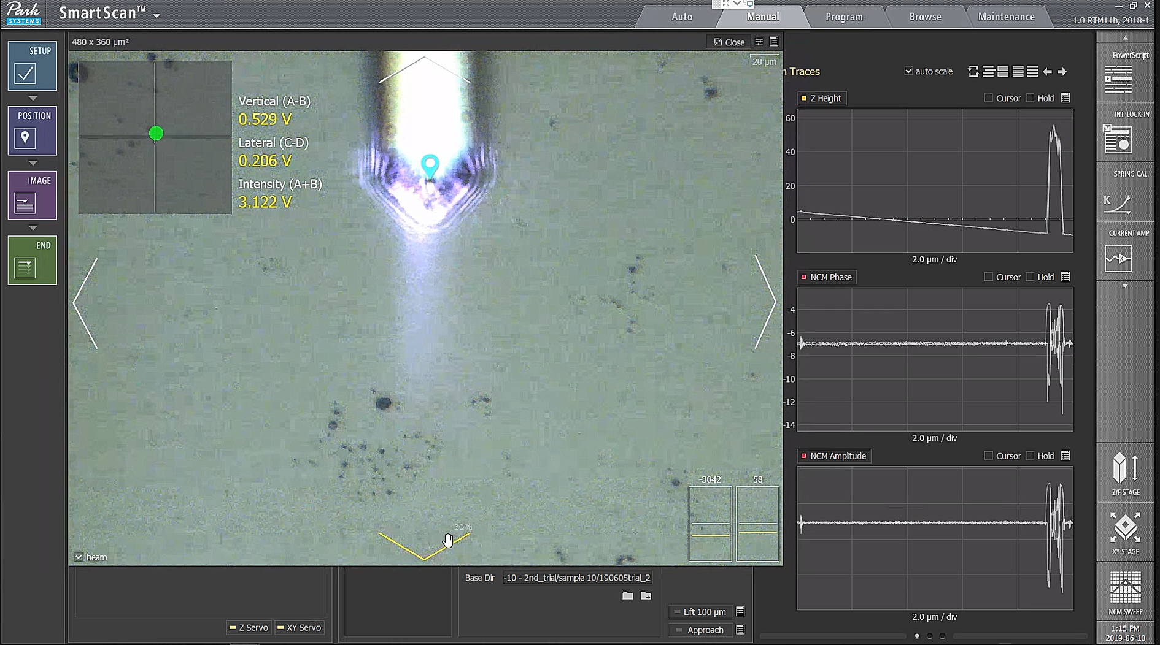

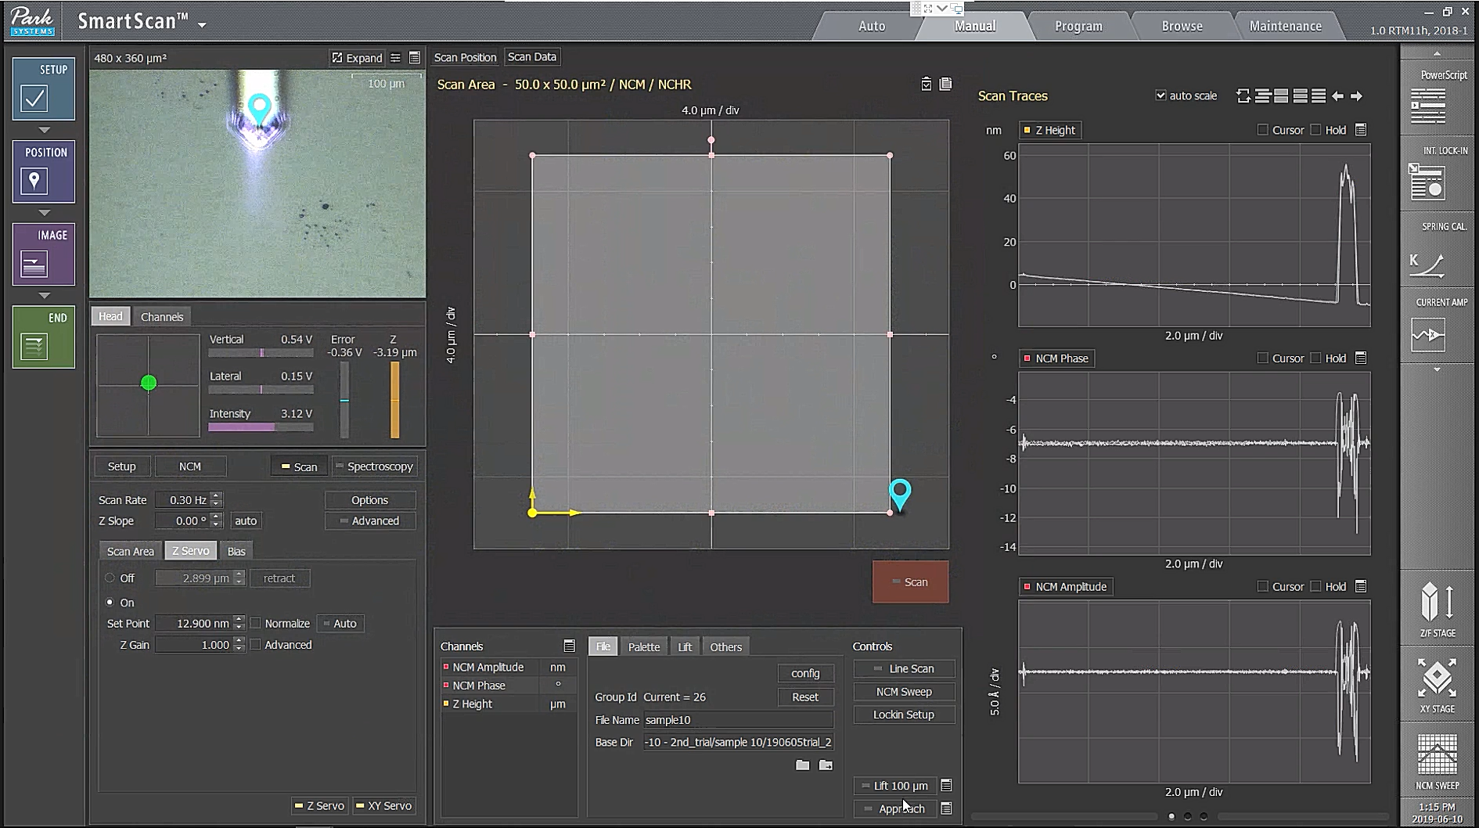

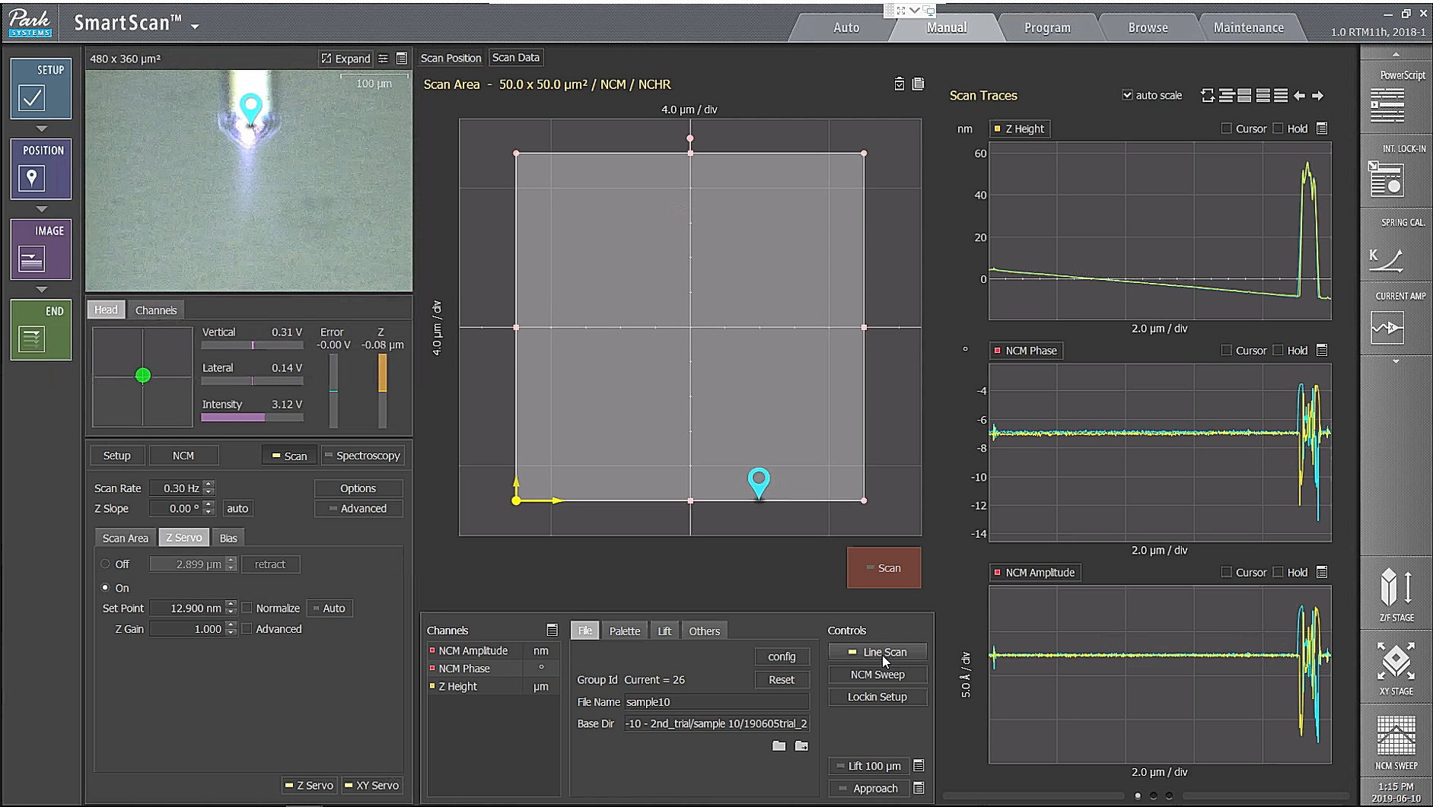

  - Start imaging the sample surface by pressing Scan button. During imaging, to avoid large imaging force and keep consistency of within independent samples, maintain a constant regime of phase change not exceeding Δ20°⁴².
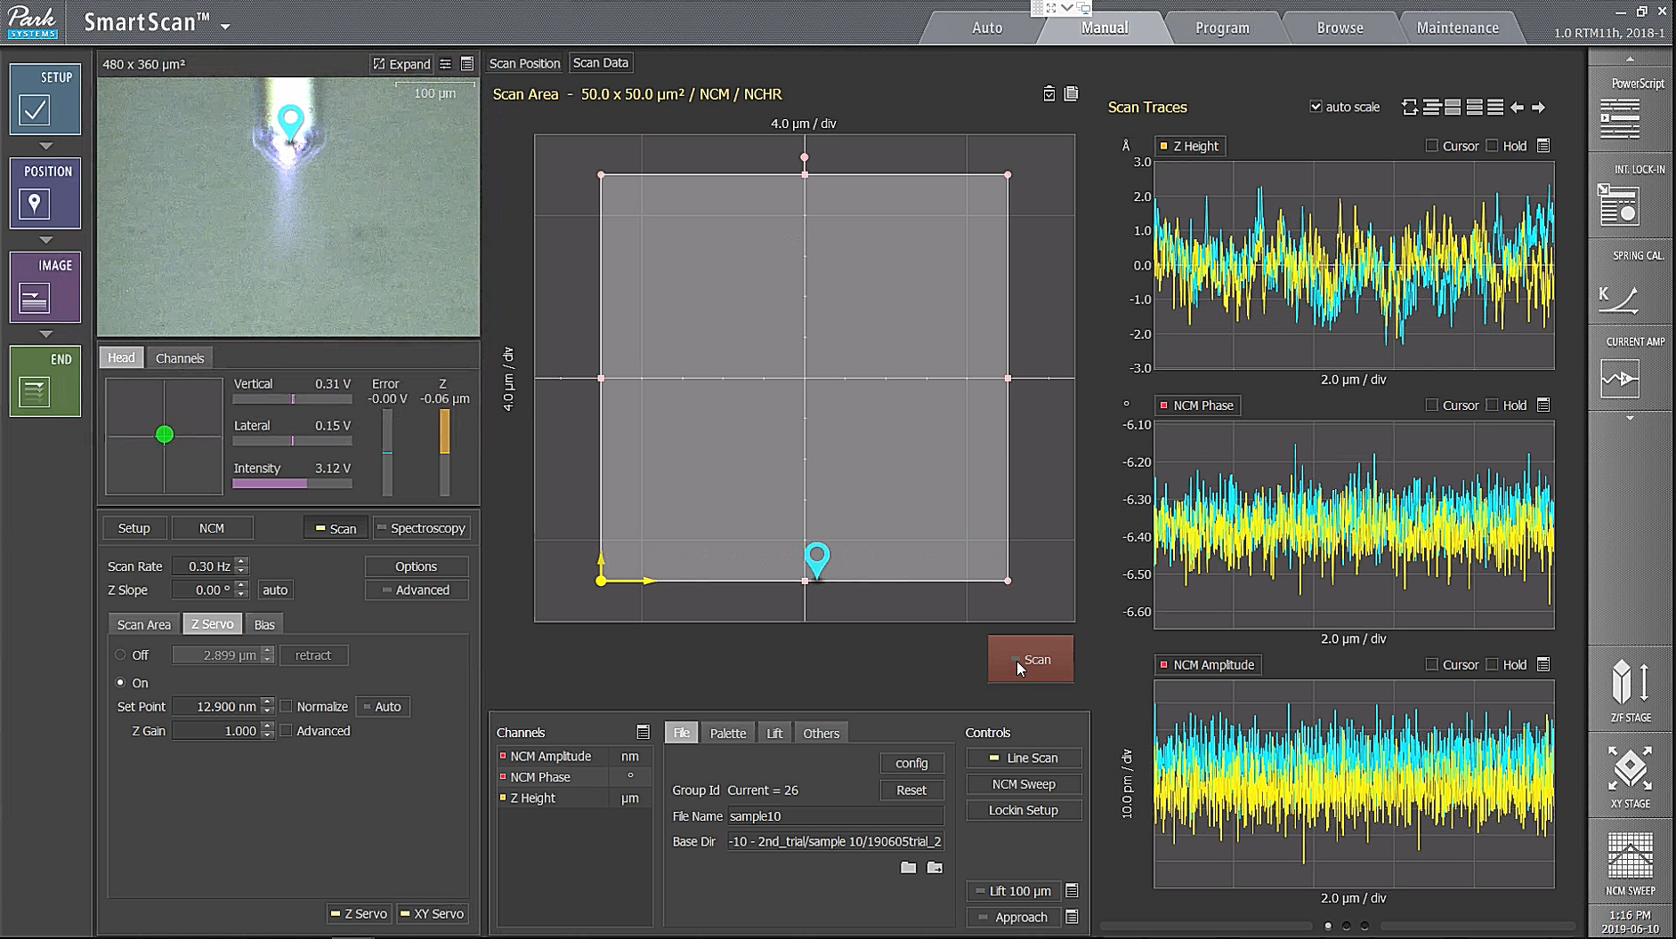

  - Enter file name and choose base directory where the acquired image will be saved.
