Derio, 4th April 2019

Editors and Academic Editors of JOVE,

Please find enclosed the original research article entitled “SUMO-binding entities (SUBEs) are useful tools for the enrichment, isolation, identification and characterization of the SUMO proteome in liver cancer ” by Lopitz-Otsoa et al to be considered for publication for JOVE. We believe that this protocol will be of the interest for many researchers interested in the role of pot translational modifications of SUMOylation in liver disease.

Best regards,
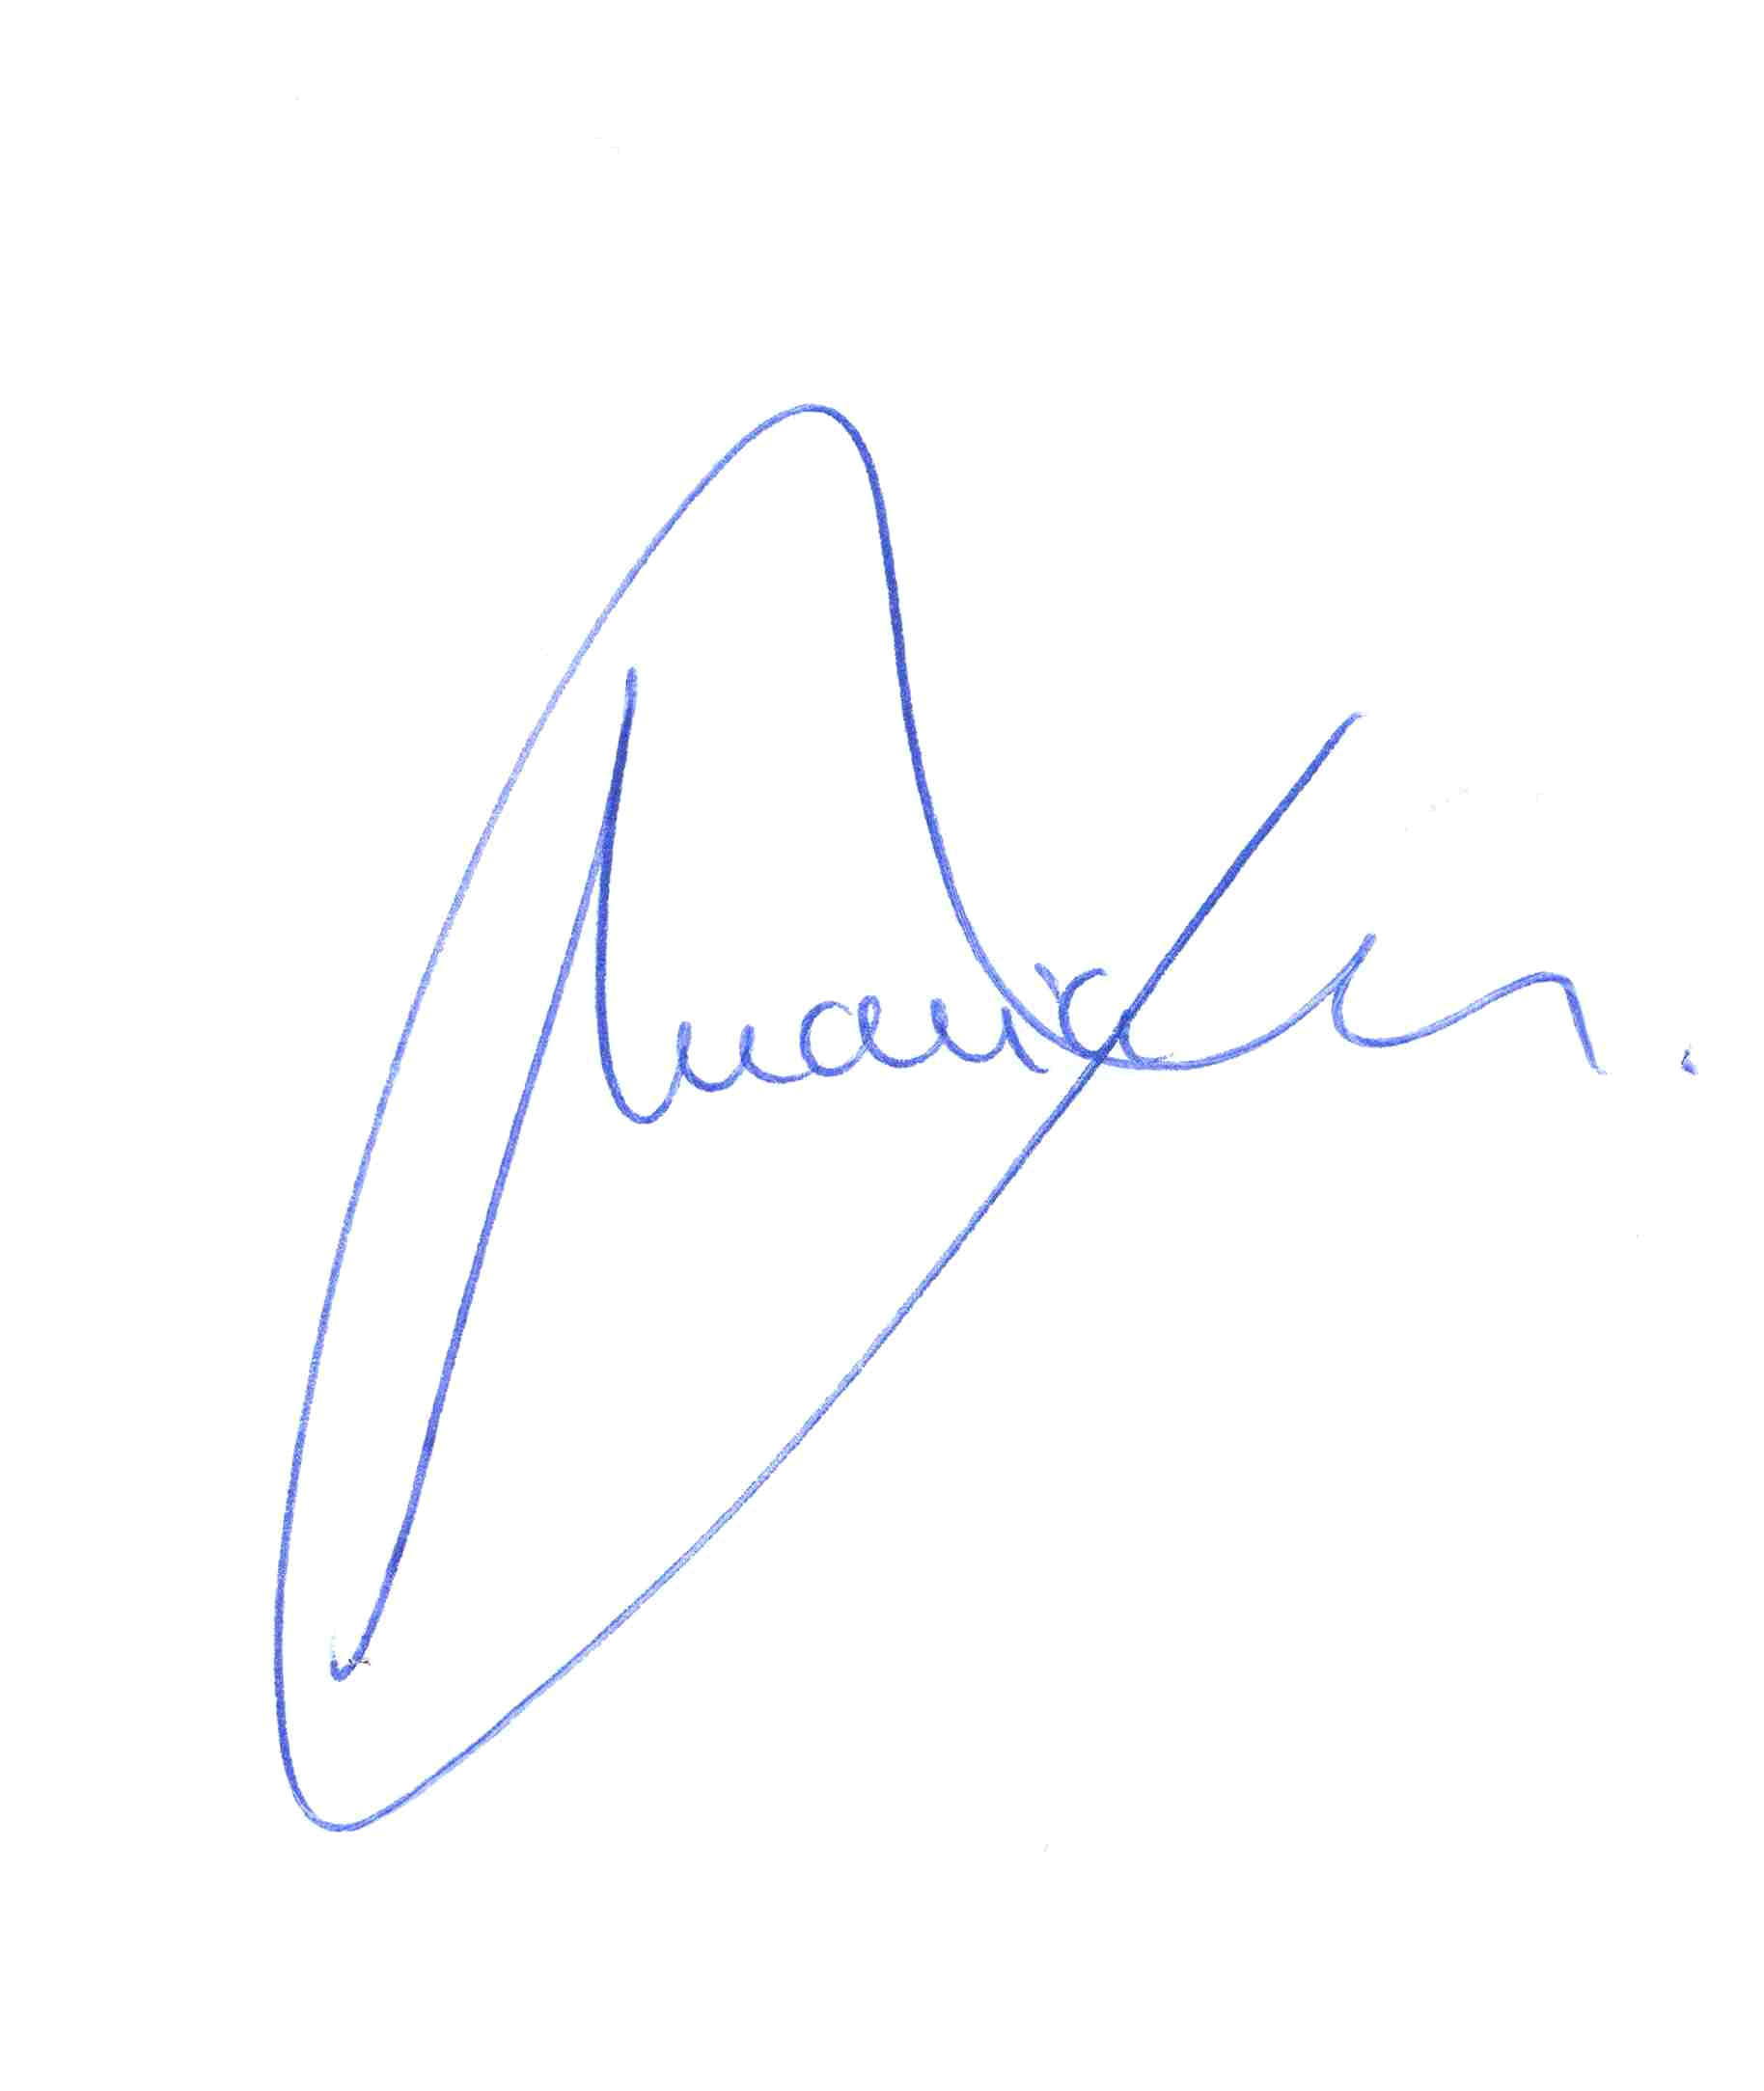

Maria L Martinez Chantar, PhD
Group Leader, Metabolomics Unit
Associate professor, University of the Basque Country
CIC bioGUNE
CIBERehd – Spanish Carlos III Health Institute
Bizkaia technology park, 801 building
48160, Derio Spain
e-mail: mlmartinez@cicbiogune.es
Tel Office: (+34)944061318
Tel Lab: (+34)944061304
Fax: (+34)944061301
http://www.cicbiogune.es

