RE: Rebuttal document for revision due Dec 17, 2019
Ref: JoVE60095
Title: “A high-throughput in situ method for estimation of hepatocyte nuclear ploidy in mice”

Dear Editor,

The following document contains a comprehensive response to both the editorial and reviewer comments. The authors comments are highlighted (in red).

Sincerely,

Dr. Luke A. Noon

Editorial comments:
Please note that the editor has accepted all changes in the submitted revision to obtain a clean version of the manuscript. All editorial and reviewer comments are made on this clean version (see the attachment) and please use this updated version for future revisions.
Changes to be made by the author(s):
1. 1.1: Please specify the age, gender and type of animals used here.
- The following text has been added to step 1.1: “(all analyses have been performed using adult female C57BL/6 mice aged 12-16 weeks)”
2. 5.3: Please specify the parameters used here.
- Step 5.3 and the note below have been edited to provide a clear description of these parameters
- The values for minimal nuclear area and nuclear detection sensitivity used in the study are now provided in the NOTE below step 5.3 and we also offer a more detailed description of the nuclear size range of hepatocytes and non-hepatocytes in the mouse liver
- Figure 2D and the corresponding figure legend have been modified to help describe in more practical terms how these parameters should be altered to achieve optimal nuclear segregation and thresholding for HNF4α.
3. 5.4: Please specify the threshold intensity used here.
- The value of threshold intensity is relative and will depend on staining efficiency and acquisition settings such as laser intensity. It should therefore be standardized by the user.
- We have added the text above to “CRITICAL STEP” section beneath step 5.4. “
4. Section 6.3: In the accompany video, will you demonstrate the analysis using your software? If so, software steps must be more explicitly explained ('click', 'select', etc.). Please add more specific details (e.g., button clicks or menu selections for software actions, numerical values for settings, etc.). For instance, combine the details regarding how to run the application in the supplemental file (section 2.3) with explanations of each step in section 6.3.
- Thank you for this comment. We agree with the editor that the new software is overlooked in the current protocol. In the video, we intend to demonstrate the analysis using the software. We have now edited the protocol as requested to add explicit steps showing how to install, input data and run the application (new steps 6.3.1 to 6.3.3 adapted from the supplementary document as suggested). A new Figure 3 has also been added, which contains screenshots illustrating data formatting, software usage and data output, and we have changed the highlighted yellow text accordingly. We feel that the changes made greatly simplify the methodology for the reader and helps bring the custom written program to centre stage.
5. Are any figures reprinted from a previous publication? If so, please obtain explicit copyright permission to reuse any figures from a previous publication. Explicit permission can be expressed in the form of a letter from the editor or a link to the editorial policy that allows re-prints. Please upload this information as a .doc or .docx file to your Editorial Manager account. The Figure must be cited appropriately in the Figure Legend, i.e. “This figure has been modified from [citation].”
- The Figure 2 legend has now been changed as recommended to state that “This figure has been modified from”. The data used in this figure comes from our PLOS Biology publication which has a Creative Commons License which enables free distribution. Please advise as to whether any further permission is required
6. Figures: Please include a space between the number and the units of the scale bar. Please delete the space before the percent sign.
- Spaces between the units and scale bar have now been checked and added in all figures
- Spaces before % in Figure 4 have been deleted
7. References: Please include volume, issue as well as page number for each reference.
- References have been edited to include volume, issue and page number

Reviewers' comments:
Reviewer #2:
i am happy with the revise manuscript.

Reviewer #5:
Manuscript Summary:
The authors present here a new method to analyze and quantify nuclear ploidy in hepatocytes in fixed/cryopreserved tissue samples. This method is described as alternative to standard flow cytometry techniques requiring cell disaggregation and the consequent loss of spatial information.
The protocol is based on the identification of hepatocytes by immunofluorescence staining with an anti-HNF4 antibody, acquisition of fluorescence images by a high-content imaging platform and analysis of hepatocyte nuclear size distribution and ploidy to distinguish different subsets of hepatocytes. As internal control, the analysis of non-parenchymal cells has been proposed and utilized.
I believe that the proposed method is interesting and useful for the analysis of ploidy in fixed tissues from normal or injured/transformed livers. This protocol could allow the analysis of ploidy changes of hepatocyte population in during liver injury, regeneration and neoplastic transformation.
The morphometric parameters utilized can efficiently characterize different hepatocytes subpopulations "in vivo". Furthermore, data presented by the authors, where the protocol has been used to analyze the impact of cholestatic injury on adult mouse livers, is convincing and supports the efficacy of the protocol.
- RESPONSE: We thank Reviewer#5 for their positive feedback and constructive comments. In the revised manuscript we have sought to address all of the reviewers concerns. Please find below a detailed breakdown of our actions:
Major Concerns:
- while the protocol of tissue preparation and labelling does not require complex procedures, the analysis of data from morphometric measures appears tricky and dependent on the operator's ability, especially in the set-up of the parameters (more than a flow cytometry analysis), and therefore not easy to be managed. The authors should add a comment about the eventual request of a specific expertise, need of skilled operators, variance due to the operator's discretion in the choice of nuclear masks.
- A sentence has been added to the introduction of step 5, which highlights the need for “some basic operator training/expertise” for optimal segmentation and thresholding.
- Extra detail has been added to the notes beneath steps 5.3 and 5.4 to further stress the role of the operator and help the user standardize the set up procedure. This includes providing reference values for expected nuclear size and minimal size cut-off.
- In the new figure 4B the statistical analysis has changed compared to the original figure 3B. Has new data been included? The authors should explain this discrepancy.
- We apologize for the confusion. No new data was included in figure 4B. In the original version of the manuscript, the calibration method for calculating nuclear ploidy used an external descriptor of 2n hepatocyte nuclear size that Reviewer#3 asked us to remove. In the revised manuscript, the calibration method was improved so that it did not require this external information. Given the change in calibration method, the ploidy estimates using the same data differ slightly, explaining the discrepancy in statistical analyses identified by Reviewer#5.
- The sections from 6.3.3.1 to 6.3.3.5 appear unclear and should be better explained
- These 5 steps (now 6.3.4.3.1 to 6.3.4.3.3) have now been edited and the language has been altered to make the calibration methodology clearer.
- the difference between "nuclear elongation factor" and "nuclear form factor" is not clearly defined. Furthermore, the calculation of "circularity index" should be better explained with examples since it is a key parameter to distinguish hepatocytes with different ploidy.
We thank the reviewer for this comment and agree that it is important to improve the clarity of the description of nuclear circularity in the manuscript:
- New Definitions of “nuclear elongation factor” and “nuclear form factor” have now been added in step 5.5
- A note has been added at the foot of step 6.3.4.1.1 (previously 6.3.1.1) to provide a clear definition of the “circularity index” used to separate “simple” and “complex” nuclei. It reads:

  - NOTE: “Nuclear elongation” and “Nuc 1/(form factor)” are two discrete measures of an object’s “circularity” that assess complementary, non-overlapping morphometric criteria. The former measures the long- and short-axes of an object, whilst the latter compares the length of perimeter of an object to that of its area. To strengthen the definition of nuclear circularity used in this protocol, these two measurements have been combined into a single “circularity index”. A previous approach to estimate nuclear ploidy using the described methodology used only nuclear elongation¹⁷. Whilst acceptable results were obtained using this approach, the authors have observed that a composite “circularity index” improves discrimination of manually selected nuclei from mononuclear and binuclear hepatocytes (data not shown)

- The “data not shown” referred to in the NOTE above are provided below (in “Figure X”) for the appraisal of the Reviewer. Use of the combined “circularity index” (B) improves the categorization of manually selected binuclear cells with “touching nuclei” as as compared to nuclear elongation alone (A) – increasing correct classification from 73.2% to 100%.
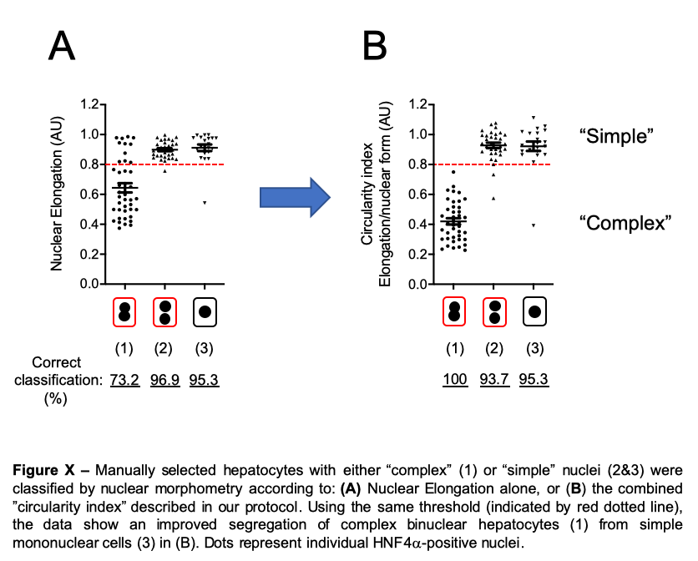
Minor Concerns:
- a minimal editing of text is required. In particular, two sentences in Introduction (lines 60-64 and lines 74-78) and in Protocol (lines 326-328 and 338-343) need to be revised.
- Sentence 60-64 has been shortened and edited
- Sentence 74-78 has been broken up and edited
- Reference to (lines 326-328 and 338-343) was difficult to find. However, calibration steps previously named 6.3.3.2 to 6.3.3.6 have been revised in response to the major concern (above) .
- change ";" in line 31 and line 223 with ":"
(done)
- change ";" in line 74 with " that is"
This sentence has been edited and improved to remove “;”
- change "means" in line 84 with "method"
(Done)
- lines 251-253: "Nuc1" and "center of gravity" terms need to be briefly explained
(Done)

Reviewer #6:
Manuscript Summary:
The manuscript by Manzano-Nunez and colleagues provides an excellent method to quantify in situ hepatocyte nuclear ploidy within liver parenchyma. Although known for long time polyploidy indeed is a fascinating characteristic of the liver parenchyma that still covers many important topics to be revealed and to be extremely important. Polyploid hepatocytes are characterized by the number of nuclei per cell (cellular ploidy), as well as the ploidy of each nucleus (nuclear ploidy). The manuscript accurately described in detailed the method to analyze nuclear ploidy. This method has been used to measure the impact of cholestatic injury on the adult mouse liver. The text is well written, clear and free of bias. The figures are clear.
- RESPONSE: We thank Reviewer#6 for their generous appraisal of the manuscript and for recognizing the potential importance of our protocol to research in this field . Please find below a detailed response to their useful suggestions and comments:
Minor Concerns:
I only have a few minor suggestions:
1) Maybe at the end of the manuscript, it will be interested to discuss what is advantage of this new method compared to others methods that have been already published to quantify hepatocyte nuclear ploidy in mice.
Gentric G, Maillet V, Paradis V, Couton D, L'Hermitte A, Panasyuk G, et al. Oxidative stress promotes pathologic polyploidization in nonalcoholic fatty liver disease. J Clin Invest 2015;125:981-92.
Miyaoka Y, Ebato K, Kato H, Arakawa S, Shimizu S, Miyajima A. Hypertrophy and unconventional cell division of hepatocytes underlie liver regeneration. Curr Biol 2012;22:1166-75.
Tanami S, Ben-Moshe S, Elkayam A, Mayo A, Bahar Halpern K, Itzkovitz S. Dynamic zonation of liver polyploidy. Cell Tissue Res 2017;368:405-10.
Morales-Navarrete H, Segovia-Miranda F, Klukowski P, Meyer K, Nonaka H, Marsico G, et al. A versatile pipeline for the multi-scale digital reconstruction and quantitative analysis of 3D tissue architecture. Elife 2015;4.
- We thank Reviewer#6 for this very useful suggestion. In response, we have added two sentences to the discussion (underlined) to elaborate the advantages of our method:

“An important innovation is the use of NPCs as an internal ploidy calibrator that enables relative assessment of hepatocyte nuclear DNA content both within and between samples. Incorporation of an HNF4α labelling step is therefore key to providing this protocol with a unique technical advantage compared to previously published 2D methods^{3,12,22}. In contrast, the relative simplicity of the methodology in comparison with 3D reconstruction workflows¹⁸ makes it technically less laborious and potentially more flexible.”
2) As described in the paper, there is an age-dependent difference in hepatocytes nuclear ploidy. For the experiments, the authors have used adult female C57BL/6 mice aged 12-16 weeks. Do the authors have analyzed if they can quantify by their method nuclear ploidy modification during normal ageing? Is there a difference of nuclear ploidy between adult male and female C57BL/6 mice (same age)?
- Unfortunately, we have not investigated age or sex dependent changes in nuclear ploidy using our methodology and agree with the reviewer that this would be interesting. Both age and sex dependent differences in hepatocyte nuclear ploidy in C57BL/6 mice have been described previously by Ohtsubo et al (1986) using FACS. This study showed that nuclear ploidy increased in both males and females with age, but that young (<5months) male mice had nearly twice the number of 4C nuclei compared to females of the same age

Ohtsubo, K. & Nomaguchi, T. A. A flow cytofluorometric study on age-dependent ploidy class changes in mouse hepatocyte nuclei. Mechanisms of Ageing and Development (1986).doi:10.1016/0047-6374(86)90013-8
3) With this methods, do the authors are able to define nuclear ploidy within binuclear fraction (2x2N, 2x4N, 2x8N) in normal liver parenchyma.
- As we have outlined in the “Interpretation of nuclear morphometry” section of the manuscript, our methodology cannot clearly discriminate between the nuclei of mononuclear hepatocytes and those of binuclear cells in which the nuclei are clearly separated within a common cytoplasm. This limitation and how it could potentially be overcome are discussed in “Future refinements and challenges”.
- Within this discussion we state that: “further segregation of “complex” binuclear cells could be achieved by radial measurements of the nuclei that their 2D masks contain”. In other words, we think that it is conceivable that morphometric interrogation of “complex” nuclei could reveal quantitative data relevant to the numbers of 2x2N, 2x4N and 2x8N binuclear cells as suggested by the reviewer.

