Nuclear ploidy analysis software
From: JoVE60095 “A high-throughput in situ method for estimation of hepatocyte nuclear ploidy in mice”

The post-processing described in step 6.3.4 of the protocol (JoVE60095) can be performed using a custom written MATLAB application, freely available for download at : https://github.com/lukeynoon. Source code is also provided for users who wish to adapt the methodology. The following section describes the methodology and use of the application for the estimation of nuclear ploidy. Please report any user issues on the GitHub site. Alternatively, please contact rp649@cam.ac.uk or lnoon@cipf.es under the subject line of Ploidy Application.

  - Description of the methodology
The algorithm uses nuclear morphometry data to firstly separate hepatocyte nuclei into two groups; (1) those with “simple” circular nuclei and (2) “complex” non-circular nuclei representative of binuclear cells with >2c ploidy. The minimal nuclear DNA content (a function of nuclear area and DNA density) is next calculated. A subsequent step then calibrates HNF4α+ hepatocyte nuclear ploidy using HNF4α- nuclei as a known 2-4N internal control. A summary of the steps taken by the software are outlined below:

    - Separate the control data into “simple“ or “complex“
      - Data is automatically separated into either HNF4α+ or HNF4α- nuclei.
      - A circularity index (defined as the Elongation divided by the Form Factor) is calculated for all nuclei.
      - Nuclei for which the circularity index <= 0.8 or >0.8 are classified as ”complex” and ”simple” respectively. Note that a value of 1.0 indicates a perfect circle.

    - Estimate the minimal nuclear DNA content of simple hepatocytes and non-parenchymal cells within the control data
1.1.2.1 The method estimates the nuclear radius (r) of both simple hepatocyte and non-parenchymal nuclei by:
$$r=\sqrt{\frac{nuclear area}{π}}$$
1.1.2.2. The nuclear volume ($v$) is then calculated per:

$$v=\frac{4}{3}×π×r^{3}$$
1.1.2.3. From which a relative value of minimal DNA content is estimated as:

$$minimal DNA content=Mean Hoechst intensity×v$$

    - Stratify minimal DNA content of “simple” nuclei according to ploidy (2c, 4c, 8c or 16c) by calibrating the dataset using non-parenchymal nuclei as an internal 2-4n control.

1.1.3.1. A histogram of the minimal DNA content of the HNF4α- nuclei is computed. Bin width is set to the square root of the number of values binned.
1.1.3.2. An average of the three most frequent bins in the histogram is used as an estimation of the modal value of the Nuclear DNA content.
1.1.3.3. The minimal DNA contents are then filtered to those that lie within 1 standard deviation of this average value.
1.1.3.4. Within this filtered range, the nuclear areas and corresponding Hoechst intensities are examined. The minimum size for which the Hoechst intensity is maximum is extracted (defined here as the minimum of the second derivative of the area vs. Hoechst intensity curve). This represents the 2n-4n transitional state.
1.1.3.5. To estimate the 4n shoulder, 1 standard deviation of the Nuclear DNA content is appended to the transitional point.
1.1.3.6 Steps 1.1.3.1 – 1.1.3.5. are repeated for all Control samples.
1.1.3.7. An average 4c stratification threshold is calculated, from which the 2c (S_{2c}) and 8c (S_{8c}) boundaries for minimal DNA content (m) are further estimated.
1.1.3.8. The corresponding ploidy value of each nucleus is calculated per:

$$Ploidy \left(p\right)=\frac{Minimal DNA content (m)}{S\text{2c}} ×2$$

For which $S\text{2c}$ represents the 2c DNA content standard, i.e. the 2n stratification threshold calculated in section 1.1.3.7.
1.1.3.9. Ploidy values (p) of non-parenchymal cells are automatically saved and simple hepatocyte nuclei are stratified into 2c/ 4c / 8c/ 8c+ ploidy brackets according to the following criteria:

“2c” Hepatocytes = p ≤ 2
“4c” Hepatocytes = 2 < p ≤ 4
“8c” Hepatocytes = 4 < p ≤ 8
“8c+” Hepatocytes = 8 < p

    - Ploidy estimation and stratification for comparative (e.g. Injured) samples.

1.1.4.1. Steps 1.1.1 – 1.1.2 are repeated for the comparative data sets.
1.1.4.2. The comparative data sets are stratified according to the control thresholds calculated in section 1.1.3.7.
1.1.4.3. The corresponding ploidy value of each cell is calculated and stratified per sections 1.1.3.8 – 1.1.3.9.

2.1 Installing the application
2.1.1 Download the packaged application from : https://github.com/lukeynoon
    - Launch MATLAB.
2.1.3 Navigate to the APP tab of the MATLAB toolstrip, click “Install App” and open the downloaded application termed “Ploidy_Application.mlappinstall”. A message will appear to confirm the successful installation.
2.1.4 The application is now ready for use and will remain in the APP tab of the MATLAB toolstrip.

2.2 Critical stages before running the application: Data must be stored according to the following instructions.

    - The exported excel spreadsheet files (.XLS 97-2004 workbook) from the high-content image analysis software must contain a sheet termed “Cell measures” which contains the data required for the ploidy analysis. It is important that the following column header names remain unchanged (see example datasets), as the analysis method finds the correct column data by searching for these names. If for example, your software does not produce a “Light flux” column shown here in column K, please manually insert a column termed “Light flux” in the same location, i.e. column K and fill it with zeros.

    - For each experimental condition, a control data set must be provided since this will be used to calculate the internal control (see 1.1.3). In this study, we used normal livers from untreated adult littermates (“Control-d0”).

    - For biological replicates (per condition), each excel spreadsheet should be stored in its own folder. The folder prefixes should be named incrementally, for example as “Sample1, Sample2, Sample3…. SampleN”, as per the filenames. For example, your data should be stored in this way:

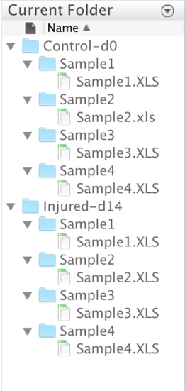
Figure: Example of data storage requirements.

2.3 Running the application.
2.3.1 Click on the Ploidy_Application via the MY APPS tab of the MATLAB toolstrip:

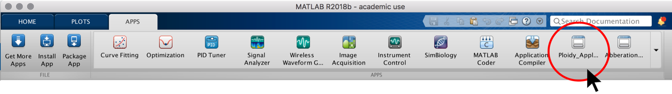
Figure: Launching the Ploidy_Application.

2.3.2 The Ploidy_Application GUI will appear:

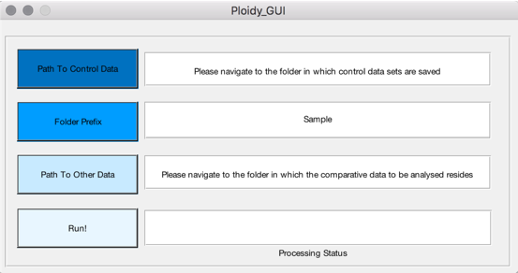
Figure: Ploidy_Application GUI.
2.3.4 Click the “Path to control data” button to navigate to the folder in which the control data replicates reside. This data path will then appear in the interface. For example, in the case of section 2.2.3 this data path would be: /Users/Desktop/Control-d0
2.3.5 Next, type the name of the folder/file pre-fix names chosen. For example, in the case of section 2.2.3 this would be: Sample. Note that this prefix can be changed to any text, provided that the folders and filenames remain incrementally named.
2.3.6 Click the “Path to other data” button to navigate to the folder in which the comparative data replicates reside. This data path will then appear in the interface. For example, in the case of section 2.2.3 this data path would be: /Users/Desktop/Injured-d14
2.3.7 Click the “Run!” button. When the analysis is complete, the status bar will read “Analysis Complete!.."

2.4 Application Outputs
2.4.1 The application will report, for each sample, stratification into ≤2n, 2n-4n, 4n-8n and 8n+ in terms of absolute counts and as a percentage of total. These files will be automatically saved in each sample folder as:
“Count_2n.txt”
“Count_2n_to_4n.txt”
“Count_4n_to_8n.txt”
“Count_8n_and_higher.txt”
“Percentage_2n.txt”
“Percentage_2nto4n.txt”
“Percentage_4nto8n.txt”
“Percentage_8n_and_higher.txt”
2.4.2 The application will automatically save, for each sample, the ploidy estimation for hepatocytes and non-hepatocytes as:
“Ploidy_All_Hepatocytes.txt”
“Ploidy_NonHepatocytes.txt”

2.4.3 For the control data set, the method also saves the thresholds used for the stratification (section 1.1.3) in a file termed “Normalised_Thresholds_Control”.

2.4.4 Finally, the application will produce a folder for the control and the other condition data termed “Summary”. This folder contains two subfolders: “Ploidy” and “Stratification” which contain the averages of all samples provided:

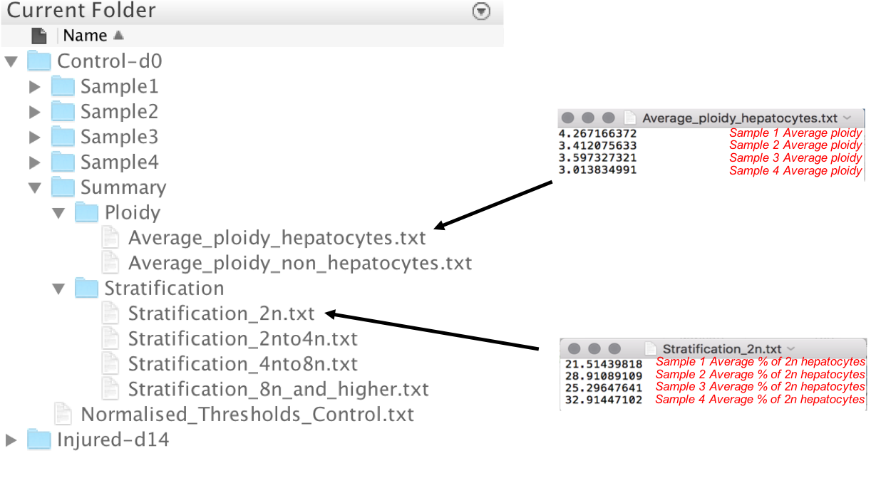
Figure: Example of the summary output files of the Ploidy Application.

