May 9, 2019

Dear Editors,

I have made the requested revisions to my manuscript titled, “Preparation of 6-aminocyclohepta-2,4-dien-1-one Derivatives via Tricarbonyl(tropone)iron.” I have addressed the comments by the editorial team and reviewers as delineated below.

Editor’s comments:

1. The manuscript has been thoroughly proofread.
2. No figures have been re-used from prior publications. Thus, after confirming with the review editor, no permissions are needed.
3. Highlighting in the protocol was adjusted such that only complete sentences are highlighted.
4. Short descriptions were added for each figure in the Figure Legend.
5. A revised Table of Equipment and Materials has been prepared that does not contain trademark symbols.
6. After consulting with the review editor, parts of the introduction and protocol that contained some overlap with previously published work has been revised. In addition, the title of the manuscript has been slightly modified to further differentiate it from previously published work.

Minor concern from Reviewer #2:

The experiment suggested by the reviewer was one we had previously attempted without success. A small addition pointing this out has been added to the Discussion section.

Thank you for your help in readying this submission for publication and I thank the reviewers for their thoughtful and helpful comments.

Sincerely,

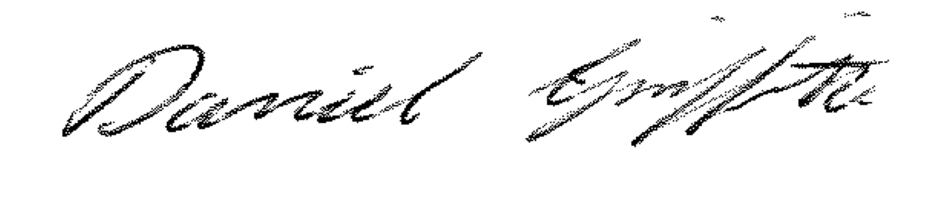

Daniel Griffith

