Robert Steward Jr.
University of Central Florida
12760 Pegasus Drive
Bldg. 40, Room 245
Orlando, FL 32816-2450

June 27, 19

Phillip Steindel
Review Editor, Jove
1 Alewife Center, Suite 200
Cambridge, MA 02140

Dear Mr. Steindel,

Thank you for your consideration of our manuscript entitled “Protocol for perturbing endothelial biomechanics by Connexin 43 structural disruption”. The authors of this paper Md. Mydul Islam and Robert Steward, Jr. very much appreciate your prompt response and the reviewer’s comments. We have addressed the editor’s comments and reviewer’s comments point by point and highlighted each change in the manuscript in green. In addition, for your convenience and the reviewer’s convenience we have also attached a document explicitly listing every change made to the manuscript in response to the reviewer’s comments

We once again thank you for your consideration of our manuscript and look forward to hearing from you.

Sincerely,
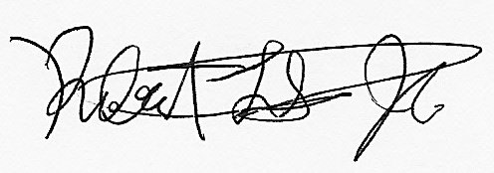
Robert Steward Jr., Ph.D.

