University Medical Center, Rheinische Friedrich-Wilhelms University
Department of Anesthesiology and Intensive Care Medicine
Sigmund-Freud-Str. 25, 53127 Bonn, Germany

To
Prof. Dr. Ronald Myers
Editor-in-Chief Journal of Visualized Experiments

Wednesday, April 17, 2019

Manuscript revision JoVE59999_R1

Dear Prof. Myers,
dear Prof. Bajaj,

we thank you for giving us the opportunity to again submit a revised version of our manuscript. We have carefully studied all editor’s comments and gratefully acknowledge the helpful suggestions that further improve our report. In order to meet all demands, we have made comprehensive modifications within the text.
All sections that should be filmed are highlighted in yellow colour. The highlighted section is no more than 2.75 pages including heading and spacings.
We added detailed comments and descriptions to the FACS processing steps and included two tables describing the preparation of FACS buffer and of staining mastermix. Furthermore, we added appropriate citations to the respective parts of the protocol

We hope that these additional clarifications address all of your concerns sufficiently and that you agree that the changes improved our manuscript and helped to clarify the report. Please do not hesitate to contact us if you should have any more questions. We are very looking forward to your decision.

Thank you very much!

Sincerely,
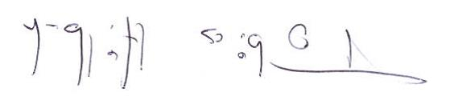

PD Dr. med. Tobias Hilbert, MD, D.E.S.A.

Department of Anesthesiology and Intensive Care Medicine, University Medical Center Bonn
Sigmund-Freud-Strasse 25
53127 Bonn, Germany
Email: thilbert@uni-bonn.de

