

April 17, 2019

To: Bing Wu, Ph.D.
Review Editor, JoVE

RE: Editorial Revisions of JoVE59995R1

Dear Dr. Wu,

Thank you for your correspondence regarding additional editorial revisions to our manuscript, “Single Cell Durotaxis Assay for Assessing Mechanical Control of Cellular Movement and Related Signaling Events”. We have addressed all of these new editorial comments, as detailed below. We have also appended the original response letter at the end of this one, to ensure that all of our responses and their information are available in one document. We hope that the manuscript is now acceptable for publication in the Journal of Visualized Experiments.

Again, we thank you and the reviewers for your time & effort in reviewing this work and we look forward to hearing from you soon.

Sincerely,

Alan K. Howe, Ph.D.
Associate Professor
Department of Pharmacology
Department of Molecular Physiology & Biophysics
University of Vermont Cancer Center & Larner College of Medicine
University of Vermont
Burlington, VT 05405

Response to Additional Editorial Comments – Summary

1. “…thoroughly proofread the manuscript…” – The text has been proofread and spelling/grammar issues eliminated.
2. through 6. “…provide…sub-heading for steps…” – Subheadings 1.1, 1.2, 1.3, 1.4, and 1.5 have now been added.
7. “…avoid long steps/notes…” – All of the steps, especially all of the highlighted sections, are now four lines or less. All notes, except for the one following step 1.4.2, are also four lines or less. The aforementioned note contains information in direct response to a reviewer’s comment; it cannot be shortened to four lines or less without significantly compromising its content.
8. “…Please remove all commercial language…” – Commercial language has been removed from the text and/or moved to the Table of Materials.
9. “…remove registered (®) symbols…” – This symbol has been removed from the Table of Materials.

April 16, 2019

To: Bing Wu, Ph.D.
Review Editor, JoVE

RE: Revisions of JoVE59995

Dear Dr. Wu,

Thank you for your correspondence regarding necessary revisions to our manuscript, “Single Cell Durotaxis Assay for Assessing Durotactic Cellular Movement and Related Signaling Events”. We appreciate the positive comments of the reviewers, as well as their detailed and insightful comments and suggestions for improvement. In this revision, we have addressed all of the reviewers’ concerns as well as all of the editorial comments; a summary of the editorial corrections and a detailed response to reviewers’ concerns are appended below. We hope that the manuscript is now acceptable for publication in the Journal of Visualized Experiments.

Again, we thank you and the reviewers for your time & effort in reviewing this work and we look forward to hearing from you soon.
Sincerely,

Alan K. Howe, Ph.D.
Associate Professor
Department of Pharmacology
Department of Molecular Physiology & Biophysics
University of Vermont Cancer Center & Larner College of Medicine
University of Vermont
Burlington, VT 05405

Response to Editorial Comments – Summary

- “…thoroughly proofread the manuscript…” – The text has been proofread and spelling/grammar issues eliminated.
- “…obtain explicit copyright permission to reuse any figures…” – This is not applicable, as all of the figures used are original and unpublished.
- “…12 pt font and single-spaced…” – This and other formatting guidelines (see below) have been implemented.
- “…keywords…” – Seven keywords/key phrases have been provided.
- “…one-line space…” – This and other formatting guidelines (see above & below) have been implemented.
- “…time units…” - This and other formatting guidelines (see above & below) have been implemented.
- “…highlight complete sentences for filming.” – Done.
- “…remove the embedded Table…” – The table has been removed from the manuscript text and supplied as a separate .xlsx file.
- “…revise the Discussion to explicitly cover the following…” – The Discussion has been extensively revised to address critical steps and troubleshooting, modifications and future applications, comparison to existing methods, and limitations.
- “…do not abbreviate journal titles…” – This formatting has been changed.
- “…include a scale bar for all images…” – Scale bars for micrographs have now been included.

Reviewer #1 – Response
We thank the reviewer for mentioning that “this is a well-written, succinct manuscript”, and for their comments and concerns, which are addressed below.

1. “…perhaps it should be noted what the benefits are of introducing microspheres in this manner…”
The benefits of the described microsphere handling ‘surface-embedding’ method, compared to uniform inclusion of beads throughout the hydrogels have been detailed in the revised Discussion section.

2. “Many common items are not found in the product list…”
There are no explicit instructions from the publisher as to what to include or exclude. Nonetheless, we have significantly expanded the product list to include items for which we feel the source is of particular importance.

3. “Perhaps reword ‘plasma cleaning’…to be a bit more descriptive.”
More detailed information for this step (e.g. the model, condition, and settings) has been included.

4. “How exactly are the authors exposing their Sulfo-SANPAH treated coverslips…?”
More detailed information for this step (e.g. the use of a light-fast enclosure surrounding the UV exposure tool) has been included.

5. “What about using other ECM molecules using this method?”
We took this comment as a request to discuss the use of other ECM molecules, rather than demonstrate their use – we hope that this is correct. The ability of the described method to be extended to use different adhesive ligands and different cells has been described in both the protocol text as well as the Discussion section.

6. “Are the bottom coverslips also in 60 mm Petri dishes?”
We apologize for the lack of clarity surrounding the bottom coverslips and 60 mm dishes. We routinely use imaging dishes with a 60 mm outer diameter and a central 30 mm glass imaging window, so there is no separate coverslip, per se – the hydrogel is cast directly on the silanated glass surface of the dish – so it cannot move or float. However, the described method is perfectly adaptable to other configurations, such as the use of a smaller diameter bottom coverslip that fits into an appropriate imaging chamber. The appropriate sections have been rewritten to clarify these details.

7. “Are cells plated in a smaller volume that just covers the bottom coverslips…?”
The cells are actually plated in a larger volume that covers the entire dish at a density of ~1000 cells/cm². This has been indicated in the protocol text.

8. “Missing period at the end of 5.2.”
We sincerely thank the reviewer for their detailed reading of the text. A period has been added, and other typographical errors have been corrected.

9. “Figure 5 is not referenced in the ‘Representative Results’ section.”
This was due to a typographical error in the original manuscript that led to us referencing Figure 6 twice. This has been corrected and all figure are now referenced.

10. “Add labels to the top of the images…in Figure 2...”
This figure has been labelled for increased clarity.

11. “It may be difficult for a reader to understand what is being shown in Figure 3A…”
This figure has been modified in a number of ways to increase clarity. Pseudo-coloring for the null and displaced bead fields have been changed and a labelled scale bar has been added to the vector and heat map panels. The position of the micropipette is outside the boundaries of the depicted bead field, but this has been now clearly indicated in the figure legend. Finally, other aspects of the legend have been re-written for clarity.

12. “…it may be less confusing for some readers if the turn angle in Figure 4E was …flip[ed] 90 degrees…”
Flipping the red lines as suggested would depict the ‘wrong’ angle (i.e. an angle we did not measure). However, we agree with the reviewer that the method depicted in the figure could be clearer, so we have changed the lines to arrows and changed the line depicting the original trajectory to a dotted line. We feel that this makes the method much clearer and evident.

13. “Figure 5 caption does not need to reference ‘(A)’ since the images are not broken down by letters.”
The ‘(A)’ has been removed.

14. “In Figure 6, how can the reader identify new focal adhesions in A?”
We agree with the reviewer regarding the requirement for increased clarity in this figure and have extensively revised both the figure and the legend to simplify and clarify their interpretation.

15. “The last sentence of the Discussion is unclear (may need a comma).”
The Discussion, including the last sentence, has been extensively revised to increase content and clarity.

Reviewer #2 – Response
We thank the reviewer for their insightful major concern, as well as the helpful minor concerns. All of these are addressed below.

MAJOR CONCERN
“I have a general question that I've never understood about this approach. Has anyone ever measured the stiffness of the substrate that is being stretched to confirm that it's actually stiffer? For example's sake, consider a spring that is behaving elastically. We know F = k*x. If we apply a force we get a displacement that is proportional to the spring's stiffness. As long as we are in the elastic regime, if we want the spring to stretch more, we simply apply a larger force. The stiffness of the spring doesn't change. As far as I can see, that's what you're doing here. You're applying a force and getting a strain field, but that doesn't make it stiffer. If the cell wants to deform the matrix further, it still has to apply the same force because the material properties of the gel are the same. This doesn't invalidate the results you see, it just changes how they are interpreted. Could you actually use your AFM to measure the stiffness of the region being pulled?”

This is a matter of central importance and we appreciate the reviewer bringing it up. Unfortunately, we cannot answer the question in the ‘simplest’ manner, i.e. through experimentation, as there is simply no way to position the micromanipulator within under the AFM we have at our disposal. However, it is important that we still endeavor to address the concern.
The reviewer is correct that the direct proportionality (F_{P}=k*Δx) of Hooke’s Law applies to a linear spring. However, the gels in this assay do not behave in a simple, linear fashion, as can be seen in the nonlinear displacement field generated by stretching the gel with the microprobe (manuscript Fig. 3 and figure below). Consider, then, that the magnitude of the restoring force (i.e. the force required to restore the stretched spring to its original length) is proportional to how far the spring is stretched from its original length; i.e. F_{R}=-k*Δx. Because the displacement increases with the proximity to the pulled microprobe (e.g. Δx1 < Δx2 < Δx3; see figure below), so then does the restoring force ((F_{R1}=-k*Δx1) < (F_{R2}=-k*Δx2) < (F_{R3}=-k*Δx3)). Functionally, this increased force or counter-tension is perceived by the cell as a stiffer substrate. Specifically, as a cell moves up this gradient (e.g. from a to b), either a ‘constant’ cell-generated contractile force would produce less and less gel movement, or the cell would have to exert higher force in order to move the gel the same distance. Indeed, this was elegantly & succinctly discussed by Lo et al in their original description of durotaxis, in which they state:
“…the force/deformation caused by the external manipulation will be superimposed on the effects of the cellular probing forces. …Because fibroblasts exert centripetal forces on the substrate, pulling the flexible substrate away from the cell center means that cell-generated forces produce less substrate motion, which may then be interpreted by the cell as being equivalent to a stiffer substrate.”
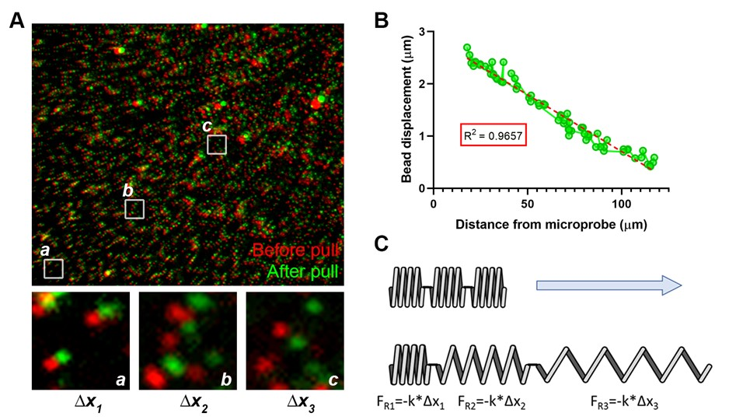
Nonetheless, to clarify the text, we have judiciously replaced certain instances of the term “stiffness” with “tension”, as appropriate. We respectfully suggest that this explanation not be included in the final, published manuscript, as (1) we feel it is not needed to appreciate the protocol as presented and (2) the explanation makes certain ‘assumptions’ (e.g. the use of a simple ‘spring’ to depict a complex pseudo-elastic material) that we feel may draw criticism from readers with formal background or training in engineering and/or physics.

MINOR CONCERNS
1. “Table 1: Are these stiffness values the Young's modulus?”
The stiffness values do, indeed, reflect the Young’s modulus. Details on their derivation (e.g. use of a Hertz model and the AFM probe size & shape) have been added to the appropriate section.

2. “Have you measured the height of the gel?”
We have measured the height of our standard gel and found the calculation to be relatively accurate, but we also have found that the height can be influenced by the thickness and manufacturer of the coverglass used for the top. These considerations, as well as a brief method for directly measuring gel height, have been included in this section of the protocol.

3. “…it might be useful to include the settings that you use successfully in your lab to generate …micropipettes”
More detailed information for this step (e.g. puller model, 1st and 2nd stage pull temperatures, 1st stage pull distance) has been included.

4. “What is the purpose of the mineral oil?”
The mineral oil prevents media evaporation during prolonged live-cell imaging sessions. This detail has now been included in the protocol text.

5. “While…the durotactic response [is described] over a period of 80 minutes, these time points are clearly variable and can be adjusted to whatever experiment the user wants to perform.”
The reviewer is absolutely correct. This has now been explicitly mentioned in the protocol text.

