Yuko Takagi
National Institute of Advanced Industrial Science and Technology
1-1-1 Higashi, AIST Central 6
Tsukuba, Ibaraki, Japan 305-8566

April 29, 2019

Dear Dr. Steindel,

Thank you for giving us the opportunity to revise our manuscript, JoVE59962 "Introducing a gene knockout directly into amastigote stage of Trypanosoma cruzi by CRISPR/Cas9 system." We greatly appreciate you and anonymous reviewers for your time and expertise to give us constructive feedback to improve the quality of our work.

We have reflected your comments in the updated version of our manuscript. Also, detailed description of changes and response to reviewers are listed below. We very much hope that the revised manuscript is acceptable for publication in JoVE.

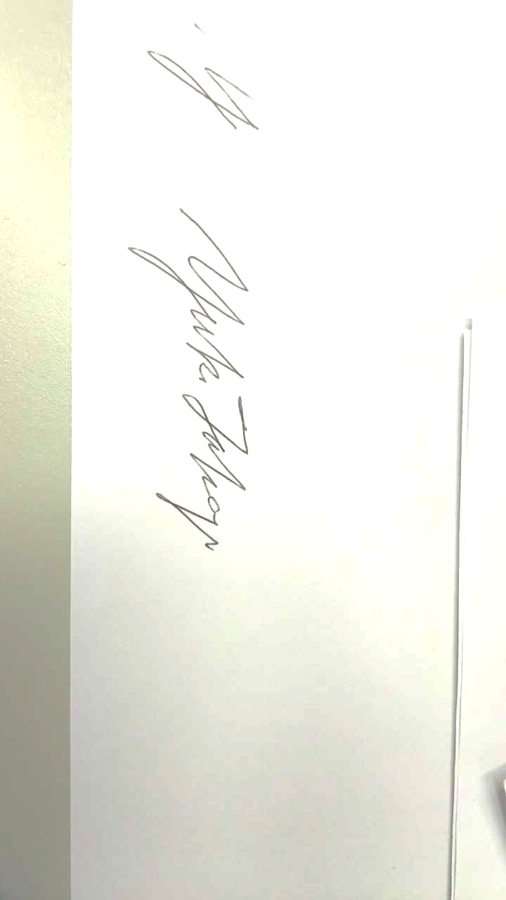
Please address all the correspondent to me at [yuko-takagi@aist.go.jp]. I will be happy to respond to any further questions and comments.

Sincerely,

Yuko Takagi, PhD

List of Changes and Responses

Comments from editor and reviewers are in bold. Please note that comments are paraphrased or shortened for simplicity.

Editorial comments:

1. Thoroughly proofread the manuscript to ensure that there are no spelling or grammar issues.
We have proofread our manuscript and corrected errors.

2. Please remove all commercial language from your manuscript and use generic terms instead.
We have deleted company names from the body text as much as possible.

3. Please add more details to your protocol steps. Please ensure you answer the “how” question, i.e., how is the step performed? Alternatively, add references to published material specifying how to perform the protocol action.
We added more details based on your following comments.

4. 1.2.2: What are the program parameters?
Exact pulse condition of the Nucleofector is proprietary to the manufacturer. This electroporation device is commonly used in the field, and program X-14 has been used by other groups as well. We added a reference that reports X-14 is the best suited pulsing condition for Trypanosoma.

5. What are the culture conditions?
We clarified that cultivation was continued at 28 ˚C.

6. 1.3.1: How are the cells counted?
We specified to use hemocytometer for cell counting.

7. 1.3.2: What happens after centrifugation?
We added the description to discard the supernatant.

8. 1.3.3: Seed at confluency? Please provide cells/mL or cells/well. How much mixture is applied?
We added the equivalent cell numbers.

9. 1.3.5: How is the trypsinization done? How much of what concentration of trypsin is used?
We added more details on trypsinization step.

10. 1.3.6: How many fresh cells are added?
We added the instruction to mix the cells at the ratio of 5 : 1 (carryover : fresh).

11. Please specify what happens after each centrifugation, presumably aspiration.
We added the line to discard supernatant after each centrifugation step.

12. Please specify the microscope parameters used: magnification, etc.
We specified that the objective lenses are 10X or 20X.

13. Please highlight 2.75 pages or less of the Protocol (including headings and spacing) that identifies the essential steps of the protocol for the video.
We highlighted major steps in yellow.

14. Please ensure that the highlighted steps form a cohesive narrative with a logical flow from one highlighted step to the next. Please ensure that the highlighted part of the step includes at least one action that is written in imperative tense.
We checked the flow of highlighted steps.

15. Please include all relevant details that are required to perform the step in the highlighting. For example: If step 2.5 is highlighted for filming and the details of how to perform the step are given in steps 2.5.1 and 2.5.2, then the sub-steps where the details are provided must be highlighted.
Sub-steps are highlighted when necessary.

16. Please obtain explicit copyright permission to reuse any figures from a previous publication. Please upload this information as a .doc or .docx file to your Editorial Manager account.
We will upload the e-mail correspondence between the author and journal staff regarding the re-use of published data.

Reviewer #1:

1. It is essential that the authors show that the knockout really worked, either by qPCR or Western blot.
We already published the concept of CRISPR/Cas9-mediated amastigote knockout elsewhere. In there, we validated the target protein reduction by GFP signal loss and enzymatic assay of the target protein. Evidence of genome editing was also observed by T7 endonuclease cleavage of PCR product.

2. Line 100 - Since constitutive expression of Cas9 is a burden for the cell. This is not necessarily true for all T. cruzi strains.
We moved the description of amastigote-specific 3’UTR to the “NOTE,” and made it optional. We also added a supplemental figure to show that Cas9-expressing T. cruzi (Tulahuen strain) grows slower than wildtype parasite in our hand, but growth kinetics can be restored by conjugating amastigote-specific 3-’UTR to Cas9 ORF.

Reviewer #2:

1- The authors did not mention that protocols to produce in vitro derived extracellular amastigote have been published since 1988. Similarly, the authors also failed to mention that several protocols for disrupting T. cruzi genes using CRISPR/Cas9 have been described since 2014.
We expanded the introduction section to include those points.

2- On Line 100, the authors stated that "constitutive expression of Cas9 is a burden for the cell" without showing any evidence for that or indicating any reference describing these findings (even though they mentioned this point as "data not shown" in line 411 in the discussion).
We moved the description of amastigote-specific 3’UTR to the “NOTE,” and made it optional. We also added a supplemental figure to show that Cas9-expressing T. cruzi (Tulahuen strain) grows slower than wildtype parasite in our hand, but growth kinetics can be restored by conjugating amastigote-specific 3-’UTR to Cas9 ORF.

3- On line 287 and figure 2, the authors should indicate the percentages of trypomastigotes and amastigotes obtained before and after the "swim out" procedure.
We added the information to the corresponding sections.

4- On line 118, the authors should indicate how to maintain the cultures "until transformants are selected to homogeneity". It should be indicated whether, during the 4 weeks period, the medium needs to be changed, etc.
We indicated that culture needs to be split to avoid saturation and to dilute out the dead cells.

5- On line 141, it can be mentioned that epimastigotes can be eliminated from the culture by culturing for 24 hours in RPMI medium containing 10% non inactivated horse serum.
We included complement-mediated lysis as an alternative way to remove epimastigote in the NOTE section. We prefer to keep the wash-away method as a default, since susceptibility to complement-mediated lysis varies among strains.

6- Because the authors used only sgRNA during transfection and did not included a donor DNA template to promote DSB repair and gene knockout by homologous recombination, it can not be concluded that the observed growth defect is due exclusively to the TcCGM1 knockout. The same question needs to be addressed regarding the experiment shown in Figure 5.
We reflected this concern in the discussion section.

7- Fig 4 should indicate the time point post-infection.
We indicated the time frame of infection and intracellular growth.

8- On line 389, please eliminate the word "temporal"
We deleted the word.

9- In the discussion, the authors failed to mention two highly relevant points: (1) published results showing distinct protocols including the use of recombinant Cas9, which may the best strategy to avoid any possible off target effect of the constitutive expression of Cas9 and, (2) important discussions regarding the need to include a donor DNA template to promote DSB repair to assure that only the target gene has been affected.
We included these points in the discussion section.

End of list

