------------------------------------------------------
Responses (R) to Reviewers' Comments (C):
------------------------------------------------------
Editorial Reviewer:
C1: Please take this opportunity to thoroughly proofread the manuscript to ensure that there are no spelling or grammar issues. The JoVE editor will not copy-edit your manuscript and any errors in the submitted revision may be present in the published version.
R1: Thanks for the reminder. We have thoroughly read the manuscript and corrected many errors.

C2: Unfortunately, there are a few sections of the manuscript that show significant overlap with previously published work. Though there may be a limited number of ways to describe a technique, please use original language throughout the manuscript. Please see lines: 65-66, 70-74, 133-134, 241-244, 274-282.
R2: The related lines have been revised as follow.
Line 65-66:
“Recently, virtual reality and robot arm have been introduced to present objects in 3D space.”
Line 70-74:
“Here, we disclose the detailed protocols for building and using an automated apparatus³⁰ which can achieve any combination of multiple target positions and grip types in 3D space. We designed a turning table to switch objects and a 3D translational device to transport the turning table in 3D space. Both the turning table and translational device are driven by independent motors. Meanwhile, the 3D trajectory of subject’s wrist and neural signals are recorded simultaneously throughout the experiment.”
Line 133-134:
Deleted
Line 241-244:
“Once the green LED (go cue) turns on at the end of ‘planning’ phase, the subject should release the button, reach into the turning table and grasp the object with the corresponding grip type as soon as possible (maximum reaction time, 0.5 s; maximum movement time, 1 s). The subject receives a water reward after a minimum hold time of 0.5 s.”
Line: 274-282
“The apparatus, which includes separately driven 3D translational device and turning table, presents multiple target positions and objects independently. That is, all predefined positions and objects could be combined arbitrarily, which is important to study multivariable encoding. On the contrary, if the object to be grasped is linked to position, for instance, the object is fixed on a panel, it’s difficult to determine whether a single neuron tunes object or position. Moreover, the apparatus presents objects in 3D space instead of on a 2D plane, which could activate more neurons with spatial modulation.”

C3: JoVE cannot publish manuscripts containing commercial language. This includes trademark symbols (™), registered symbols (®), and company names before an instrument or reagent. Please remove all commercial language from your manuscript and use generic terms instead. All commercial products should be sufficiently referenced in the Table of Materials and Reagents.
For example: data acquisition (DAQ) board (USB-6341, National Instruments, 176 TX, USA), motion capture system (Motion Analysis Inc., USA), Cerebus, Blackrock Microsystems Inc., USA, etc.
R3: We have removed all company name from the manuscript.

C4: Please rephrase the Short Abstract/Summary to clearly describe the protocol and its applications in complete sentences between 10-50 words: “Here, we present a protocol to …”
R4: We rephrase the summary as follows:
“Here, we present a protocol to build an automatic apparatus that guides subject to perform a flexible reach-to-grasp task. The apparatus combines a 3D translational device and a turning table to present multiple objects in arbitrary position in 3D space.”

C5: Please adjust the numbering of the Protocol to follow the JoVE Instructions for Authors. For example, 1 should be followed by 1.1 and then 1.1.1 and 1.1.2 if necessary. Please refrain from using bullets or dashes.
R5: The numbering of the protocol has been adjusted.

C6: Please ensure that all text in the protocol section is written in the imperative tense as if telling someone how to do the technique (e.g., “Do this,” “Ensure that,” etc.). The actions should be described in the imperative tense in complete sentences wherever possible. Avoid usage of phrases such as “could be,” “should be,” and “would be” throughout the Protocol. Any text that cannot be written in the imperative tense may be added as a “Note.” However, notes should be concise and used sparingly.
R6: Thanks for the reminder. We have tried our best to use imperative tense in protocol.

C7: The Protocol should contain only action items that direct the reader to do something. Please move the discussion about the protocol to the Discussion.
R7: We have moved the related parts into the Discussion.

C8: The Protocol should be made up almost entirely of discrete steps without large paragraphs of text between sections. Please simplify the Protocol so that individual steps contain only 2-3 actions per step.
R8: We have revised steps in protocol to ensure that individual steps contain only 2-3 actions per step.

C9: Please add more details to your protocol steps. Please ensure you answer the “how” question, i.e., how is the step performed?
R9: We add details in protocol steps.

C10: Software steps must be more explicitly explained ('click', 'select', etc.). Please add more specific details (e.g. button clicks for software actions, numerical values for settings, etc.).
R10: We added more details about setup of software in protocol.
“4.4 Prepare the paradigm software.
4.4.1 Open the paradigm software.
4.4.2 Set the 3D coordinates of reaching positions in a txt file and load it into the paradigm software.
NOTE: We set eight target positions located at vertices of a cuboid workspace (90 × 60 × 90 mm) in the position pool.
4.4.3 Select the target objects in the object pool.
4.4.4 Set the time paradigm including “baseline time”, “motor run time”, “planning time”, “maximum reaction time”, “maximum reach time” and “minimum hold time”.
4.4.5 Run the paradigm software.
4.5 Open the synchronization software. Click the “Motion Capture”, “Neural Signal Acquisition” and “Paradigm” buttons to connect the synchronization software with the motion capture system, neural signal acquisition system and paradigm software, respectively.”

C11: 4: When is the animal brought into picture? What kind of animal was used? Any age sex strain specific bias? How was the trial performed? Please rewrite this section with all specific details required for this experiment.
R11: The rhesus monkey is brought into picture after all software (e.g. paradigm program, synchronization software and recording programs of both motion capture system and neural signal acquisition system) are run. There is no age sex strain specific bias.
“4.6 Seat the rhesus monkey on the monkey chair and fix its legs and one arm. Then fix the monkey chair to the holder of the 3D translational device.”
The complete trial process is described in results section.
“Specifically, the monkey has to start a trial (Figure 3 bottom) by pressing down the button and hold it before go cue. After 0.4 s (baseline phase), the 3D translational device transports the turning table to a position that is pseudo randomly selected from the predefined position pool. In the meantime, the turning table presents a pseudo randomly selected object to the subject (‘motor run’ phase). This phase lasts 2 s and all four servo motors (three in 3D translational device and one in turning table) start and stop at the same time. The ‘motor run’ phase is followed by a ‘planning’ phase (1 s) during which the subject plans the following movement. Once the green LED (go cue) turns on at the end of ‘planning’ phase, the subject should release the button, reach into the turning table and grasp the object with the corresponding grip type as soon as possible (maximum reaction time, 0.5 s; maximum movement time, 1 s). Then subject could receive a water reward if it grasps the object for a minimum hold time (0.5 s). One trial will be aborted if the subject releases the button before go cue, or does not release the button within maximum reaction time after go cue.”

C12: Will the animal be available for filming purpose?
R12: Yes, but not the face of the animal.

C13: Please highlight 2.75 pages or less of the Protocol (including headings and spacing) that identifies the essential steps of the protocol for the video, i.e., the steps that should be visualized to tell the most cohesive story of the Protocol.
R13: The protocols have been highlighted in the manuscript

C14: Please expand the Representative Results in the context of the technique you have described, e.g., how do these results show the technique, suggestions about how to analyze the outcome, etc. The paragraph text should refer to all of the figures. Data from both successful and sub-optimal experiments can be included.
R14: We expanded the results as suggested by reviewers in the revised manuscript.

C15: Please obtain explicit copyright permission to reuse any figures from a previous publication. Explicit permission can be expressed in the form of a letter from the editor or a link to the editorial policy that allows re-prints. Please upload this information as a .doc or .docx file to your Editorial Manager account. The Figure must be cited appropriately in the Figure Legend, i.e. “This figure has been modified from [citation].”
R15: Permission for one of the figure (Fig. 4) has been attached.

C16: As we are a methods journal, please revise the Discussion to explicitly cover the following in detail in 3-6 paragraphs with citations:
a) Critical steps within the protocol
b) Any modifications and troubleshooting of the technique
c) Any limitations of the technique
d) The significance with respect to existing methods
e) Any future applications of the technique
R16: We revised the Discussion as suggested.

C17: Please expand the journal titles in the references section.
R17: We expand the journal titles in references as you suggested.

C18: Figure 3: Please label the x-axis
R18: We labelled the x-axis in Figure 3.

C19: Please alphabetically sort the materials table.
R19: The table has been sorted alphabetically as suggested.

Reviewer #1:
C0: The manuscript describes an apparatus to present different objects to a monkey for reach-to-grasp movements in context of electrophysiological experiments. The mechanical design, including electronic motors and sensors are described in detail and easily to understand. A step by step instruction, images and a list of components is present and allows rebuilding the apparatus. However, a few more representative results would be necessary since currently only a single trial is presented. In my opinion, the scientific community would benefit from this work and I recommend it for publication after expanding the results section and some minor changes.
R0: Thanks for the comments. Detailed responses are addressed point by point below.

My major concerns refer to the results section:
C1: This part needs more substance. One trial is not enough. There should be PSTHs for a few neurons over multiple trials to validate that the system is working (i.e. clear modulation for different conditions should be shown). This should also be done for the motion capture data to give an idea about the behavioral variability imposed by this setup.
R1: We added the PSTH plot (Figure 5) of two example neurons that shows clear modulation for both position and objects. The reconstructed trajectory of monkey’s wrist in 3D space during reaching phase was also plotted based on time-aligned motion capture data (Figure 4).
C2: Figure 3 lacks a lot of information in the caption. You need to describe properly what is presented. For instance, what is the "Position Index"? Where does X, Y and Z come from? etc.
R2: We added more information both in the figure and in the legend.
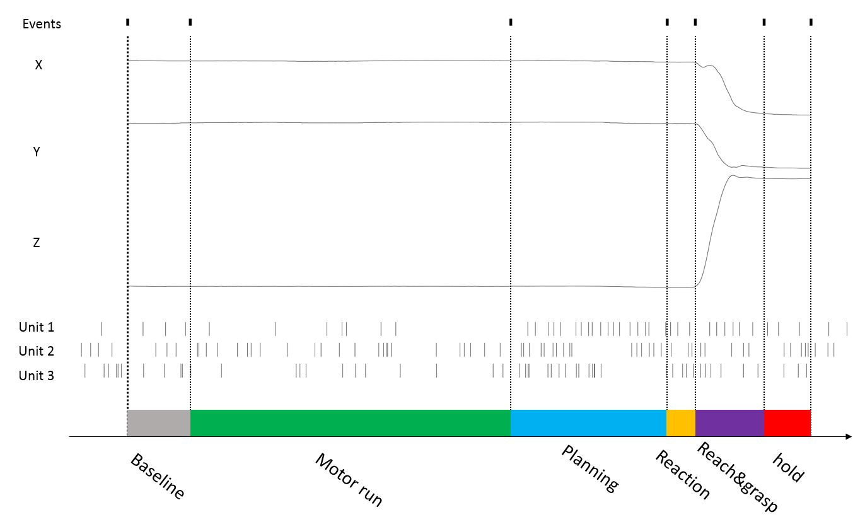
“Figure 3. Time aligned data in a successful trial. All the event timings, wrist trajectories (X, Y and Z) and neuronal activity (example unit 1-3) were recorded simultaneously. The short black lines in the top row are the event labels. “Button On” indicate the time when the monkey pressed the button down; “Position Index” is a number from 1 to 8 indicating which reaching position is presented; “Object Index” is a number from 1 to 6 indicating which object is presented; “Motor On” indicates the start time of four servo motors. “Motor Off” indicates their stop time; “Go cue” indicates the moment when the green LED tunes on; “Button Off” indicates the moment when the monkey release the button; “Touch On” indicates the moment when the touch sensors in the object detect the monkey’s hand; “Reward On” indicates the moment when the pump begins to deliver the water reward and represents the end of a trial. The “Button On”, “Position Index” and “Object Index” labels are saved successively in a very short time at the beginning of a trial. The 2 – 4 rows plot the trajectory of monkey’s wrist in three dimensions recorded by motion capture system. The 5 – 7 rows show the spike trains of three example neurons recorded by neural signal acquisition system. The bottom row shows the timeline for a complete trial which is divided into six phases based on event labels.”

C3: I have a hard time picturing the scale of the apparatus relative to the monkey. An image showing the monkey in front of the device would help a lot.
R3: The monkey is seated in a monkey chair which is positioned 250 mm away from the front side of presentation space (90 x 60 x 90 cm). Below is a picture showing the experiment setup. We did not include the picture in the manuscript because the whole setup will be shown in the video.
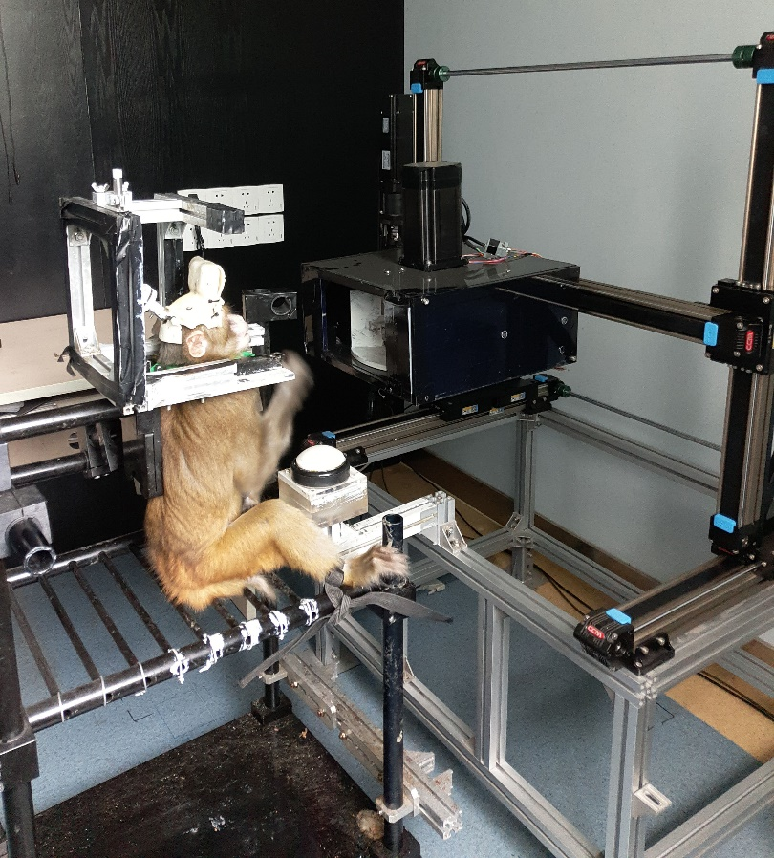

C4: For which monkey species is this setup designed?
R4: We mainly used rhesus monkey (macaca mulatta) in our study. However, due to the adjustable range of the translational system, it is also competent for other primates with similar or larger body size or even human beings.
“Moreover, although the apparatus was designed to train rhesus monkey (macaca mulatta), due to the adjustable range of the 3D translational device, it is also competent for other primates with similar or larger body size or even human beings.”

C5: How many sessions is this setup in use without issues (or with issues but then please report the issues)
R5: The apparatus has been used to train one monkey to do a reach-to-grasp task for over one month (35 sessions) during which no issue was found.

C6: What kind of array do you record from?
R6: We recorded signals from a commercial Utah array (Blackrock Microsystem Inc. USA) implanted in motor cortex.
“To demonstrate the utility of the system, we have trained a monkey (with a Utah micro-electrode array implanted in motor cortex) to do a delayed reach-to-grasp task with the system”

C7: What do you track here? Arm? Finger?
R7: We tracked the arm position in 3D space, i.e., the markers were attached at the end of the arm, close to wrist.
“4.6 Attach three reflective markers at the end of the subject’s arm (close to wrist) and calibrate the Motion Capture system.”

C8: What is the spatial precision of the XYZ-rails?
R8: The spatial precision of the 3D translational device (measured by motion capture system) is less than 0.1 mm.
“… The kinematic precision of the 3D translational device is less than 0.1 mm”

C9: How fast is a change in the spatial position? You say 2s "motor run" phase. Does this refer the time needed to rotate the object table? To move from the two most distant positions with the slider? Or is this just a time you set in your control software?
R9: The 2 sec “motor run” phase is just what we set in the software. Actually, the translational system can run as fast as 500 mm/sec, which means that it takes less than 1 sec to move between two most distant positions. However, in our experiment, the device takes 2s to move from one position to another no matter how far away they are.
“4.4.4 Set the time paradigm including “baseline time”, “motor run time”, “planning time”, “maximum reaction time”, “maximum reach time” and “minimum hold time”.”
“After 0.4 s (baseline phase), the 3D translational device transports the turning table to a position that is pseudo randomly selected from the predefined position pool. In the meantime, the turning table presents a pseudo randomly selected object to the subject (‘motor run’ phase). This phase lasts 2 s and all four servo motors (three in 3D translational device and one in turning table) start and stop at the same time.”

C10: Can you use the full X-Y-Z-position? I am asking, since the outer most positions would lead to a significant difference in reach angle and as such might require a different hand posture for grasping. Am I wrong?
R10: The full range of the system is 600, 300 and 500 mm in x, y and z-axis, respectively. To fit the reach range of monkey, we adapt the range to a cuboid of 90 × 60 × 90 mm. In this way, we hope to minimize the reaching position’s effect on grip types, or vice versa.
“The size of complete workspace of the apparatus is 600, 300 and 500 mm in x, y and z-axis, respectively.”
“We set eight target positions located at vertices of a cuboid (90 × 60 × 90 mm) in the position pool”

Abstract:
C11: First couple of sentence: You make a strong claim that reaching and grasping is "usually studied separately" but later in the introduction you name correctly a number of studies that investigate reach-to-grasp movements. You are contradicting yourself. Please do not try to overstate the importance of your work. It is also not necessary. Even though several studies investigated reach-to-grasp movements, it is still (or because of that) important to present an apparatus that can be rebuilt by the community.
R11: We agree with you. Actually, there have been increasing number of studies on combination of reaching and grasping movement in the last decade. We revise the sentence as follows:
“Reaching and grasping are highly-coupled movements, and their underlying neural dynamics have been widely studied in the last decade. However, few experimental apparatuses have been developed to achieve a flexible combination of reaching and grasping in one task.”

Introduction:
C12: The motivation for the apparatus and previous literature is presented appropriately. Only a minor comment: In line 57 you list only one citation, however all the other following citations fall under the category you describe here (investigating reaching and grasping). You can keep mentioning them in the following lines but list them once in addition in line 57 to make clear that there are a number of studies that investigated reach-to-grasp movements.
R12: We agree with you and revise the citation as you suggested.
“More recently, reaching and grasping movements have been studied together, i.e., the subjects reached multiple positions and grasp with different grip types in an experimental session¹⁵⁻²⁶.”

Protocol:
C13: The assembly of the whole apparatus (Part 1 and 2) is well described. Also the figures 1 and 2 are helpful but would be even more helpful with labels. When you write down the names as used in the text next to the elements it is easier to refer the text to the figure. Especially labeling x-, y- and z-axis in figure 1 would help a lot.
R13: Thanks for your suggestion. We label key parts in figure 1.
“Figure 1: Step-by-step instructions for the 3D translational device assembly (see text for detail). I-I X-rail, I-III Y-rail, I-II Z-rail, II connecting shafts, III servo motors, IV planetary gearheads, V connecting rings, VI diaphragm couplings, VII pedestals, VIII T-shaped connecting boards, IX right triangle frames. A. The materials for the translational device assembly. B. Building the frame and install the Y-rails (step 1.1 - 1.4). C. Fixing two Z-rails onto Y-rails (step 1.5 - 1.7). D. Fixing X-rail onto Z-rails (step 1.8 - 1.9). E. Installing servo motor and gearhead (step 1.10 - 1.11). F. Completely assembled 3D translational device (step 1.12 - 1.3).”

C14: Also the parts list is helpful. However, I am missing information about the costs of the individual parts and the apparatus as a whole. This is important information for a lab to decide whether or not to build such an apparatus. Part 3 (Setup) and 4 (preparation) are pretty vague but I understand that this is rather specific for the individual systems used in parallel.
R14: As you suggested, we added the unit price of parts in table1. The total amount of cost for each system (excluding motion capture and neural signal acquisition system) is around $4269 US dollar.

further comments:
C15: -Replace "Cerebus" with "neural data acquisition system" (or something similar), your protocol is not specific for the Cerebus system.
-You sometimes wrote motion capture system in capital letters
R15: They have been corrected.

Discussion:
C16: As mentioned above, you might want to discuss the potential problem that at different positions the angle relative the shoulder is different and, as such, might lead to different hand postures during grasping.
R16: Yes, we discuss this problem in discussion as follows:
“… One major concern in the behavioral task combining reaching and grasping movement is that whether the hand posture differs across different reaching positions even the monkey grasps object with the same grip type. Although we generally regard reaching and grasping as two different movements, their effectors (arm and hand) are linked. It’s inevitable that the reaching movement physically interacts with grasping. According to the observation in our experiment, the monkey’s wrist angle changed slightly when grasping the same object in different positions, but significant difference in the hand posture was not observed.”

C17: I like that you discuss the problem of having visual information available. But I think you can elaborate this a bit more. I do not understand why you say seeing the target object leads to "unexpected" tuning. Why is it "unexpected"? Or do you mean "undesired"? Furthermore, if you manage to block the visual information, e.g. by your proposed shutter glasses, what about the sound of the motors? Does a movement to the right sounds exactly like a movement to the left or up? I could imagine that auditory stimuli that are informative of the spatial location, can also lead to a tuning.
R17: In the revised manuscript, we include the PSTH of an example neurons which shows significant selectivity for both position and object during “motor run” phase. This is what we said the “unexpected” tuning, but obviously, “undesired” is more suitable.
“The subject could see the target object throughout the whole trail, which leads to the undesired tuning before the planning period.”
The noise of apparatus during moving is quite low (60 dB), but we are not sure whether the monkey could identify the location of turning table from the sound. It would be good if we could mask the motor moving sound with white noise.
“… In the same way, white noise could be employed to mask the motor running sound, which will prevent the subject from identifying the location of object through the sound of motor.”

C18: Line: 284 - 290: Unnecessary. You discuss your software but you do not present your software. Also, software that can be used for different task parameter is the minimal standard in the field and does not have to be explicitly mentioned. (Unless you publish the software and report about it in detail.)
R14: We remove this part as you suggested.

Reviewer #2:
C0: Chen and colleagues propose here a nice and improved version of the current devices designed to present graspable objects in the 3D space for monkey research purposes. The suggested device is highly flexible, allowing the display of different tasks (reaching and grasping), manipulations of the tested objects (shape and orientation) as well as the presentation of these objects at multiple spatial localizations. Although going through the manuscript no major concerns have been detected, in the following lines, I list some minor concerns which I think they should be fixed before publication.
R0: Thanks for the comments. We address your concerns point by point below.

-Introduction.
C1: The authors list here some of the current devices used to explore the reaching and grasping functions in macaque monkeys (lines 50 and 55). I believe their intention is to just present some of the strategies followed in the recent years and not to provide an exhaustive list of the protocols developed in the field. However, it seems a bit striking to me that they do not include in this list the use of touch screens, vertical rotating panels or button panels, very often used in the field.
R1: We included the use of touch screen in the revised manuscript:
“In reaching tasks, touch screen^{1,2}, screen cursor controlled by a joystick³⁻⁷ and the virtual reality technology⁸⁻¹⁰ were employed to present 2D and 3D targets, respectively.”
The rotating panel is currently used by Rouse et al and is cited in our manuscript.
“To vary target position and grip type, experimenters exposed multiple objects simultaneously, but the relative (or absolute) position of targets and the grip types were bound together, which caused rigid firing patterns through long-term training^{22,27,28}.”

C2: Also, in the introduction they propose their device as a solid alternative to robotic arms, which then claim to be easily damaged by monkeys. I agree that the reaching-grasping device designed by the authors is highly flexible and an attractive alternative to the use of robots, but I am not sure that the argument used in the text is valid.
R2: We agree with the reviewer. The robotic arm is an alternative to present object in 3D space. The advantage of our apparatus is that combination of 3D-space object presenting and distinct objects switching (enabled by the turning table). We delete related comments on robotic arms.

Section 2.2.
C3: The authors refer to the positioning of the sensors into the groove. I understand this positioning has been previously studied and optimized for the grasping style adopted by the monkeys. However, each monkey, despite of the amount of training provided, will grasp the objects slightly differently, making contact with them at different points, which will require to adapt the positioning of the sensors depending on the animal used. It would nice that the authors clarify at this point how versatile their system can be to address this issue.
R3: Once the sensors were positioned into the groove, we didn’t adjust their positions to different monkey. Instead, we trained the monkey to learn to place their fingers on proper area to form a specific grip type (and activate sensors). It’s not difficult for monkey to learn a grip type because the touch area of the sensor is not very small and there are usually less than three sensors in an object. Generally, the monkey takes less than three days to master a grip type.

C4: Similarly, based on the design of their apparatus, it seems that the combination of the 3D translational device and the turning table makes this device much more flexible than the majority of other equipment available in the market, except robots. However, one big advantage of using a robotic arm is that, with this system, the object can be displayed at any coordinate not only in the x and y axes, but also at any distance with regards to the monkey. This alternative allows the testing of complex visuomotor transformations related to the grasping response such as the response to objects with different retinal sizes or other major aspects related to arm position and reaching strategies. It would be interesting to know if the device here proposed can be adapted to that use, and if so, to remark in the text the high versatility of the apparatus based on the manipulations proposed. These are very interesting features to take into account in those reaching and grasping studies recording the neural activity of motor areas other than the primary motor cortex. In these brain structures, certain populations show a clear visuomotor profile, in such a way that the visual information of the stimulus (shape, volume, retinal size) drives (at least in some degree) the neuronal selectivity during motor performance.
R4: I guess there is a little misunderstanding here. Our apparatus was designed to present object at any coordinate in 3D space, not just in x and y axes. The translational device includes three independent groups of rails (driven by three independent motors) corresponding to X, Y and Z axes. In the revised manuscript, we included a new figure to show the trajectories when the monkey reached to 8 positions in space, from which, one can see that the system can transport the objects/turning table to any distance regards to the monkey.

Representative Results.
C5: The authors first claim to follow a randomized design when programming their device for object presentation (Line 234), but few lines after, they refer to have used instead a pseudo random design (line 239). Please, clarify the degree of randomization allowed by the apparatus.
R5: Both position and object were chosen pseudo randomly in our experiment. We have corrected this mistake in manuscript.
“After 0.4 s (baseline phase), the 3D translational device transports the turning table to a position that is pseudo randomly selected from the predefined position pool. In the meantime, the turning table presents a pseudo randomly selected object to the subject (‘motor run’ phase).”

C6: Also, in the same section, it seems a bit unclear the use of the start button. From the text I infer that the animal has to press that button in order to start the trial, but that later in the trial, the device itself resets this button after the presentation of the go cue. What's this button used for? If that controls any particular motion sequence of the apparatus, what would it happen in those trials where the monkey ignored the go cue? Would that then interrupt automatically the trial? Please, clarify.
R6: As you said, the animal has to press and hold the button to start a trial. After go cue, the animal released hand from the button (not reset by the device) and started to reach and grasp the target object. The main purpose of the button is to make sure that the monkey is motionless (holding still on the button) before go cue. If the monkey released the button before go cue, that trial will be aborted and excluded from following analysis.
“… Specifically, the subject has to start a trial (Figure 3 bottom) by pressing down the button and hold it before go cue. … Once the green LED turns on (go cue), the subject has to release the button and reach to the turning table and grasp the object with the appropriate grip type within a time window (maximum reaction time, 0.5 s; maximum movement time, 1 s)”
“… One trial will be aborted if the subject releases the button before go cue, or does not release the button within maximum reaction time after go cue.”
C7: Also, clarify the extent (size) of the workspace (deg of visual angle) covered by the device and if the start position is also flexible. It is possible that some authors would be interested in adapting this device to record neuronal activity when the object to-be-grasped is located in the center of the visual field, over the neuronal RF, or at a distance. In those cases, it would be much more convenient if the device can start at any of those positions.
R7: The extent of the system is 600, 300 and 500 mm in x, y and z-axis, respectively. However, one can define any subspace (and start position) as the workspace for a specific experiment. For example, we set a cuboid (90 × 60 × 90 mm) workspace for the monkey to match its reach range. We included more details about the target presentation space and the position of monkey’s eyes in the Results.
“The size of complete workspace of the apparatus is 600, 300 and 500 mm in x, y and z-axis, respectively.
…NOTE: We set eight target positions located at vertices of a cuboid workspace (90 × 60 × 90 mm) in the position pool.
…4.7 Fix the monkey chair to the aluminum construction frame. Keep the monkey’s head 250 mm away from the front side of the cuboid and its eyes 50 mm above the top side of the cuboid workspace (horizontal visual angle: 20 degree; vertical visual angle: 18 degree).”

C8: Clarify the LED position (on the object, on the turning table,...where?).
R8: The LED is installed on the front side of turning table.
“2.10. Stick the green LED onto the front side of the case.”

-Discussion.
C9: At the end of the discussion the authors refer as a potential limitation of their device the fact that the subject could partially see the target object before the planning period and propose alternatives to obscure its view. However this must be a necessary feature to be added when planning a visually-guided grasping task. Is the device intended for testing exclusively the isolated motor function (grasping in the dark) or can it be flexibly adapted to measure visuomotor responses? Please, clarify.
R9: No, the device is not intended for testing exclusively the isolated motor function. In our specific experiment, we are more interested in the neural activity during planning period (i.e. before go cue). However, the subject could still see the object and/or the position of the object during planning phase (which should not be the case). That is the reason why we mention in Discussion that we need a switchable glass, to precisely control the view of the subject.
“…The subject could see the target object throughout the whole trail, which leads to the unexpected tuning before the planning period. To prevent the subject from getting visual information, a switchable glass controlled by software could be installed in front of monkey’s head. The switchable glass is opaque during baseline phase and planning phase and turned transparent after go cue. In this way, the visual view of the subject is precisely controlled.”

-Figure 3.
C10: I don't fully understand the 'motor run' phase. Why is this not included in the intertrial interval? If the object is not yet visible and due to the motion of the turning table, all data collected during this period cannot be included in the baseline period, it would be cleaner to rotate the motor at the end of each trial, having a new object ready before the next trial begins.
R10: We agree with the reviewer that this is an alternative to our current solution. However, if we have a new object ready before the next trial begins, some of the neurons will start to fire even before the actual planning begins (due to visuomotor response mentioned above), which is not desired in this experiment.

Reviewer #3:
C0: This method paper describes how to build an apparatus that enables monkeys to grasp objects of different sizes and shapes in different spatial positions. This device will enable new protocols to study reaching and grasping in the same experimental session. I think that this apparatus will be very useful for researchers. I have only minor concerns
R0: Thanks for the comments. Detailed revisions are listed below.

C1: In the introduction, please cite also Fattori et al 2009 as a study that uses a device similar to what was used by Murata and Scherberger's groups.
R1: Thanks for your suggestion. We have included the citation in the manuscript.
“An alternative is to use visual cues to inform subjects to grasp the same object with different grip types¹²⁻¹⁵.”

C2: Is it possible to record kinematics of the fingers during grasping? When grasping the objects, the hand goes inside the groove containing the object, and I guess that the motion capture system is not able to capture the fingers positions. Please clarify.
R2: As you said, the motions of fingers could not be recorded due to the blocking problem. We regarded it as a limitation in discussion.
“Another limitation of the apparatus is that the motion of fingers could not be track. This is because the monkey has to reach the hand into the turning table to grasp the object, which will block the cameras to capture the marks on monkey’s hand.”

C3: Is this device safe for the monkeys? Will the monkeys' hand be hurted at any point during the task by the rotating device? Please clarify.
R3: We have successfully trained one monkey using this apparatus, and no safety issue raised. First, the turning table rotates only in the ‘motor run’ phase, during which, the monkey must put the hand on the switch. In the first day of training, the monkey quickly learns that the hand must be retracted before next trial starts. Second, the turning table rotates slowly (maximum speed is 180°per second), so the monkey has enough time to retract its hand.

C4: It is not clear to me whether the objects can be presented at different depths with respect to the animal position. Please clarify.
R4: The apparatus was designed to present object at any coordinate in 3D space, not just in a 2D plane. The 3D translational device includes three groups of rails corresponding to X, Y and Z axes. Each group of rails is driven by one motor, so that the sliders on X-rail could be move to any coordinate. For instance, if the experimenter wants to present object at different distance with regards to the monkey, he/she just needs to send commands to the motor driving Y-rails and keep the other two motors (X and Z) motionless. In the revised manuscript, we add a new Figure 4 to show the trajectories of that arm in 3D space (including different depths).

C5: Is the rotation's noise annoying for the monkeys?
R5: the main noise come from the linear rails and turning table, which is less than 60dB measured at 20 cm distance. It is quite smoothing movement and the monkey became used to it soon and no passive emotion such as anger or aggressiveness was evoked.

