ImageJ steps

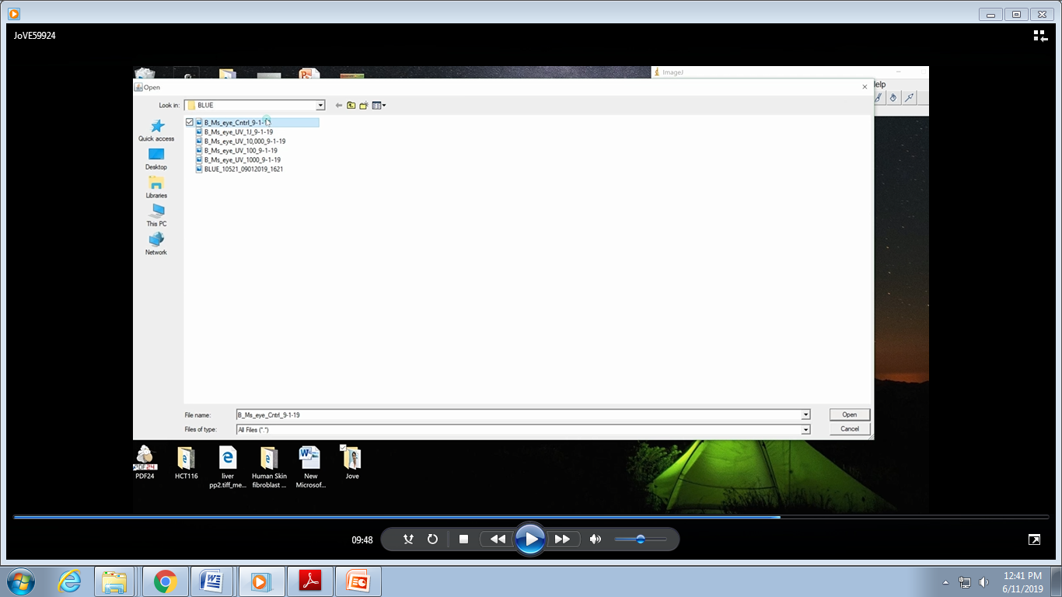

Step 6.2: Blue channel images

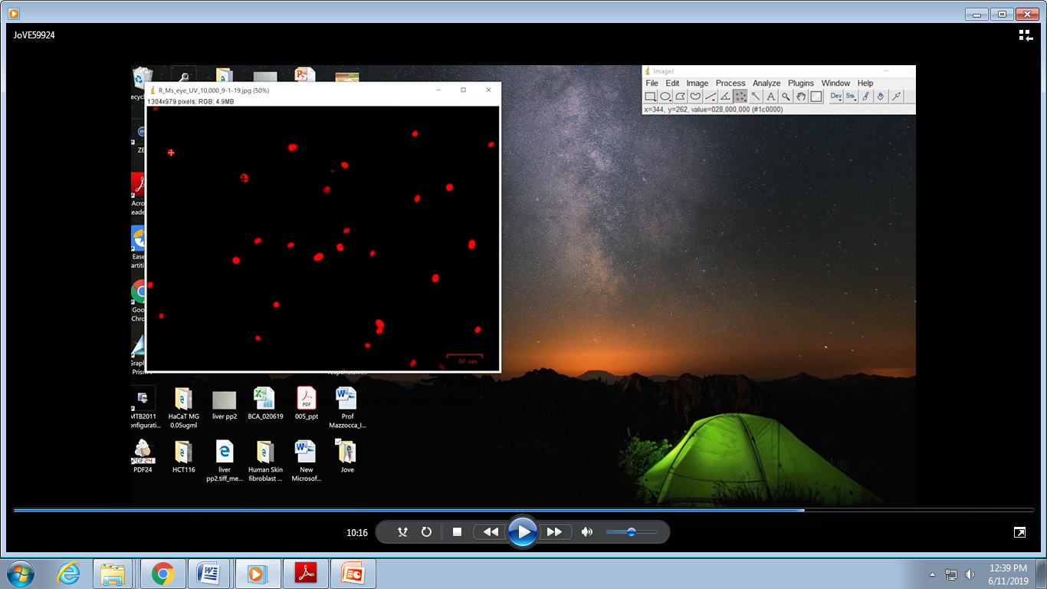

Step 6.3: Cell counting tool
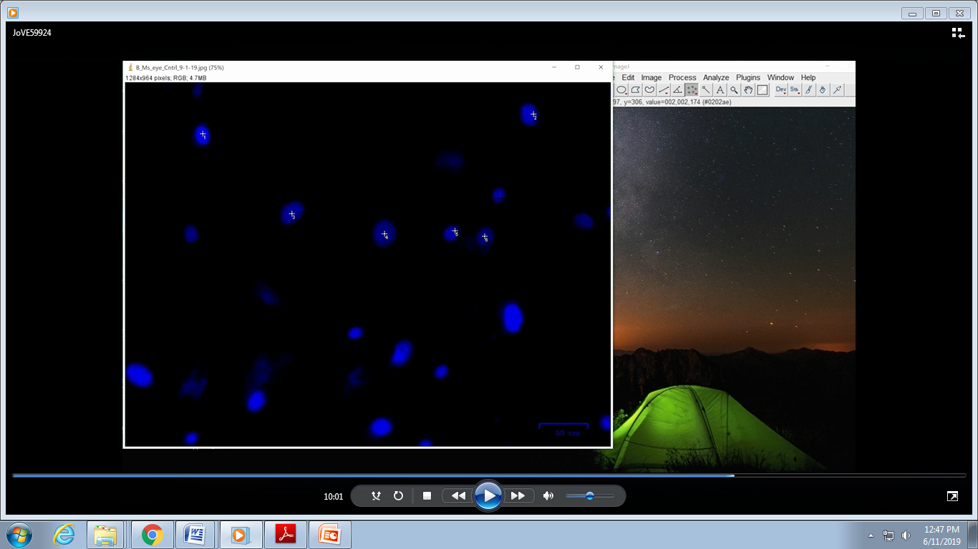

Step 6.3: Clicking on the blue/Hoechst stained nuclei

