April 18, 2019

Editorial Staff
JoVE

Manuscript ID: JoVE59920

Dear Editors,

We have addressed all the points raised by the reviewers and revised the manuscript accordingly. Please see our responses in the ‘Response to Reviewers’ file, item by item. In addition, the revised manuscript with all revised changes, the new figures, as well as the copyright permission file have been uploaded.

We thank you and the reviewers for their thoughtful reviews and the helpful suggestions in improving our manuscript.

Yours sincerely,
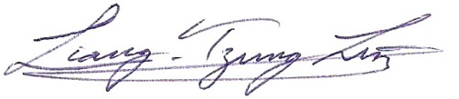

Liang-Tzung Lin, PhD.
Associate Professor
Department of Microbiology and Immunology
Taipei Medical University

