Rosario, August 9th 2019

Dr. Vineeta Bajaj
Review Editor
JoVE

Dear Dr. Vineeta Bajaj,
We recently revised the Editorial comments our manuscript entitled "Synthesis of a Deuterated Standard for the Quantification of 2-Arachidonoylglycerol in C. elegans” that received the ID JoVE59882R2. We have completed attended all Editorial and production questions and requests that have been detailed below.
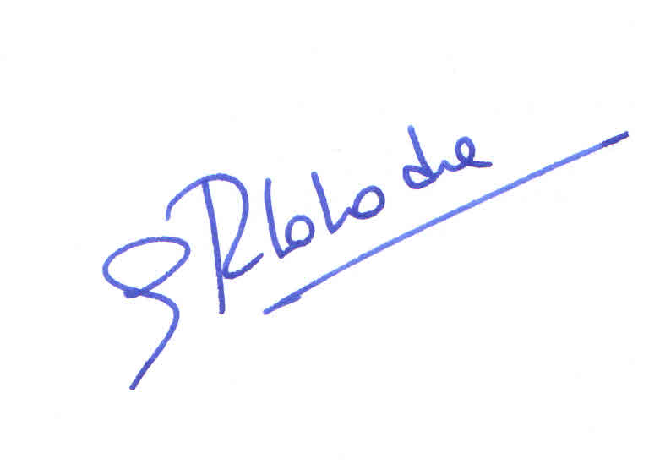
We believed that the revised manuscript is now finally ready to be publish in the Journal of Visualized Experiments.
Sincerely,

Prof. Dr. Guillermo R. Labadie
Full Professor and Chair
Organic Chemistry Department
Facultad de Cs. Bioquímicas y Farmacéuticas
Universidad Nacional de Rosario

Answer to The Editorial Service

Editorial and production comments:
1. The editor has formatted the manuscript to match the journal's style. Please retain the same.

The manuscript format has not been modified
2. Please address specific comments marked in the manuscript. ANSWERED
The manuscript has been modified and/or corrected to match the video.

3. Video:
- The title of the video is not the same as that of the text. Please ensure that the change is performed in both the front and the end title cards.

The title has been modified to match the manuscript.

- Please remove the numbers from the section title cards. Please just keep the chapter titles without any numbers and ensure that these are same as that of the text.

The numbers have been removed.

- 3:38: The Voice over says -78 degrees here however the text in the manuscript is 78 degrees. Please check.

The voice match the video been in both 78 degrees

