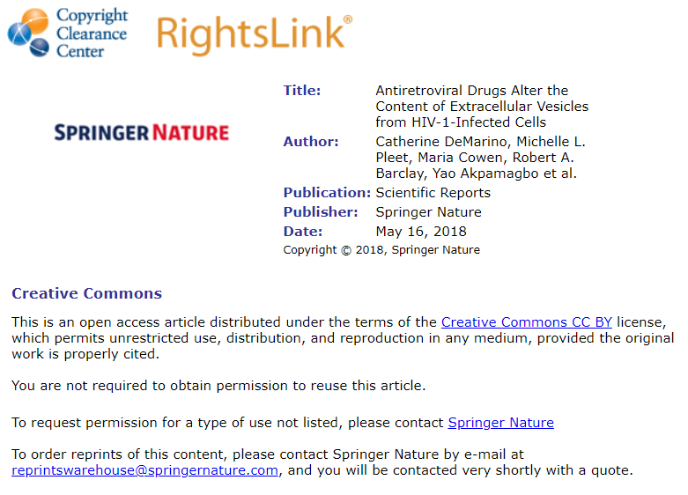
Creative Commons Licenses:
https://creativecommons.org/licenses/

