22 Apr, 2019
Dr. Bing Wu
Review Editor
Journal of Visualized Experiments

Dear Dr. Wu,

We sincerely thank you for your rapid handling on our manuscript (JoVE59870). Enclosed please find an electronic version of the revised version of manuscript entitled “Tuning the acidity of Pt/CNTs catalysts for hydrodeoxygenation of diphenyl ether” for your consideration of publication as an Article in Journal of Visualized Experiments. We have revised our manuscript carefully with red marked according to your suggestions and the reviewer’s comments. Meanwhile, we have answered all questions from the reviewers. A point-by-point response to the reviewers’ concerns and a detailed description of the changes are attached in the letter.

In response to your kind comments, we have made the following revision:
Editorial comments:
- Please take this opportunity to thoroughly proofread the manuscript to ensure that there are no spelling or grammar issues.
Reply: Thanks for your reminding, we have checked our spelling and grammar carefully.

- Please obtain explicit copyright permission to reuse any figures from a previous publication. Explicit permission can be expressed in the form of a letter from the editor or a link to the editorial policy that allows re-prints. Please upload this information as a .doc or .docx file to your Editorial Manager account. The Figure must be cited appropriately in the Figure Legend, i.e. “This figure has been modified from [citation].”
Reply: Thanks. We have obtained the letter of permission and should have already uploaded during the last submission and we will upload it again this time. The Figure Legend will be added, as can be seen from the following answer points.

- For in-text referencing, please put the reference number before a comma or period.
Reply: Thanks for your reminding, we have revised it. For example:
Before modification:
“For example, the dehydration of 2-cyclohexene-1-ol to produce 1,3-cyclohexadiene using H₂SO₄ will leads to polymerization byproducts.¹”
After modification:
“For example, the dehydration of 2-cyclohexene-1-ol to produce 1,3-cyclohexadiene using H₂SO₄ will leads to polymerization byproducts¹.”

- Please use a single space between numerical values and their units.
Reply: We are really for our careless, we have revised it.
Before modification:
“Sonicate the solution at 300K for 1.5 hour to remove surface impurities and to enhance anchoring effect of the catalyst.”
After modification:
“Sonicate the solution at 300 K for 1.5 h to remove surface impurities and to enhance anchoring effect of the catalyst.”

- JoVE cannot publish manuscripts containing commercial language. This includes company names before an instrument or reagent. Please remove all commercial language from your manuscript and use generic terms instead. All commercial products should be sufficiently referenced in the Table of Materials and Reagents.
Reply: We have revised it based on your suggestion, for example:
Before modification:
“7.5 Identify the liquid products by an Agilent 7890B GC (HP-5, 30 m×0.32 mm×0.25 μm) with 5977A MSD and analyzed off-line by gas chromatograph (Bruker GC 450, FID, FFAP capillary column 30 m×0.32 mm×0.25 μm).”
After modification:
“7.5 Identify the liquid products by an GC (HP-5, 30 m×0.32 mm×0.25 μm) with 5977A MSD and analyzed off-line by gas chromatograph (GC 450, FID, FFAP capillary column 30 m×0.32 mm×0.25 μm).”

- Step 1.1: What’s the concentration of nitric acid?
Reply: The concentration of nitric acid used in this work is 14.4 mol/L (65.0 wt.% by weight).

- Each figure must be accompanied by a title and a description after the Representative Results of the manuscript text.
Reply: We are really sorry for our careless mistakes, we have revised it as follows:
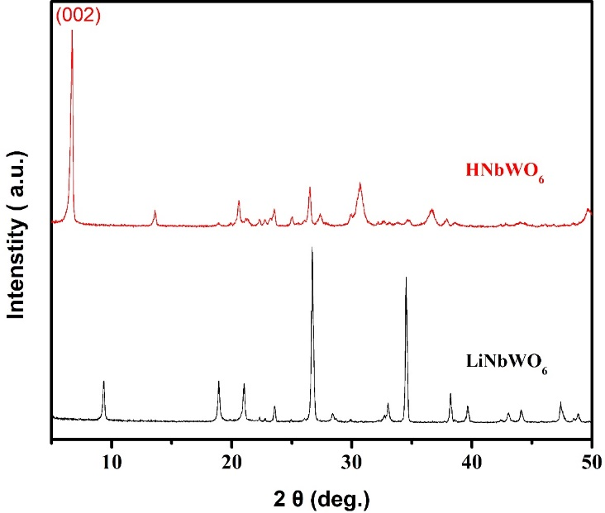
Figure 1. XRD patterns of the LiNbWO₆ and the corresponding proton-exchanged sample.
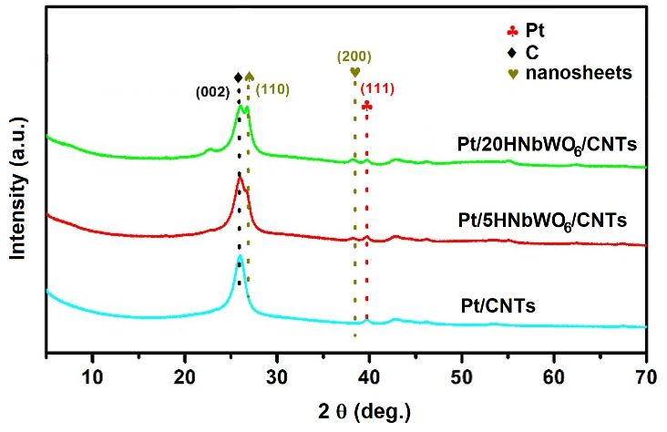
Figure 2. XRD patterns of supported Pt catalysts with different amount of the solid acid nanosheets.

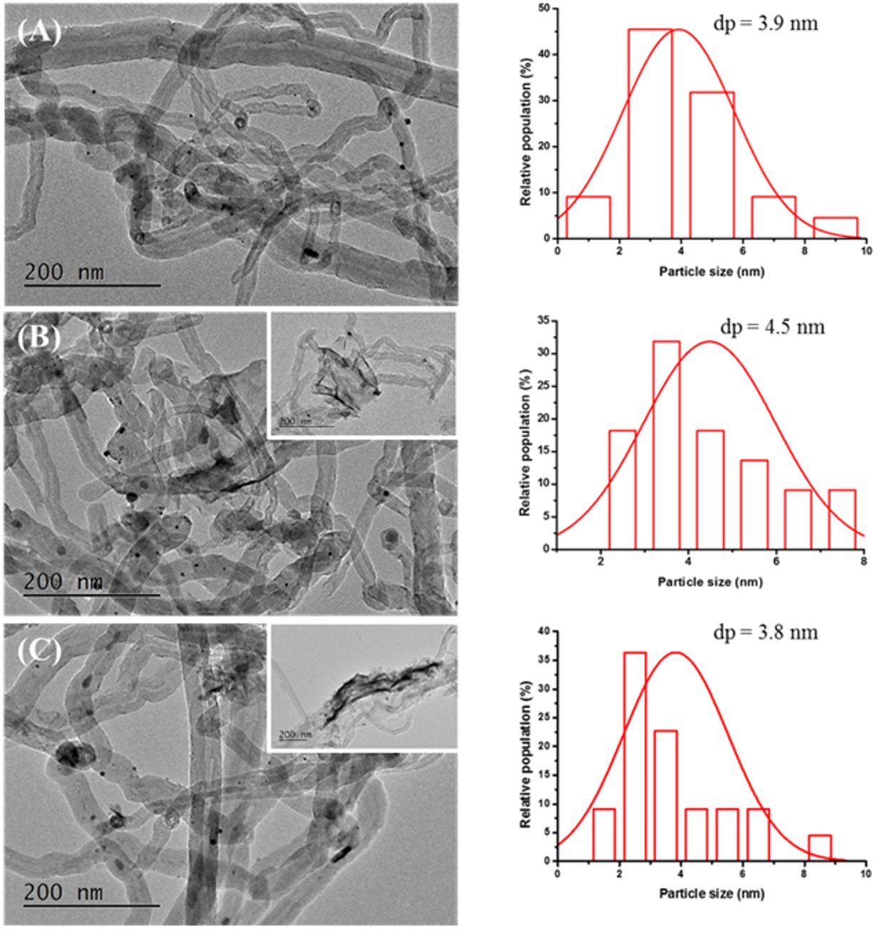
Figure 3. TEM images and Pt particle size distribution of different catalysts: (A) Pt/CNTs, (B) Pt/5HNbWO6/CNTs, (C) Pt/20HNbWO6/CNTs.

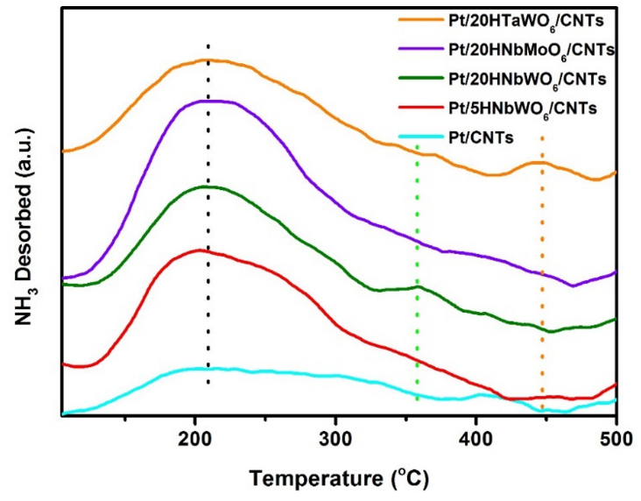
Figure 5. NH₃-TPD profiles of different catalysts.

- Please remove the embedded figure(s) from the manuscript. All figures should be uploaded separately to your Editorial Manager account.
Reply: We have removed figures from manuscript and placed it in a separately file.

- Please remove the embedded Table from the manuscript. All tables should be uploaded separately to your Editorial Manager account in the form of an .xls or .xlsx file.
Reply: We have removed Table from manuscript and placed it in a separately file in the form of an .xls file.

Reviewers' comments
Reviewer #1:
this manuscript described detailed process and it can be accepted as it is.
Reply: We really thank for your appreciation.

Reviewer #2:
This paper reports on the preparation of Nb and Ta-based solid acids nanosheets modified Pt/carbon nanotubes. The authors also investigated the catalytic hydroconversion of lignin-derived compounds using such Pt/20HNbMoO₆ as catalyst. I would like to recommend its acceptance for publication after the following revisions:
1. HRTEM images for the composites should be provided.
Reply: The HRTEM images of Pt/CNTs, Pt/5HNbWO₆/CNTs, and Pt/20HNbWO₆/CNTs are presented as follows:
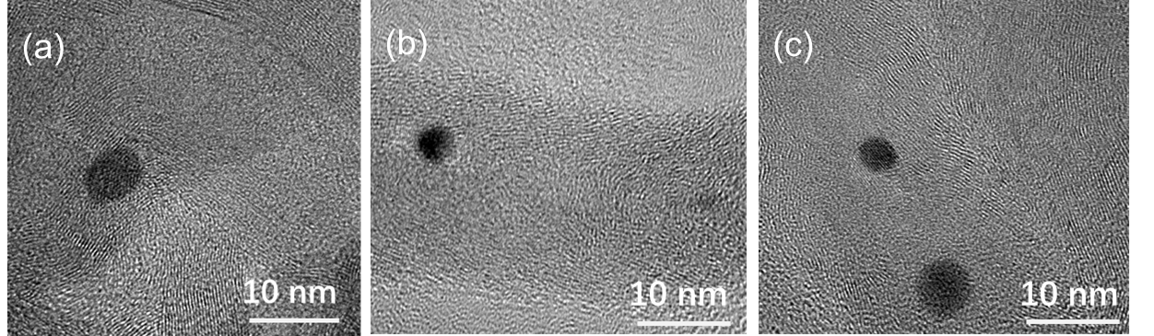
The HRTEM images of (a) Pt/CNTs, (b) Pt/5HNbWO₆/CNTs, and (c) Pt/20HNbWO₆/CNTs.
2. After catalysis, can the catalyst maintain its morphology and structure?
Reply: The TEM images of Pt/20HNbWO₆ catalyst after reaction are shown below. Obviously, the catalyst maintains the morphology and structure quite well.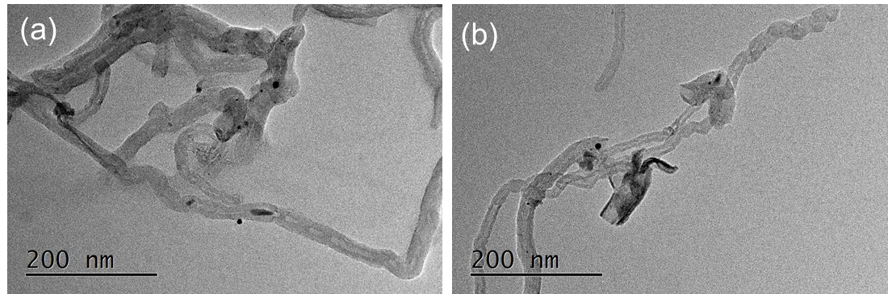

Reviewer #3:
Guan et al. reported an interesting work on improving the acidity of carbon nanotubes supported Pt catalyst for highly selective biomass conversion. The reported results are convincing and hence, I recommend this article for the publication after the adequate revision.
- The title can be modified. Try to use a concise and attractive title, for instance ''Tuning the acidity of Pt/carbon nanotubes based catalysts for selective biomass conversion''
Reply: Thanks for your suggestion, we have modified based on your comment.
Before modification:
“Solid Acid Modification of Carbon Nanotubes Supported Pt Catalyst for Highly Selective Biomass Conversion”
After modification:
“Tuning the acidity of Pt/ carbon nanotubes catalysts for hydrodeoxygenation of diphenyl ether”

- Abstract: it was reported that ''We herein present a method for the synthesis of Nb and Ta-based solid acids nanosheets modified Pt/carbon nanotubes''. However, Mo and W species also exhibit acid properties and sometimes much better than the Nb and Ta oxides. So, the above sentence must be modified.
Reply: Thanks for your comment, we have modified the sentence.
Before modification:
''We herein present a method for the synthesis of Nb and Ta-based solid acids nanosheets modified Pt/carbon nanotubes''
After modification:
“We herein present a method for the synthesis of HNbWO₆, HNbMoO₆, HTaWO₆ solid acid nanosheets modified Pt/carbon nanotubes”

- Abstract: Pt/CNTs < Pt/5HNbWO6/MWNCTs < Pt/20HNbMoO₆/CNTs < Pt/20HNbWO₆/CNTs < Pt/20HTaWO₆/CNTs. here, only in the second catalyst nomenclature, MWCNTs is mentioned?
Reply: We are sorry for our mistakes. MWCNTs which is multi-walled carbon nanotubes.
Before modification:
“Pt/CNTs < Pt/5HNbWO₆/MWNCTs < Pt/20HNbMoO₆/CNTs < Pt/20HNbWO₆/CNTs < Pt/20HTaWO₆/CNTs”
After modification:
“Pt/CNTs < Pt/5HNbWO₆/CNTs < Pt/20HNbMoO₆/CNTs < Pt/20HNbWO₆/CNTs < Pt/20HTaWO₆/CNTs”

- There is a nice review article (Chem. Soc. Rev., 2018, 47, 8349-8402) on catalytic biomass conversion; including carbon nanotubes based catalysts for lignin conversion. It would be useful to improve the introduction part.
Reply: Thanks for your suggestion. We have added some more examples within line 81 – 95.

- Line 209, why the only Pt/20HNbWO₆/CNTs catalyst is selected for the reaction? Pt/20HTaWO₆/CNTs catalyst exhibits higher acidity. I think it will exhibit higher activity than the Pt/20HNbWO₆/CNTs catalyst as the hydrodeoxygenation also depends on the acidic properties including redox properties.
Reply: The activity of Pt/20HTaWO₆/CNTs (88.8% conversion, not shown in this paper) is lower than Pt/20HNbWO₆/CNTs (99.6%), thus the yield of cyclohexane decreases. Hence, although, higher selectivity of cyclohexane was obtained over Pt/20HTaWO₆/CNTs, lower conversion of diphenyl ether limits its utilization. We have corrected our description.

- Fig. 1, LiNbWO₆? There is no XRD of Pt/20HTaWO₆/CNTs.
Reply: We have LiNbWO₆ as shown in Fig. 1 and Pt/20HNbWO₆/CNTs as shown in Fig. 2. We have the XRD results of Pt/20HTaWO₆/CNTs published elsewhere “Molecular Catalysis 467 (2019) 61-69”. However, only LiNbWO₆ series are presented here in this paper as an example, as we believe that the scope of Jove focuses on the protocol, and not the characterization data.

- Provide another table or figure with the activity results
Reply: The activity results are presented in Table 1, as an excel file.

- Take care of English and type errors.
Pt supported catalysts to supported Pt catalysts, line 48
have been to has been, line 51
Bronsted, line 72
Units of temperatures, K in line 115, 127 but oC in line 135, 144, etc.
Temperate units, line 202.
Reply: We have corrected it in revised manuscript.

We believe that all the points raised have now been sufficiently addressed and the paper should now be in its proper form acceptable for publication. We thank you for your time and consideration. I hope that the referees and you are satisfied with our responses to the referees’ comments and with the changes to our manuscript.
Thank you for your kind attention.

Yours sincerely,

Chi-Wing Tsang (Dr.)
Technological and Higher Education Institute of Hong Kong
Tel: 852-68962636
Email: ctsang@vtc.edu.hk

