Figure 4

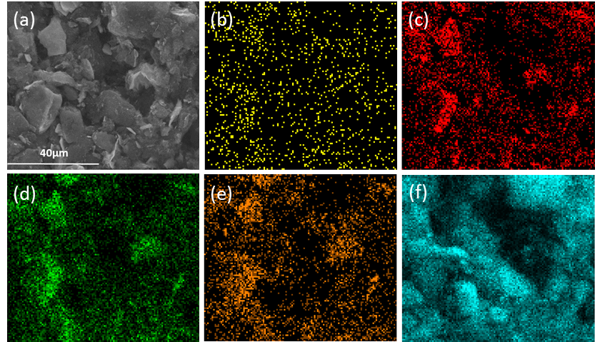
SEM image (a) and elements mapping of Pt (b), O (c), Nb (d), W (e) and C (f) over Pt/HNbWO₆/CNTs.

