Dear Phillip Steindel, PhD, Review Editor, Journal of Visualized Experiments:

We are excited to submit the revision of our manuscript, “Inverse Probability of Treatment Weighting (Propensity Score) using the Military Health System Data Repository and National Death Index” for consideration for publication in the Journal of the Visualized Experiments (JoVE).

We very much appreciate the thoughtful review and feedback by the editors and reviewers. The suggested changes have further strengthened the article and we feel it will be a helpful addition to the literature as a methods paper for use of the opportunity to submit the manuscript reviewing the use of the Military Health Systems Data Repository for a retrospective database study. Additionally, it provides a protocol for applying propensity analysis to account for selection bias in a retrospective design.

With the growing popularity and availability of administrative data sets, we believe our study is a timely addition to the journal and will be well received. It is inherent that investigative groups that are interested in using this study methodology have a guide to its appropriate use.

On behalf of the authors, I thank you for considering our revised manuscript for publication in the Journal.

Sincerely,

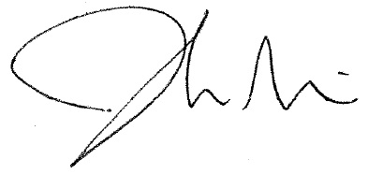

Joshua D. Mitchell, MD
Assistant Professor of Medicine
Division of Cardiology
Washington University School of Medicine in St. Louis

