[Supplementary information]
The server operation manual
- Sign up
1.1 User Registration
1.1.1 Display the server login screen at the login URL.
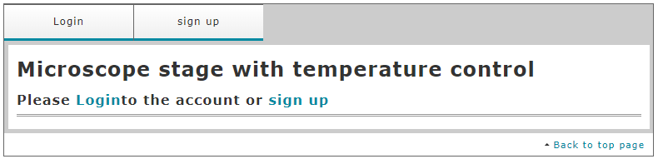
1.1.2 Click [sign up] button. Enter necessary items according to the message.
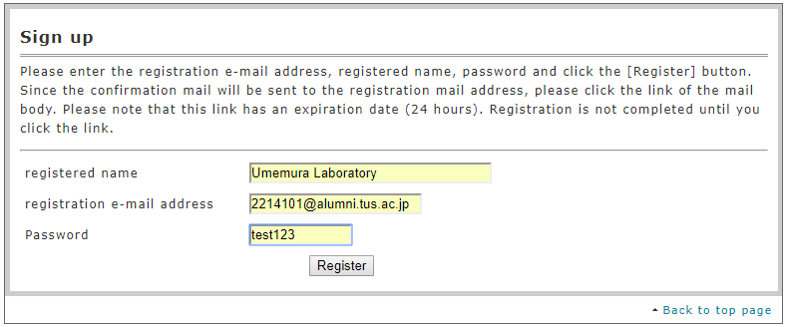
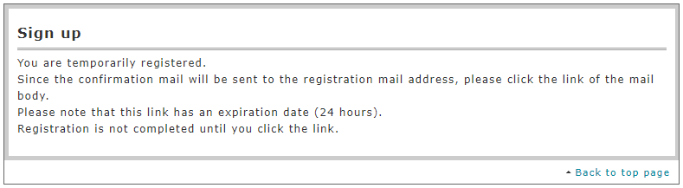
  - Terminal Registration
1.2.1 Display the server login screen at the login URL.
    - Click [Login] button. Enter e-mail address and password.
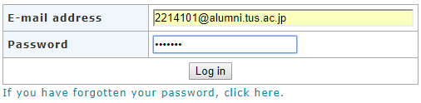
    - Click the [Login] button to display the next screen.
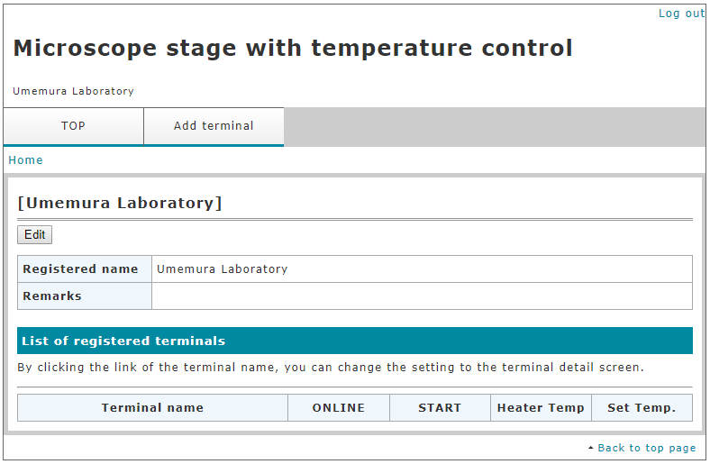
    - Click [Add terminal] button to display the next screen, and enter necessary information.
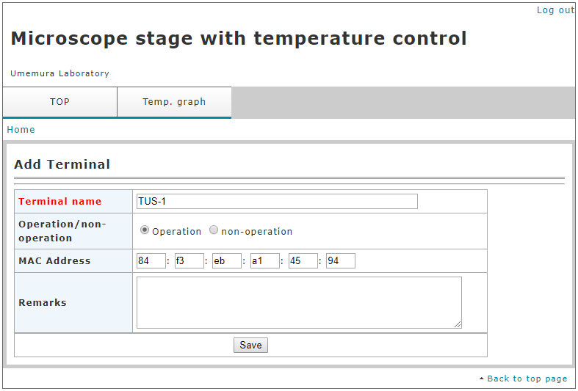
2. Operation
2.1 Operation Status
    - Log in and call up the next screen.
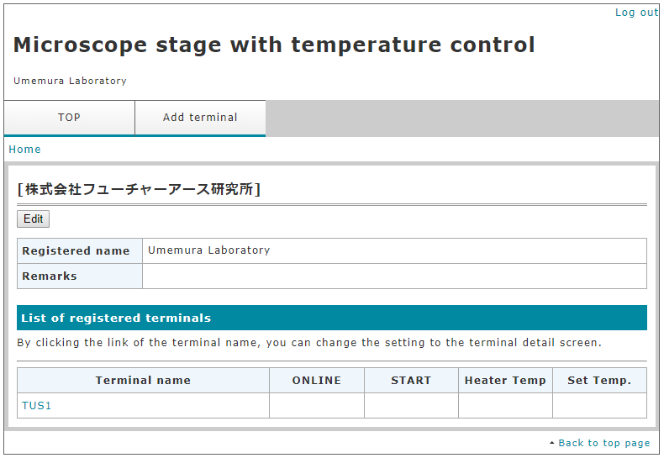
    - Click [Terminal name] button to display the next screen and confirm terminal information.
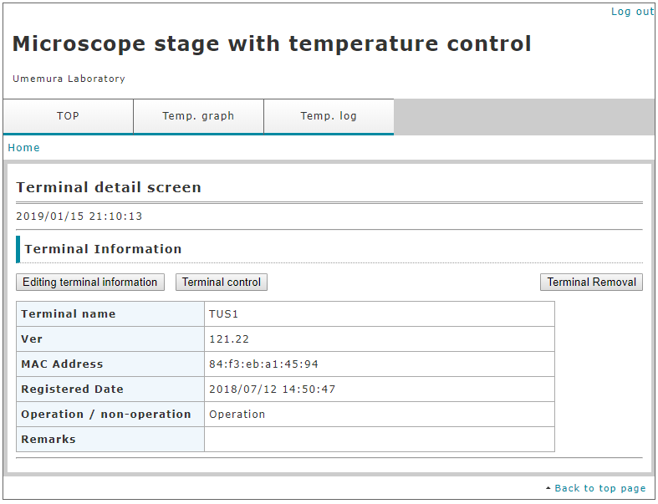
    - Click [Editing of terminal information] button to display the next screen and change the operation status.
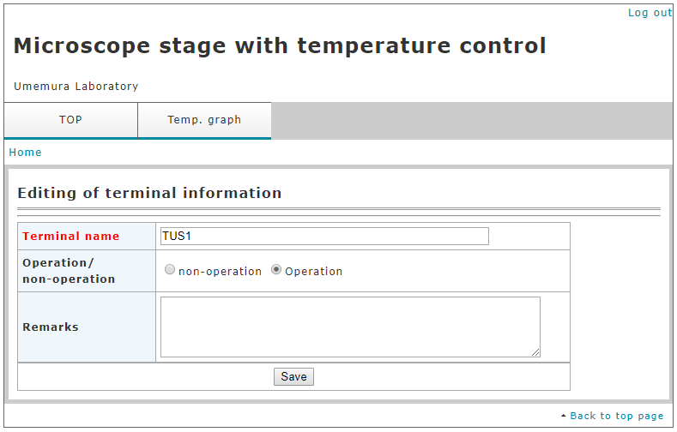
  - Temperature setting
    - Call up the next screen.
2.2.2 Click [Terminal control] button to display the next screen and set the target temperature.
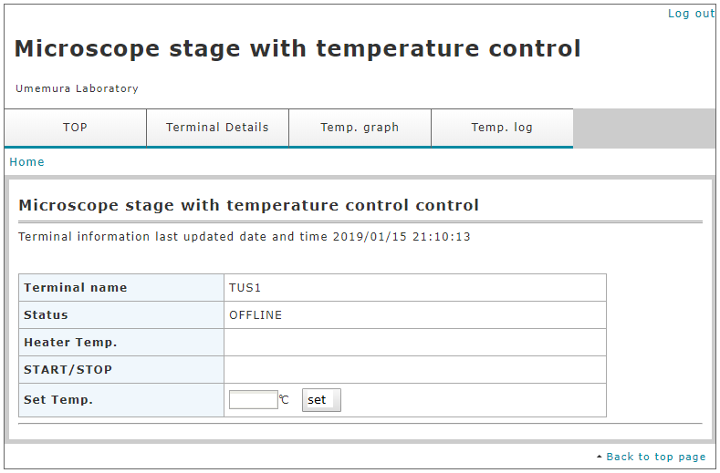
  - Display of temperature graph
    - Call up the next screen.
2.3.2 Click [Temp. graph] button on the terminal details screen. The following screen is displayed.
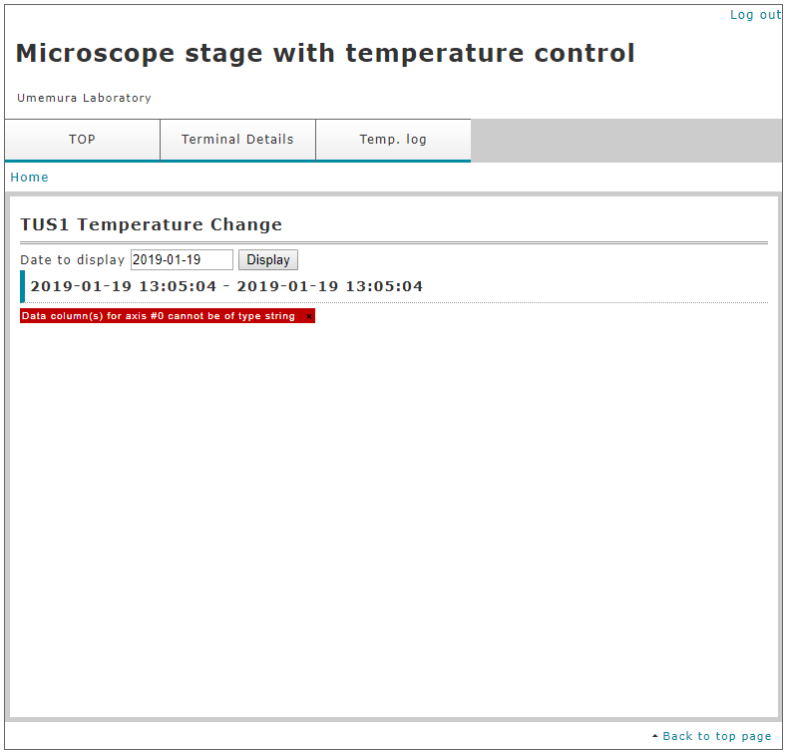
2.3.3 Specify the date to be displayed and click [display] button. The following graph is displayed.
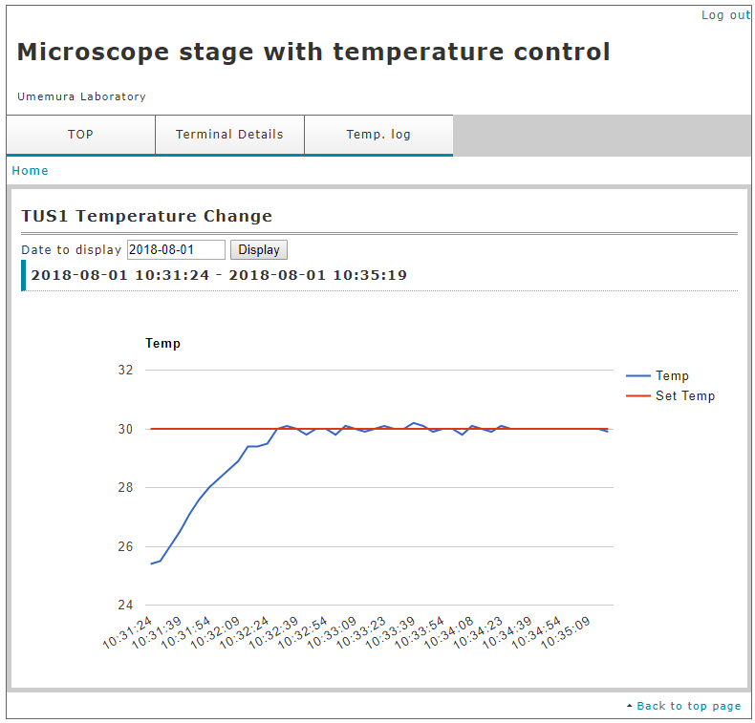
  - Download of temperature log data.
    - Call up the next screen.
    - Click [Temp. log] button on the terminal details screen. The following screen is displayed.
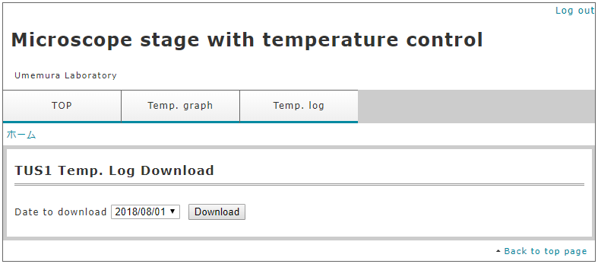
  - Specify the date to be displayed and click [download] button. The following CSV data is downloaded.
